**Anatomy of digital EDI card**

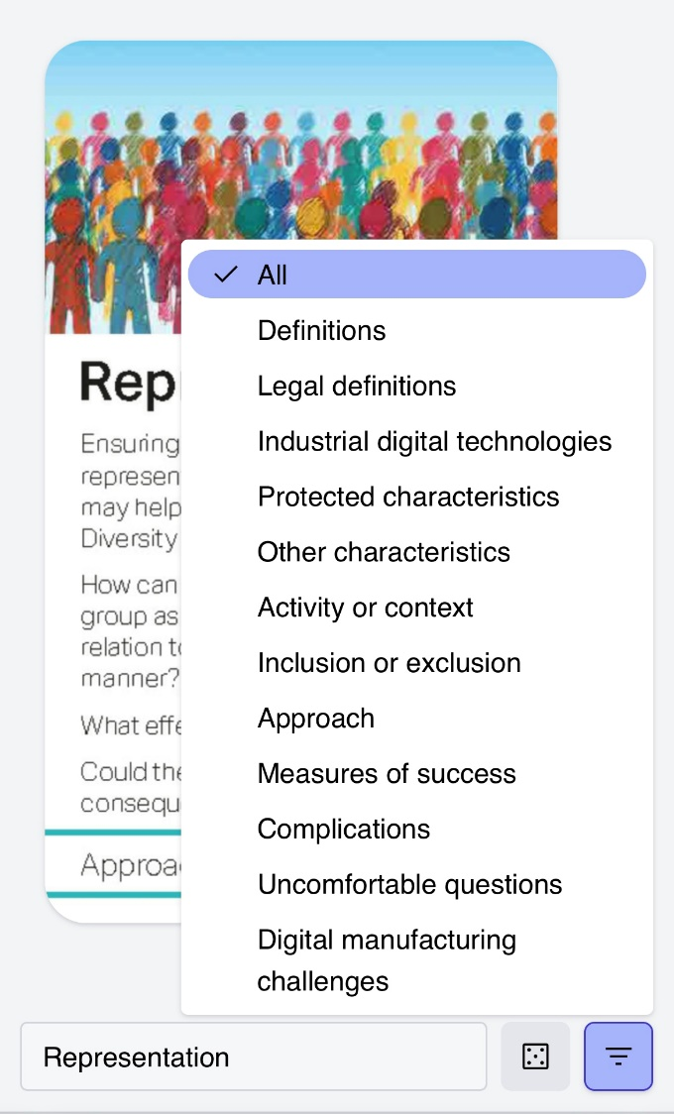

Dice for random card selection

Search for card

Access to list of suits

The list of suits and selection of 1 or more suits

The suit the card belongs to

The card you have selected

The card you have selected

You can swipe on a phone or click on a laptop left or right to get to different cards.

Please note that the digital cards may take time to load they contain multiple images. This can happen on both phones and laptops. Please be patient, they will download!