Facilitation guide for using the Equality, Diversity and Inclusion (EDI) cards

- The EDI cards were developed by Peter Craigon, Debra Fearnshaw, Oliver Fisher and Emma Hadfield-Hudson at the University of Nottingham
- The development of the EDI cards is an ongoing research project lead by Peter Craigon
- The 11 guide cards, described on the following pages, were created by Research Consulting following additional research by University of Nottingham
- The EDI cards are sorted into 12 categories (see the bottom of the card). You are free to use all the cards or just select cards from certain categories
- The EDI card categories can be further grouped into 4 wider themes for use (Definitions, Scenario, What am I going to do? Complications and Practicalities)
- We hope these cards will help facilitate discussion and support engagement with EDI. Improving issues of EDI is a constant ongoing process which is never done

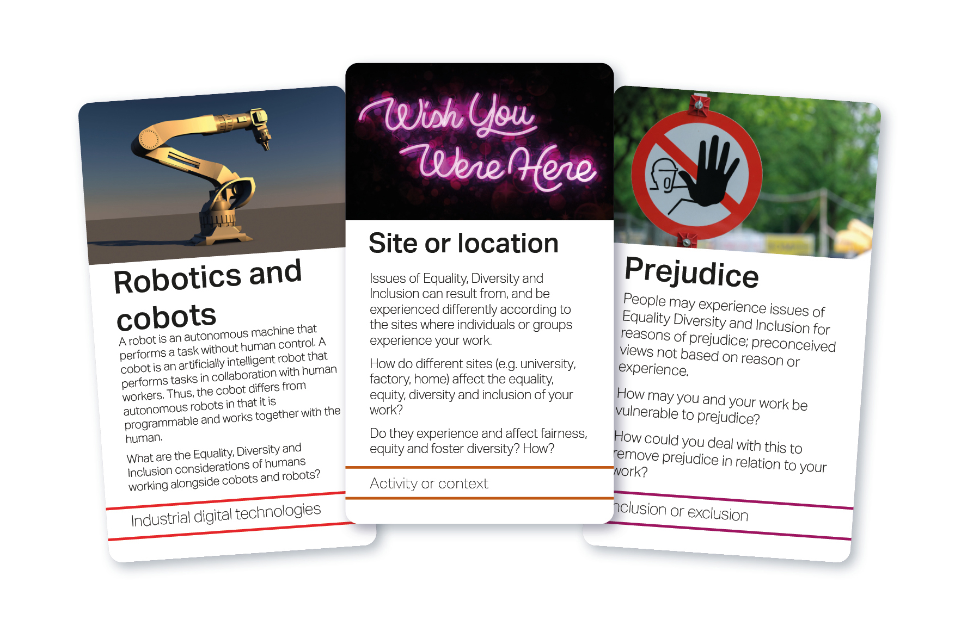

Start here! - This is not a rulebook!
We are pleased you’re interested in the Equality, Diversity and Inclusion (EDI) cards. The cards are intended to be used flexibly, as an aid for discussion and reflection on EDI in a variety of settings.
You do not need to use all the cards!

This guide is not a rulebook! Rather, it provides prompts and suggestions for you to use in your own way, in your own workplace, organisation or context.

This guide will also cover:
- Key principles
- EDI card themes
- Starting point, objectives and how to get there
- Introductory exercise
- Suggested activities
- Example use cases
- Prepare in advance
- Facilitation support
- Take home message
- Further resources

To access a digital version of the cards scan this QR code or go to the EDI digital cards website

Key principles
We hope these cards will be helpful to your engagement with EDI.
To help you use the cards, we suggest:
- Familiarise yourself with the cards. How might they meet your needs?
- What is the context that you are using them in? Which categories are most useful in this context?
- Conversations about EDI can be sensitive. Any activities you do with the cards need to be considerate of everyone’s lived experiences

More ideas to consider:
- These cards can be used in any way which suits those using them – there are no rules!
- Developing your own card activities will best help you meet your needs
- Other people using the cards may have different lived experiences from yourself and may or may not choose to share them
- Ensuring a safe, respectful and welcoming environment during a card activity is important

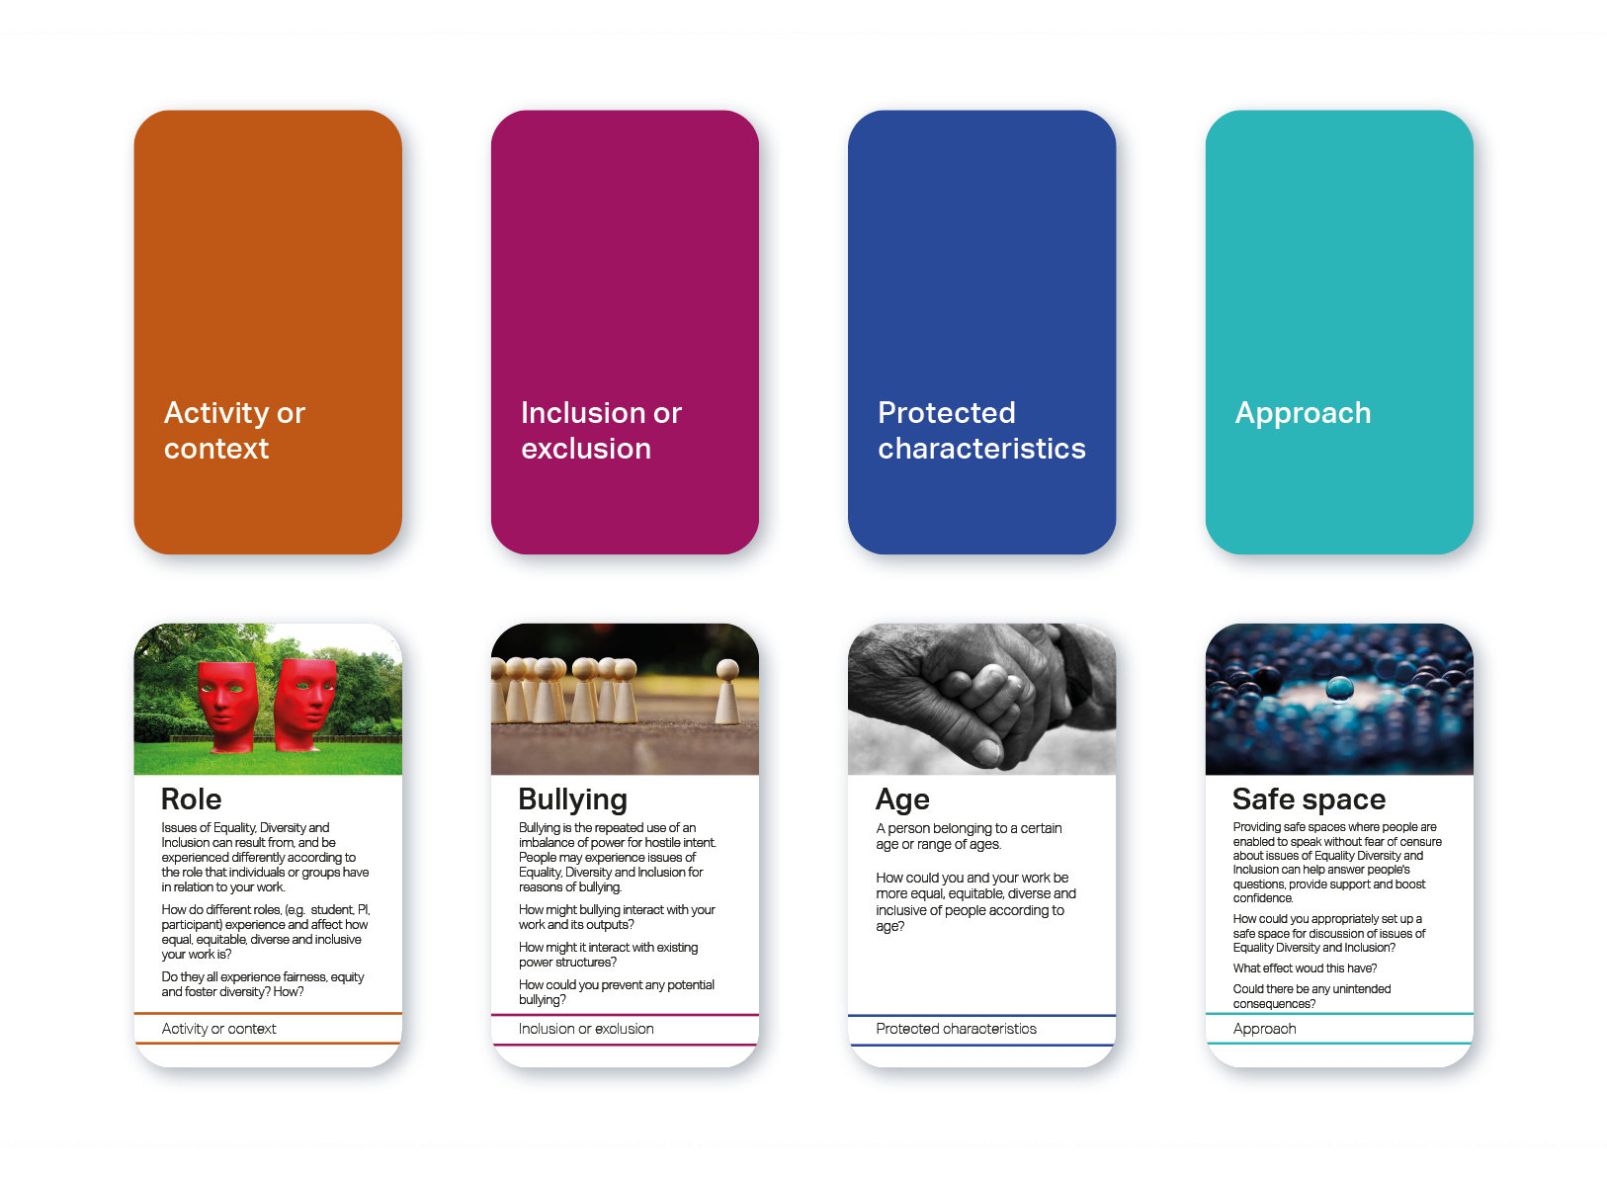

EDI card themes
The cards contain 12 categories, which can be sorted into 4 broad themes. These are:
- Definitions – Definitions, Legal definitions
- Scenario – Protected characteristics, Other characteristics, Activity or context, Inclusion or exclusion Industrial digital technologies*
- What am I going to do? – Approach, Measures of success
- Complications and Practicalities – Complications, Uncomfortable questions, Digital manufacturing challenges*
* These are for a specific research area and may be put aside.

More ideas to consider:
- It may be helpful to consider these themes when designing and carrying out activities and exercises. For example, pick one random card from each theme and discuss
- You may also consider using the individual categories separately depending on what you need
- You do not need to use the full set of cards. A first step could be to consider which categories are most useful for you. For example, only use the Protected characteristics, Activity or context, Inclusion or exclusion and Approach categories

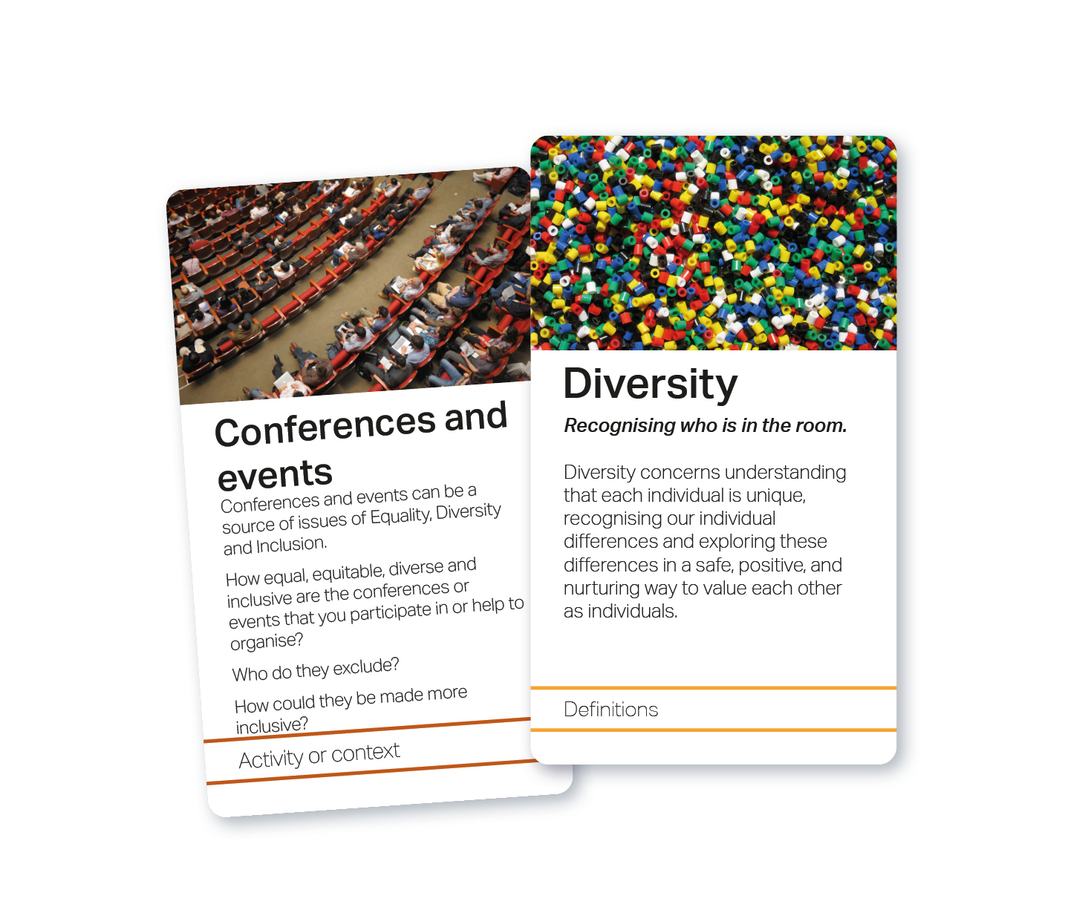

Starting point, objectives and how to get there

Everyone starts from a different place, with different experience, skills, objectives and needs. Key things to think about when using the cards are:
- What do you want to get out of the session?
- What results would you like?
- What would you like the take home message to be from the session?

Additional factors to consider when using the cards, such as the nature of the attendees and session, can be viewed on the website.

More ideas to consider:
When using the cards, you may want to think about:
- Why do you want to use the cards? What are your needs?
- Who is using the cards? What experience do they have?
- What do you want people to do? Discuss? Design? Reflect?
- How will the session be carried out? e.g., individually, collectively, face-to-face, online, etc.
- How and when will the sessions take place?
Think about what you want to get out of the session:
- Education or awareness - e.g., considerations of EDI generally
- Project or research related - e.g., viewing a piece of work from an EDI perspective
What results would you like?
- Is a discussion enough?
- What influence or change would you like to have?
- How do you measure success?
What would you like the take home message to be from the session? You could encourage people to:
- Do something different
- Find something out
- Ask somebody
- Consult with others

Introductory exercise

Introduction
- Start with piles of the ‘Activity or context’ and ‘Inclusion or exclusion’ categories, face down
- Draw one card from the top of each pile
- Discuss how these may be related (or not!)
Progression steps
- Additionally draw a card from the ‘Protected characteristics’ pile
- Consider how this characteristic may or may not be impacted by the other two cards

More ideas to consider:
Further progression
- Choose another category you believe may be relevant for your context/team/project and do the same with this
Alternative ways to play:
- Deal hands of the additionally chosen categories (Protected characteristics, Approach etc.) and have team members propose cards they think are relevant or important and discuss
- Draw 5 cards of additional categories and collectively rank these by relevance or importance to your scenario

Suggested activities

There are many different actions that you can do with cards that could be used or combined, such as:
- Pick a card – at random? From a selection?
- Rank – importance, significance, relevance
- Discard – Select cards to consider further, discard others
- Cluster – does a combination of cards mean something different – e.g., Intersectionality
- Deal – this is a way of distributing the cards at the beginning of the activity
- Hands – who’s got the most appropriate card, play from a hand
- Categorise/group
- Start from a project – select cards relevant to a project
- Start from a card or principle – think of a project relevant to a card
- Collective – discuss a group of cards
- Align spatially – where the layout means something, e.g., rank, alignment

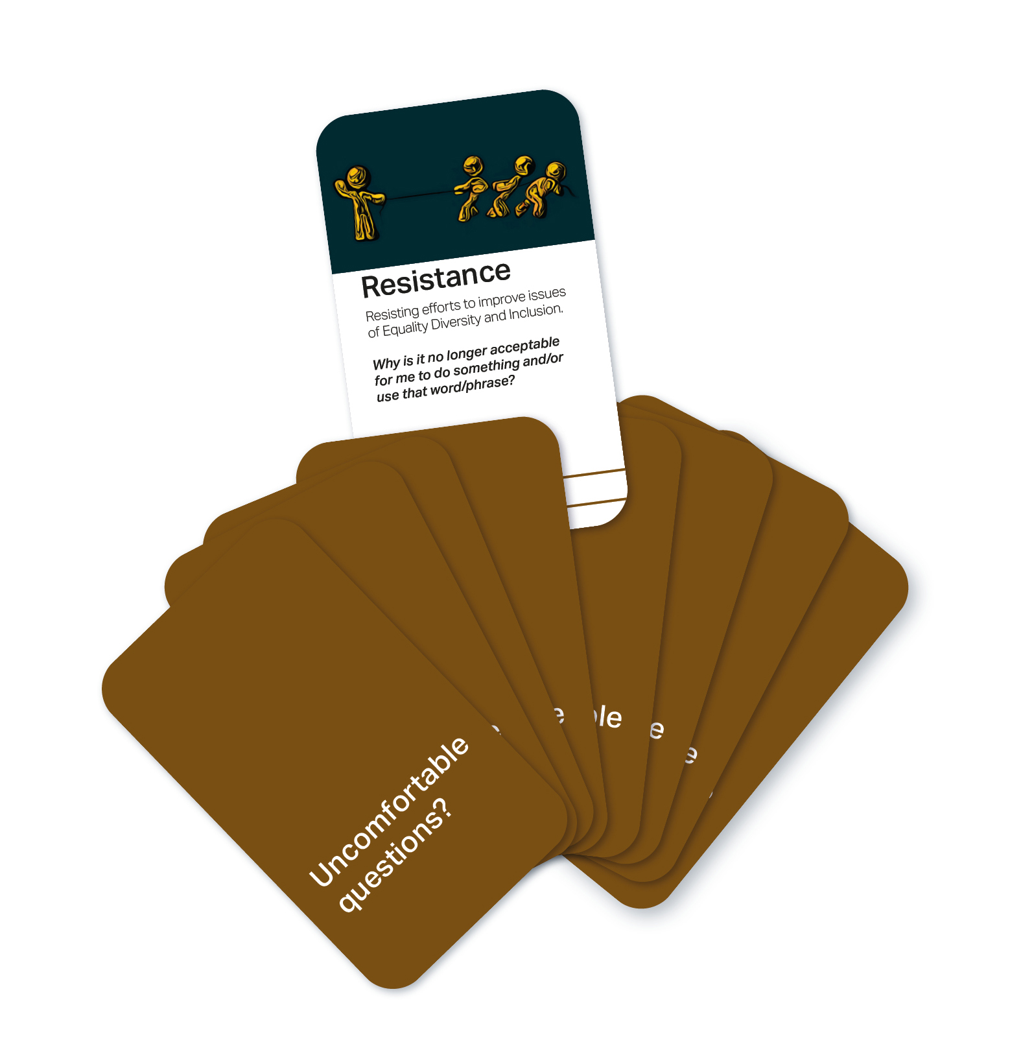

Example use cases

Random draw
- Pick card(s) at random (from each of the 4 themes) – with each card that is drawn discuss how this in combination with the others relates to experiences of EDI
‘EDI by Design’
- Define a project or context
- Select cards to:
  - Identify potential positive and negative impacts of the project which relate to EDI
  - Determine ways of maximising positives and minimising negatives
  - Identify practical challenges of implementing these steps

More ideas to consider:
Do the same exercise with multiple groups to include different voices and perspectives.
- Before = Design
- During a project = Reflection
- After = Review

“We used the EDI cards at a diversity event for students, it was great to see how much students engaged with these cards and the room was full of discussion. By randomly choosing cards students were talking not necessarily about issues they faced but were empathetically thinking about problems others face and how they can help address these problems.”
Dr Katie Severn (she/her), Assistant Professor, School of Mathematical Sciences, University of Nottingham

Prepare in Advance

Things to think about when preparing your session might include:
- Ground rules for the discussion, to ensure a safe and respectful discussion
- Which cards you want to use? All? Some categories? Selected few? These may help structure the task
- Keeping the activities simple and appropriate. Can you adapt an already existing activity or process?
- Do you need extra equipment e.g., pens, sticky notes etc.
- How are you going to record the activity and what will participants take away? This could be done through notes, card selections or recordings
- Preparing a short presentation with instructions. This can be a helpful way to start the activity and make copies for your participants to refer back to
- How does this activity fit in with others you might do?
- Will the activity be spread over multiple sessions?
- It may be helpful to run through a worked example of an activity - see the website for a filmed example

More ideas to consider:
- Prepare yourself in advance for how you will appropriately deal with potentially difficult discussions and disagreements. It may be useful to research some strategies ahead of the session
- Prepare information about internal and external sources of support following the session, should participants need this
- Think about what is essential to your session and what is less so

Facilitation support

Each session will be different, and the confidence to facilitate discussion will come with experience.
Using the cards is similar to other discussion-based activities.
Some tips for facilitating discussion include:
- Set expectations for a respectful discussion. Clear ground rules will create a safe and supportive space for discussion, ensuring that everyone in the room feels comfortable and will be respectful of each other
- Provide structure but be flexible
- Be comfortable with silences
- Provide multiple ways of contributing to the session. (e.g., written, spoken, anonymously online)
- Provide a goal or take home message for participants
- Embrace the unexpected
- Everybody should have equal voice and be encouraged to share as much or as little of their own experiences as they feel comfortable with
- Bring discussion back to the cards if it’s going off at a tangent
- Reflect and learn from your experiences for next time

More ideas to consider:
- Questions may come up that you can’t answer. That’s fine. You are there to facilitate, not to have all the answers. You could look for an answer afterwards or point to other sources of support or information (see further resources)
- It might be useful to provide statements as jumping off points and then ask people to expand on them
- Silences do not necessarily mean that people are not listening, thinking or engaged. People may get value out of the sessions without saying much. People don’t always find it easy to contribute to sessions like this. Some people may be quieter but will be listening, thinking and reflecting on the discussions

Take home message

Using the cards should lead to valuable discussions, but how can this be used to progress EDI?
- What are you and your participants going to do differently as a result?
- How will you and your participants record and follow up on this?
- Questions to consider:
- What will I/we do differently?
- How can I/we ensure that this is appropriate?
- Who can help me/us?
- Where can I/we find out more?

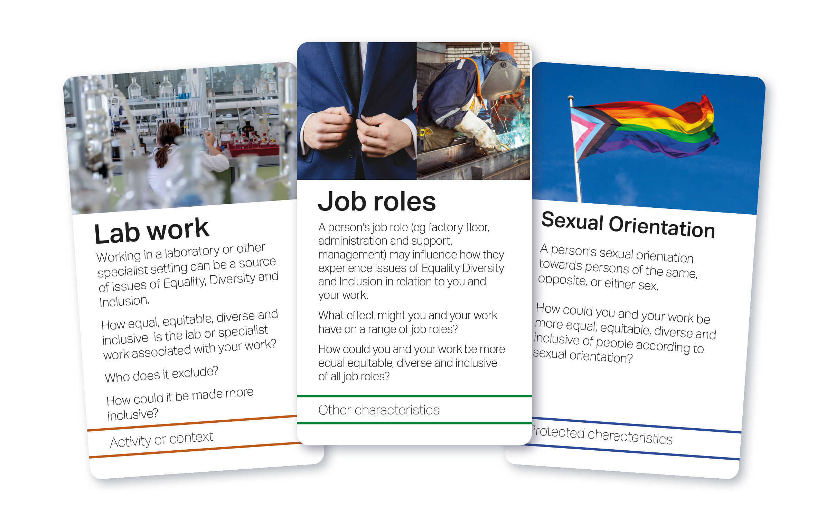

Further resources

Further resources to support these cards can be found on University of Nottingham website EDI cards page.

As the research continues, the research team intends to publish our findings. The first output published is The Equality, Diversity and Inclusion Cards – Introduction and Work in Progress which was presented at the First International Symposium on Trustworthy Autonomous Systems in July 2023.

More ideas to consider:
- University of Nottingham EDI Resource Bank
- Equalities and human rights commission – protected characteristics
- Advance HE guidance
- ESPRC EDI expectations
- University of Newcastle – EDI Toolkit for Researchers
- Oxfam – Inclusive Language Guide
- Royal Society – what is research culture?
- UKRI – Equality, Diversity and Inclusion strategy
- Disability Rights UK – Social Model of Disability
- A recording sheet may be useful to see what needs to be picked up in future sessions
- An action sheet for participants to record what they may do after the session
- If you wish to feedback on the EDI cards, you can complete this short form
- You may want to discuss with the participants where they can find more support if conversations raise certain issues. BBC Action line may offer good suggestions for support as well at your university services

Acknowledgements

The EDI guide cards were written by Research Consulting in June 2023 following additional research by University of Nottingham.

The original research associated with the development of the EDI cards was funded through Connected Everything (EP/S036113/1). The production of this guide, a digital version of the cards and website resources were funded by UKRI Trustworthy Autonomous Systems (EP/V00784X/1) and University of Nottingham.

