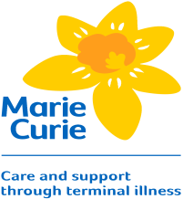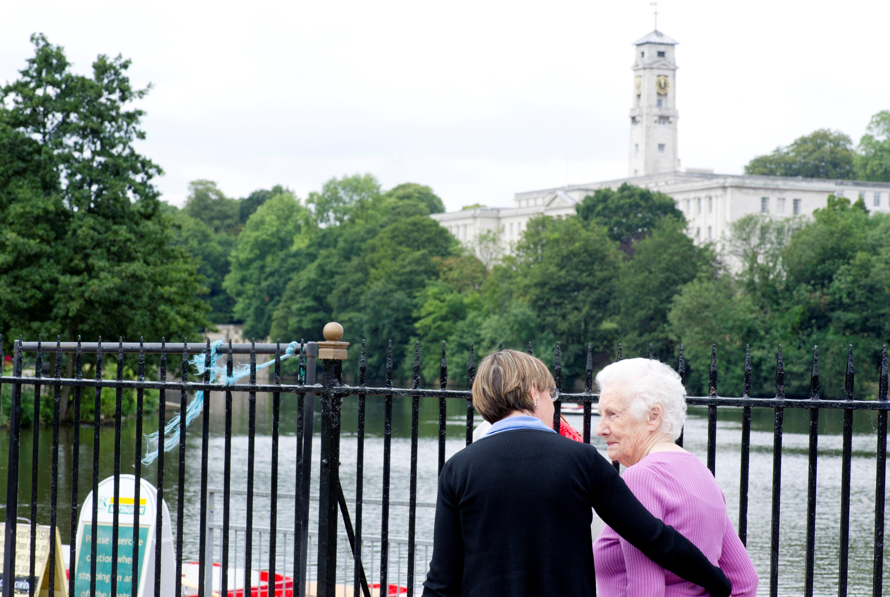

The aim of this free course is to equip those who offer support to carers in a home based end of life context with the confidence and skills to do so safely.

The course will cover the following topics:

Caring and being cared for, supporting in practice, being a safe supporter, the principles of supporting, Boundaries and exit strategies, ongoing learning and development

No previous knowledge or experience is assumed, and the course is free to attend. Refreshments and lunch will be provided and assistance with travel costs may be available.

(Contact details, who and how)

for further information and to reserve a place.

**Supporting carers in end of life care:**

**An introductory Programme**

**(Date)**

**(Time)**

**(Location)**

The aim of this free course is to equip those who offer support to carers in a home based end of life context with the confidence and skills to do so safely.

The course will cover the following topics:

Caring and being cared for, supporting in practice, being a safe supporter, the principles of supporting, Boundaries and exit strategies, ongoing learning and development

No previous knowledge or experience is assumed, and the course is free to attend. Refreshments and lunch will be provided and assistance with travel costs may be available.

(Contact details, who and how)

for further information and to reserve a place.

