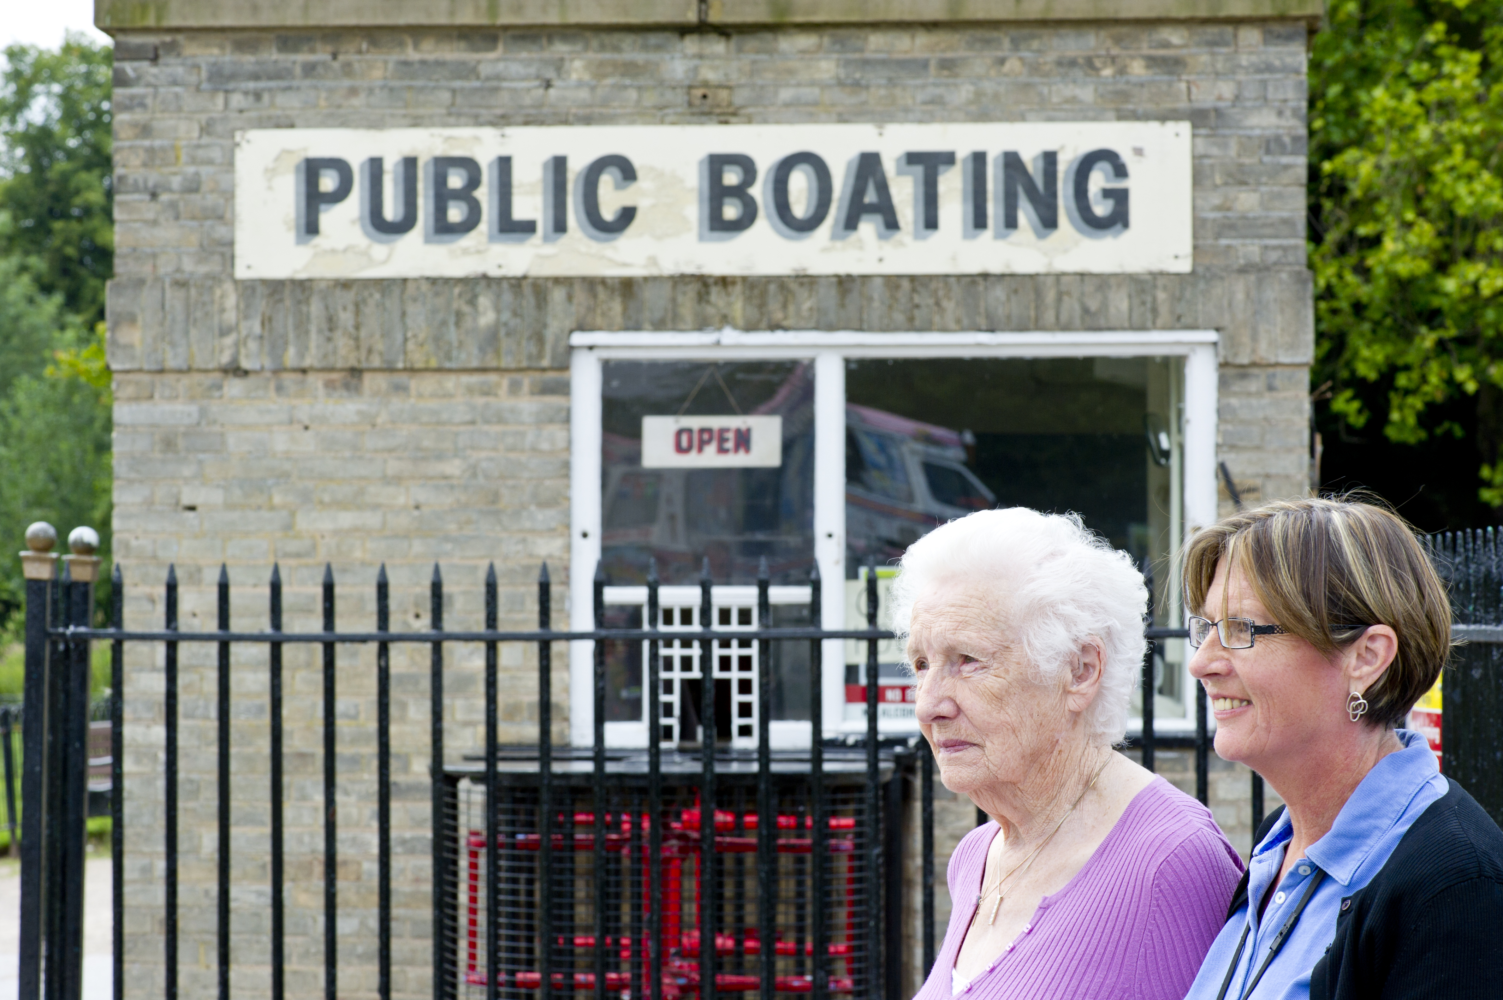
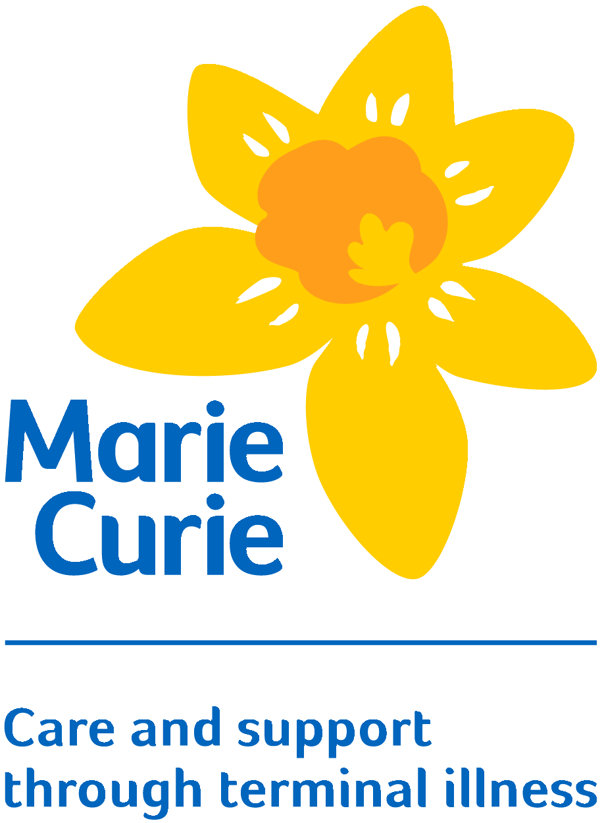

Supporting carers
in end of life care:
An introductory
programme

Trainee
Workbook

Introduction

This workbook is intended for you to use in the way that suits you best. It contains details of all the activities, plus copies of the power point slides can be found at the back of the workbook. There is also space in which you can record your thoughts and ideas throughout the day. What you write in this workbook is not intended for anyone other than you although you can, of course, share it with others if you wish.

Session 1: Introduction and Welcome

Key learning points

At the end of this module, you will have:

- Met the facilitators and other participants.
- Been introduced to the day’s programme.
- Set ground rules for the day.

Timetable for the day

The training programme is divided into seven short sessions, as follows:

Session 1: Introduction and welcome (30 minutes)
Session 2: Caring and being cared for (1 hour)
Session 3: Supporting in practice (45 minutes)
Session 4: Being a safe supporter (1 hour)
Session 5: The principles of supporting (30 minutes)
Session 6: Boundaries and exit strategies (30 minutes)
Session 7: Ongoing learning and development (45 minutes)

You may like to use this space for any notes you would like to make

Session 2: Caring and being cared for

Key learning points

At the end of this session, you will:

- Understand that ‘end of life’ is described in a variety of ways and be familiar with the different terms.
- Identify that carers may have a range of relationships with the person who is ill.
- Recognise that carers have a range of support needs, including help for themselves, and help to support the person who is ill.
- Understand the importance of actively listening to carers talk about their experiences.
- Be given the chance to think about strategies for dealing with carers who are upset.

Session 2 exercise 1: exploring terminology

Working in small groups, think of all the different words and phrases you have heard in relation to death, dying, palliative and end of life care.
Write these on the flip chart paper.

You may want to make your own notes about your discussions.

Session 2 exercise 2: the need for support in end of life care

Watch the film of Jacqui talking about her experiences. Whilst you are watching, consider what types of issues Jacqui discusses in relation to her caring role. The transcript of this clip is included on the next page for your reference. You may want to make some notes whilst you are watching.

Being a Carer: the experiences of Jacqui (Transcript of the film clip) www.healthtalkonline.org
I used to try and cheer him up and like make him laugh and things like that but for the last few years, it was like carers, district nurses. Not only the emphysema but he also had to have a bag in his stomach so like he like it was sort of pipes everywhere because he couldn’t pass water. He, at the end he really couldn’t do anything and it was hard. I think one of the hardest things that happened was district nurses, they wasn’t very helpful, and I, I didn’t realise that I was losing control. But I had a lovely nurse, a Macmillan nurse came in, [nurse’s name], and she was like a breath of fresh air, and the district nurses said I had to have a hospital bed in the room.

So not only did we have all these machines but we had this hospital bed come in. I was sleeping in the front room on a blow up bed and that was finishing Terry off, because we always had each other. He was…he was the main person that I always leant on, like always I could always depend on him. He was strong and the roles changed. I’d become the strong one for him but when they brought this hospital bed in he said to me, “It’s like.” He said, “I feel it’s over.” He said, “If we haven’t got each other in bed of a night.” And I, I didn’t know I could say no and this lovely nurse came up, [nurse’s name], and my daughter was here with us, and she said, “is there anything that’s worrying me?” And I’d been trying to stop my children to see how I was feeling about everything because, you know, you try and be strong for everybody. And like I said to this nurse and I broke down and I said, “He feels it’s the end because like at least we could comfort each other. I’d go to bed early just so that I can hold him, show him how much I loved him, and felt it was all taken away.” And she said to me, “But you don’t have to have that. You don’t have to do this. You can tell them you don’t want that.” And I didn’t realise I could do that. I thought, you know, they’re telling me I’ve got to do the best for Terry and I thought, “Okay.” Like, “You know best.” But she said, “No.” That I knew best and I thought, and it was a turning point, and I thought, “Yeah, you’re right. I know what’s best for him” And we got our bed back and got, they, they the put like it was a bit of a performance but we got the hospital bed back out and it give Terry that lift again because I always tried to make him laugh and like just to just to cuddle. Like I used to cuddle him, just feel like I wanted my strength to go into him, to like make him strong again.
Session 2 exercise 3: managing distress

- Listen to George talking about his experiences. Whilst you are listening, think about what George says about being a carer for his wife. You may want to make some notes.

- Imagine that you are supporting George who has been talking about his wife’s brain tumour. George starts crying whilst he is talking. In your small group, discuss what you might do.

You may like to use this space for any notes you would like to make

Session 3: Supporting in practice

Key learning points

At the end of this session, you will have:

- Applied learning from session two to case study examples.
- Discussed carer needs at the end of life, and reflected on the supporting role.
- Recognised that there are a range of activities that can be used to support carers.
- Understood that there are a range of agencies involved in end of life care and recognised the importance of signposting.
- Appreciated that you will already have many skills that are transferable to this context.

Session 3 exercise 1: case studies

Read the case study that has been assigned to your group (the different case studies are at the end of this section). In your small groups, discuss the following questions about your case study.

Be prepared to feedback your discussion to the rest of the group.
Question 1: What support needs do you think this carer might have?

Question 2: What do you think this carer might want from a supporter?

Question 3: What do you think you might offer the carer in your supporting role?

Question 4: How might you explore this with the carer?

Case Study 1: Will

Will is 21 years old. His dad, John, has Motor Neurone Disease (MND) in the advanced stages. Will lives at home with his mum, Sarah.
John has been ill for a number of years, and Will has become used to helping his dad. MND is a progressive disease that affects how messages are passed between the brain and the body. Initially this meant that John was not able to walk very well, and had to use a wheelchair which Will pushed when they went out for the day. John’s illness has got a lot worse over the last year, and now he can’t swallow very well. He has a tube fitted into his stomach called a PEG tube. Will and his mum use the tube to give John liquid food four times a day. They also give John some medicines down the tube. The muscles of John’s lungs have also been affected and he has a special machine that helps him to breathe. This is called Non-Invasive Ventilation and was very scary at first, and even though he now he feels like he has got used to it, it is still worrying to think what might happen if it stopped working for some reason. They have also had to turn their living room into a bedroom for John as he cannot get upstairs anymore. The room is full of equipment that the carers need to help John get washed and dressed. Sarah and Will also use this equipment sometimes if John needs his personal care doing and the carers are not there. Lots of people come to visit John and Sarah but this is often when Will is at college. John sleeps a lot at the moment but Will likes to be around the house in case he is needed, and to be with his Dad.
Will has been struggling with his college work and has been thinking about dropping out so that he can help his mum more at home. He worries about the future but doesn’t want to upset his mum or dad by talking about it.
Sarah has asked you to get in touch with Will as she is worried about how he is coping with his Dad’s illness.
Case study 2: Nadia

Nadia’s mum, Rahela, was diagnosed with lung cancer 4 months ago. Rahela has lived alone since her husband died two years ago. Nadia is her main carer, and tries to visit her mum every day. Nadia lives in the next town to her mum and it takes about half an hour to get to her house. Nadia has two teenage children who live at home.
Rahela recently had some chemotherapy to help manage her disease, but it doesn’t seem to have done any good and made Rahela feel very ill. The doctors discussed this with Rahela and Nadia, and they decided that it wasn’t going to help Rahela to have more chemotherapy. They suggested that a palliative approach would be better and they would aim to manage her symptoms. Rahela felt very well for a few weeks, but has recently been losing a lot of weight, lacks energy, and has lost interest in the things she used to enjoy. She now spends most of her time in bed.
The GP came to visit Rahela last week and said to Nadia that he thinks her mum is now in the last few weeks of life. He asked the district nurses to visit, and there is also a Macmillan nurse that comes to the house. The district nurses arranged for a special hospital bed, and for carers to come to the house in the morning and at night. The carers let themselves into the house via a key code at the front door.
Nadia has been struggling to sleep. She is worried about what is going to happen in the future, as her mum is dying. She doesn’t want her mum to be in any pain. Nadia has slept at her mum’s house a few times as she doesn’t want to leave her alone at night. Before Rahela was diagnosed, she had asked Nadia to promise never to send her to a nursing home. Nadia would like to honour her wishes and for her mum to stay at home, but she worries about what to do if her mum gets ill at night and how she will cope. Nadia doesn’t like to leave her children and feels very stretched trying to meet everyone’s needs.
Nadia has lots of questions but doesn’t ask the nurses when they are visiting as she knows how busy they are. She would rather their time was spent helping her mum. Nadia has been referred to your service by the district nurses.

Case study 3: Joyce

Joyce suffers with arthritis. She is the main carer for her husband, Robert, who has a lung condition called Chronic Obstructive Pulmonary Disease (COPD).

Robert’s health has significantly deteriorated recently. He is unable to leave the house, and struggles to walk more than a couple of yards without becoming extremely breathless. Robert wears an oxygen mask most of the time. Joyce and Robert live in the same house that they brought their children up in, but now mainly use the ground floor. Neither of the children lives locally, but they do visit when they can. Their daughter rings every other day to check how Robert is.

Joyce doesn’t like to leave Robert alone. She worries about him falling or needing help, so she doesn’t go out apart from to the local shop to collect their groceries. There are lots of doctors and nurses who have been involved with Robert’s care. This includes the doctors at the hospital, Robert’s GP, a respiratory nurse specialist who visits at home, and the district nurses who come and take Robert’s blood and also got them a commode. The nurses had suggested that Robert might need some carers coming in to help to get washed and dressed. Robert declined this as he would be embarrassed by them attending to his personal needs. He would rather that Joyce did this.

Joyce’s arthritis has been getting worse, and she knows that it flares up when she is under stress. Joyce knows that she is struggling to cope, but feels like she is failing in her role as Robert’s wife if she can’t look after him how she would like to. She does not want to let Robert down by telling him how she feels, or to upset him by discussing what they might do if the situation gets any worse.

Case study 4: Frank

Frank and Tilly are in their 80s and have been married for 62 years. Frank and Tilly don’t have any family of their own. They used to be very active in the community and regularly attended church. Recently they have become more reclusive as their mobility has decreased. Tilly has been diagnosed with advanced cancer and told it is unlikely she will live for more than a few months.

Frank and Tilly have always looked after each other. Now that Tilly is ill, Frank is doing what he can to make sure that his wife gets everything she needs. A nurse came to see Tilly at home last week, but Frank is not sure what her name is or where she was from. He has found it hard to take in everything he has been told about what is going to happen. Frank is anxious about giving Tilly her tablets, especially as he knows that some of the painkillers are very strong drugs. Frank has never been in a situation like this and does not know what he should be doing for the best. Tilly has been feeling quite weak, and is struggling to get to the toilet in the night so Frank has been helping her. They forgot to mention this to the nurse.

Before they knew about Tilly’s illness, Frank and Tilly had both made wills, and discussed how they would be like to be buried together in the local cemetery. However, since Tilly received her diagnosis Frank has not spoken to Tilly about her wishes for the future. He is worried that if he raises the subject it will impact on how she copes, and he doesn’t want to upset her, or himself.

Tilly had always looked after the house, but is unable to do this now. Frank is struggling to do the housework, and look after Tilly. His own health is suffering, and last week Frank tripped and fell over.

You may like to use this space for any notes you would like to make

Session 4: Being a safe supporter

Key learning points

At the end of this session, you will have learned that:

- Supporting in end of life situations can be emotionally challenging.
- Being a safe supporter means looking after your own wellbeing.
- There are strategies available to assist you in looking after their own wellbeing.
- Ongoing support is important to enable you to maintain the quality of support you provide.

Session 4, exercise 1: grief: assumptions and understandings

Thinking about grief – True or False?
Working on your own, decide whether you think these statements are true or false.
True or false?
We only grieve deaths.
Only family members grieve.
Grief is only an emotional reaction.
Individuals should leave grieving at home.
We slowly and unpredictably recover from grief.
Grieving means letting go of the person who has died.
Grief will not last for ever.
Grievers are best left alone.

You might want to make some notes about the reasons for your answers:

Session 4, exercise 2: putting it onto practice
Case Study
Read or listen to the short case study, and answer questions which follow.

Sarah has been assigned to be the supporter for Joyce (whose situation is described on page 17). She has met with Joyce on a couple of occasions and Joyce has been talking about the difficulties she is facing in looking after Robert. Joyce and Sarah have planned to meet again next week.

Sarah’s dad died of lung cancer when she was a little girl. She doesn’t remember him very well, but she does remember his panic when he became very breathless towards the end of his life. Joyce has been talking about how scared Robert gets when he is breathless and how powerless she feels to help him. This has made Sarah think about her own dad, and how hard it must have been for her mum to watch him being ill.
Sarah did not think she would have any issues working with people in end of life care situations. Her dad’s death was a long time ago, and she has never had any other close bereavements. After her last visit with Joyce she found herself in floods of tears in the car on the way home.

Sarah is confused by her reaction, and doesn’t understand why she responded in this way.

Question 1. Why might Sarah have become upset after leaving Joyce’s house?

Question 2. Should Sarah continue to work with Joyce? Give reasons for your answer.

Question 3. What could Sarah do to promote her own well-being?

Session 4, exercise 3: organisational support
Organisational Support
Think about the following questions.
What support does your organisation offer you? How do you access this support? Is it mandatory or voluntary? What might you do if this support is not meeting your needs? If your organisation does not offer support, what steps could you take to ensure your well-being is protected?

You may like to use this space for any notes you would like to make

Session 5: The principles of supporting in end of life contexts

Key learning points

At the end of this session, you will have learned that:

- There are a number of principles which underpin the supporting role.
- The supporting role needs to be adapted to your own specific role and working environment.

What are the principles about?

- When working directly with people who may be vulnerable it is important that professionals work in a way that is consistent with good practice.
- The principles listed in the table below are intended as a framework for good practice.
- It is likely that you already put many of the principles into practice, without necessarily realising it.

The principles
- The supporter is someone who will listen.
- The supporter will have an awareness of the palliative approach to care.
- The supporter appreciates the wider context of ‘caring’ and recognises that carers may have a variety of responsibilities.
- The supporter understands that they are part of a larger team of people involved in supporting the carer and the person being cared for.
- The supporter will be aware of his or her own knowledge and skills.
- The supporter and carers are clear about the supporter’s role and that the relationship is constrained by professional boundaries and contractual obligations.
- The supporter will work within the scope of their own organisation’s policies and procedures.

Session 5: exercise 1

You will be given some post it notes.

Around the room are sheets of flip chart paper, each with one of the principles written on it.

Think about the things that you do in your work of supporting carers, and how those things may illustrate the principles.

For example, you may liaise with a social worker or a district nurse when you are planning how to support a particular carer. This would be an example of principle d.

There are more examples on the power point slide.

As you think of examples, write them on post it notes and put the post its on the relevant flip chart sheet.

Feel free to move around the room and talk to your colleagues if you wish.
You may like to use this space for any notes you would like to make

Session 6: Boundaries and Exit strategies

Key learning points

At the end of this session, you will have learned that:

- Boundaries are an essential element of an effective relationship between carer and supporter.
- It is important to have an exit strategy when a supporting relationship comes to an end.

Session 6, exercise 1: boundaries and exit strategies

Working in pairs or small groups you will be asked to consider either Scenario 1 (boundaries) or Scenario 2 (exit strategies).

Scenario 1: boundaries
You are providing support to Mrs Smith, who is looking after her dying husband at home. There are a number of agencies involved in Mr Smith’s care, but you have built up a good relationship with Mrs Smith. On one visit she tells you that she is worried about her husband – his breathing has changed and become laboured. She asks you to see him and tell her what this change means.

What do you do?
Discuss in your group what you would do in this situation, and consider the following questions:
- Does what Mrs Smith has asked you to do cross the boundaries of your supporting role?
- Why is it important to establish and maintain boundaries in the supporting relationship?
- What are the boundaries?

Scenario 2: exit strategies

You have been asked to provide support for Mr Jackson during the period when his partner is dying at home. You are aware before you go to meet him that Mr Jackson has been waiting some time to be allocated support. At your first meeting with Mr Jackson it is clear that there are many things he needs to talk about, including complaints that he has about the actions and inactions of other agencies.

What do you do?
Discuss in your group what you would do in this situation, and consider the following questions:
- How do you go about establishing the limits of your supporting relationship with Mr Jackson?
- What strategies do you use during your relationship with Mr Jackson to maintain those boundaries?
- How do you ensure that your relationship with Mr Jackson, which must end once his partner dies, will end well?

You may like to use this space for any notes you would like to make

Session 7: Ongoing Learning and Personal Development

Key learning points

At the end of this session, you will have learned that:

- There are a range of resources available that are suitable for use with carers and which can aid you in carrying out your role.
- You have the responsibility to consider and address your own ongoing learning needs.
- You need to develop your own knowledge about local services available for carers and be ready to signpost carers on when necessary.

Session 7, exercise 1: planning to support carers

This activity involves discussing 4 questions with a partner. The questions are in the boxes below, and there is space where you can jot down any thoughts you might have.

Question 1: Can you identify something that you have learned from the day?
E.g. I have a better understanding of the wide range of support needs carers might have.

Question 2: How will you use that learning in your work or volunteering?
E.g. I will make sure that I listen to what carers say to me, rather than making assumptions about their needs.

Question 3: Can you identify one skill or piece of knowledge that you could gain, which would benefit your work?
E.g. I would like to know what services are available in the area where I work to support people who have been bereaved.

Question 4: How could you go about acquiring the skill or knowledge you identified in question 3?
E.g. I will begin by doing an online search and discussing the results with my line manager during supervision.

Session 7, exercise 2: Individual planning
Take a few minutes now to think about your personal responses to the previous activity, and any ideas you might have about the steps you can take to improve your knowledge or skills for working with carers in an end of life context. You might wish to use the boxes on the previous pages to help organise your ideas, or jot your thoughts down here. What you write here is intended for your eyes only and need not be shared with anyone else (unless you want to tell someone else).

You may like to use this space for any notes you would like to make

The following websites may be useful, if you are interested in further training:

e-Learning for Healthcare, End of Life Care programme: http://www.e-lfh.org.uk/programmes/end-of-life-care/

Social Care Institute for Excellence, End of Life Care: http://www.scie.org.uk/key-topics/end-of-life-care

Skills for Care, End of Life Care: http://www.skillsforcare.org.uk/Skills/End-of-life-care/End-of-life-care.aspx

The web addresses were correct at the time this workbook was compiled. Please note, inclusion of an organisation here does not imply a recommendation of the training provided.

