History Festival  2022 | 7 May to 14 May 2022

WELCOME
Welcome to the University of Nottingham’s History Festival.
The 2022 Festival includes a wide range of talks and workshops, online activities and a photographic competition.
All activities are free to participate in and everyone is welcome.

Live talks and activities will be taking place online via MS Teams.
Recorded talks and online activities will also be available during the festival. See the website for more information.
You can stay updated with Festival news via social media as well.
We hope you enjoy the Festival and look forward to seeing you.

The History Festival has been coordinated by the History Department at the University of Nottingham, and is a collaboration between students, staff and community partners.
Special thanks go to Dr Sarah Holland (Festival Organiser),
Dr Andrew Cobbing (Head of History), members of the student History Festival Committee and all the contributors participating in the Festival.
Keep in touch…
Email: sarah.holland@nottingham.ac.uk
Twitter: @UoNHistFest
PLEASE NOTE: All events and activities part of the History Festival are subject to change.
Please check the website for updates.

Who is the Festival for?
The Festival should appeal to a wide audience. This includes staff and students at the University of Nottingham, school children and their families, schoolteachers and anyone interested in history.
If you want to find out more about an event or workshop please contact the Festival Organiser, Dr Sarah Holland: sarah.holland@nottingham.ac.uk or visit the festival website: https://www.nottingham.ac.uk/humanities/departments/history/news-and-events/history-festival.aspx
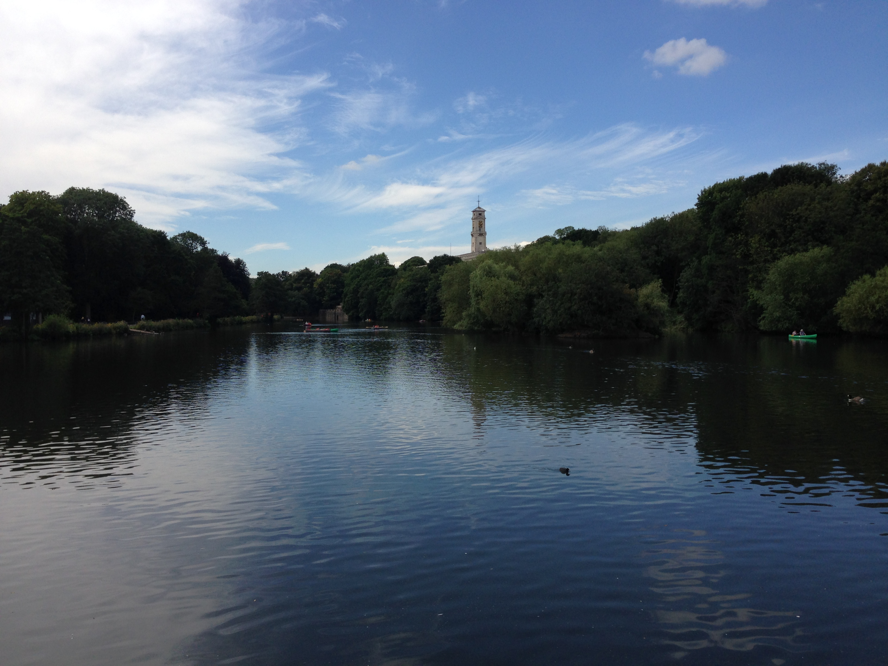

CONTENTS
Welcome p. 2
History Festival 2022: At A Glance p. 5
Events In More Depth p. 6

History Festival 2022: At a Glance – Live online talks and workshops
- Anne Enfield's views of early nineteenth-century Nottingham……............................................……p. 6
- In the Service of the Emperor: The Life and Experiences of the Napoleonic Soldier.........................p. 7
- National identities in 1917- the course of revolution in Ukraine and Russia..................………………..p. 8
- Reading diversity in English records is not political correctness, — it’s history! …….........................p. 8
- The 1958 Nottingham Riots: Popular and Official Responses...........................................................p. 9
- History in Schools: an introduction to the History in Schools volunteering programme…………….…p. 9
- Chivalry in Late Medieval Europe: A Guide to being the Perfect Knight?.......................………………p. 10
- Behind the Scenes of a Library and Archives in Lockdown……………………………………………………..p. 11
- Listening to lost voices: the Civil War Petitions project………………………………………………………….p. 12
- Jews in Medieval England: a foreign community?...................................………………………………….p. 13
- Bears in Nottinghamshire and beyond………………………………………………………………………………..p. 13
- Women of Nottingham...................................................................................................................p. 15
- How to talk like a Tommy………………………………….........................………………………………………..p. 15
- Studying history at university – find out more.................................................................................p. 16

History Festival 2022: At a Glance – pre-recorded talks, online activities and photographic competition
- pre-recorded talks on aspects of history, local history and archaeology........................................p. 17
- online activities and quizzes….......................................................................................................p. 18
- Photographic competition............................................................................................................p. 18

History Festival 2022: Events in More Depth
Talks and workshops (online – book in advance)
- Anne Enfield's views of early nineteenth-century Nottingham with Professor Ross Balzaretti
This workshop looks at the life of Anne Enfield (1801-65), an amateur artist from Nottingham. We will be looking at original examples of Anne's drawings and paintings of local places. Please come along and see if you can help to identify the places Anne painted, some of which have changed considerably since her day.
Saturday 7 May at 10:30-11:30 am (online)
Booking link: https://www.eventbrite.co.uk/e/history-festival-anne-enfields-views-of-early-19th-century-nottingham-tickets-289871321927

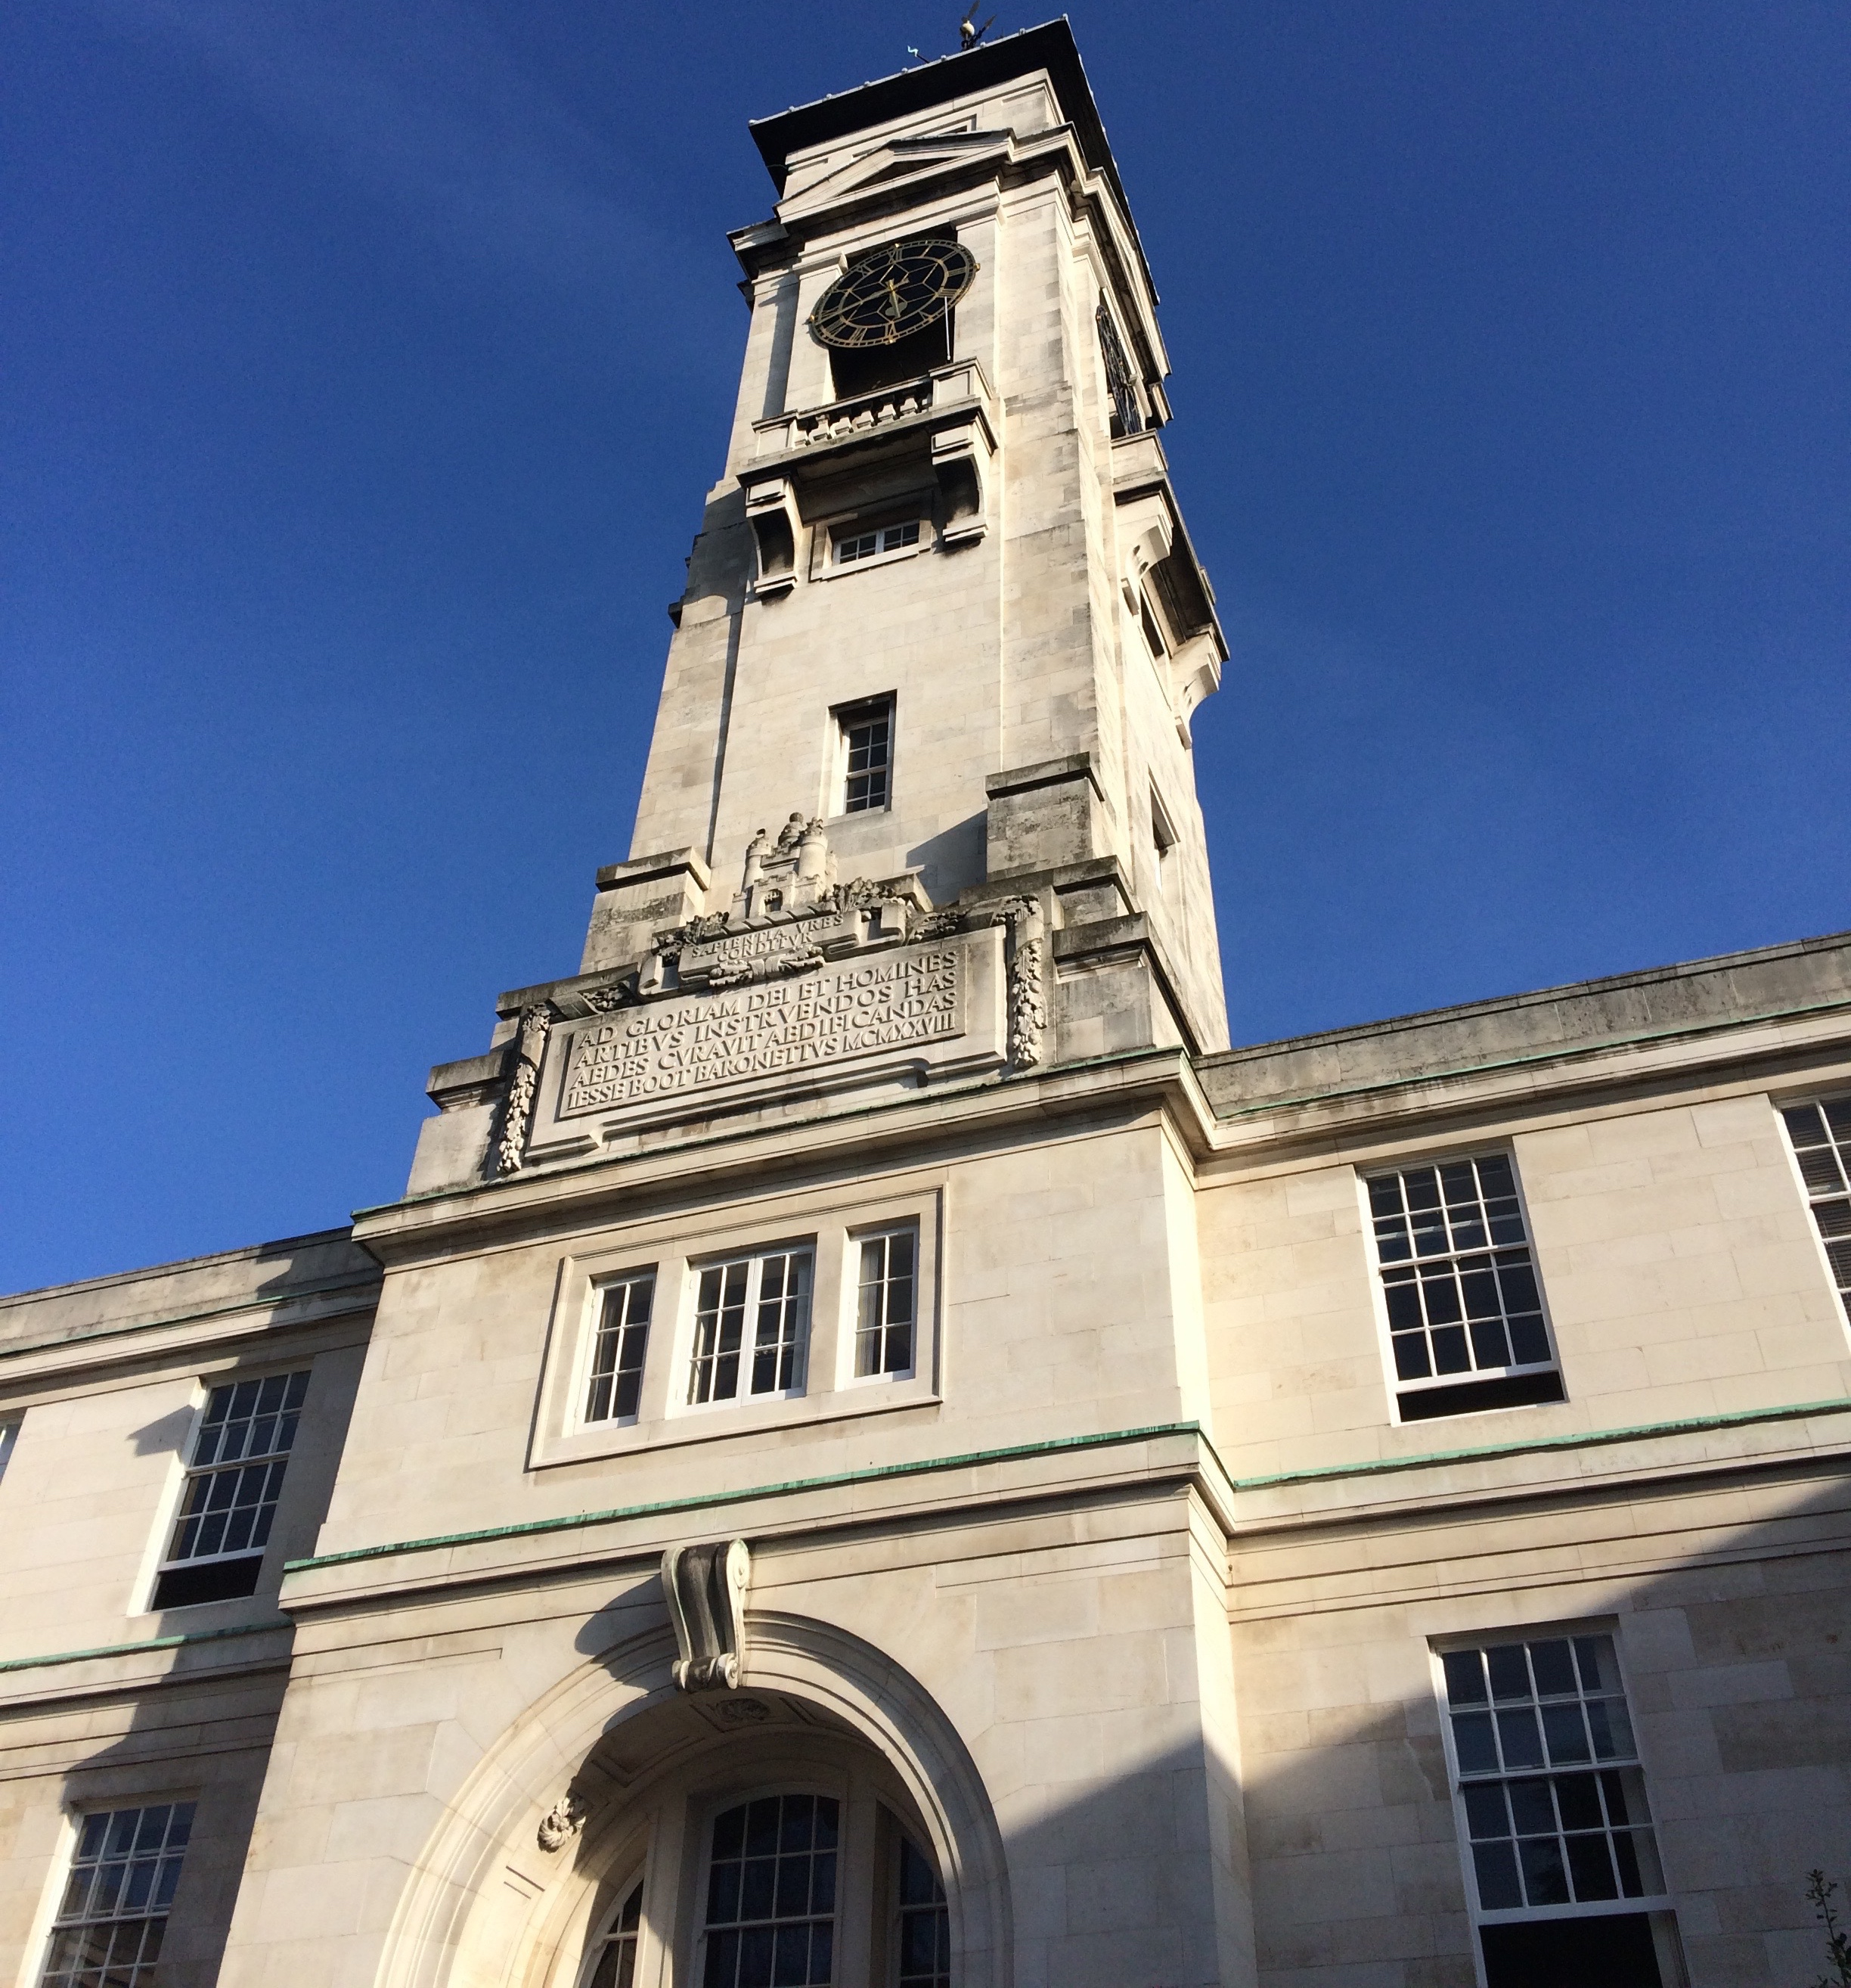

- In the Service of the Emperor: The Life and Experiences of the Napoleonic Soldier with Edward Hammond
In this talk, Napoleonic re-enactor Edward Hammond will offer insights into the realities of military life for the ordinary fusilier in Napoleon’s renowned ‘Grande Armée’, the most professional military force of its day. As traditional historical narratives have given rise to an often-unbalanced focus on the ‘great men’ of history, the demanding responsibilities and frequently harsh, unforgiving lives of the unassuming men and women of the times can quite easily go unrecognised. Yet it was these individuals who, in the case of Napoleonic France, fuelled Napoleon’s ambitions for imperial conquest as he sought to stave off the threat posed by the old monarchies of Europe. Many of them, too, were motivated by fervent patriotic feeling and an unwavering loyalty to the Emperor – just one of the many defining characteristics which set the French Imperial army apart from its adversaries. In this presentation, you will have a chance to become familiar with many aspects of daily life in Napoleon’s army, including the interesting minuities of uniform etiquette and regulation, weaponry, battle tactics, and many features of domestic camp life which make up the modern-day hobby of Napoleonic re-enactment.
Saturday 7 May at 1:30-2:30 pm (online)
Booking link: https://www.eventbrite.co.uk/e/the-life-and-experiences-of-the-napoleonic-soldier-tickets-289887570527

- National Identities in 1917 – the course of revolution in Ukraine and Russia with Professor Sarah Badcock
This short talk will discuss the ways in which the Russian revolution challenged and enabled national narratives in the territories of the Russian Empire, with particular attention to the situation in Ukraine.
Monday 9 May at 4:30-5:15 pm (online)
Booking link: https://www.eventbrite.co.uk/e/national-identities-in-1917-the-course-of-revolution-in-ukraine-and-russia-tickets-289828383497

- Reading diversity in English records is not political correctness, — it’s history! with Dr Onyeka Nubia
Recorded history only governs a small portion of a nation’s past, — mythology, mythos and urban legends often fill the gaps. And in these gaps truisms can grow – ideas unsupported by evidence, but ‘their truth,’ is passed down from generation to generation. These ideas are often emotionally believed, making them very difficult to challenge. One of these truisms is that the peoples of England were mono-ethnically white. Moreover, that it is only ‘recent’ immigration that has changed this. Following the trajectory of this notion, any counter arguments can be dismissed as ‘political correctness gone mad!’ But the evidence written by Englishmen of this country’s past, does not support such a truism. This evidence shows a rich tapestry of peoples, cultures and languages present in England’s past. It is an English past with a more complicated and interesting narrative than has ever been postulated.
Tuesday 10 May at 2pm (online)
Booking link: https://www.eventbrite.co.uk/e/diversity-in-english-records-is-not-political-correctness-its-history-tickets-301927211417

- The 1958 Nottingham Riots: Popular and Official Responses with Will Noble
Tuesday 10 May at 3:15-3:45 pm (online)
Booking link: https://www.eventbrite.co.uk/e/history-festival-the-1958-nottingham-riots-popular-and-official-reponses-tickets-301928886427

- History in Schools: an introduction to the History in Schools volunteering programme with Dr Joe Merton and project volunteers
History in Schools gives undergraduate History students the opportunity to design and deliver a sequence of classroom sessions on a particular historical theme for primary aged children (KS 1-2). The project intends to stimulate enthusiasm for history and raise aspiration to further study, including the study of history, in Nottingham schools and communities with low levels of progression into higher education. This session will offer an introduction to the programme and its aims and objectives. Former volunteers will give an insight into their experiences volunteering on the programme and showcase some examples of their work in schools.
Tuesday 10 May at 4-4:30 pm (online)
Booking link: https://www.eventbrite.co.uk/e/history-festival-talk-history-in-schools-tickets-289725265067

- Chivalry in Late Medieval Europe: A Guide to being the Perfect Knight? with Dr Matt Hefferan
When we think of the Middle Ages, many immediately picture a ‘chivalric’ knight charging downhill on horseback, or performing some daring deed. But was this really what chivalry was about in the late medieval period? In this talk, I will explore the many facets of chivalry in the fourteenth and fifteenth centuries to consider whether or not this is an accurate picture of the ‘perfect’ medieval knight, and who it was that was setting out these ideals.

Tuesday 10 May at 4:30-5 pm (online)
Booking link: https://www.eventbrite.co.uk/e/chivalry-in-late-medieval-europe-a-guide-to-being-the-perfect-knight-tickets-289816979387

- Behind the Scenes of a Library and Archives in Lockdown with Kathryn Steenson from UoN Manuscripts and Special Collections
The library and archives may have been shut to the public, but behind closed doors the team were busy with new acquisitions as different as genteel Victorian children’s books, the bloody French Revolution, and the glitz and glamour of the theatre. Join Manuscripts & Special Collections as they show some of the rare books and archives that arrived during the pandemic and are ready for their Reading Room debut.

Wednesday 11 May at 2-2:30 pm (online)
Booking link: https://www.eventbrite.co.uk/e/history-festival-behind-the-scenes-of-a-library-and-archives-in-lockdown-tickets-289803017627
https://www.nottingham.ac.uk/manuscriptsandspecialcollections/

- Listening to lost voices: the Civil War Petitions project with Dr Dave Appleby
This interactive workshop will demonstrate how to search the project’s database, and other online materials, and will include some practical roleplay using actual petitions to show the issues involved in trying to help military veterans and widows after the British Civil Wars.
Wednesday 11 May at 4-4:45 pm (online)
Booking link: https://www.eventbrite.co.uk/e/listening-to-lost-voices-the-civil-war-petitions-project-tickets-289859496557
Supporting resources/websites/etc to link to https://www.civilwarpetitions.ac.uk/

- Jews in Medieval England: a foreign community? with Dr Anna Rich-Abad
Jews from France came to England after the Norman Conquest and rapidly were put at the centre of conflicted economic and ideologic dynamics in their new place of inhabitation. In this session we will examine how and where the Jewish communities in England lived; how were they perceived by their Christian neighbours and how did they perceive themselves? How did they confront increasing pressures that were formulated through antisemitic legislation, propaganda such as the blood libel, riots and, finally with expulsion? Did the Anglo-Jewish Jewry ever fully settle in England or was it a passing presence?
Thursday 12 May at 4-4:30 pm (online)
Booking link: https://www.eventbrite.co.uk/e/jews-in-medieval-england-and-bears-in-nottinghamshire-and-beyond-tickets-289774331827

- Bears in Nottinghamshire and beyond with Professor Hannah O’Regan
This talk will look at the role of bears in human lives, drawing together evidence of bear baiting in Nottingham from the 1500s onwards (including pots!), along with discussions of bears more broadly in the Midlands, from places like Kenilworth Castle, and in events like the Great Fire of Nantwich.
Thursday 12 May at 4:30-5 pm (online)
Booking link: https://www.eventbrite.co.uk/e/jews-in-medieval-england-and-bears-in-nottinghamshire-and-beyond-tickets-289774331827

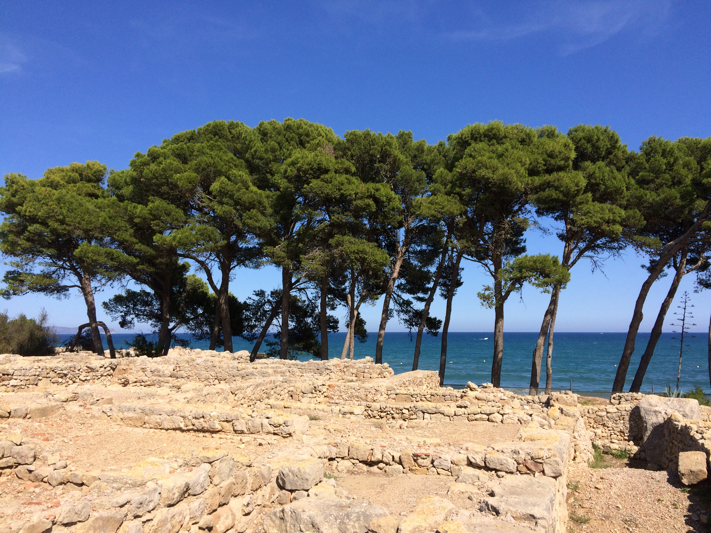

- Women of Nottingham with Jessica Lloyd and Victoria Myhand
A discussion of influential women in Nottingham from the 12th through the 20th century. From royalty and suspected witches to writers and suffragettes, learn about how women shaped Nottingham’s history
Friday 13 May 4-4:30 pm
Booking link: https://www.eventbrite.co.uk/e/women-of-nottingham-tickets-301937121057

- How to talk like a Tommy with Professor Ross Wilson
In this interactive talk, we examine the songs and slang of the citizen soldiers of the British Army during the First World War. We look at how these individuals used language to survive and the legacy of this in the way we speak today. All ages welcome.
Friday 13 May at 4:30-5 pm (online)
Booking link: https://www.eventbrite.co.uk/e/how-to-talk-like-a-tommy-songs-slang-and-the-first-world-war-tickets-289861693127

- Studying History at University
Join staff and students to find out more about studying history at university. This session will include information and insights from staff and students, interactive elements to give a taste of studying history at university, and plenty of opportunities to ask questions.
This will be of particular interest to those thinking about studying history at university or interested in finding out more, including school children of any age, college students and prospective mature students, as well as schoolteachers.

Friday 13 May at 5-5:30 pm (online)
Booking link: https://www.eventbrite.co.uk/e/history-festival-studying-history-at-university-tickets-289810229197

History Festival 2022: pre-recorded talks
A range of short, pre-recorded talks will be available on our website during the festival: https://www.nottingham.ac.uk/humanities/departments/history/news-and-events/history-festival.aspx
- Remembering the First World War in Nottingham – Professor Ross Wilson
This talk examines the ways in which the monuments and memorials that mark the end of the First World War were built in Nottingham. This was a war that saw death in wartime on an unprecedented level as well as citizen participation through volunteering and conscription. The memory of the war was contested and we examine the arguments and debates about how this conflict should be remembered.
- Listening to lost voices: the Civil War Petitions project – Dr Dave Appleby
The Civil War Petitions project is a four-year multi-university project to collect, digitise, transcribe or calendar literally thousands of documents relating to the care of maimed soldiers, war widows and orphans from the British Civil Wars of the mid-seventeenth century. Dr David Appleby, a member of the project team, will give an overview of this free online database and learning resource, which now contains details of almost 10,000 veterans, widows and orphans, including their war experiences and medical care.
- Exploring the international history of Boots the Chemist – Dr Hilary Ingram
Boots is an iconic staple on the UK high street. But how 'British' is this quintessentially British brand? This talk will use case study examples to highlight how from the early twentieth century Boots relied on strong international ties to secure raw materials, to build research, and to develop retail and manufacturing opportunities overseas. In turn, Boots introduced international products and fashions to the UK market. Come join us as we explore how a hometown pharmaceutical retailer navigated the interface between the local and the global. Part of the AHRC funded research project, ‘Chemists to the Nation, Pharmacy to the World’: Exploring the Global Dimensions of British Healthcare and Beauty with Boots the Chemists, 1919-1980'.

- Dr Dan O’Neill: Boardmarsh: a History of Skateboarding in Nottingham
- Dr Onyeka Nubia: Why English history is for everyone?
- Professor Jeremy Taylor: Forgetting and Remembering Chiang Kai-shek
- Professor Hannah O’Regan: Favourite Archaeological Artefacts – A Moment in Time and A Shoe!
- Professor Mark Pearce: Favourite Archaeological Artefacts – Bronze Age Weapons

If you are interested in history and archaeology, you might be interested in a new British Museum Touring Exhibition - Ancient Iraq: New Discoveries which will be in Nottingham from Saturday 26 March to Sunday 19 June 2022 at the Djanogly exhibition. For more information visit the Lakeside Arts website: https://www.lakesidearts.org.uk/exhibitions/event/5542/ancient-iraq-new-discoveries.html

History Festival 2022: online activities and photographic competition
- During the festival, there will be a range of online activities and quizzes, and a photographic competition. Please see the festival website during this period for further details.

Follow us Twitter: @UoNHistFest
Check out the website: https://www.nottingham.ac.uk/humanities/departments/history/news-and-events/history-festival.aspx
