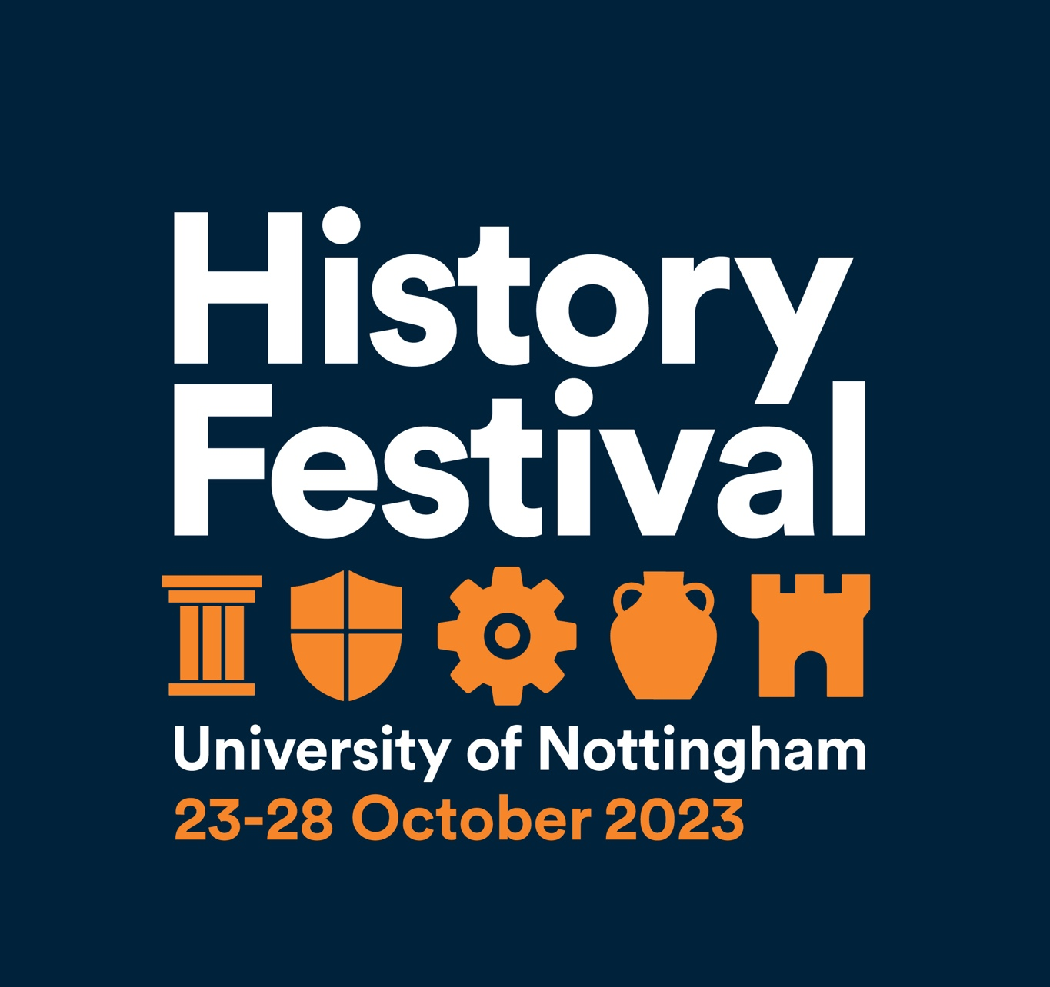
Welcome to the 2023 History Festival.
The History Festival, organized by the Department of History, is a collaborative event bringing together staff, students and the wider community. It includes a series of history themed events including talks from specialists, historic walks and behind the scenes tours, family-friendly activities, and much more.
Events are free and open to anyone interested in history.
History Festival Programme: At a glance
 | Monday 23 October | Wednesday 25 October | Thursday 26 October | Friday 27 October | Saturday 28 October
Morning | Global Lace – a guided walk | ‘Living Letters’ - a private tour of exhibition, Lakeside |  | Behind the Scenes at the Manuscripts and Special Collections | Local History Seminar: Wollaton Park and Nottingham Castle
Afternoon | The Caves Beneath Our Feet – a guided walk | History Festival: varied activities on University Park Campus (see below for more details) | Agitating the Lawless Rabble – a guided walk (People’s Histreh) |  | Health and Disease in the Medieval Town of Nottingham – a walking tour
Evening |  | Rosewood - Film Screening  Dark Histories at Lenton Priory – a twilight tour | Teaching History in an Age of Climate Crisis
Visitors to the 2023 History Festival might also be interested in the new exhibition at the Djanogly Gallery, Lakeside Arts, 'Reimag(in)ing the Victorians', which runs from 23 September to 7 January (for more information, visit: https://www.lakesidearts.org.uk/exhibitions/event/5856/reimagining-the-victorians.html
Please note: all details are subject to change. For the latest information about the festival and information on where to find us, please visit the History Festival web page: https://www.nottingham.ac.uk/humanities/departments/history/news-and-events/history-festival.aspx
Wednesday 25 October: History Festival (Humanities Building, University Park Campus) 1.30 to 5.30pm
Drop-in activities/exhibits/stalls:-
- Archaeology Society
- Arms and Armour of a Medieval Knight
- Boots: history and heritage
- Box Office Bears: Animal Baiting in Early Modern England
- City of Caves
- Communicating the Past: student showcase (Classics and Archaeology)
- Digital Transformations Hub
- Friends of Nottinghamshire Archives
- Folk Society
- History Society
- Manuscripts and Special Collections
- Medieval Combat Society
- Nottinghamshire Women’s History Group
- Sparrows’ Nest Library and Archive
- Viking Treasure Workshop (2 to 4pm – no need to book)

Scheduled talks and workshops (booking required)
- When Poetry, Politics and Black Women Meet with Dr Panya Banjoko
- Edward Lear (1812 to1888) at Sestri Levante: topographical art as a source for landscape history with Professor Ross Balzaretti
- A tale of two wives (and four husbands?): the story of two exceptional women from Imperial Rome with Dr David Massimo and Chloë Choong
- Writing ‘Prehistorical’ Historical Fiction: Finding Ourselves in the Past with Thomas Legendre
- Writing a Queer History of Nottingham: Archival and Oral History in Publication with CJ DeBarra
- Nottinghamshire, Centre of the LGBT Universe (Nottinghamshire Rainbow Heritage)
Events In More Depth

Monday 23 October 2023

Global Lace Walk with Dr David Gehring (10.30 to 11.30am – booking required)
This walk starts and ends at Weekday Cross, with a stroll through the Lace Market to see its global connections during the nineteenth and twentieth centuries. We shall note the architectural and historical aspects of Nottingham Lace, which can be explored more fully at the Nottingham Industrial Museum at Wollaton Hall. Because of the uneven nature of the streets and walking paths, comfortable shoes are strongly advised.

The Caves Beneath Our Feet with Dr Charlotte May (1.30 to 2.30pm – booking required)
This walk starts at the Brew House Yard off Castle Road, in front of the sandstone cliff and ends at Market Square by the Lions. Did you know that there are over 800 caves in Nottingham? As one of the city’s unique heritage assets, they have been used as everything from pub cellars and ale storage to medieval tanning and malting. This walk will incorporate Broad Marsh and some of the oldest streets in Nottingham. We will be talking about where caves are and how the change of land use has impacted the creation of, and access to, various cave sites. Please note that this walk will not include going into caves themselves, but rather provide an understanding as to how what we see on the surface impacts the underground, and vice versa. For those wishing to experience the caves of Nottingham, the City of Caves tourist attraction is open for visitors and can be booked online.
Comfortable footwear, but we will be staying on-street level and not descending into any caves on this particular walk.

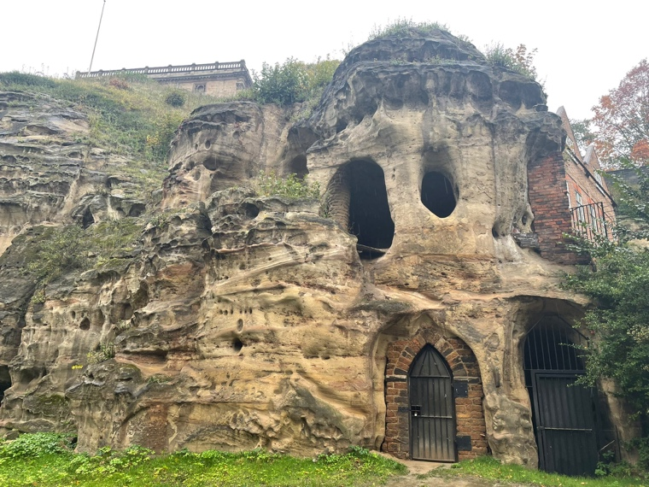

Wednesday 25 October 2023
‘Living Letters: Correspondence Then and Now’ - a private tour of this new exhibition (11am to 12 noon – booking required)
For centuries letters have been key vehicles of human communication. This exhibition (from 12 October 2023 to 3 March 2024) explores correspondence from the medieval period to the present and celebrates the letter’s enduring importance. It examines letters’ capacity to chronicle all stages and aspects of human life - from birth to death - and to capture both the personal and the professional. It reveals how they are powerful in their abilities to connect with and impact on the lives of others. It illuminates how letters are also deeply vulnerable, fragile objects whose preservation is liable to the vicissitudes of time, fashion, and chance. This exhibition has been jointly curated by University of Nottingham Libraries, Manuscripts and Special Collections, and Professor Lynda Pratt, School of English, University of Nottingham.
Join us for a guided walk through the exhibition and learn about the stories behind the items on display.
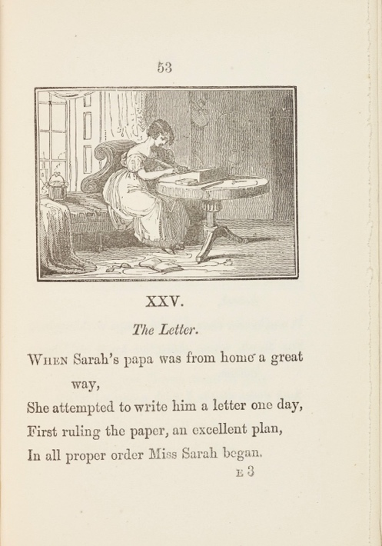
‘The Letter’, from Mrs [Elizabeth] Turner, The cowslip, or, More cautionary stories in verse; with thirty engravings by Samuel Williams (1885). University of Nottingham Manuscripts and Special Collections, Briggs Collection, PZ6.7.T8
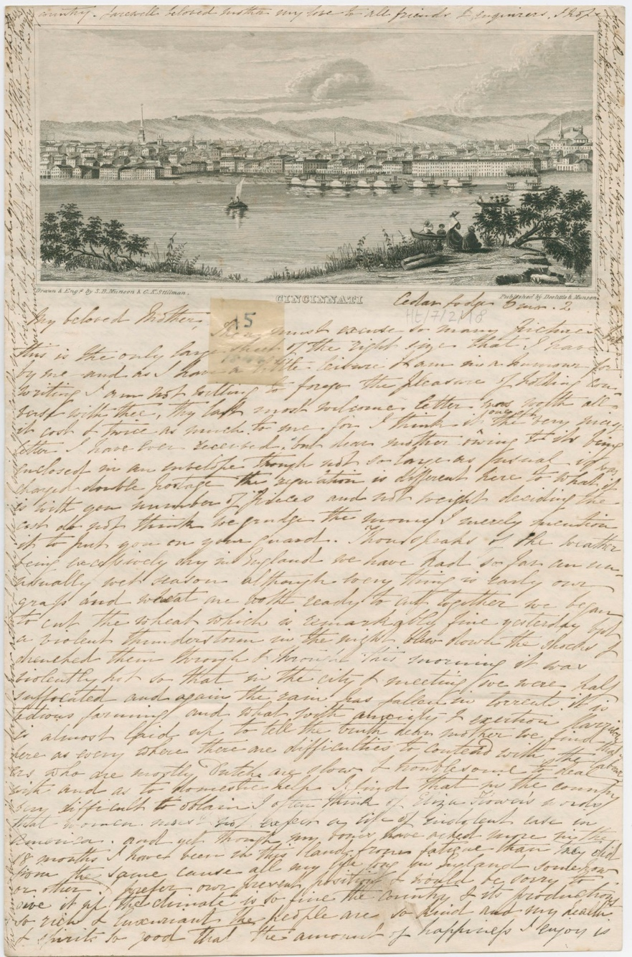
Letter from Emma Alderson, Cedar Lodge, [Cincinnati], U.S.A., to her mother Ann Botham, 19 May 1844. University of Nottingham Manuscripts and Special Collections, Howitt Collection, Ht/7/2/18
History Festival (Humanities Building, University Park Campus) 1pm to 6pm
Drop-in activities/exhibits/stalls (from 1.30pm):-
- Archaeology Society
- Arms and Armour of a Medieval Knight with Dr Matt Hefferan
- Book Stall: charity book sale of second-hand History books at bargain prices.
- Boots: history and heritage with Jack Moss
- Box Office Bears: Animal Baiting in Early Modern England with Professor Hannah O’Regan and Sam West
- City of Caves with Dr Chris King and Dr Charlotte May
- Communicating the Past: student showcase with Dr Lynn Fotheringham and students (Classics and Archaeology)
- Digital Transformations Hub – timed entry
- Friends of Nottinghamshire Archives
- Folk Society – live performance in the afternoon
- History Society
- Manuscripts and Special Collections
- Medieval Combat Society – live performances during the afternoon
- Nottinghamshire Women’s History Group
- Sparrows’ Nest Library and Archive
Viking Treasure Workshop (2 to 4pm – no need to book)
Take inspiration from the designs of Viking jewellery and coins to craft your own designs using embossed foil, guided by artist facilitator Elaine Winter. This activity will be a great way to appreciate the artistry of the Viking makers, and also think about how studies of their jewellery and coins and the metals they were made from, have informed our understanding of Viking people's movements, trading routes and beliefs.
This activity is suitable for everyone over the age of 7 (anyone under the age of 16 must be supervised by an adult).
Elaine Winter is an arts educator who works throughout Nottinghamshire and Lincolnshire schools, is part of the team of artist practitioners at Inspire and is an Associate Artist at both Nottingham Lakeside Arts and New Art Exchange. She teaches adult workshops at Nottingham Playhouse and for ArtSpeak. She has experience of working with all ages from early years (including as Creative Practitioner for Ignite! Curious Tots programme) to adults (including those living with dementia and people receiving hospice care).
Scheduled talks and workshops (booking required)
When Poetry, Politics and Black Women Meet with Dr Panya Banjoko (1.15 to 2.15pm)
The legacy of Nottingham women who performed poems at the Association of Caribbean Family and Friends (ACFF) Centre are now being surfaced through oral histories. Through mining Nottingham Black Archive (NBA) the women who harnessed performance poetry to inspire young people in Nottingham, in the belief that poetry was a tool through which cultural awareness might be developed and confidence instilled in young Black people, have been surfaced. Their stories once hidden as cultural producers and their impact on the city politically is now being amplified by NBA.
Dr Panya Banjoko is founder of Nottingham Black Archive (NBA) and has directed it since 2009. The Archive has recovered the stories of World War I soldiers in an Arts Humanities Research Council funded project and the narratives of the Windrush generation through a Windrush Day Grant. Panya is also a UK based writer and multi-award-winning poet and her practice as poet and cultural historian often centres on her personal engagement with museums and archives over two decades. Her poems feature in numerous collections, anthologies, and exhibitions and her most recent collection (Re)Framing the Archive was published by Burning Eye Books in 2022.
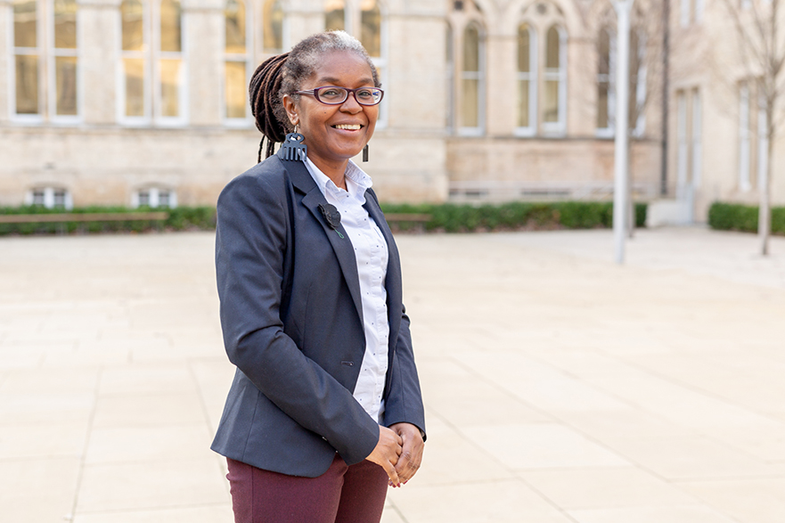
Edward Lear (1812 to 1888) at Sestri Levante: topographical art as a source for landscape history with Professor Ross Balzaretti (2.30 to 3.30pm)
This illustrated talk will examine the historical significance of Edward Lear's drawings in and around the small town of Sestri Levante, on the Italian Riviera. Lear’s trip in this region came at a significant point in his life in May 1860, as he had just left Rome for the final time, having fallen out of love with the city. Although he considered publishing a journal as he had done for his trips to Albania and Calabria, this Ligurian trip has barely been mentioned by his numerous biographers.
The drawings he made show this part of the Italian Riviera before it was changed by the railway, and later motorways. They provide a coherent record of this part of the coast, seen by one man between 14 and 23 May 1860. Lear’s work can be compared with earlier and later artistic representations.
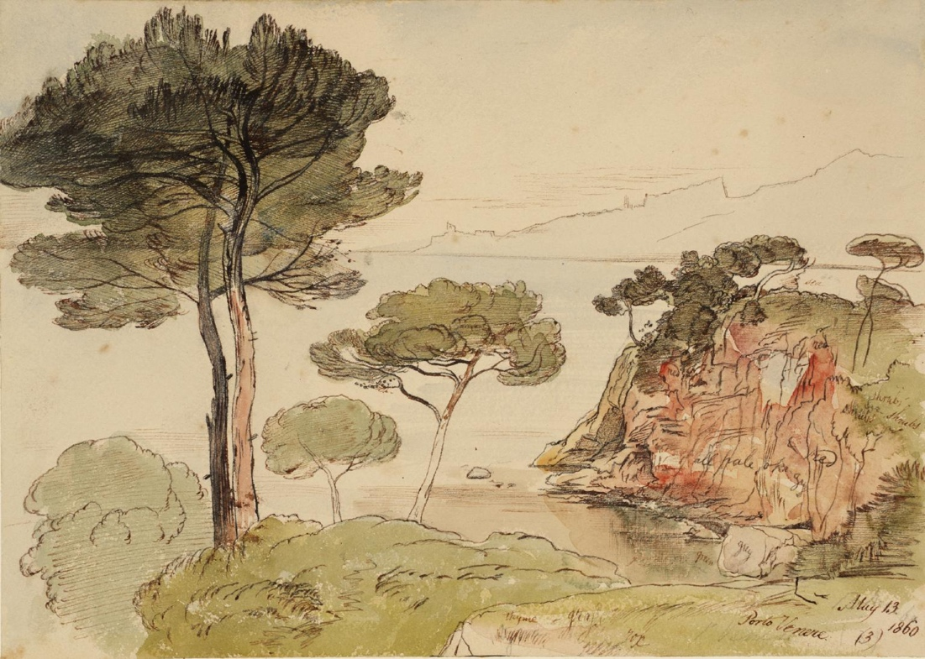
Edward Lear, Porto Venere, title of work, 1860 © Tate Britain Photo © Tate
CC-BY-NC-ND 3.0 (Unported) https://www.tate.org.uk/art/artworks/lear-porto-venere-n02798
A tale of two wives (and four husbands?): the story of two exceptional women from Imperial Rome with Dr Davide Massimo and Chloë Choong (3.30 to 4.30pm)
This screening of a short film (10-15’, Italian with English subtitles), featuring Dr Davide Massimo (Classics and Archaeology - Nottingham), Dr Chiara Cenati and Mirko Tasso (Vienna) was funded by the University of Vienna and supported by the University of Nottingham and the BSR. The short tells the story of two exceptional women from Imperial Rome as told by two poetic inscriptions (in Latin and Greek) preserved at the Museo Nazionale Romano (Rome): these women, though in very different ways, seemingly embraced unconventional marriages, the details of which remain mysterious for us. Their story is apparently narrated by their husbands, which complicates the picture further. This film is part of a larger strategy aimed at bringing to light lesser-known stories and using story-telling techniques to connect the public with museum collections. Following the screening, Dr Massimo will be joined in conversation with Chloë Choong (PhD student at Nottingham, whose research includes issues of ancient sexuality) and there will be questions from the audience.
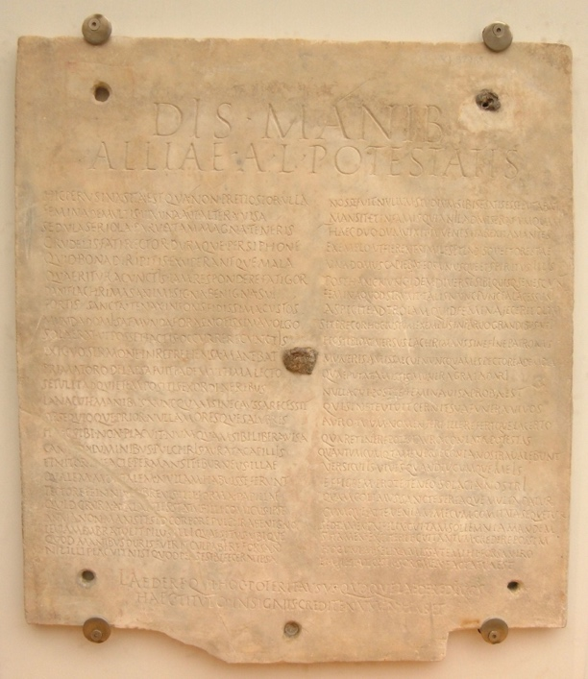
https://en.wikipedia.org/wiki/Allia_Potestas#/media/File:Sepulchral_inscription_of_Allia_Potestas_(1st%E2%80%934th_century_CE)_-_200505.jpg Has a CC BY-SA 3.0 license
Meet the author: Thomas Legendre – Writing ‘Prehistorical’ Historical Fiction: Finding Ourselves in the Past (4.00 to 4.45pm)
Thomas Legendre takes us on a journey to Kilmartin Glen, Scotland, exploring prehistoric landscapes through fictional writing.
How do these landscapes and their layered (pre)histories become vivid or ‘alive’ to us?
How does the past become present, and the present past?
There will be a short reading from his novel, Keeping Time, some discussion, and plenty of time for questions.
Thomas Legendre is an Assistant Professor in the School of English. His work includes the novels The Burning, Spring Fever, a radio drama entitled Dream Repair, and Half Life, a site-specific play performed at Kilmartin Glen, Scotland. His novel Keeping Time involves (pre)history, music, and time travel. For more detail, visit https://www.thomaslegendre.com/keeping-time
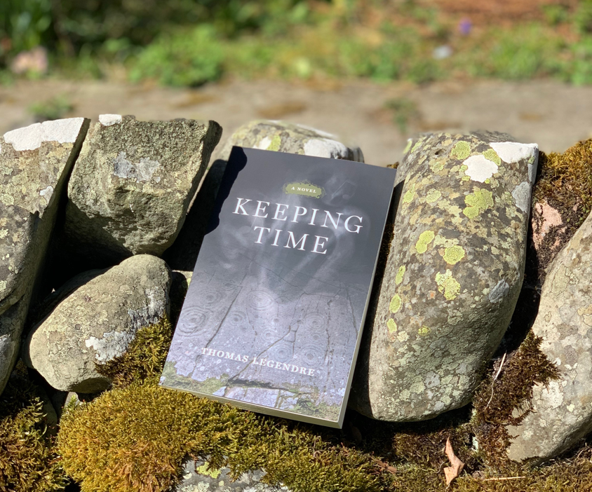
LGBTQ+ History (5 to 6pm)
Writing a Queer History of Nottingham: Archival and Oral History in Publication with CJ DeBarra
CJ DeBarra is a queer author and journalist based in Nottingham. They launched the Notts Queer History Project in 2022 with a view to documenting the vibrant oral history of the LGBT+ community based here. The result will be two books due in July 2024 published by Five Leaves Bookshop. The focus will be on the decades spanning from 1960 to 2022 covering events, buildings, politics and much more.
As part of the project, CJ has been visiting a number of archives and conducting interviews with LGBT+ people who have spent time in Nottingham. They are currently on interview number 84 and they are attempting to reach over 100.
This has raised interesting dilemmas when it comes to how best to document the stories and scandals? Join CJ to hear about documenting the hidden queer histories of Nottingham.....
Free hand-printed posters for 1970s London Pride for the first 20 people.
Nottinghamshire, Centre of the LGBT Universe (Nottinghamshire Rainbow Heritage)
The title may be tongue in cheek, but Nottinghamshire does own a surprising number of LGBT "firsts", as this presentation will reveal with examples from the 14th century onwards.
Film screening: Rosewood (1997)
Based on the 1923 Rosewood massacre in Florida and using recollections from survivors and their descendants, this movie explores events in the prosperous black town in Florida and the response of a handful of residents to save several women and children.
Dr Onyeka Nubia (University of Nottingham) will introduce the film and lead discussion afterwards.
Start time: 5pm
Location: Hallward Library (LG140 Screening Room)
Dark Histories at Lenton Priory – a twilight tour with Dr Henry Parkes (7pm)
Lenton Priory was Nottingham’s largest and richest medieval monastery. Situated within the footprint of the old church building, this outdoor evening talk will explore the often-ignored role of night and darkness in medieval monastic life, from the priory’s foundation in the twelfth century to its gory end under Henry VIII. The talk will also feature live musical illustrations. In the garden of the Boat Inn, Priory Street. Weather-appropriate clothing advised. Duration c. 30 mins.
Thursday 26 October 2023
Agitating the Lawless Rabble – a guided walk (with People’s Histreh)
Starting at the Left Lion (Council House) in Market Square, this guided walk around Nottingham City Centre explores episodes related to Nottingham’s proud tradition of independent bookshops and radical publishing.
Using primary sources, we will listen to the echoes of incredible people’s voices and remember some of their courageous struggles, from Susannah Wright defending her bookshop against riled up bigots in the 1820s to the community papers which fuelled grassroots resistance to the Poll Tax in the late 1980s and 1990s.
The walk lasts about one hour and ends on Heathcoat Street. The route is wheelchair accessible but there are some hills along the way. 1pm start.

Teaching History in an Age of Climate Crisis with Michael Riley (UCL Institute of Education and former Director of Schools History Project) – this will talk place via MS Teams (5.30 to 6.30pm)
The importance of teaching young people about our planetary crisis is hard to overstate. This is the defining existential challenge of our time and helping students to understand how we reached this point has relevance of the way we navigate our way out of it. In this SIG, Michael Riley will draw on his work for UCL’s new Centre for Climate Change and Sustainability Education, considering the potential of history to contribute to young people’s understanding of the planetary crisis and to explore what history teachers can do to adapt their teaching to address their greatest challenge of our times.

Friday 27 October 2023
Behind the Scenes at the Manuscripts and Special Collections (11am to 12noon)
Join us for a behind-the-scenes tour of Manuscripts and Special Collections at the University of Nottingham to discover our unique holdings. Our store, located in the former Carlton television studios, has over 8 kilometres of shelving and is home to over 3.5 million archive documents and over 80,000 special collections items! In addition to the chance to take a look behind the curtain at the inner workings of our department, you will also be able to view a pop-up exhibition of some of the jewels in our collections: a selection of unique treasures relating to the history of Nottinghamshire.
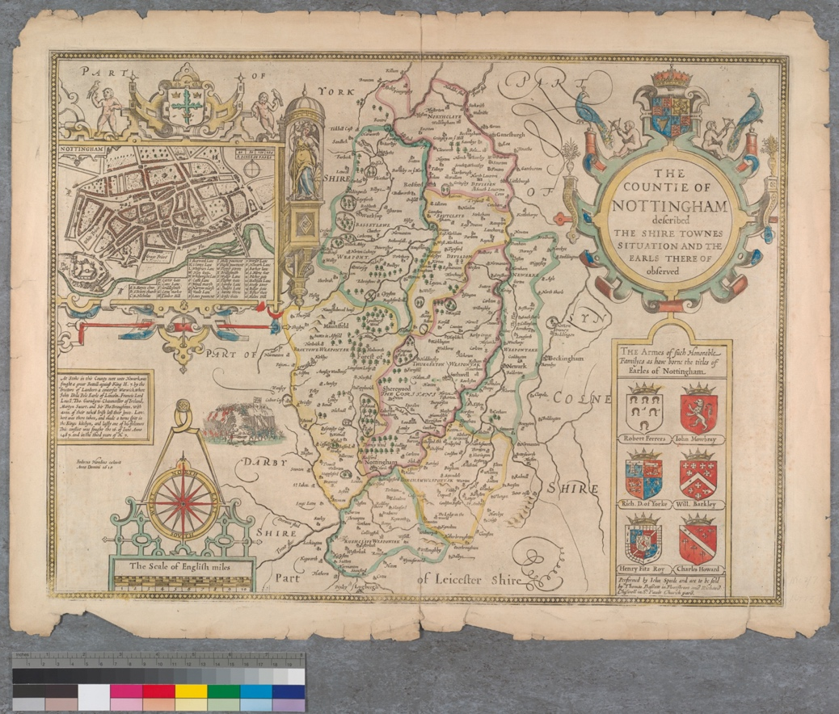
Map of the County of Nottingham by John Speed (1610), courtesy of Manuscripts and Special Collections, Kings Meadow Campus, University of Nottingham (Not 1.B8.C76)
Saturday 28 October 2023
Local History Seminar (10am to 12.30 noon)
Join us for two fascinating talks:
‘Four Lords (plus Ladies) and their ‘improvements’ to Wollaton Park in the eighteenth century’ - Megan Doole.
Little has been known about any physical alterations made at Wollaton by the Willoughby family in the eighteenth century. A current History PhD research project has used the Middleton Collection at the University of Nottingham Archives to fill in some of the gaps and increase understanding of existing knowledge. Some of the project's findings will be discussed in this short talk. Project funded by Midlands3Cities/AHRC in partnership with Nottingham City Museums.
‘“Wiping out a little disgrace”: The origins of Nottingham Castle Museum’ – Frances Potts
Nottingham Castle Museum opened in 1878 but its history goes back long before this date. This talk will explore Nottingham’s relationship with its museums, the influence of London in establishing Nottingham Castle Museum and how the Castle went from a burnt-out ruin to “a temple to the muses”.
Location: A18-A19 Lenton Grove, University Park Campus, University of Nottingham
(marked number 5 on campus maps, near West Entrance)

Health and Disease in the Medieval Town of Nottingham – a walking tour with Dr Chris King (1.30pm start)
This walking tour of the medieval streets of Nottingham will take you back in time to explore places of health, illness and pollution in the pre-modern urban landscape. What was the standard of health and medicine, and where did people go to seek treatment? And were medieval towns really as dirty and disease-ridden as popular myth would have us believe?
The tour is approximately 1.5 hours of walking and standing in a city centre environment and is suitable for those with moderate levels of fitness or mobility.
Start and end point: the Left Lion in front of the Council House in Old Market Square.
In addition, we are pleased to acknowledge our external partnerships during the 2023 History Festival.
Hucknall U3A is hosting a talk for their members by Dr Richard Gaunt (Department of History, University of Nottingham): Nottingham Castle: Past, Present – and Future? – where he will discuss his experience as Curator of Rebellion at Nottingham Castle
The WI Nottinghamshire is hosting a talk by Dr Charlotte May (University of Nottingham) on the Caves of Nottingham. This is open to non-members. Thursday 26 October 2-4pm at Oxton Village Hall, Main Street, Oxton, NG25 0SA. Unlike the main events, there is a charge for this event run by the WI. Price is £7.00 with refreshments (closing date 16 October to book tickets) – all proceeds go to Federation funds. To book tickets please contact Nottingham Federation of Wis, Trent Bridge House, Beastmarket Hill, Newark, NG24 1BN with contact name, email and address (if tickets are to be posted out). Pay by cheque: payable to Notts Fed of Wis and sent to above address.
Pay by BACS: use ref BT027 – bank details: Virgin Money, Sort Code: 05 06 22, Account Number: 50342581; Account Name: Notts Fed WI Reg.
We are also working with Nottingham City Council Independent Living Schemes to host sessions delivered by the UoN’s Manuscripts and Special Collections.

With thanks to the School of Humanities, the Department of History, and the Institute of Policy and Engagement for financial support for the History Festival.
Thanks also goes to Professor Jeremy Taylor, Head of the Department of History, for supporting the festival, to Dr Sarah Holland, Associate Professor in History, for organizing the Festival, Adam Forsey (Humanities Marketing), Sally Nightingale (Institute of Policy and Engagement), colleagues from the Faculty of Arts marketing team and external relations, and the many colleagues and external partners contributing to the 2023 History Festival.
