Public Health and Housing - lesson plans for teachers

Lesson 5 – “Things can only get better”
In what ways has life got better for the inhabitants on Sun Street and what can the granddaughter look forward to in the future?

Aims
- Drawing on the sources they have used, bring a conclusion together on how life on Sun Street has changed over the generations
- Compare the early 20th century living conditions in Nottingham to today’s early 21st Century living conditions - what has changed?
- Analyse the usefulness of the sources to find out about the past. What sources would they keep and what would they discard?
- Produce a PowerPoint/display about the health and living conditions of Nottingham

Core Resources
- Picture 1 - Aerial view of dense working-class housing in the Narrow Marsh area of Nottingham in 1919. (Picture the Past, NTGM001896)

- Document 1 - Extracts from J.R. Martin, 'Report on the Sanatory Condition of Nottingham, Coventry, Leicester, Derby, Norwich, and Portsmouth' (Second Report of the Commissioners for inquiring into the State of Large Towns and Populous Districts, Appendix Part II; 1845 (602) (610), XVIII.1, 299)

- Document 2 - Thomas Hawksley's obituary from The Times, 25 Sep. 1893 (4 pages)

- Document 3 (Map) - Detail from Plan of the Town of Nottingham and its Environs by Edward W. Salmon, 1862 (East Midlands Special Collection Not 3.B8.E6), centred on the Narrow Marsh and Leenside area. See separate download.

- Case studies - Extracts from S.W. Wheaton, Local Government Board Reports and Papers on Cholera in England in 1893. (Medical Rare Books WC264 FAR: pp 145-147). See separate download.

Other Resources
- All other resources used in previous lessons
- Access to computers if available
- Library resources and book boxes if available

Outline Starter
- Set the scene with the pupils. The granddaughter is now grown up and her own granddaughter is asking her how living conditions have changed from the mid 19th century to the present day.
- They will then have to produce a PowerPoint/display using the evidence to show these changes over time and answer the question, “Have things always got better?”

(cont)

Main
- Pupils to do independent research and use prior knowledge from the documents to begin to present information.
- They should have access to all the documents they have previously used either via the internet or by hard copy and their presentation must cover the mid 19th century, early 20th century and conclude with them looking at the present day and what health and living conditions today are like.
- Specifically refer to the principal collection of resources downloadable for this lesson. Pupils can also include other ones as they see fit.
- In their PowerPoint they should consider the following:
  - What evidence was most useful?
  - What can be learnt collectively from the sources?
  - How useful are the sources when studying the living conditions and health of the people of Nottingham?
  - Are there any limitations to the sources and also what else they have been able to find out?
  - How applicable is this case study to other areas of Great Britain during this period?

Plenary
- Would you have liked to have lived in Nottingham during the mid 19th century? Why?

Alternative options
- PowerPoint/poster presentation
Picture 1 - Aerial view of dense working-class housing in the Narrow Marsh area of Nottingham in 1919. (Picture the Past, NTGM001896)

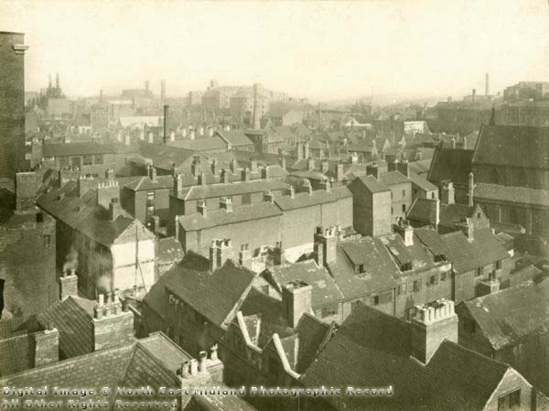
Document 1 - Extracts from J.R. Martin, 'Report on the Sanatory Condition of Nottingham, Coventry, Leicester, Derby, Norwich, and Portsmouth' (Second Report of the Commissioners for inquiring into the State of Large Towns and Populous Districts, Appendix Part II; 1845 (602) (610), XVIII.1, 299)
[p.250]
In all the parishes there are numbers of streets to be found of the worst construction as regards ventilation, construction of habitation, sewerage, supply of water, paving, and lighting; but, as might be expected, these defects are most conspicuous in the older quarters, and in the lower levels, as under the Castle, and down to the Narrow-Marsh, Canal Street, Leen-side, and in the greater part of St. Ann's and Byron Wards...
I believe that nowhere else shall we find so large a mass of inhabitants crowded into courts, alleys, and lanes, as in Nottingham, and those, too, of the worst possible construction. Here they are clustered upon each other; court within court, yard within yard, and lane within lane, in a manner to defy description, - all extending right and left from the long narrow streets above referred to. The courts are always, without exception, approached through a low-arched tunnel of some 30 or 36 inches wide, about 8 feet high, and from 20 to 30 feet long, so as to place ventilation or direct solar exposure out of possibility on the space described. The courts are noisome, narrow, unprovided with adequate means for the removal of refuse, ill-ventilated, and wretched in the extreme, with a gutter, or surface-drain, running down the centre: they have no back yards, and the privies are common to the whole court: altogether they present scenes of a deplorable character, and of surprising filth and discomfort. It is just the same with lanes and alleys, with the exception that these last are not closed at each end, like the courts. In all these confined quarters, too, the refuse matter is allowed to accumulate until, by its mass and its advanced putrefacation, it shall have acquired value as manure; and thus it is sold and carted away by the "muck majors", as the collectors of manure are called in Nottingham.

Document 2 - Thomas Hawksley's obituary from The Times, 25 Sep. 1893 (4 pages)
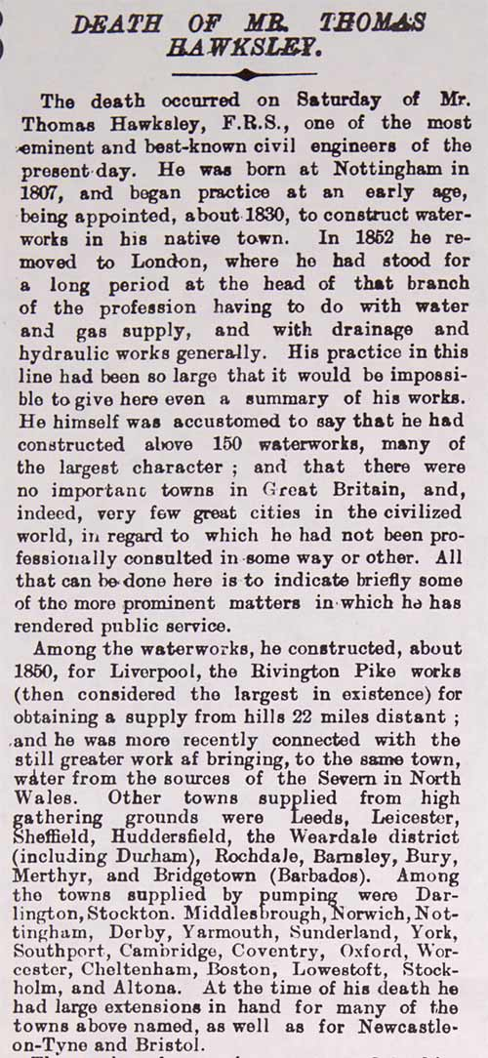
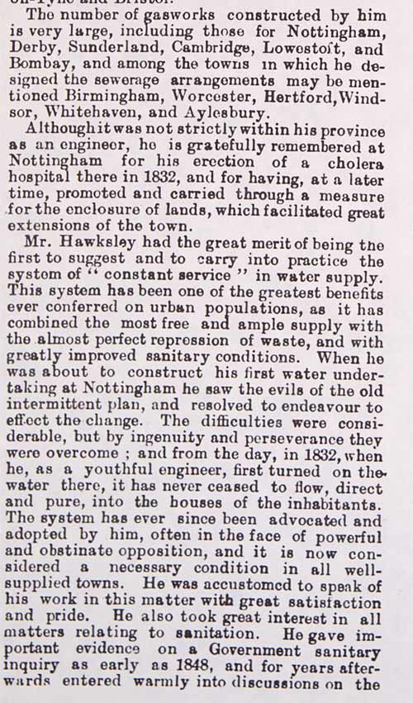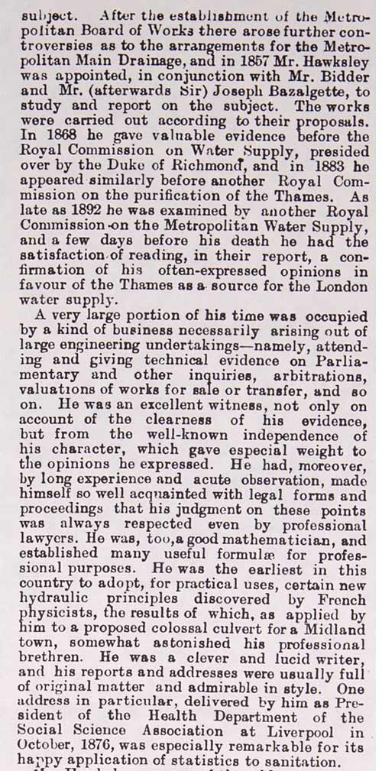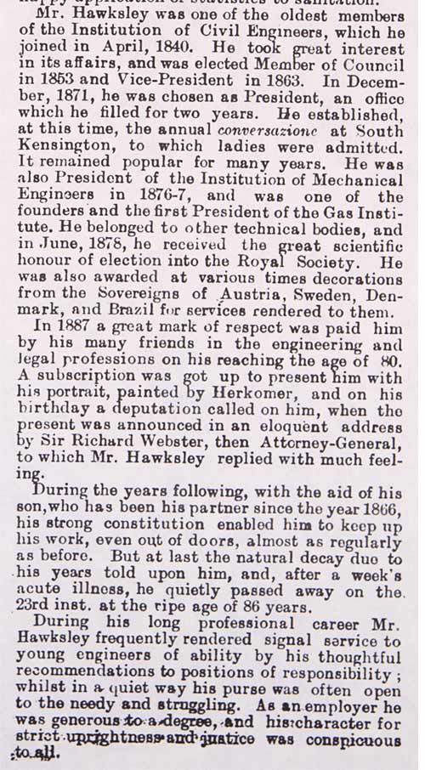
Document 3 - Detail from Plan of the Town of Nottingham and its Environs by Edward W. Salmon, 1862 (East Midlands Special Collection Not 3.B8.E6)

See separate download for A3 sized map ready for print: 5-doc3-map-a3.doc

Case studies – Extracts from S.W. Wheaton, Local Government Board Reports and Papers on Cholera in England in 1893. (Medical Rare Books WC264 FAR: pp 145-147)

See separate download for four case studies relating to a cholera outbreak in Ilkeston in 1893: 5-casestudies.doc

