Seizure Detection Script User Guide (v1)
Author Sarin Leigh (2014)

LAUNCHING THE MAIN WINDOW

Quick Start User Guide

- To start the programme run ‘SingleChannelAnalysis.m’ using the ‘F5’ button or the button in the Matlab editor. | 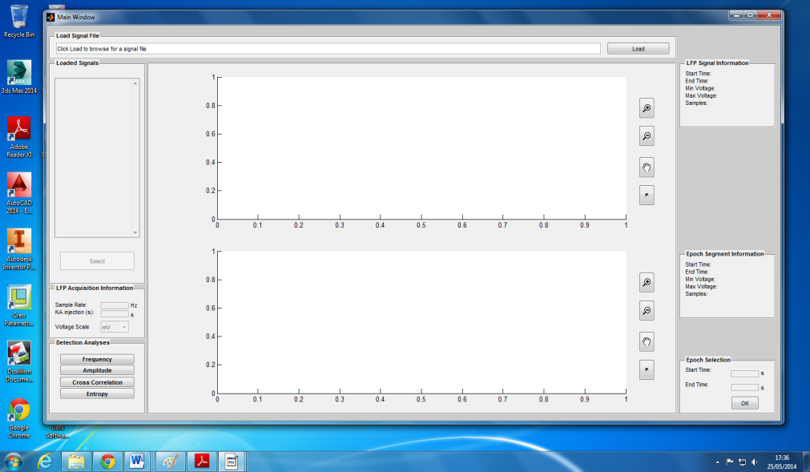
- Once software requirements have been checked, the Main Window for single channel analysis will open.

- Load a signal file by entering the file pathname into the ‘Load Signal File’ panel or click the ‘Load’ button to launch the ‘Pick a data file’ dialogue box, and select the desired signals for analysis. Multiple signals can be loaded.

Note: only *.mat files will be recognized in this programme.

- Selected signals will be loaded into the workspace and displayed in the ‘Loaded Signals’ list box.

Select the desired signal and press the ‘Select’ button to view the channel in the Main Window.

Note: existing variables in the Matlab workspace will be displayed in the list box when the Main Window opens.

- The raw LFP signal will be displayed in the top axis titled with the variable name. Information about the selected LFP channel is displayed in the ‘LFP Signal Information’ panel.  The view of the signal can be manipulated using the buttons located next to the axes:  Zoom in : click the axis to zoom into the signal or drag a square with the mouse to view a particular region. Double click to zoom fully out.  Zoom out : click the axes to zoom out of the signal. Double click to zoom fully out.  Pan : click and hold to drag the signal along the axis.  Undock : loads the plot in a new window (right) with enhanced manipulation features. See Undocked Figures for more information. | 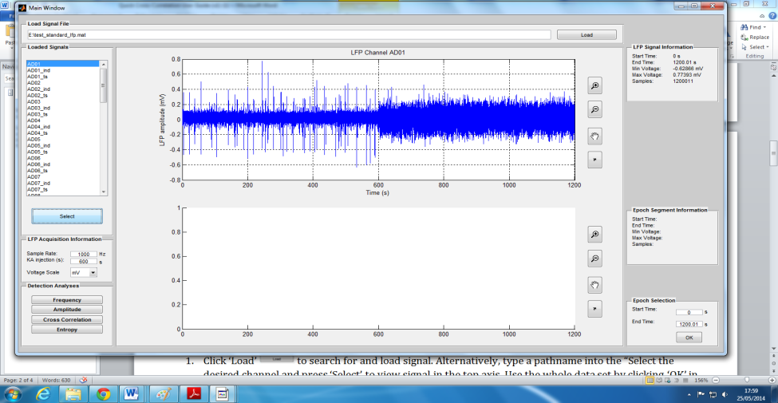
- The ‘LFP Acquisition Information’ panel will now be enabled with default values of 1kHz and 600s for the sample rate and kainite injection time displayed with the default scale of mV for amplitude. These values can be edited to comply with the data acquired and experiment design. Plotted data will be updated following new inputs.

- The ‘Epoch Selection’ panel will now be enabled with the start and end time of the LFP channel displayed.

This panel allows the user to view a segment of the LFP channel by entering start and end times within the LFP channel. To view the selected epoch in the lower axes of the Main Window press the ‘OK’ button.

Note: if the start and end times are not within those of the LFP channel a warning will be displayed for guidance.

- The selected epoch signal will be displayed in the bottom axis titled with the start and end times of the segment. Information about the selected epoch is displayed in the ‘Epoch Segment Information’ panel.

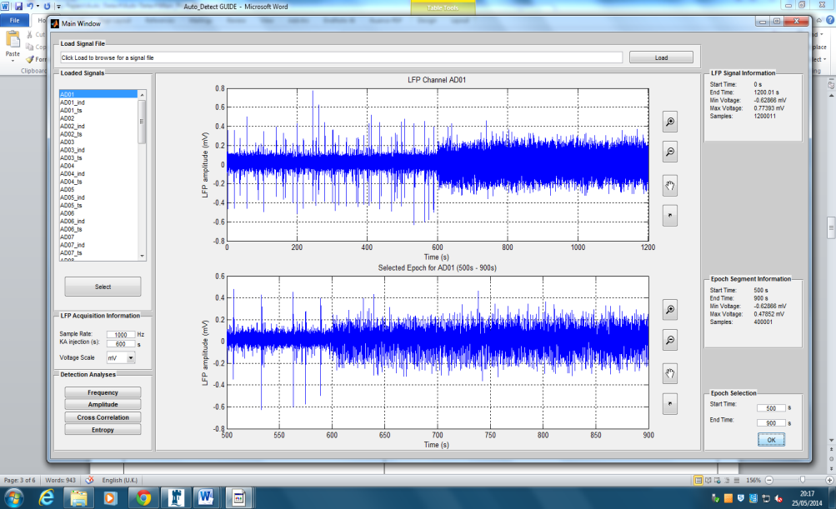
The plot is updated whenever new start and end times are selected as in step 7.

Note: the segment epoch is used for all subsequent analysis. If no epoch is selected the error: ‘??? Error while evaluating uicontrol Callback’ will be returned in the Matlab command window. The user is reminded to select an epoch as in step 7.

- Seizure detection method is chosen by selecting the appropriate button in the ‘Detection Analyses’ panel which launches a new GUI platform for the associated algorithm .  : launches a new GUI platform for the ‘Fast Fourier Transform’ (FFT) algorithm. The algorithm analyses the frequency components of the selected epoch and compares this to that of the basal portion of the LFP. See Frequency Detect GUI Platform.  : launches a new GUI platform for the ‘Sliding Window Mean’ (SWM)algorithm. The algorithm analyses the amplitude of the selected epoch and compares this to that of the basal portion of the LFP. See Amplitude Detect GUI Platform.  : launches a new GUI platform for the ‘Cross-correlation’ algorithm. The user can select a template and search for this waveform in the rest of the selected epoch with a user defined correlation threshold. See Cross-correlation Detect GUI Platform.  : launches a new GUI platform for the ‘Rank Vector Entropy’ (RVE)algorithm. The algorithm analyses the complexity of the selected epoch and compares this to that of the basal portion of the LFP. See Entropy Detect GUI Platform. | 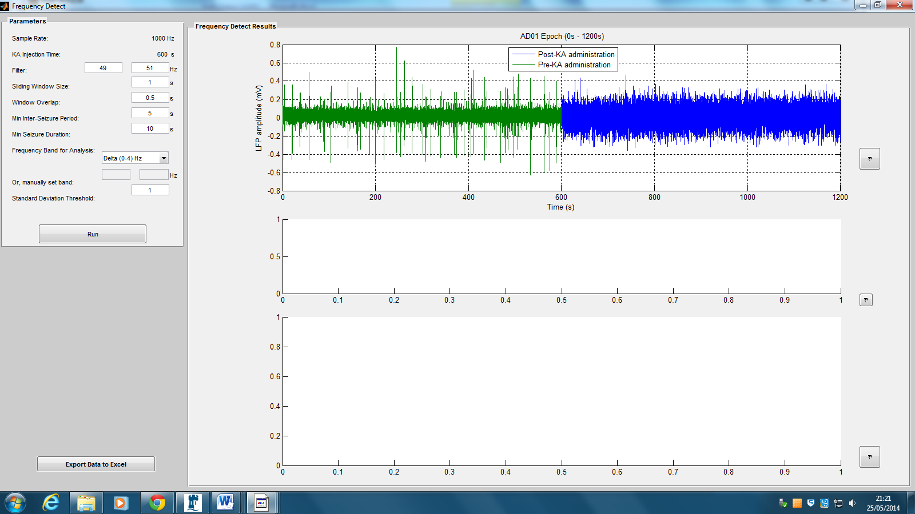  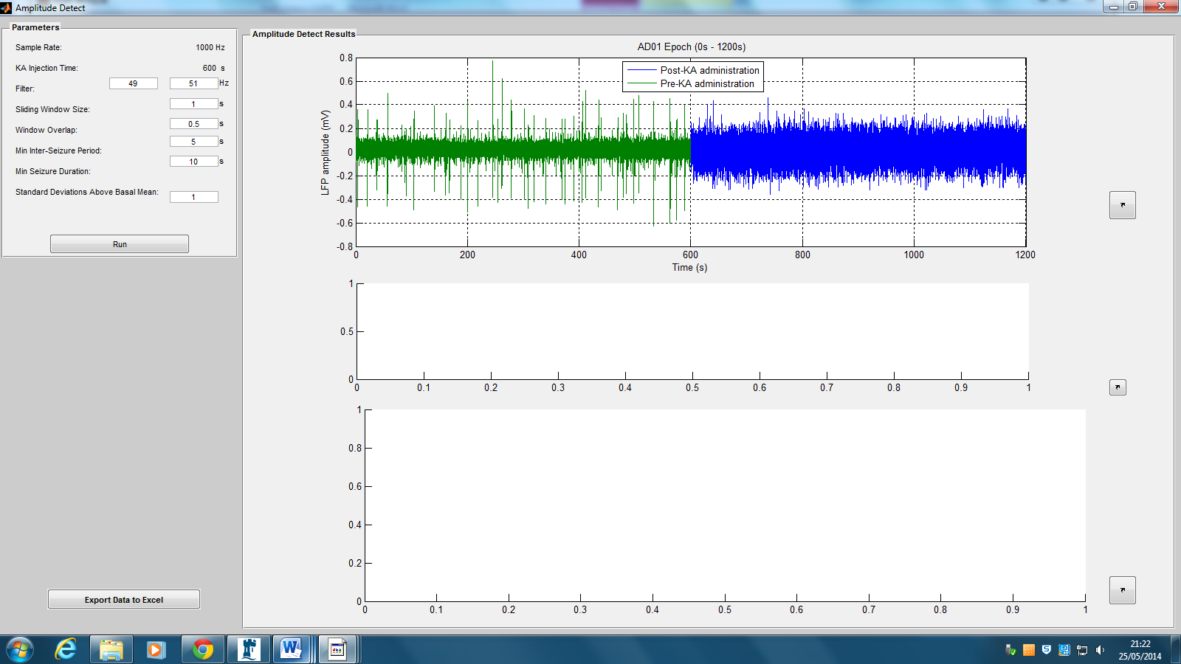  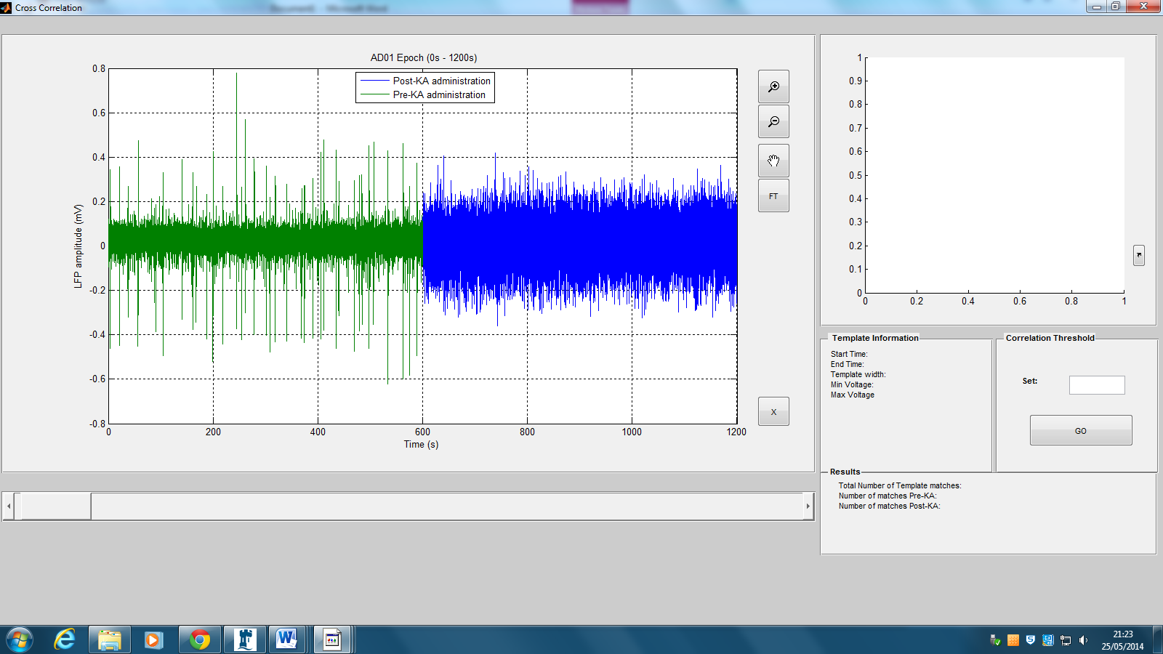  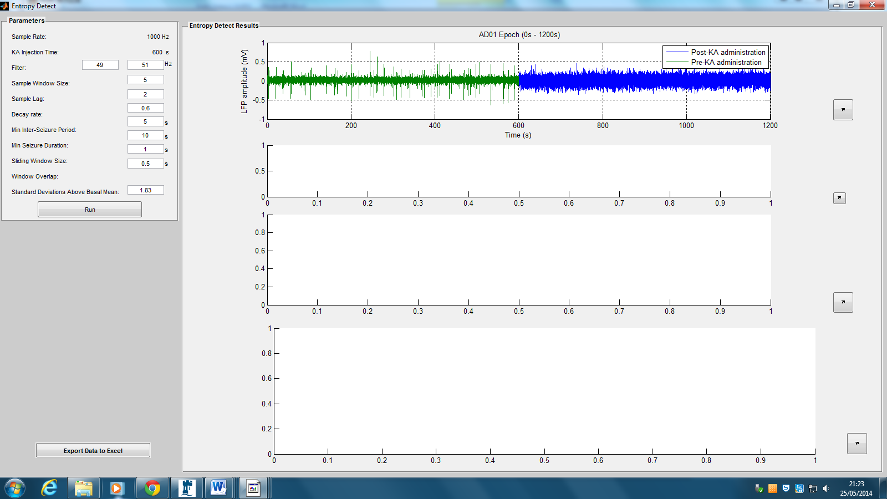

Frequency Detect GUI Platform

- The Frequency Detect GUI platform is launched from the Main Window when the ‘Frequency’ button is pressed in the ‘Detection Analyses’ panel. | 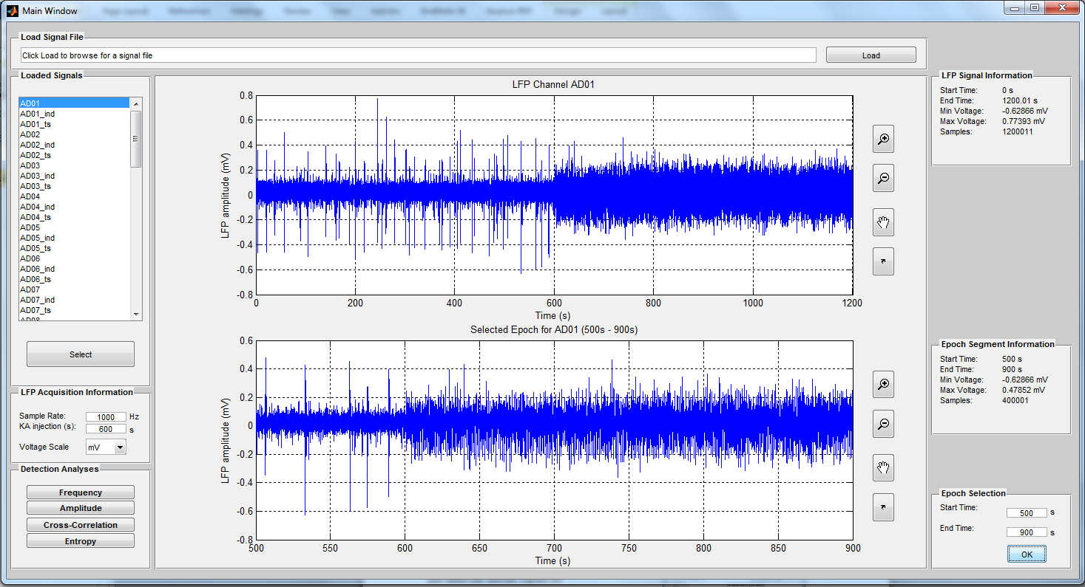
- The selected epoch is plotted in the ‘Frequency Detect Results’ panel showing the basal period of the LFP signal in green (before kainite injection). The sample rate and kainate injection time set by the user in the Main Window is displayed in the ‘Parameters’ panel. | 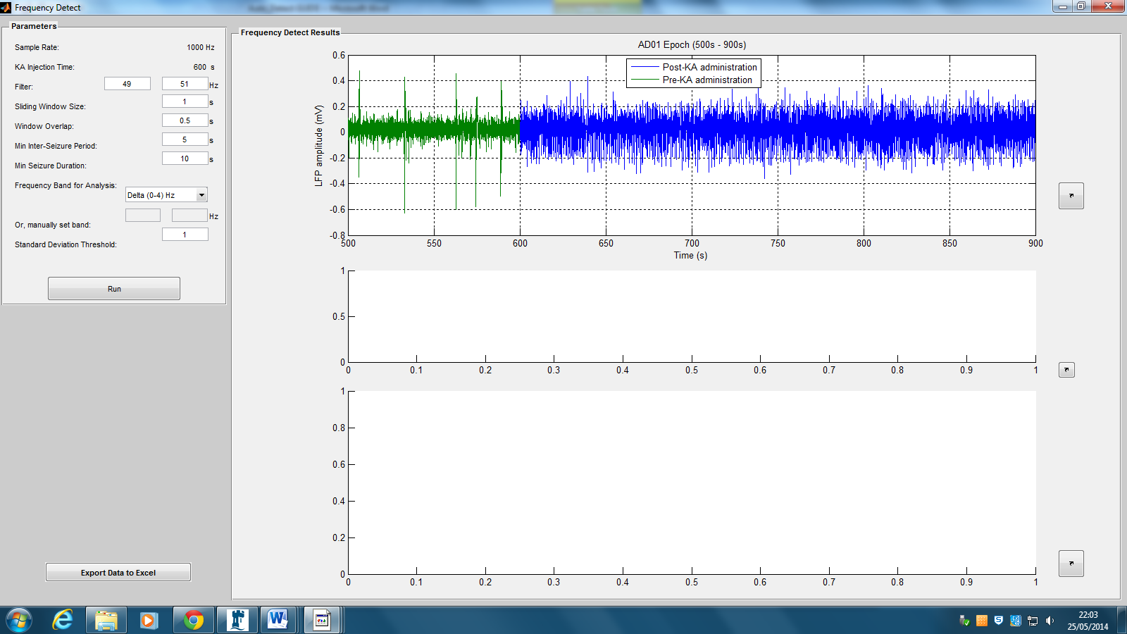
- All Adjustable parameters are found in the ‘Parameters’ panel with default parameters displayed when the platform is launched. These are edited by clicking in the text boxes and entering the appropriate numbers.

Note: hover cursor over text edit boxes to get instructions for each parameter, e.g:

- The ‘Filter’ adjustable parameter determines the upper and lower bounds of the butterworth filter applied to the selected epoch. Default values of 49 and 50Hz are set for the upper and lower bounds to remove mains 50Hz noise.

The user is required to enter an upper and lower limit for the frequency bounds in the first and second text box, respectively.
See ‘Detection Parameters’ for more information on adjustable parameters for seizure detection in the ‘Parameters’ panel.

- The FFT algorithm requires a defined frequency band to analyse in comparison with the basal portion of the data. The user can select pre-set wave bands from a drop down list or select ‘Manual’ to enter frequency bounds manually.

- Selecting ‘Manual’ from the drop down list enables the ‘Or, manually set band’ text edit boxes. The user is required to enter an upper and lower limit for the frequency bounds in the first and second text box, respectively if the manual option is selected.

- Selecting the ‘Run’ button runs the FFT algorithm with the current parameter set and displays the ‘Seizure Events and Duration’ results as well as a spectrogram for the selected epoch in the ‘Frequency Detect Results’ panel.  All axis have an undock button to load the plot in a new window for enhanced manipulation features. See Undocked Figures for more information. |  | 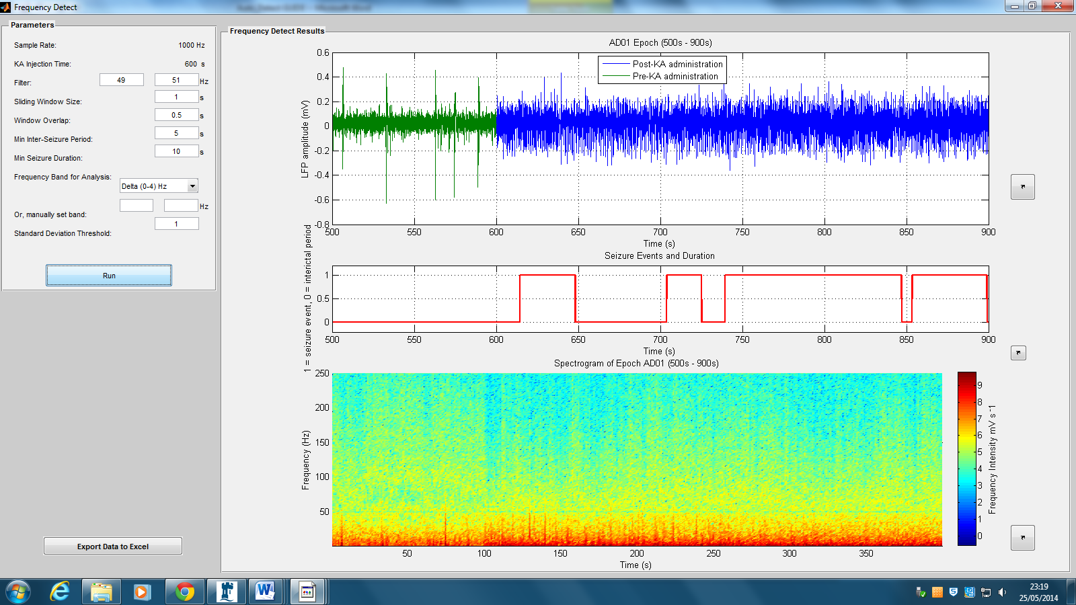
- ‘Seizure Events and Duration’ axes displays events recognised as seizures by the algorithm for the selected epoch with the current parameter set.

Detection Parameters

Frequency Detect, Entropy Detect and Amplitude Detect GUI platforms have the same adjustable parameters that direct the detected seizure output. The parameters include: Sliding Window Size, Window Overlap, Min Inter-Seizure Period, Min Seizure Duration and Standard Deviation Threshold. This section gives an overview of these parameters. The reader is directed to the Auto_Detect report for more information about the

- ‘Sliding Window Size’ parameter is the size of the segment of data (in seconds) the algorithm uses to calculate the mean value of the feature the algorithm is sensitive to.

- The ‘Window Overlap’ parameter sets the overlap (in seconds) of the sliding window through the data to calculate the mean value.
- Defines the minimum inter-rictal time between seizures. Evaluated as the minimum time between seizures that the mean window value must fall below the threshold to be displayed as interictal event in ‘Seizure Events and Duration’

- Defines the minimum duration of seizure.
Evaluated as the minimum time (in seconds) the mean window value must exceed the threshold to display as a seizure event in ‘Seizure Events and Duration’ axis.

Amplitude Detect GUI Platform

- The Amplitude Detect GUI platform is launched from the Main Window when the ‘Amplitude’ button is pressed in the ‘Detection Analyses’ panel.
- The selected epoch is plotted in the ‘Amplitude Detect Results’ panel showing the basal period of the LFP signal in green (before kainite injection). The sample rate and kainate injection time set by the user in the Main Window is displayed in the ‘Parameters’ panel. | 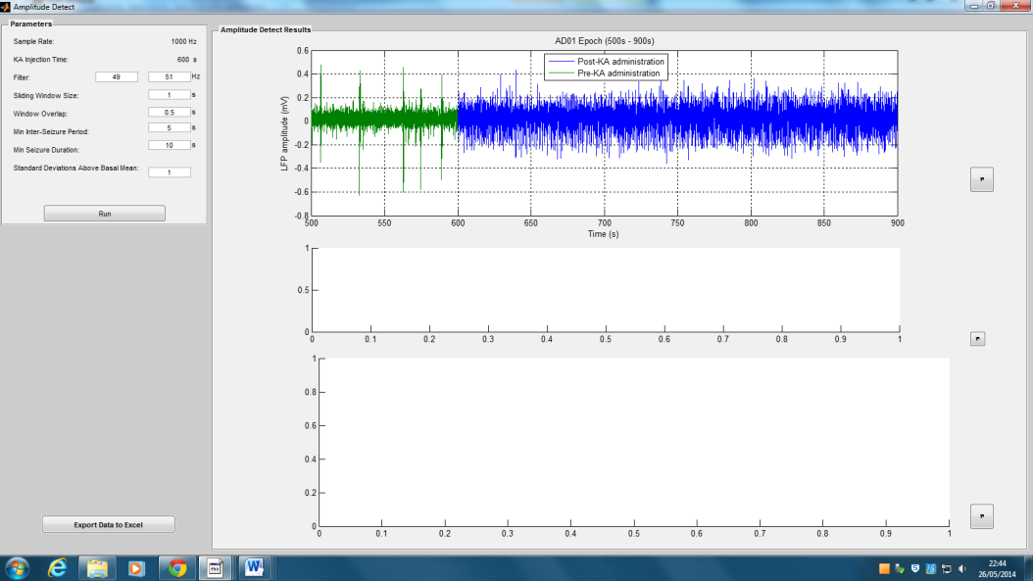
- All Adjustable parameters are found in the ‘Parameters’ panel with default parameters displayed when the platform is launched. These are edited by clicking in the text boxes and entering the appropriate numbers.

Note: hover cursor over text edit boxes to get instructions for each parameter, e.g:

- The ‘Filter’ adjustable parameter determines the upper and lower bounds of the butterworth filter applied to the selected epoch. Default values of 49 and 50Hz are set for the upper and lower bounds to remove mains 50Hz noise.

The user is required to enter an upper and lower limit for the frequency bounds in the first and second text box, respectively.

See ‘Detection Parameters’ for more information on adjustable parameters for seizure detection in the ‘Parameters’ panel.

- Selecting the ‘Run’ button runs the SWM algorithm with the current parameter set and displays the ‘Seizure Events and Duration’ results as well as a spectrogram for the selected epoch in the ‘Amplitude Detect Results’ panel.  All axis have an undock button to load the plot in a new window for enhanced manipulation features. See Undocked Figures for more information. |  | 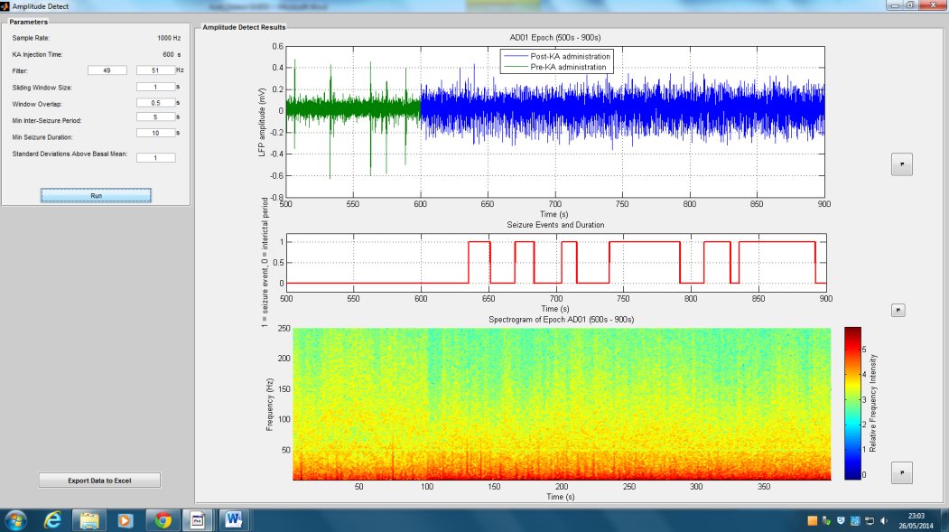
- ‘Seizure Events and Duration’ axes displays events recognised as seizures by the algorithm for the selected epoch with the current parameter set.

Entropy Detect GUI Platform.
- The Entropy Detect GUI platform is launched from the Main Window when the ‘Entropy’ button is pressed in the ‘Detection Analyses’ panel.
- The selected epoch is plotted in the ‘Entropy Detect Results’ panel showing the basal period of the LFP signal in green (before kainite injection). The sample rate and kainate injection time set by the user in the Main Window is displayed in the ‘Parameters’ panel. |  | 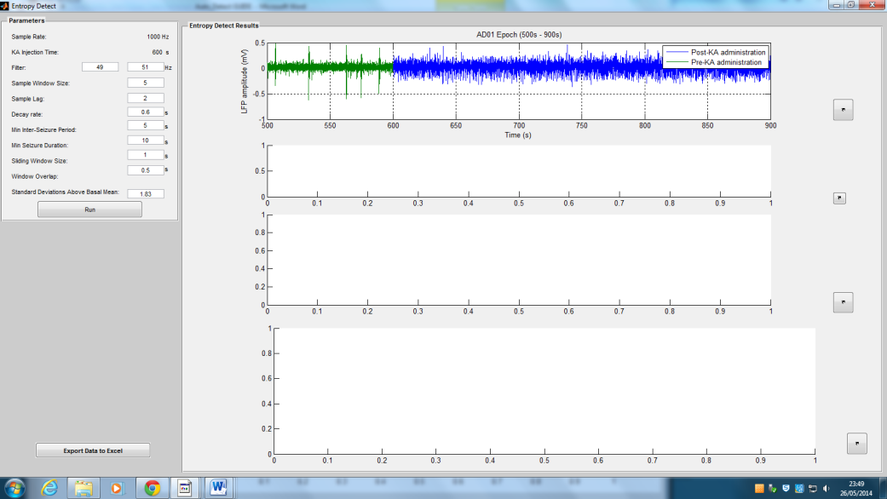
- All Adjustable parameters are found in the ‘Parameters’ panel with default parameters displayed when the platform is launched. These are edited by clicking in the text boxes and entering the appropriate numbers.

Note: hover cursor over text edit boxes to get instructions for each parameter, e.g:

- The ‘Filter’ adjustable parameter determines the upper and lower bounds of the butterworth filter applied to the selected epoch. Default values of 49 and 50Hz are set for the upper and lower bounds to remove mains 50Hz noise.

The user is required to enter an upper and lower limit for the frequency bounds in the first and second text box, respectively.

- The RVE algorithm requires a sample window size to be entered, defining the length of the rank vector.

Increasing the window size from the default value increases computing time from minutes to hours for sample windows of up to 7 samples and higher.
- The RVE algorithm does not require every sample be included in the sample window. A lag can be set between samples included in the window to decrease computing time of the algorithm.
A sample lag of 2 includes every other sample in the window until it has the same number of samples as that set in ‘Sample Window Size’.

Note: increasing the lag loses sensitivity to high frequencies in the complexity analysis.
- The RVE algorithm requires a decay rate to be entered by the user.

The decay rate determines the impact of the ‘leaky integrator’ which down weights all rank vector symbol counts in the frequency distribution from which the state probability distribution is calculated and used for the Shannon Entropy calculation.

The decay rate is how long it takes for the state
count to decay to 1/e of its original value.
See ‘Detection Parameters’ for more information on adjustable parameters for seizure detection in the ‘Parameters’ panel.

- Selecting the ‘Run’ button runs the RVE algorithm with the current parameter set and displays the ‘Seizure Events and Duration’ results as well as a spectrogram for the selected epoch in the ‘Entropy Detect Results’ panel.

All axis have an undock button to load the plot in a new window for enhanced manipulation features. See Undocked Figures for more information.

- ‘Seizure Events and Duration’ axes displays events recognised as seizures by the algorithm for the selected epoch with the current parameter set.

- The entropy time course is displayed in the axis below the ‘Seizure Locations and Durations’ axis.

Cross-correlation Detect GUI Platform

- The Cross-correlation Detect GUI platform is launched from the Main Window when the ‘Cross-correlation button is pressed in the ‘Detection Analyses’ panel. | 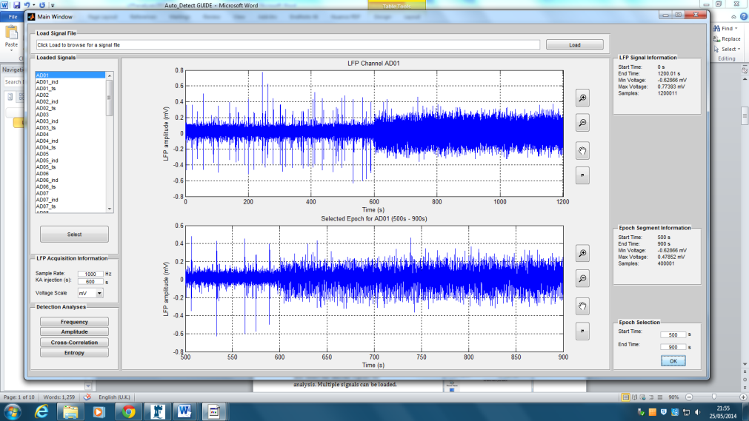
- The selected epoch is plotted in the ‘Cross-correlation’ window showing the basal period of the LFP signal in green (before kainite injection).

- Use plot manipulation buttons to scroll, zoom and pan across the data to search for the desirable waveform for cross-correlation.

A scroll bar is added to increase efficiency of template search for long channels.
- Pressing opens a plot of the absolute fourier transform for the selected epoch. The results of the butterworth filter applied to the epoch can be viewed.

Note: A butterworth filter between 49 and 51Hz is applied to the selected epoch by default in this GUI platform. See ‘Editing Source Code’ for more information on changing default values.
- Once a waveform is in view in the axis, enable cross-hairs for manual template selection by pressing the button.

Click on the left and right hand side of the desired waveform to view the template in the template axis. This can be repeated until the user is satisfied with the template displayed in the axis.

If the template selection is not recognised ‘click again’ will appear in the ‘Template information’ panel. In this instance, repeat the step.

Note: the start time of the template will always round down to the nearest second. This might increase the length of the template.

Long templates will return fewer matches.

- Once a suitable template is selected and displayed, information is presented in the ‘Template Information’ panel.

Note: template information is updated if a new template is selected. The line colour of the template depends on whether it is taken pre- or post-KA.

- Once a template is selected, the correlation threshold box is enabled with the default threshold parameter displayed. See ‘Editing Source Code’ for more information on changing default values

The user can set the threshold between 0 and 0.99 in the ‘Correlation Threshold’ panel to search for regions within the signal that have a pearson correlation higher than the threshold set.

Press the ‘GO’ button in the ‘Correlation Threshold’ panel to run the cross-correlation algorithm and view template matches.

- All correlation coefficients returned from the algorithm are plotted in a new window with the threshold plotted in red.

Lines crossing the threshold indicate a threshold match.

Note: the legend can be removed by using the icon. See ‘Undocked Figures’ for more information.

- All template matches are displayed in red over the original LFP in the main axis of the Cross-correlation window. The template is still in view, and can be undocked for template match comparison.

- The total number of matches as well as the number pre- and post-kainate are displayed in the ‘Results’ panel.

- To view individual template matches in the LFP use the plot manipulation buttons to scroll, pan and zoom until a match is in close view in the axis.
- To view a template match in the template axis, ensure the plot manipulation buttons are toggled off.

Then click once on the white main axes to pause Matlab. (See command window for Matlab status)

When ready to select template, press the space bar to un-pause the programme. This will change the pointer to a data cursor in black.

Double click on the red template to view the ‘Selected Template Match’ in the template axis. Undock the figure to view the template in a new window and compare to other selected templates. See ‘Undocked Figures’ for more information.

Any number of ‘Selected Template Matches’ can be treated this way. The templates can be saved for future reference, See ‘Undocked Figures’ for more information.

Note: to be able to view templates in the template window, the selected epoch from the Main Window must be the same length as the original file.
- The start time and location of all template matches are returned in the command window. | 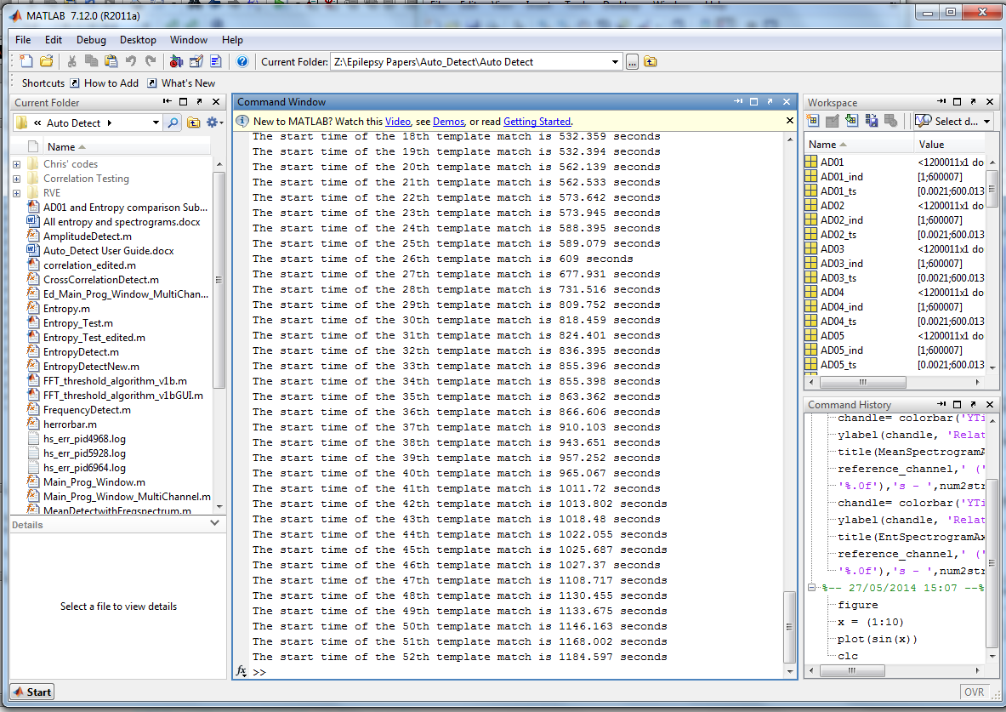

Undocked Figures

Undocking figures using the icon plots the figure in a new window giving the user further manipulation options. All default Matlab figure icons are available in the new window:
Print | Print figure
Save | Save figure to file
Rotate | Rotate figure 360 degrees
Brush | Brush to annotate figure. The figure can be saved and printed with annotations included.
Legend | Remove legend
Plot Tools | Opens Plot Tools where the figure can be annotated with lines and arrows, line colours and axes labels changed as well as additional subplots added. All figure properties can be edited by launching the ‘figure inspector’ by pressing the ‘More Properties’ button . Changes to the figure can be saved and printed.

Editing Source Code

The beginning of each GUI platform displays all default parameters for the algorithm. The default values are displayed when the GUI is launched and are used if no new parameters are entered. The defaults can be edited by the user at their discretion, although they are advised to consult the main body report before any changes are made. It is not advised to edit the source code outside of the default parameters shown below for each algorithm, as the software is not guaranteed work as shown in this guide.

FrequencyDetect.m
%%%%%%%%%%%%%%%%%%%%%%% Default Parameters %%%%%%%%%%%%%%%%%%%%%%%%%%%%%%%
WindowSize_Default = 1;
WindowOverlap_Default = 0.5;
Seizure_Duration_Default = 10;
InterSeizure_duration_Default = 5;
Standard_Deviation_Threshold_Default = 1;
Filter_lower_limit_Default = 49;
Filter_Upper_limit_Default = 51;

%Delta = 1, Theta = 2, Alpha = 3, Beta = 4, Gamma = 5, Broad = 6, Manual =
%7
Default_wave_band = 1; %alpha band
%%%%%%%%%%%%%%%%%%%%%%%%%%%%%%%%%%%%%%%%%%%%%%%%%%%%%%%%%%%%%%%%%%%%%%%%%%

AmplitudeDetect.m
%%%%%%%%%%%%%%%%%%%%%%% Default Parameters %%%%%%%%%%%%%%%%%%%%%%%%%%%%%%%
WindowSize_Default = 1;
WindowOverlap_Default = 0.5;
Seizure_Duration_Default = 10;
InterSeizure_duration_Default = 5;
Standard_Deviation_Threshold_Default = 1;
Filter_lower_limit_Default = 49;
Filter_Upper_limit_Default = 51;

%%%%%%%%%%%%%%%%%%%%%%%%%%%%%%%%%%%%%%%%%%%%%%%%%%%%%%%%%%%%%%%%%%%%%%%%%%

EntropyDetect.m
%%%%%%%%%%%%%%%%%%%%%%% Default Parameters %%%%%%%%%%%%%%%%%%%%%%%%%%%%%%%
Filter_lower_limit_Default = 49;
Filter_Upper_limit_Default = 51;
SampleWindowSize_Default = 5;
Lag_Default = 2;
Decay_Rate_Default = 0.6;
Seizure_Duration_Default = 10;
InterSeizure_duration_Default = 5;
WindowSize_Default = 1;
WindowOverlap_Default = 0.5;
Standard_Deviation_Threshold_Default = 1.83;
%%%%%%%%%%%%%%%%%%%%%%%%%%%%%%%%%%%%%%%%%%%%%%%%%%%%%%%%%%%%%%%%%%%%%%%%%%

CrossCorrelationDetect.m
%%%%%%%%%%%%%%%%%%%% Default Parameters %%%%%%%%%%%%%%%%%%%%%%%%%%%
threshold = 0.6;
Filter_lower_limit_Default = 49;
Filter_Upper_limit_Default = 51;
%%%%%%%%%%%%%%%%%%%%%%%%%%%%%%%%%%%%%%%%%%%%%%%%%%%%%%%%%%%%%%%%%%%%%%%%%%

