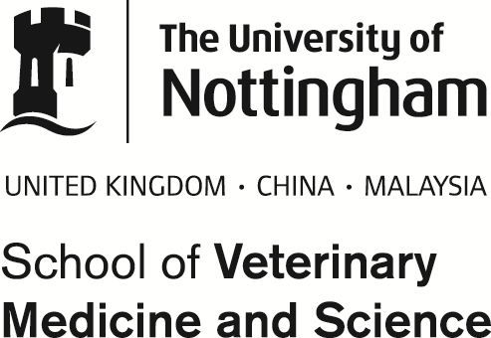
Biobank
Phone: 0115 95 16563
Email: SV-Biobank@exmail.nottingham.ac.uk

BIOBANK TISSUE STORAGE FORM

Name ……………………………………. Department……………………….………

Phone………………………………… …. E-mail………………………………….

Project for which the samples are being stored: …………………………………………….
…………………………………………………………………………………………………….

Section 1
Material or tissue:

Species and signalement:

Size and number of samples:

Preservation buffer:

Section 2
How samples must be stored/processed. | ☐ 10% neutral buffered formalin at RT (max 500g tissue)  ☐ 4-6⁰ Celsius fridge (max 1kg tissue)  ☐ -20⁰ Celsius freezer (max 10 ml per sample)  ☐ -80⁰ Celsius freezer (max 2ml per sample)  Other – please specify below:

Please sign ___________________________________________________ Date ____________________________________
And attach one printed copy to the sample(s) and e-mail this to
SV-Biobank@exmail.nottingham.ac.uk

SAMPLES WILL NOT BE COLLECTED AND PROCESSED WITHOUT THE SIGNATURE AND CONFIRMATION OF ALL OF THE ABOVE DETAILS.
THE UNIVERSITY ACCEPTS NO RESPONSIBILITY FOR THE COLLECTION, LOSS OR DAMAGE OF STORED SAMPLES

