Guidance for Off-site ExamSys Exams 2022/23

Introduction
This document is designed to be a working user guide, to offer general advice, guidance, support and practical explanations for students taking off-site ExamSys (previously called Rogo)exams, and for staff who are supporting students in these assessments. This guide is not an exam rubric, and does not contain assessment regulations. Some Schools may have specific requirements that mean that they do not follow this guide precisely. These should be communicated directly to relevant students. It is recommended that this guide is made available to students in advance of their exam, so that they have time to read it and raise any queries ahead of their exam.

How do off-site ExamSys exams work?

Preparing to access your exam
Off-site ExamSys exams are taken using your own device in a location that suits you. This location should be somewhere quiet, somewhere that you can be alone (or at least where you will not be interrupted), with good internet connectivity and where you can sit comfortably for an extended period of time.
Off-site ExamSys exams are not invigilated directly, but it is still expected that you will not collude with others, and that your work is your own. You may be expected to make a declaration to this effect at the start of your exam.
Off-site ExamSys exams do not have a specific exam link. Instead, the generic ExamSys.nottingham.ac.uk is used. When you log in, ExamSys will only show you exam papers scheduled at that time that match your enrolments. Please refer to the login procedure detailed on the next page.
You will need an additional password in order to access your exam paper. This is shown on your exam timetable. If you are looking at your timetable on the app, this is shown under the ‘Notes’ field. You will be prompted to enter this password after you have successfully logged in to ExamSys. Do not use the exam password to try to access the system.

Timings in off-site ExamSys exams
Your off-site ExamSys exam has a fixed start time. This is shown on your exam timetable. You will not be able to access your exam until 15 minutes before the stated start time. If you try to access your exam before this, you will see an error message saying ‘No exams found’. You should try to start your exam as close to the stated start time as possible.
Your exam duration will be controlled by a countdown timer. It is important to note that your countdown timer is individual to you, and will not start counting down until you click to start the exam. Therefore you will not lose writing time if you have any minor difficulty accessing the exam at the precise start time.
Your countdown timer will run continuously once it has begun, and your work will be automatically submitted and your access stopped if it reaches zero. You should usually submit your work before this point by clicking on the ‘Finish’ button on the final screen, which will then display a confirmation message. Please note that ExamSys does not send submission confirmation emails.

Technical difficulties in off-site ExamSys exams
If you lose access to ExamSys for any reason during your exam, please do not be concerned. Close any remaining browser windows and open a new one. Then repeat the login process. You will then be able to pick up exactly where you left off. However, please be aware that your countdown timer will have continued in the background.
You will notice a discrepancy between the duration stated on your exam timetable, and the duration that shows on the start screen of your exam and on your countdown timer. This will usually be 10 minutes.

This additional time has been added to the duration of the exam to mitigate for any minor technical difficulties that you may experience – for example WiFi instabilities, screen freezing, or sudden and unexpected device updates. You should try not to use this time unless you need it, and you should report any technical difficulties experienced using the query form linked at the end of the exam. Use of this additional time can be monitored by markers.

Additional information for students with Support Plans
If you have additional writing time or rest breaks as part of a support plan, you have been granted 50% additional time in ExamSys exams. This has been manually applied to your ExamSys user account by the Exams Operations team. Once set up, this additional time will be automatically applied to all of your future ExamSys assessments.
If you have provision in your Support Plan for you to begin 9am exams at 10am, then this will also apply to your off-site ExamSys exams. Your exam timetable will still show a start time of 9am, but you should begin your exam at 10am as stated in your support plan.
When you look at your exam timetable your additional time will not be shown there. However, when you look at the start screen before you start your exam, the duration stated will include your additional writing time. If this is incorrect, please contact the Exams Office immediately and we will be happy to look into this and rectify any errors before you begin, and to ensure that you do not lose out on any writing time that you should have.

Exam Login Procedure
- On the day of your exam, navigate to ExamSys.nottingham.ac.uk around 15 minutes before your exam is due to start. (If you attempt to login before this, you will see the message ‘No Exams Found’)
- Login to the ExamSys system using your usual university IT username and password.
- This will take you to the start screen (shown in detail on the next page), which will show important details about the exam. Please read these carefully.
- When you click on ‘Start’ you will be asked for an additional password.
- Please enter the specific exam password from your exam timetable
- The paper will then begin, and the timer will start counting down.
- Once you finish your exam, please click the ‘Finish’ button on the final screen to submit your script.

Start screen

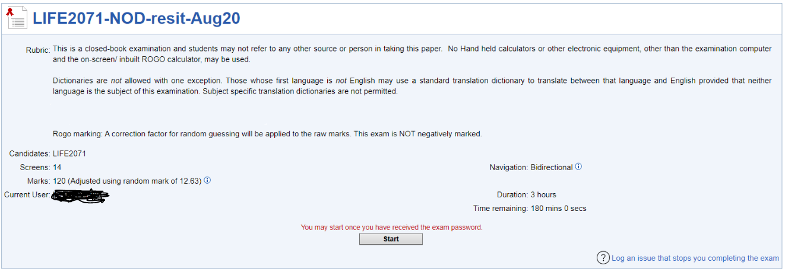

  - Title: This should include the module code, confirming the identity of the paper
  - Rubric: These are the instructions and regulations specific to the exam. Read these carefully.
  - Candidates: Further confirmation of the module code
  - Screens: This is the number of screens in the exam
  - Marks: This is the number of marks available for the exam. This may reference adjustment using a random mark. This is a correction factor applied to all scripts to account for random guessing. This is not negative marking.
  - Current user: This should be you.
  - Navigation: This will either say Bidirectional or Unidirectional. If it says unidirectional this means that you can only move forwards through the paper. Once you have moved on from a particular screen, you cannot return to it.
  - Duration: This is the total duration of the exam, including the additional 10 minutes in case of technical difficulties, and any additional writing time you may be entitled to as part of a Support Plan. If you should have additional time from a Support Plan and this is not displayed, please contact the Exams Office.
  - Time remaining: This shows the amount of time you have left on the countdown timer. Before you start, this should be the same as the duration. If you leave your exam part way through and return to it, it will show how much time you have left.

Reporting technical issues & troubleshooting
This section shows some common ‘Error’ screens that you may encounter in ExamSys, and what they are likely to mean. Please consult this section before contacting the Exams Office, as it is likely that you will be able to solve the problem without additional assistance.

‘No exams found’

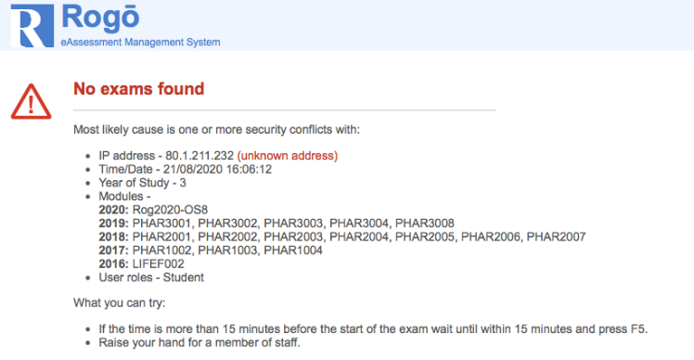

If you see this message on logging in to ExamSys, there are a number of things it might mean.
- You have logged in on the wrong day or at the wrong time for your exam – either too early, or too late. ExamSys will only show your exam at the time it is scheduled for. At all other times it will show the ‘No exams found’ message. Check your exam timetable to be sure you have the right date/time.
- Alternatively, there may be a problem with your module enrolment for the exam you are expecting. ExamSys automatically takes your module enrolments directly from your student record, and updates them overnight. You can check these are correct by looking at the information on the screen. ExamSys displays your enrolments and associated academic sessions on this screen under ‘Modules’ – check that the module code for the exam you are expecting falls under 2021.

‘Access Denied’

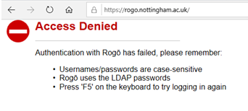
If you see this message on logging in to ExamSys, it may mean one of two things.
- You have typed your university username or password incorrectly. This is the most common scenario. You must use your IT username (not your full email address, or your firstname.lastname format for O365), and the password that corresponds with this. Common errors also include trying to use a student ID number, or the exam paper password to log in to ExamSys.
- It is also possible (although much less likely) that there has been an error on your student record, and the integration to ExamSys has not worked properly. If you suspect this to be the case, please contact the Exams Office.

‘Save failed’ error

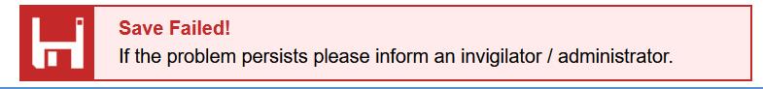
If you see this message at the bottom of your screen when you try to advance to the next screen of the exam, please do not worry.
This means that your answer data is in a queue at the server, it does not mean that your answers have been lost. Your data will reach the top of the queue and be recorded in due course.
This error message is more common in unidirectional exams, which can be especially unnerving as it is not possible to go back and check your answers at the end. If this happens, please complete the query form, but be reassured that it does not mean that your answers are lost.

‘Confirm form resubmission’ or ‘Page cannot be displayed’
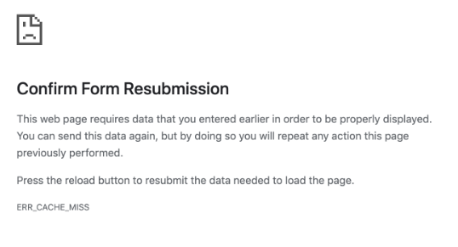
If you see either of these messages during your exam, this is likely to be as a result of a problem with your internet connection. You should complete the query form once the problem has resolved. You may need to repeat the login procedure in order to get back to your exam. You may need to re-enter answers from the screen that you were on when the problem occurred.

If you have been unable to resolve your problem by reading through this guidance, please contact examsoffice@nottingham.ac.uk and we will assist you as soon as possible.

