Submission Information for

Postgraduate Research Students

Compiled by Student Services

Contents

Introduction 3
Key Dates 5
For July Graduation 5
For December Graduation 5
Inter-ceremony 6
For March Inter-ceremony 6
For October Inter-ceremony 6
Preparation, Submission and Examination of Thesis for a Research Degree 7
Notification of Submission of Thesis for Examination 7
Submission of Thesis for Examination 7
Late Submission of Thesis 7
Extension to Thesis Pending 8
Softbound version for Examination 8
Searchable PDF version for Examination 8
Submitting your Softbound and electronic thesis 8
Outcomes of Examination 9
Award of degree for which you are registered 9
Typographical errors or minor amendments 9
Referral 9
University of Nottingham Deposit of Electronic Thesis 10
Confidential Content 10
Third Party Copyright Content 10
Applying for an Embargo 10
Applying for a Restriction 10
How to upload your thesis 11
The steps in the Deposit process 11
Graduation Arrangements for Research Degree Candidates 15
Supplementary Information for examiners, supervisors and candidates 16
Criteria for award of PhD and other qualifications at Doctoral Level 16
Options available to the examiners 17

Introduction

Enclosed is all the information necessary for your thesis pending and examination period including submission, uploading your final thesis to the University’s etheses service (http://eprints.nottingham.ac.uk/etheses/) and Graduation. If you have any queries about anything in this document, please do not hesitate to contact Student Services.

Student Services Team
Contact for | Telephone number
Voluntary interruption of studies, additional periods of registered study, registering in thesis pending, extension requests and thesis submission. | +44 (0)115 74 86500 or use the enquiry form at: https://www.nottingham.ac.uk/studentservices/contact-us/index.aspx

- The Notification of Submission of Thesis form - should be completed and returned to Student Services at least three months prior to the actual submission of your softbound thesis to allow for the appropriate arrangements to be made for your examination. Any delay in submitting your form can lead to a delay in your examination taking place.
- Contact details – Please make sure that you keep you contact details up to date on the University Portal as we will write to you about your examination process.

If your submission deadline falls on a non-working day then you should ensure that your thesis is submitted on a working day before this deadline. Information on the Student Services Centre opening times can be found at:
http://www.nottingham.ac.uk/studentservices/studentservicescentres/index.aspx
Information on dates of University closure can be found at:
http://www.nottingham.ac.uk/staff/bankhol.phtml

The accepted ‘word limits’ (not targets), inclusive of appendices, footnotes, tables and bibliography, are:
- MPhil – the thesis should not normally exceed 60,000 words
- PhD – the thesis should not normally exceed 100,000 words
- Other research degrees - please see specific regulations at:
  - http://www.nottingham.ac.uk/academicservices/qualitymanual/researchdegreeprogrammes/index-page-research-degree-regulations.aspx
- Theses in alternative formats – please see specific regulations at:
  - http://www.nottingham.ac.uk/academicservices/qualitymanual/researchdegreeprogrammes/alternative-formats-of-thesis-submission.aspx

Further information about the submission process can be found at:
http://www.nottingham.ac.uk/academicservices/currentstudents/examinations/researchstudent/index-research.aspx

Key Dates

You are required to submit your thesis for examination by the submission deadline notified to you during your course of studies. The dates below are for graduation guidance only. Even when they have been correctly observed, no guarantee can be given that the necessary examination procedures will have been completed in time for a candidate to graduate at the next degree congregation.

For July Graduation

Activity | Date
Submission of “Notification of Intention to Submit” form | No later than 1 February
Submit Softbound Thesis | No later than 1 April
Deadline for uploading corrected thesis or final thesis to the University etheses service (http://eprints.nottingham.ac.uk/etheses/) | 1 June
Deadline for final version of work to be approved in order for Graduation eligibility | 15 June

For December Graduation

Activity | Date
Submission of “Notification of Intention to Submit” form | No later than 1 July
Submit Softbound Thesis3 | No later than 1 September
Deadline for uploading corrected thesis or final thesis to the University etheses service (http://eprints.nottingham.ac.uk/etheses/)4 | 1 November
Deadline for final version of work to be approved in order for Graduation eligibility | 15 November

Inter-ceremony

In addition to the two degree congregations in July and December, there are two inter-ceremonies held in March and October. These allow you to graduate and receive your certificate but not attend a ceremony.

The recommended dates for uploading your work to the University’s etheses service (http://eprints.nottingham.ac.uk/etheses/) are the 1 September for October Inter-ceremony and the 1 February for the March Inter-ceremony.

For March Inter-ceremony

Activity | Date
Submission of “Notification of Intention to Submit” form | No later than 1 October
Submit Softbound Thesis | No later than 1 December
Deadline for uploading corrected thesis or final thesis to the University etheses service (http://eprints.nottingham.ac.uk/etheses/) | 1 February
Deadline for final version of work to be approved in order for Graduation eligibility | 15 February

For October Inter-ceremony

Activity | Date
Submission of “Notification of Intention to Submit” form | No later than 1 May
Submit Softbound Thesis5 | No later than 1 July
Deadline for uploading corrected thesis or final thesis to the University etheses service (http://eprints.nottingham.ac.uk/etheses/)6 | 1 September
Deadline for final version of work to be approved in order for Graduation eligibility | 15 September

Preparation, Submission and Examination of Thesis for a Research Degree

Notification of Submission of Thesis for Examination

Your supervisor’s signature on the ‘Notification of Intention to Submit’ form acts as a confirmation:
- That the thesis is the result of work done mainly while the you have been registered as a student of The University of Nottingham
- That the you have been given appropriate plagiarism guidance
- That if appropriate to your discipline, you are aware of the requirement to submit all data collected during the period of study as a research student of this University, to your School prior to arrangement of the viva voce examination

The form can be downloaded here: http://www.nottingham.ac.uk/academicservices/qualitymanual/researchdegreeprogrammes/procedures-for-assessment.aspx

Once it is received by Student Services, we contact your School to ask them to arrange examiners for you.

Submission of Thesis for Examination

You are not precluded from incorporating in your thesis any part of work already submitted by yourself for a degree in this or any other university, provided that in the application to the University for admission to the course for the degree for which you are registered, or at an appropriate later date, you stated a desire to do so, and in the thesis itself you indicate the part of the work so incorporated. In any such case you may be required to produce previous work.

Late Submission of Thesis

You are required to submit your thesis for examination by the submission deadline notified to you during your course of studies. Full time doctoral students submitting a thesis after this deadline, without receiving formal approval from the University for an extension of time (http://www.nottingham.ac.uk/academicservices/qualitymanual/researchdegreeprogrammes/the-thesis-pending-period.aspx), will be permitted to submit up to twelve months after their latest submission date as long as the maximum period from initial registration (http://www.nottingham.ac.uk/academicservices/qualitymanual/registrationattendanceandstudy/maximum-period-from-initial-registration.aspx) has not been reached. Once the work has been submitted the late submission fee for each month or part month (as per the University Fee Schedule https://www.nottingham.ac.uk/fees/index.aspx) that passes between your expected submission date and the date that your thesis is actually submitted will be raised and is payable immediately.

For students who are not on doctoratal programmes, or who are not full time, or for whom this is not the first submission, there is no recourse to submit a thesis late and an extension to thesis pending must be requested (http://www.nottingham.ac.uk/academicservices/qualitymanual/researchdegreeprogrammes/the-thesis-pending-period.aspx).

Extension to Thesis Pending

The Extension to Thesis Pending policy can be found in the University’s Quality Manual: http://www.nottingham.ac.uk/academicservices/qualitymanual/researchdegreeprogrammes/the-thesis-pending-period.aspx. Applications for extensions of time should be made to a Student Service Centre, the Student Registry at UNMC or the Graduate School at UNNC. Please note, that extensions are only approved for the reasons outlined in the policy.

Softbound version for Examination

Theses should be presented on A4 paper, normally with 12 font typescript. There should be a margin of at least 1.5 inches, preferably 2 inches (5cm), on the left side of the page, both for typescript and diagrams, to allow for binding. Other margins should be of at least 1 inch (2.5 cm).

Searchable PDF version for Examination

You are also required to provide an electronic version of your thesis for examination. This should be on a compatible disc (CD) or USB stick and be clearly labelled with your student ID number.

Submitting your Softbound and electronic thesis

You must submit to Student Services two soft-bound copies of your thesis, e.g. spiral-bound or plastic binding as well as an electronic version saved as a searchable PDF on a CD or USB stick and be clearly labelled with your student ID number. Theses presented in lever-arch or box-files will not be accepted unless the work is in a different format as per “Alternative formats of thesis submission” regulations: http://www.nottingham.ac.uk/academicservices/qualitymanual/researchdegreeprogrammes/alternative-formats-of-thesis-submission.aspx

Update, 18/03/2020:
** During the CoVid-19 pandemic (until further notice) you can submit your thesis electronically only, rather than as a soft-bound copy and USB/CD digital copy. Please upload it via University’s etheses service (http://eprints.nottingham.ac.uk/etheses/). For further instruction please see Student Services websites, here. **

Outcomes of Examination

Award of degree for which you are registered

If the outcome of your examination is that your work needs no further corrections, you should upload the work to the University’s etheses service (http://eprints.nottingham.ac.uk/etheses/). Your examiner will then check that the version that has been uploaded is the same work that has been approved at examination. Once this approval has been given, you will become eligible for graduation. Please see the Key Dates section for the appropriate dates for Graduation eligibility. If your examiner informs us that they will not be able to approve your work in time for you to become eligible for Graduation we will inform you in writing of this.

Typographical errors or minor amendments

If you have been recommended minor corrections to your thesis within one month or three months, you should upload the corrected work to the University’s etheses service (http://eprints.nottingham.ac.uk/etheses/). Once you have uploaded your thesis the relevant examiner will check that the corrections are satisfactory. If they are they will formally approve your work by informing Student Services. Once this is done, Student Services will write to you confirming your Graduation date (if known). If your examiner informs us that they will not be able to approve your work in time for you to become eligible for Graduation we will inform you in writing of this. Please see the Key Dates section for the appropriate dates for Graduation eligibility.

Referral

If it has been recommended that you resubmit your work within twelve months, then you should follow the same procedure per your initial softbound submission. A referral recommendation carries a fee. Please see the University Fee Schedule for more information: https://www.nottingham.ac.uk/fees/index.aspx

For other outcomes of examination, please see The University regulations: http://www.nottingham.ac.uk/academicservices/qualitymanual/researchdegreeprogrammes/phd-and-mphil-regulations.aspx

University of Nottingham Deposit of Electronic Thesis

All successful candidates for research degrees are required by University regulations to upload a final version of their thesis to the University eTheses service (http://eprints.nottingham.ac.uk/etheses/). This will be archived as a record of the work which has been examined and must reflect the version submitted to the examiners with any required corrections made.
Before uploading your thesis, you should consider the following:

Confidential Content
If the content of the thesis contains confidential material then a second version with the sensitive material removed should also be submitted. Similarly, if you have conducted a survey or presented a case study, the data may need to be anonymized.

Third Party Copyright Content
You need to identify whether the thesis reproduces any substantial material for which copyright belongs to a third party. If it does, you are personally responsible for establishing in advance that it is lawful to retain this in the version of your thesis to be published via Nottingham eTheses. You must also ensure that ownership of copyright in any such third party content is explicitly and sufficiently acknowledged within the thesis. Any material that was created by someone else, whether or not it was previously published, is likely to fall under the definition of third party copyright. Examples could be reproductions of photographs, graphs, illustration or extensive quotations. The guide Copyright and intellectual property guidance for electronic thesis submission outlines various avenues open to you to establish permission to retain this content.

Applying for an Embargo
Unless you indicate a different preference on the thesis submission template, the public version of the thesis will be published online once the degree has been conferred. By default, in order to view the full text, readers will need to identify themselves and to agree to a declaration that they will not reproduce the thesis or any substantial portion of it, without obtaining the written permission of the author. You may prefer to select the option to make your thesis fully open access as recommended by many funding bodies. You may also wish to delay online publication of the full text by requesting an embargo period, normally for two years, to allow publication through alternative channels. You must discuss these options with your supervisor.

Applying for a Restriction
In special cases the Senate may impose a restriction on the consultation of a thesis for a period of two years from the date of the award of the degree if requested to do so. Full information is available at:
http://www.nottingham.ac.uk/academicservices/qualitymanual/researchdegreeprogrammes/application-for-a-restriction-to-be-placed-on-a-thesis.aspx.

Once the full text of your thesis has become publicly available an electronic copy may also be included in the British Library Electronic Thesis Online System (EThOS) and the metadata will be discoverable via Internet search engines.

How to upload your thesis

Once the degree has been conferred, the thesis will be published (i.e. the full text made available on an open access basis online) unless:

- The content contains confidential material. In this case an alternative version with the copyright or sensitive material removed should also be submitted.
- The content includes third party copyright material for which permission to reproduce cannot be established. There are several options that may lead to permission for third party copyright material to remain (the guide Copyright and intellectual property guidance for electronic thesis submission outlines these). If none of these succeed, an alternative version with the copyright material removed should also be submitted.
- A restriction has been applied for due to time-limited confidentiality issues (http://www.nottingham.ac.uk/academicservices/documents/qmdocuments/research-students-thesis-restriction.docx). In this case bibliographic details and the full-text would only be visible to repository staff.
- An embargo has been requested. The thesis is not formally restricted but the author wishes it to remain confidential prior to publication in a different form. In this case bibliographic details would be searchable but the full-text would only be visible to repository staff.
Written theses should be deposited in PDF format. (This option is usually available within word processing software. For example Microsoft Word offers a 'save as PDF' option. Open your Word document, click on the Office button on the top left corner, go to save as, then click PDF. This will save your document in a PDF format.) However data, audio and video files may also be uploaded.

The steps in the Deposit process

Please ensure that you have discussed the terms under which your thesis will be made available with your supervisor.
As outlined above, please also ensure that you have established permission to retain any third party copyright that is reproduced in the thesis.
Similarly, if you have conducted a survey or presented a case study, the data may need to by anonymised.
1. You will need the following information:
- the type of degree - PhD, DM, MPhil, MRes, etc.
- the full title of your thesis
- the abstract of your thesis
- the names of your supervisors
- the year and month when you expect to graduate
- the full text of your thesis, in PDF format
- At the Nottingham etheses Home Page, Login with your University username and password
- Click on "New Item"

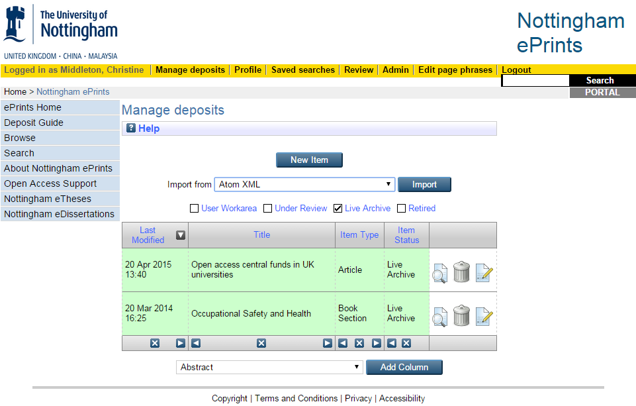

- On the following pages, select Item Type (i.e. "Thesis"), Thesis type and Faculty/School from the pick lists.
- Upload your PDF(s). For each file you will need to provide further information.

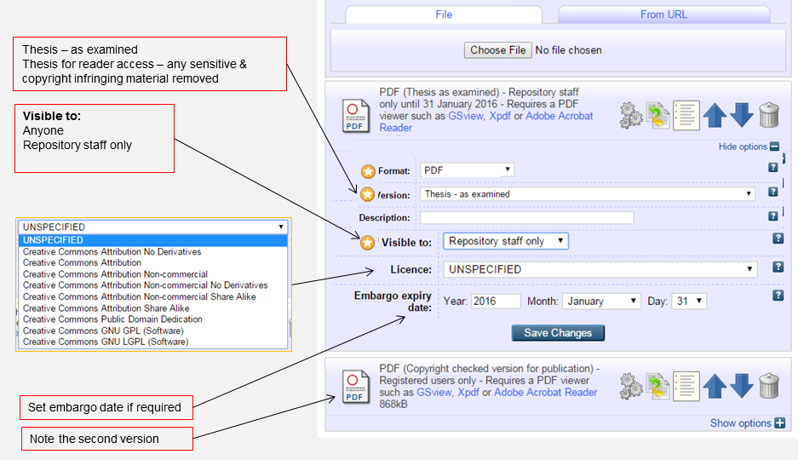

Use Version to indicate:
- Thesis – as examined
- Thesis for reader access – any sensitive & copyright infringing material removed
The free text Description box allows you to enter extra information such as Volume 1, Volume 2.
Visible to allows you to specify who can access the full text of your thesis. You must check this and the Licence and Embargo fields with your Supervisor.
Select:
- Anyone: the document is available to anyone via the world wide web
- Repository staff only: the document can be requested by site visitors who identify themselves via a web form.
Repository staff only should be used for any access other than the Open Access “Anyone” option. It allows a log to be maintained of those requesting the full text of a thesis. If the title is embargoed, (i.e. suppressed pending future publication), then access will be declined. If the thesis is restricted then there is a later option to specify this and it will not be discoverable at all.
Licences: LRLR can advise on the meaning of Creative Commons licences (email copyright@nottingham.ac.uk). The supervisors know the circumstances surrounding the research – the commercial and ethical sensitivity, the possibility of patent application. We have received strong indications that supervisors want and need to be involved in this decision.
Embargo: You may request an embargo period if you wish to suppress the full text pending publication of an article or book based on the content of your thesis. The bibliographic details including any abstract will be visible.

- Click Next to fill in the bibliographic details template (author, title, abstract etc).

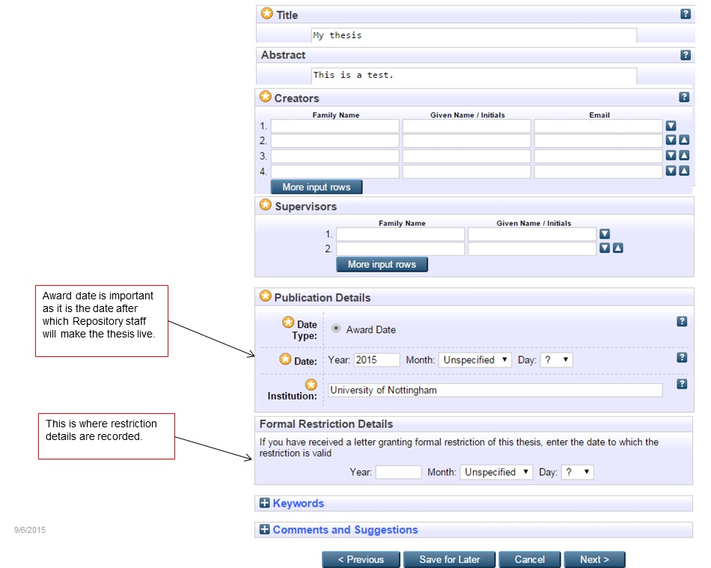

For Award Date enter the date when you expect to graduate.
If a thesis has an official Restriction then enter the details here to ensure that the thesis is not visible within the live repository.
Optionally add Keywords to help others to find your thesis
Comments and Suggestions are only visible to you and administrative staff. If there are particular reasons why you would need an embargo for longer than 2 years, please give details here.

- Read the Deposit Licence carefully and deposit your files(s)
- Your submission will be checked and a public version will appear in the archive after your award has been conferred.

Graduation Arrangements for Research Degree Candidates

The University holds degree congregations twice a year, in July and December. The usual expectation is that students will graduate at the next ceremony following the successful completion of their studies. If you have special reasons for wishing to defer graduation you may make a written application to a Student Services Centre to request permission to defer. You will need to explain the special circumstances leading to your request. Permission to defer will only be granted in exceptional circumstances and you should be aware that your degree certificate will not be issued, nor can we confirm that your degree has been awarded, until your degree has been formally conferred at a ceremony.

In order to make appropriate arrangements for the ceremony, information is normally available in September for Winter Ceremonies or February for the Summer Ceremonies to candidates who are expected to be eligible to graduate. It is important that you keep your contact details up to date via the Portal (https://portal.nottingham.ac.uk/) so that information about graduation reaches you. You will be asked to complete an online graduation form, indicating whether or not you wish to attend the ceremony, by a deadline in October for Winter Ceremonies or March for Summer Ceremonies. As arrangements have to be made well in advance of the Ceremonies, you may be sent information and asked to apply before your final results are known. Even if you are not sure whether you will have completed in time to graduate at the ceremony, you should still respond by the deadline, as it will not be possible for you to be added to the proceedings after the closing date. If you subsequently find that you have not completed in time to graduate at the Ceremony, your name will be withdrawn and you will be issued a refund for your graduation tickets. Please remember it is your responsibility to ensure that you have completed the graduation form well in advance.

In order to be eligible for graduation your Internal Examiner or Lead External Examiner (in cases where there are two external examiners) will have to formally approve the final electronic copy of your thesis.

If you have any queries about degree congregations you may wish to contact the Graduation Team (Tel. 0115 9515108, email: graduation@nottingham.ac.uk) who co-ordinate the arrangements for the ceremonies. If your query concerns the submission of your thesis or the examination process you should contact Student Services (Tel. 0115 74 86500, or use the enquiry form at: https://www.nottingham.ac.uk/studentservices/contact-us/index.aspx.

Supplementary Information for examiners, supervisors and candidates

Note: The official regulations for higher degrees are given in the Quality Manual at
https://www.nottingham.ac.uk/academicservices/qualitymanual/researchdegreeprogrammes/regulations-for-higher-doctorates.aspx

Criteria for award of PhD and other qualifications at Doctoral Level

These are awarded to students who have demonstrated:

(i) the creation and interpretation of new knowledge, through original research or other advanced scholarship, of a quality to satisfy peer review, extend the forefront of the discipline, and merit publication;
(ii) a systematic acquisition and understanding of a substantial body of knowledge which is at the forefront of an academic discipline or area of professional practice;
(iii) the general ability to conceptualise, design and implement a project for the generation of new knowledge, applications or understanding at the forefront of the discipline, and to adjust the project design in the light of unforeseen problems;
(iv) a detailed understanding of applicable techniques for research and advanced academic enquiry.

Typically, holders of the qualification will be able to:
(a) make informed judgements on complex issues in specialist fields, often in the absence of complete data, and be able to communicate their ideas and conclusions clearly and effectively to specialist and non-specialist audiences;
(b) continue to undertake pure and/or applied research and development at an advanced level, contributing substantially to the development of new techniques, ideas, or approaches;
and will have:
(c) the qualities and transferable skills necessary for employment requiring the exercise of personal responsibility and largely autonomous initiative in complex and unpredictable situations, in professional or equivalent environments.

- The thesis must be presented in a satisfactory manner. The subject matter must be clearly and precisely expressed, its arguments logical and intelligible, and its language appropriate. It must show that the candidate not only has ideas, but also has the power of putting them into suitable words.

- The thesis must be the result of the candidate’s own work. This requirement does not preclude a candidate obtaining limited assistance with the routine collection and/or processing of data under guidelines and instructions clearly devised by the candidate. When such help is obtained it should be with the prior approval of the supervisor who must be satisfied that the spirit of the ‘own work’ requirement is not breached.

- Prior publications of papers arising from the research being undertaken will not adversely prejudice the assessment of the thesis by the Examiners.

- The viva voce examination is an essential and important part of the examination of the candidate. It will normally include questions designed to ascertain that the thesis embodies the candidate’s own research. It will test the candidate’s general comprehension of the field of study within which the subject of the thesis falls. It will test the candidate’s acquaintance with the general literature of the subject, knowledge of the relation of the work to the wider field of which it is a part, and the respects in which the work advances, modifies, or otherwise affects this wider field of scholarship.

Options available to the examiners

When the examiners assess the candidate’s thesis they will be following the guidelines set out in the Quality Manual: http://www.nottingham.ac.uk/academicservices/qualitymanual/researchdegreeprogrammes/index-page-research-degree-regulations.aspx

The form should be submitted in person or by post to one of the Student Service Centres: http://www.nottingham.ac.uk/studentservices/studentservicescentres/index.aspx
Two softbound copies of your thesis and one searchable PDF should be submitted in person or by post to one of the Student Service Centres.
This date is for graduation eligibility only. You are required to submit your thesis for examination, at the very latest, by the submission deadline notified to you during your course of studies.
This date is for graduation eligibility only. You are required to submit your corrected work, at the very latest, by the deadline given to you in your examination outcome letter.
This date is for graduation eligibility only. You are required to submit your thesis for examination, at the very latest, by the submission deadline notified to you during your course of studies.
This date is for graduation eligibility only. You are required to submit your corrected work, at the very latest, by the deadline given to you in your examination outcome letter.

