Travel to Lisbon and to the Carcavelos campus

Airplane
The easiest way to come to Lisbon is by airplane to the Lisbon airport. The easiest way to get from the airport to the Nova campus in Carcavelos is by Taxi or Uber. It is a 30Km journey that costs up to 35 EUR by taxi.

Car
If you arrive by car, you can use the campus parking or park for free in the campus’ surrounding areas.

Train
You can travel overnight by train. There are trains connecting Madrid (Lusitânia Comboio Hotel), Vigo (Celta train) and Irun (Sud Expresso) to Lisbon.
The Carcavelos Campus is located halfway between Lisbon and Cascais. It is accessible by car and through public transport.
If you wish to stay in Lisbon city centre, there are four subway lines that reach the suburban areas and the Cais do Sodré Train Station. This train leaves from the station “Cais do Sodré” to either the “Oeiras” or the “Carcavelos” train station and takes approximately 35-minutes. From the Oeiras train station it is a 20-minute walk to the campus. It is 25-minute walk or 5-minute ride with the MobiCascais shuttle from the train station in Carcavelos. This train also connects Carcavelos to Cascais along the coast and can also be an option to arrive to the campus if you stay in Cascais municipality.

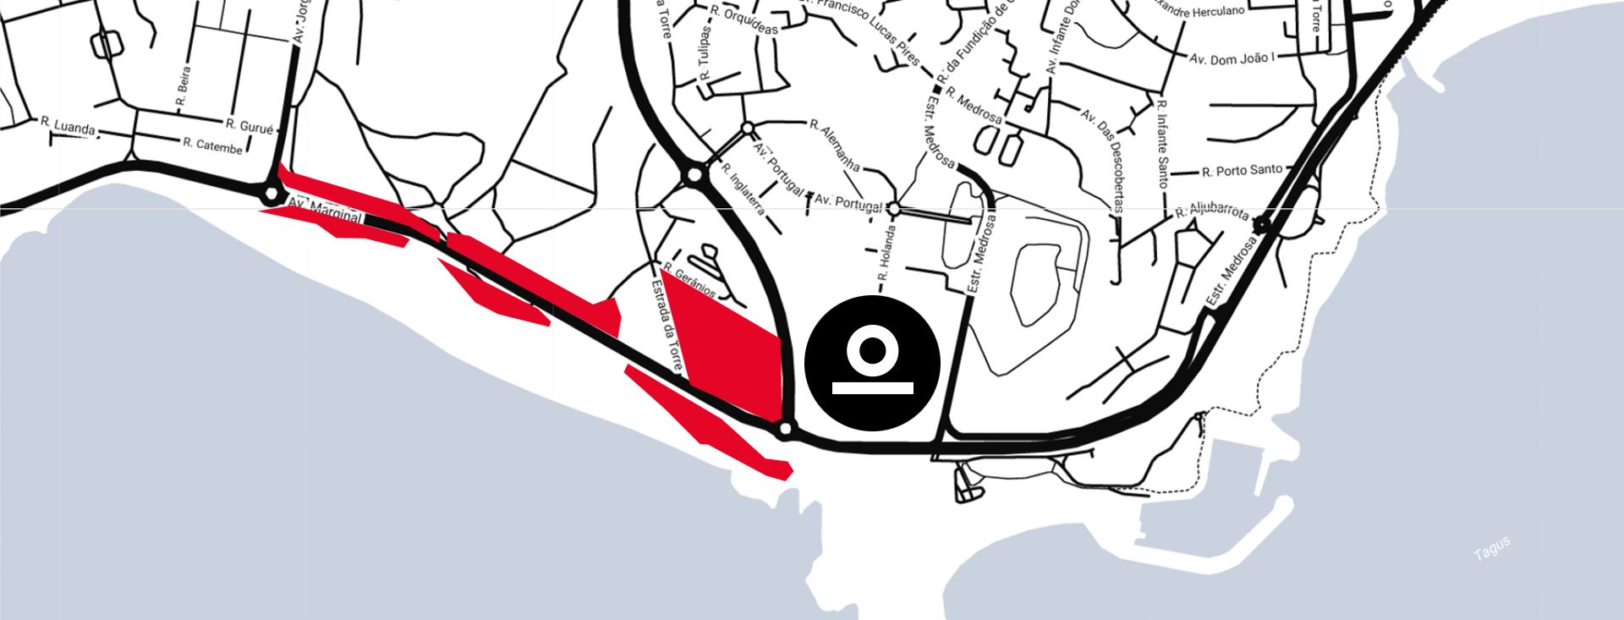
Address – The campus has two entrances. When driving, please use the main entrance of the campus, off N6-7/Av. Marginal - easily seen from the road and well-signposted. You can also access to the campus by the entrance located at the Rua da Holanda). Postal address: Carcavelos Campus, Rua da Holanda, no. 1, 2775-405 Carcavelos, Portugal.

Local Accommodation

Carcavelos Beach Hotel 4****
Special prices upon availability until May 23rd, 2025 (for the nights on 23 - 25 July): 105€/Night – Single Standard Room | 115€/Night – Double Standard Room | 125€/Night – Single See View Room | 135€/Night – Double See View Room (breakfast and Wi-Fi Internet included) | Cancellation Policy: free of charges if cancelled until 72h before check in| Reservations through email using this address carcavelosbeach@almeidahotels.pt or by phone +351 21 458 51 00 using the promotional code “ARG82025” | 25-minutes walking distance along the coast.
website

Riviera Hotel Carcavelos 4****
Special prices upon availability until May 23rd, 2025 (for the nights on 23 - 25 July): 112€/Night – Single Room | 127€/Night – Double Room (breakfast and Wi-Fi Internet included) | Cancellation Policy: free of charges if cancelled until 72h before check in| Reservations through email using this address vera.moura@rivierahotel.pt or this reservas@rivierahotel.pt using the promotional code “ARG8” | 30-minutes walking distance along the coast.
website

