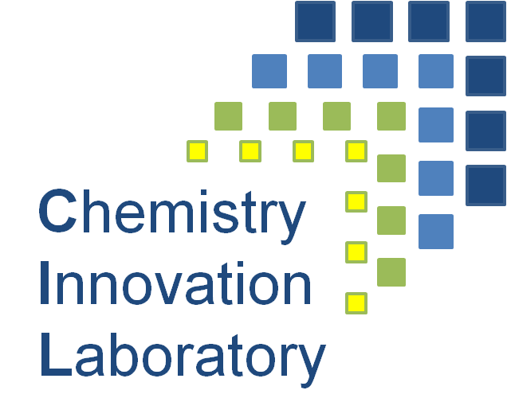

University of Nottingham NMR Showcase
21 November 2012

Dr. Adrienne Davis, School of Chemistry
‘NMR Spectroscopy – a Brief Introduction to Its Uses and a Whistle-Stop
Tour of our Facilities’

Dr Huw William, Centre for Biomolecular Sciences
High Field NMR Facilities: Case Studies and Research Collaborations

Professor Mark Searle, Centre for Biomolecular Sciences
“NMR in Structural Biology’
External Speaker- to be confirmed
Dr Miguel Castro-Diaz, Chemical and Environmental Engineering
‘NMR to Understand Hydrocarbon and Biomass Processes’

Dr. Jeremy Titman, School of Chemistry
“What Did Solid-State NMR Ever Do for Us? Structure and Dynamics in Molecules and Materials.”

Dr Bill McNaughtan- Food Science
“Food Science; Bread and Butter Experiments”

Dr Sean Rigby, Chemical and Environmental Engineering
Characterisation of porous media using NMR’

Dr. Clare Daykin, Metaboconsult
“NMR-Based Metabolomics: A Story of Blood, Sweat and Urine”




