Title of Abstract in Times New Roman Font, 14 Points Bold, Centred

¹First Author, A.A., ²*Second Author, B.B., ²Third Author, C.C. and ²So On, D.D.
*Lead presenter
¹E-mail address of lead presenter, Institution, Address, City, Country.
²Institution, Address, City, Country.

The main text, like the Author names, should use Times New Roman font, 13 points for the Author names, 11 points for the figure caption, 10 points for the references and 12 points for the remainder of the abstract. Type or paste your text into this file and remember to keep the page margins the same as set here, which is 2.5 cm all round. Paragraphs are justified (straight-edged) on both left and right.

Use single-line spacing and leave a line gap between paragraphs. If you would like to insert a figure, use the insert picture command and paste special as an enhanced metafile for ease of handling. You can set the text to flow around the figure, but do remember to include a figure caption. It will help if you include the figure in a table (see Fig. 1), the figure should be centred in the paragraph. We suggest adding one figure in the abstract, referred to as Fig. 1.

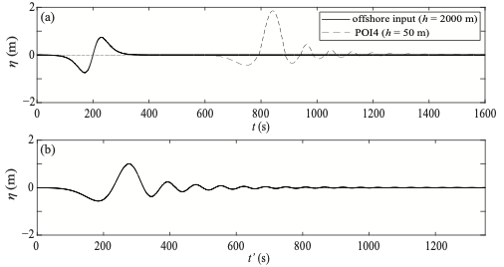
Figure 1: A description of the figure in Times New Roman, 11 points font, centred.

Referencing should follow Harvard referencing style, for example Ruffini et al. (2021).

The abstract deadline is the 19th December 2025. Please submit the abstract in Word format via email to ycsec2026@nottingham.ac.uk. There is no fee for submission of an abstract, but if you do not register and pay the outstanding registration fee in full by the deadline of the 6th March 2026, the abstract will not appear in the conference programme.

You will be informed of acceptance of your abstract by mid-January 2026, with confirmation as to whether it is accepted for oral or poster presentation. We will confirm the format of oral presentations in due course.

The length limit for your abstract is one page. Abstracts that do not meet these formatting requirements will be returned.

Ruffini, G., Heller, V. and Briganti, R. (2021). Numerical characterisation and efficient prediction of landslide-tsunami propagation over a wide range of idealised bathymetries. Coastal Engineering 167, 103854.

