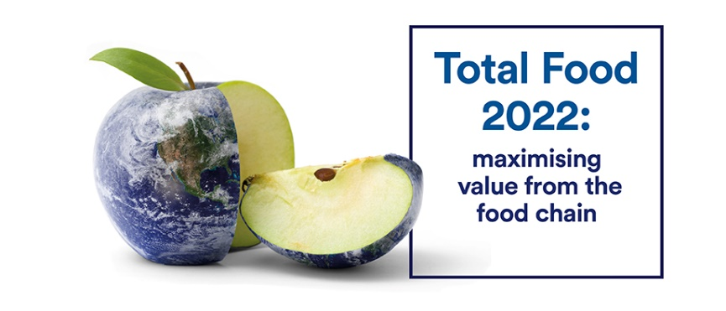

Please send your poster abstract to [totalfood2022@nottingham.ac.uk](mailto:totalfood2022@nottingham.ac.uk). There is only a few poster spaces still available, please submit as soon as you can.

**Poster abstract submission, please indicate type of delegate presenting:**

Student  Academic  Industry

|  |
| --- |
| **Presentation title:** |
|  |
| **Authors & affiliations:** |
|  |
| **Abstract:** No more than 300 words |
|  |