The Nottingham Institute for Research in Visual Culture presents:
21st Century Anxiety
with Prof. WJT Mitchell (University of Chicago)
Thursday 3rd July
Department of Art History, University of Nottingham

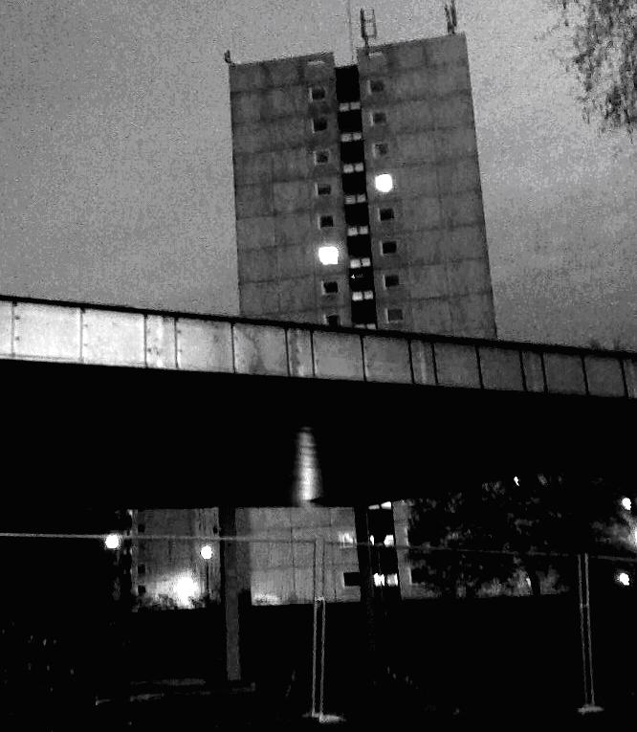
This interdisciplinary conference explores the issue of cultural anxiety in the 21st Century, as represented in contemporary art, photography, film, literature, cyber-culture and architecture. The program aims to highlight how cultural anxieties have been expressed both historically and in the last decade, and explore what the future holds for anxious representations and/or the representation of those anxieties.

We are pleased to present this event as the second part of the three-day contribution of Nottingham Institute for Research in Visual Culture (NIRVC) to WJT Mitchell’s Leverhulme visiting Professorship.

The program will consist of eight diverse papers from internationally-based scholars, and a plenary discussion led by WJT Mitchell. Also featured will be new work by digital film-maker Casper Below.

Session 1 Peter Mörtenböck & Helge Mooshammer (University of Vienna, Goldsmiths)

‘Gunners and Runners: Guidelines for the Design of Terror-Proof Buildings in an Age of Fear’
Fabienne Collignon (University of Glasgow)
‘Silo Psychosis’
Session 2 Tracy Marie Taylor (Columbia College, Chicago)
‘The Painter’s Anxiety in the Age of New Media’
John Rimmer (University of Derby)
‘Division and Subtraction (the digital in painting)’

Sara Andersdotter (Wimbledon College of Art)

‘Choking on the madeleine: issues of the metaphor considered through a practice-led research project’

Session 3 Ignaz Cassar (University of Leeds)
‘Anxieties of the Latent: Liminalities, Trauma and the Politics of Representation in Atom Egoyan’s Ararat’
Mark Goodall & David Robsion (University of Bradford)
‘At the Foot of the Uncanny Valley: the Zombie and Cultural Anxiety’
Tim Martin (De Montfort University, Leicester)
‘Title tbc’
Plenary Discussion with WJT Mitchell (University of Chicago)

Please note: there will be limited places on this day, so please download the appropriate registration form at http://www.nottingham.ac.uk/nirv/ and return as early as possible. Closing for registration is 30th June 4pm.
There is no charge for this event, and therefore lunches will not be provided.

Any enquiries may be directed to either Jennifer Pollard or Suzy Freake at anxiety21@nottingham.ac.uk and further information on the whole program of events is available at http://www.nottingham.ac.uk/nirv/

