Blood and Soil: the politics and poetics of artistic geographies
Lakeside Arts Centre, University of Nottingham
Saturday May 10 2008
(organized by Tania Woloshyn, Postgraduate Research Student,
Department of Art History, University of Nottingham)

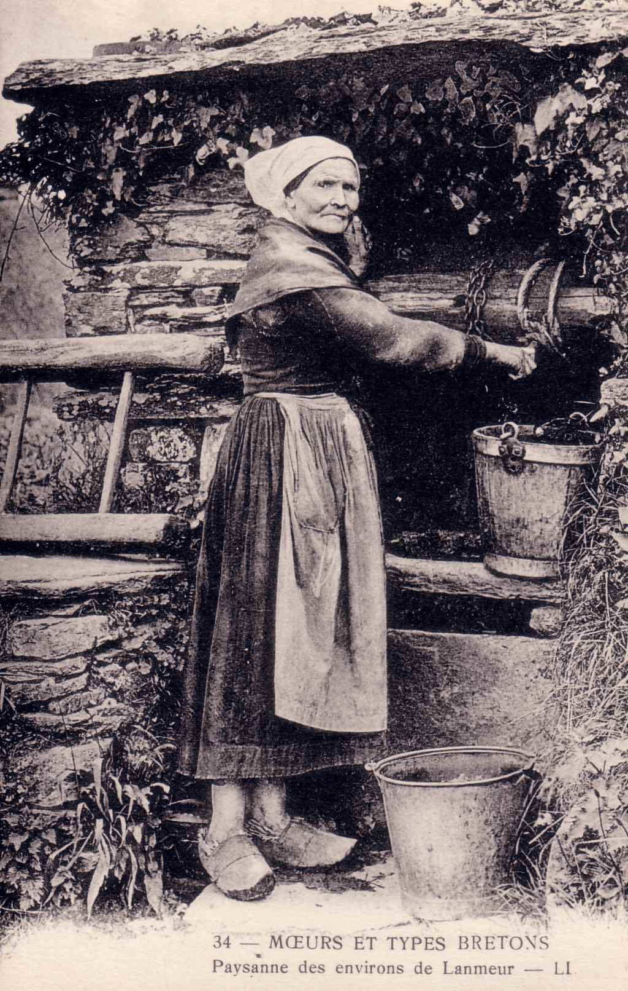

A multidisciplinary, postgraduate conference being organised through the department of Art History at the University of Nottingham on themes relating to the artistic experience of landscape. Throughout history indigenous populations have been attributed to having an intrinsic, profound connection to their land; subsequently their local artists have been projected as authentic producers. However, the visiting artist, by way of education, heightened sensitivity, and even racial superiority, has been considered at an advantage to capture a true rendering of a terrain and its inhabitants. Race and heritage – blood and soil – are essential concepts that not only inform the validation of landscape production by a network of art historians, cultural aesthetes and critics, but also perpetuate affluent tourist industries.
Timetable Booking form
Further information from: Tania Woloshyn, Department of Art History, email: adxtw@nottingham.ac.uk or Liz Jennings, Conference Secretary, email: elizabeth.jennings@nottingham.ac.uk. Department of Art History, Lakeside Arts Centre, University of Nottingham, Nottingham, NG7 2RD Tel: +44 (0)115 846 7779 Fax +44 (0)115 846 7778

