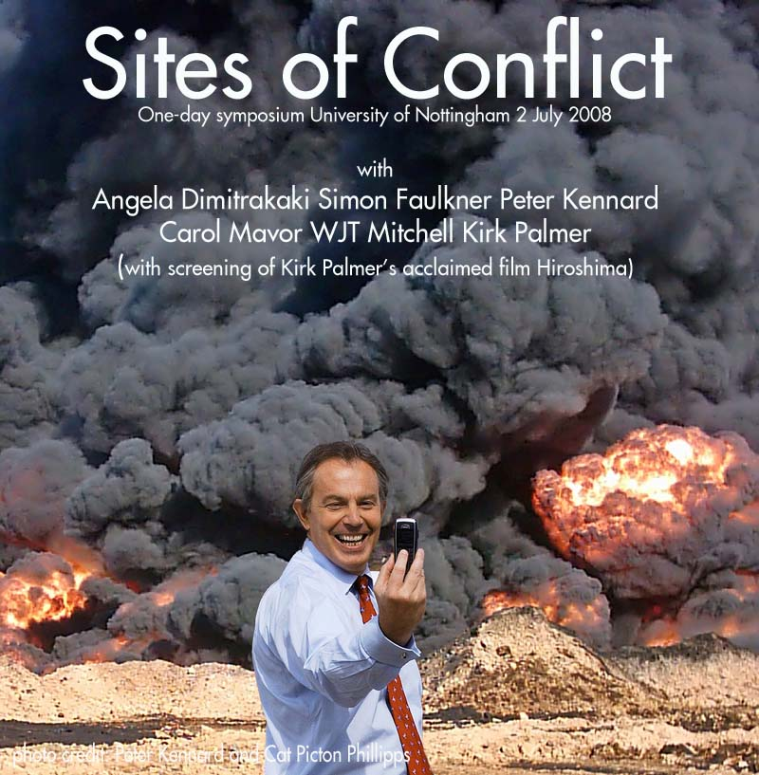

Symposium will start at 11.00am and finish by 5.00pm
Venue: Art History Lecture Theatre (A30) Lakeside Arts Centre
For further information please contact: mark.rawlinson@nottingham.ac.uk
To book a (free) place contact: elizabeth.jennings@nottingham.ac.uk

11.00 Introduction to symposium

11.10 Professor W.J.T. Mitchell
(Visiting Leverhulme Professor, University of Nottingham)
Gilo’s Wall and Christo’s Gates

11.50 Dr. Angela Dimitrakaki (University of Edinburgh)
Art and Labour Today: On the Globalisation of Discontent

12.30 Response/Discussion – Janice Kerbel/Janice Misurell-Mitchell

1.00 LUNCH (can be obtained from Café L in the Arts Centre)

2.00 Peter Kennard
War on War

2.40 Simon Faulkner (University of Manchester)
Painting the Words of the Occupation

3.20 Discussion – chair Mark Rawlinson

3.40 TEA/COFFEE

4.00 Screening of Hiroshima by Kirk Palmer
Followed by Kirk Palmer in conversation with
Carol Mavor (University of Manchester)
Chair Simon Baker

5.00 Symposium ends

