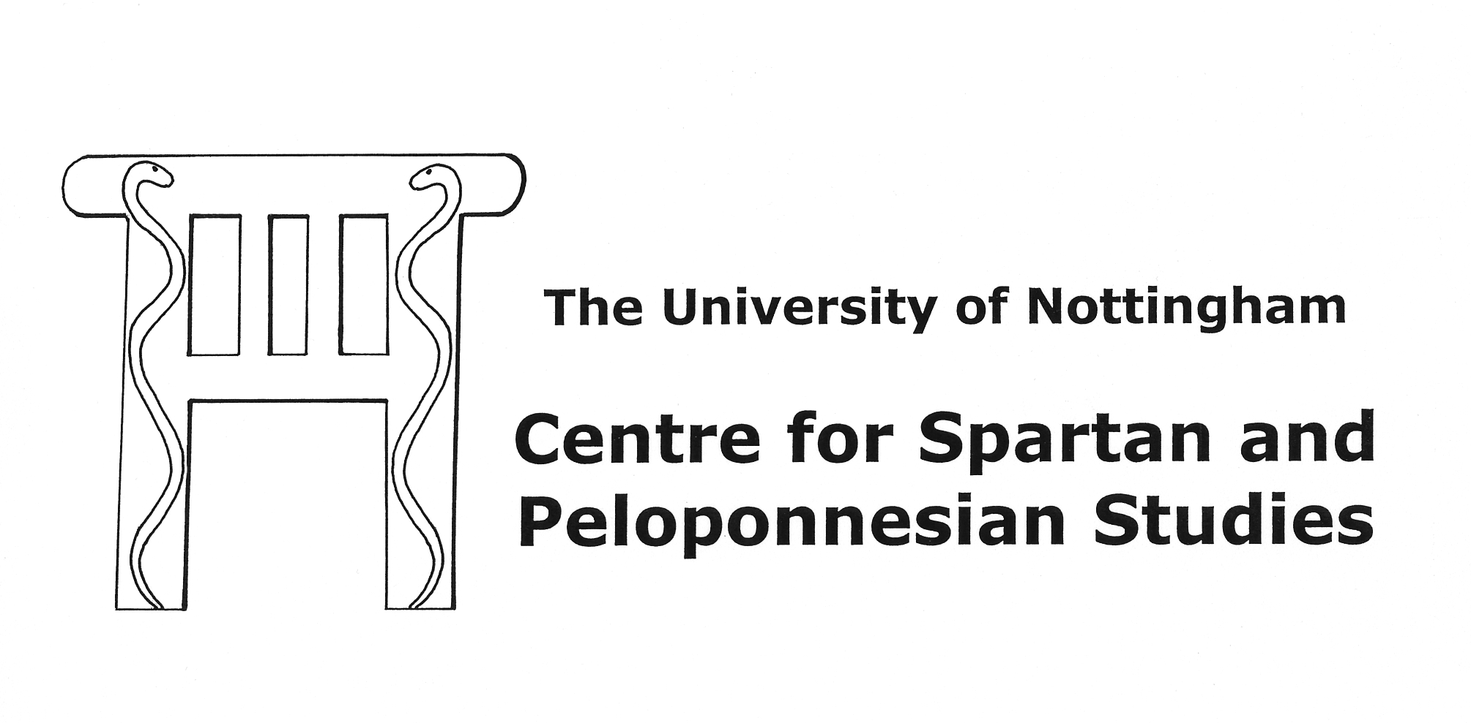
REGISTRATION FORM

2nd CSPS Postgraduate and Early Career Conference
‘Conflict in the Peloponnese: Social, Military, and Intellectual’
22nd - 24th of March 2013

1. Participants information
Name: Title:

Affiliation:

Address:

Postal/Zip code: City:

Country:

Telephone: Email:

2. Instructions to attendees:

All events, but the dinners, will take place in the Humanities Building, University of Nottingham, University Park Campus, Nottingham, NG7 2RD. The dinners will take place in the centre of Nottingham. For further details of travel and accommodation see the CSPS website at www.nottingham.ac.uk/csps.
3. Attendance (admittance free)
22nd of March [CSPS annual lecture]: attending: YES / NO
I would like to attend the dinner (roughly £20): YES / NO

23th of March: attending: YES / NO
I would like to attend the lunch (free of charge): YES / NO
I would like to attend the dinner (roughly £15): YES / NO

24th of March: attending: YES / NO
I would like to attend the lunch (free of charge): YES / NO

4. Dietary Requirements:

Non-vegetarian / vegetarian / other (please specify):

Special dietary requirements:

5. CSPS Membership:

Would you like to become a CSPS member (admittance free): YES / NO

Return this form completed to: csps@nottingham.ac.uk
Or to by post to: CSPS, c/o Peter Davies,
Humanities B01,
University of Nottingham,
University Park,
Nottingham,
NG7 2RD,
UK

