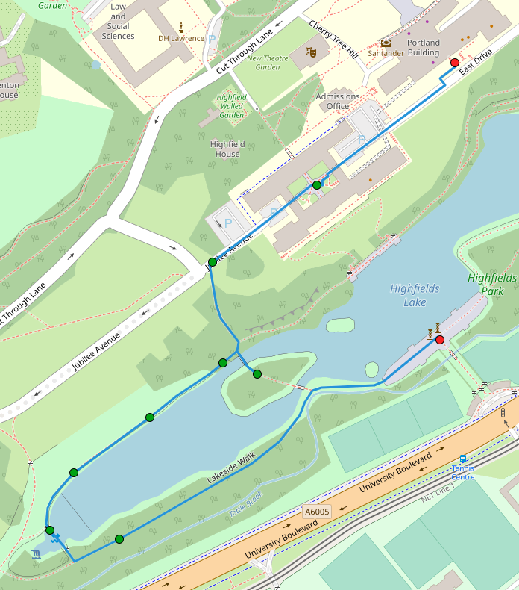
A brief walk, beginning at the Portland Building, leading through the Trent Building, then down to the lake, onto the island, then back around the lake on the north shore, across the stepping stones and round to the University Boulevard pedestrian entrance.
Points for reflection:
- As you set off from the Portland building, be mindful of what you carry with you. What weighs upon your thoughts? If you are with someone as you walk, feel free to share if it feels right.
- As you move down towards the lake, make the decision to set aside those concerns. We do this not out of ignorance, but out of choice – we have recognised and acknowledged them, but in this moment we choose to set them aside. Sometimes easier said then done…
- As you stand on the island, seek to be fully present. Look around you, feel the air on your skin. Here, there is often life, be it squirrels or a variety of birds. Listen to the sounds, and if with someone on this walk, share what you notice.
- As you reach the stepping stones, begin to think about what gives you joy; what do you feel gives you life? Again, if you’re with someone and it feels right to do so, share this.
- Finally, as we move towards the walks end, consider what you have planned over the next few days. Make sure you have set aside space each day to do something that gives you life. If you find yourself unsure of where to find that space, then ask yourself what you can give up in order to do so.
I hope this brief walk will be of help to you.
Grace and Peace - Matt

