Introduction
Toolkit for supporting disabled staff
Guidance on making reasonable adjustments
A guide for staff and managers on the approaches and techniques for making reasonable adjustments for disabled and neurodivergent staff
This guide forms part of the University of Nottingham’s toolkit for supporting disabled staff.
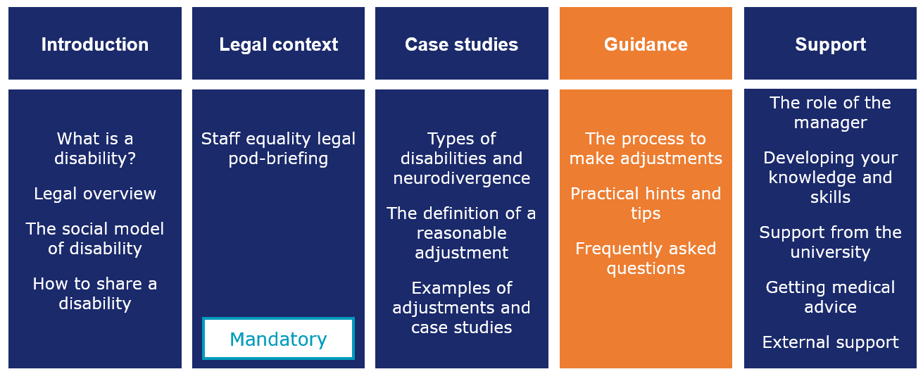
4. Guidance – this component of our toolkit:
- Describes the reasonable adjustment process
- Breaks each process step down and provides useful tips
- Shares helpful questions to steer conversations
- Explores what to do if you can’t agree on adjustments
- Answers frequently asked questions

Contents
The reasonable adjustment process 4
Helpful questions to steer the conversation 14
Top tips for managers of neurodivergent staff 15
What do we do when we can’t agree an adjustment? 17
Getting more support from our toolkit 21

The reasonable adjustment process
Our reasonable adjustment process has five key stages:
1. Identify the need | 2. Prepare | 3. Meet and explore | 4. Agree and act | 5. Review
This process may not necessarily be iterative. You may repeat the same step several times, you may not be able to agree, and circumstances may also prompt you to go back to the start of the process.
Watch this video to find out how a line manager can help a disabled staff member through this process.
This video (along with a transcript) can also be accessed at: Susan Inness – Tips for managers
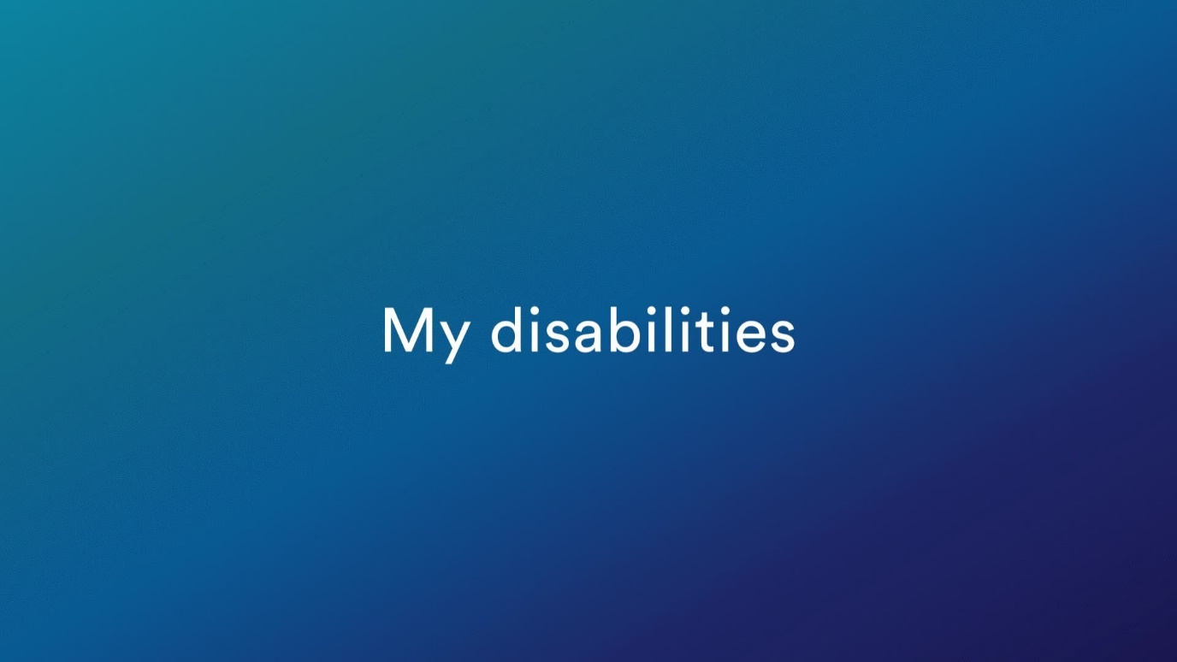
- Identify the need
During recruitment our recruitment services team can guide and advise hiring managers on appropriate adjustments for disabled or neurodivergent applicants.
Recruitment panels will receive mandatory training which will outline their responsibilities in ensuring disabled applicants are treated fairly throughout the recruitment process to:
- Avoiding using any shortlisting and selection criteria that may disadvantage or discriminate against disabled applicants
- Use of more inclusive language in job descriptions and advertisements
- Taking active steps to identify and eliminate biases that may have an adverse impact on disabled people during selection (for example, non-verbal bias against tics/poor eye contact/poor delivery at interviews because of a hidden disability)
- Avoid using discriminatory interview questions and proper use of probing to help those who struggle with interview situations because of a disability
- Ensuring selection decisions are made on merit, against the job criteria and that health or disability status does not have any bearing on this decision
- Choosing and designing selection activities that do not disadvantage or discriminate against disabled candidates
- Avoid discriminating during the deliberation process (e.g. health status impacting on the decision to appoint)
Applicants are invited to tell us about their disability or condition in their application and if they are offered a job, we ask them to complete an occupational health questionnaire which may also flag a condition requiring support. Our occupational health provider will highlight this and provide support.
During onboarding, where a manager is made aware of the need for reasonable adjustments they should:
- Arrange to speak with a new staff member as soon as they accept a job offer to explore what adjustments they may need and agree a plan
- Arrange for a PEEP form (Personal Emergency Evacuation Plan) to be undertaken (if required)
- Arrange for the new staff member to complete their online DSE assessment and contact their local DSE assessor should they require additional support/reasonable adjustments.
- Remember the staff member needs to contact Access to Work, if needed, within six weeks of starting their new role!
- Help them understand their role and the university so that they can suggest helpful adjustments
- If adjustments are required, try to ensure that they are in place for when they start work
- Discuss and agree what information will be shared with other members of the team to remove barriers and prejudice and ensure adequate understanding and support i.e. the nature of the condition, how it affects the individual and agreed adjustments
During employment we encourage disabled and neurodivergent staff to tell us about their disability using MyView. We also encourage staff to discuss their condition with their manager and explore adjustments that could be made or support they require.
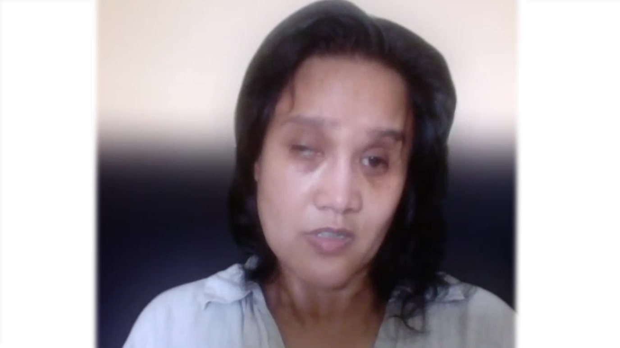
Recently disabled staff may be less likely to understand their long-term requirements and may take some time to come to terms with their diagnosis. Managers may have to keep the adjustments and the person’s progress under closer and more regular review in this initial phase.
This video (along with a transcript) can also be accessed at: Susan Inness: Accepting my disability

- Prepare
Once a staff member has shared information about their disability or condition then managers are encouraged to:
- Schedule some time to discuss this with the employee
- Explain that this meeting is an informal meeting
- Consider using a reasonable adjustment passport to structure the conversation and record any agreed adjustments
- Ask them if they would like a companion, carer or colleague
- Consider visiting remote/virtual workers to hold a conversation in person
- Arrange for the conversation to happen in a quiet place
- Review our disability toolkit to prepare for conversations
- Complete any training flagged by the disability toolkit
- Conduct research using the links in our disability toolkit
- Consult with HR or occupational health if they need specific guidance or advice
- Research the condition to better understand this but be careful not to make assumptions based on this research!
Irrespective of the number of conversations held, the manager must ensure confidentiality and reassure the staff member that they will be empathic and supportive throughout.

- Meet and explore
Managers should meet with staff to explore the reasonable adjustments required from the beginning of and during employment especially where a disabled or neurodivergent person has a long term or progressive condition.
The reasonable adjustment passport is a useful tool for managers and staff to use when discussing, agreeing and recording reasonable adjustments. The purpose of the passport is to ensure there is a clear record of the agreed adjustments, and to act as a template for conversations about current and future adjustments.
The discussion between the disabled or neurodivergent person and their manager is therefore critical, and managers should try to follow these principles to promote openness and build trust.
Managers need to use the following key skills to discuss reasonable adjustments with disabled or neurodivergent staff:
- Be open and available
- Give the employee space to talk
- Avoid interruptions and switch off phones
- Ask simple and non-judgmental open questions such as what, how, when, tell me
- Avoid asking why since this might make the person feel like they’re being interrogated
- Speak calmly
- Maintain good eye contact (but be sensitive to neurodiverse individuals who may find this uncomfortable)
- Listen actively and carefully
- Encourage the employee to talk
- Show empathy and understanding
- Be prepared for some silences and be patient
- Seek advice if you need to
Managers may also consider the following tips to encourage productive and supportive conversations:
- Focus on the person and their needs
- Avoid making assumptions or being prescriptive
- Remember many people can manage their condition and perform well in their role without any adjustments
- Remember every disabled or neurodivergent person’s experience is different, and how you respond should be entirely dependent on the individual
- Try to understand the employee’s experiences and how their disability impacts on them inside and outside of work
- Be sensitive, some diagnoses are long term or potentially terminal and can be hugely distressing
- Only discuss an employee’s condition or adjustment with the team if the disabled or neurodivergent staff member has agreed to this. It’s not always necessary to disclose the reason for the adjustment (i.e. the nature of the disability) to the rest of the team
- Treat the discussion as confidential and sensitive
- Be sensitive to the fact that a disabled or neurodivergent team member may not initially want to discuss their disability or may not wish other members of the team to know about their disability
- Consider contacting your (Local) Business Unit Health and Safety Coordinator to get support to do a risk assessment if a disabled person is working from home for long periods or shielding
- If you feel the adjustments suggested aren’t reasonable or you’re just not sure, then contact HR for advice
Disabled members of staff can follow these tips to get the most out of these conversations:
- Review the university’s staff disability web page
- Share their experience so far here at the university and elsewhere
- Share how your disability affects you at work – consider the requirements of the job, which elements you find easy, and which are more challenging because of your disability. Think about what would help you to be able to fully perform in the role.
- Share any ideas of how you can be supported to work best, in the form of work practices or adjustments
- Discuss how any adjustments agreed are communicated to the rest of the team, if they are communicated at all
- Share any upcoming circumstances which might change the way you work and any support you might need
- Agree how often you would like to check in with your manager to discuss support and adjustments at work, and what form you would like these discussions to take

- Agree and act
Managers may also consider the following tips to agree a plan and put it in place:
- Keep a record of the plan showing what adjustments will be made and by when and include when the plan will be reviewed. This could be a simple email, or you can download and use the reasonable adjustment passport as a live record.
- Do not discuss a person’s condition or disability with anyone else until you have agreed with the staff member what information can be shared and with whom. If adjustments are made, it is not always necessary to disclose the reason for the adjustment (i.e. the nature of the disability) to the rest of the team
- Be guided by the discussion you have with the disabled employee around how they would like any agreed adjustments to be communicated to the rest of the team, or if they should be communicated at all
- In some cases, adjustments may change some elements of work for other team members, for instance the provision of training which they are required to attend, or changes to work schedules and responsibilities. There may be instances where you are required to mediate between the differing needs of team members.
- Consider training and coaching, both for you and your team to help everyone understand more about disability and how they can support their disabled colleague. Training and other support available is outlined in our toolkit for supporting disabled staff.
- Many adjustments are quick to make and low cost. Others may take time to implement. It is important to keep the staff member updated on progress and any delays
- Give the employee ample time to get used to the agreed adjustments. Learning to use new equipment or software for example, takes time!

- Review
It is important to review agreed adjustments periodically to ensure they are still appropriate and identify and agree any further reasonable adjustments required. This is especially important for disabled staff:
- Who have progressive conditions
- Who are undergoing treatment
- After a period of absence
Managers should be as proactive and supportive as possible so disabled staff feel they can approach their manager at any time if they are having difficulties, even outside of formal review meetings.
Managers may consider the following tips to review reasonable adjustments:
- Consider how new initiatives/ways of working will impact on a disabled or neurodivergent employee
- Take reasonable adjustments into account as new situations emerge
- Explore the impact of any proposed change and the options available before making any changes
- Do not make assumptions on the employee’s capability to undertake certain duties. Explore the task with them to ensure they feel able to carry it out and ask them what support they need to do so

Helpful questions to steer the conversation

Build rapport …
Have you seen our toolkit for supporting disabled staff?
How might/does your condition impact on you in your job?
Tell me about adjustments that have worked for you before?

Agree the plan …
What support do you think you might need?
How feasible do you think it would be to do this here?
When might we start?
Would you or anyone in the team need any extra training?
Might we be able to secure funding through Access to Work?
What other sources of support could we consider?
Would you like to use a reasonable adjustment passport to record any adjustments?

Implement and review the plan …
When should we next review these adjustments?
How often should we review them?
Do we need to discuss any adjustments with the team? How?
When might we do this?
How would you like us to record our action plan?
When should we review it?

Top tips for managers of neurodivergent staff
Neurodivergent staff may not have been formally diagnosed but may benefit from adjustments to help them perform and thrive in their role.
It is important that managers discuss the needs of their staff member to explore and understand the challenges they face and their ideas to remove any barriers.
A manager may observe or be informed of behaviour of their staff member which impacts on performance or the dynamics in the team and the manager should:
- Observe carefully
- Speak with the staff member in private during a 1:1 (make sure this is a quiet place) to discuss WHAT they have observed
- Take time to give the staff member feedback on what they and others see
- Discuss their behaviour to help the staff member understand the impact on others
- Ask the staff member if they recognise their behaviour and the impact it has
- Ask the staff member how they feel where they work now
- Ask the staff member if they have a sensitivity to noise/light/smell
- Ask the staff member what changes could be made to improve things
- Listen carefully and attentively, repeat back to the staff member the key points
- Observe the ’10 second rule’ where you speak in short bursts and then give the staff member time to process what you’ve said
- Put requests/agreed plans in writing so it is clear, and the staff member can refer to it
- Some neurodivergent staff may struggle to make or maintain eye contact. This doesn’t necessarily mean that that are not listening
- Summarise what you’ve discussed and agreed
- Consider offering noise cancelling headphones (sound) or move the staff member to another quieter or less bright location
- Act on the suggested changes and agree to review this (agree a date)
- Explore whether the employee would like to record any agreed actions in a reasonable adjustment passport
Managers may also need to communicate slightly differently with some disabled or neurodivergent staff when agreeing and reviewing the completion of tasks.
Following the discussion, if the observed behaviours continue and the employee does not share any underlying reason then we encourage the manager to contact hr@nottingham.ac.uk to discuss this in more detail.

What do we do when we can’t agree an adjustment?
Sometimes a disabled or neurodivergent person may not need any adjustments. Even if this is the case, knowing that their manager understands and is supportive in case things change is incredibly helpful.
We encourage managers and staff to explore all the support available to them in these circumstances. Our toolkit for supporting disabled staff lists many sources of support.
In rare circumstances the manager and staff member may not be able to identify or agree reasonable adjustments which will reduce or remove barriers for the staff member. This may then require a change to the current job or for the disabled person to consider taking a different job if a vacancy is available.

Change the current job
The employer should always consider if changes could be made to the current job to allow them to continue working. Managers should discuss with the employee what kind of job changes might be appropriate and what their preferences would be.
For example, a change may involve reallocating some of the disabled employee's duties to others. This might be feasible where the employee's impairment affects only the minor or occasional duties of the job.
Managers must consider the impact on other employees of taking on additional duties, so it would be advisable to:
- Seek medical advice concerning the employee's ability to do the job
- Consult other employees whose job duties or workload might be affected by any proposed adjustments to the disabled employee's duties – remember to get the disabled employee’s consent first!
Ensure staff are aware that employers are obliged by law to take reasonable steps to accommodate the needs of disabled employees and encourage them to take a positive attitude towards supporting the employee who has become disabled
Take account of any reasonable objections that the employee's colleagues have before making any final decision on what adjustments to make to the employee's job duties

Find an alternative job
The staff member may benefit from moving to another job if a vacancy is available.
This would depend on whether the alternative job is reasonable for the employee to do and whether they are willing to do it (after necessary training).
It may also be reasonable for the university to exempt a disabled employee from any internal procedures usually applied to internal transfers, for example a requirement to undergo a competitive interview or rigorous selection test.
In these circumstances, the university does not have to maintain the employee's existing level of pay or conditions, although the university will need to obtain the employee’s agreement to the transfer itself and to any contractual changes. It is important to discuss this in detail.
As well as providing required training and a full induction, it may be wise to offer a trial period in the new job to assess whether the employee has found the new job to be a reasonable adjustment.
Our redundancy and redeployment guides can provide more information. Contact hr@nottingham.ac.uk to discuss this in more detail.

Frequently asked questions
Q The staff member doesn’t seem keen to discuss their disability with me
A Consider why this might be. Explain that you are there to provide support
Q I suspect that my team member may be on the autistic spectrum, but they haven’t ever been diagnosed. How should I manage this?
A Managers are not qualified to diagnose neurodivergent conditions and should always discuss what they see (behaviour) and the impact this has. The manager’s role is to provide feedback and offer support
Q My staff member has contacted Access to Work but they haven’t responded. Should we still explore what the university can do to help, or do we just wait?
A It is always wise to explore all options open to you
Q As a manager I’m not sure if the adjustments my team member is suggesting are reasonable. How do I get advice?
A You can contact hr@nottingham.ac.uk to get advice
Q My team member has recently been diagnosed with a condition that may be a disability and I am not clear on what adjustments might help them. How can we get support?
A Our toolkit (support section) provides links to charities and organisations that specialise in providing guidance and support on a wide range of conditions. If the condition you are discussing is not listed, then a quick internet search may help. Managers can make a referral to our occupational health provider to seek guidance on reasonable adjustments.
Q Is there a formal way to record reasonable adjustments?
A To support staff and managers in discussing, agreeing and recording reasonable adjustments, the university offers a reasonable adjustment passport. This is an optional tool which acts as a live record of adjustments agreed between the staff member and their line manager.
Q The disabled team member and I have agreed some adjustments, but the team member does not wish to share their disability with the team. What should I do?
A You should always respect their request for privacy. If they ask for their condition and associated adjustments to be confidential then you must not share this with the team.
Q We have requested some support from (IT/Estates) but this is taking a while to happen and is impacting on the performance of my team member. What should I do?
A Chase up the request with the service desk or service manager.
Q The staff member would benefit from some adjustments which will be noticeable to or impact on the team, but they don’t want me to discuss this with them. How should I manage this?
A You should always respect their request for confidentiality. If asked by team members, you could respond along the following lines: ‘There are good reasons why some adjustments might need to be made. However, I’m unable to discuss the details with you as this information is confidential.’

Getting more support from our toolkit
This guide forms part of the University of Nottingham’s toolkit for supporting disabled staff.
Click here to access the full toolkit.
Please contact hr@nottingham.ac.uk for further guidance and support.
- End -

