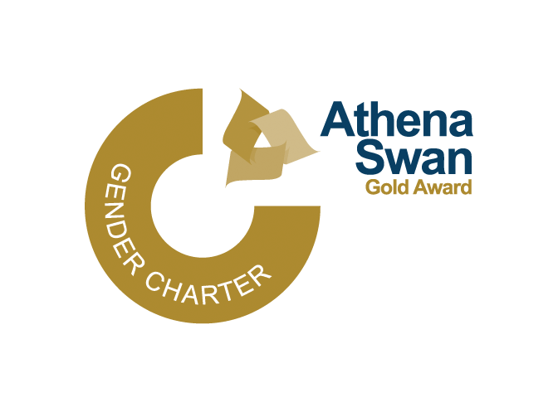
Athena Swan Gold Action Plan: Additional Reproductive and Gynaecological Health Actions

As part of our EDI Priorities in 2023/24 we committed to:

(2.3) Reproductive and gynaecological health awareness
We will work with colleagues across the university to bring together a package of support materials focusing on health and wellbeing.

During 2023/24 we worked to create a reproductive and gynaecological action plan (more details about this process are available in our EDI Annual Report 2023/24 (see page. 24)). The Action Plan was approved by our People and Culture Committee on 27 June 2024 and are Actions that support our Athena Swan Gold Action Plan.

Actions | Person Responsible | Owning Service/Dept | Start Date | End Date | Expected Output/What is the action going to achieve? | Success Criteria
AG09.05.02.01 Champion-style support for reproductive and gynaecological health themes should be considered as part of a wider review of how champion roles support projects such as our staff wellbeing and mental health strategy. | Organisational Development Adviser  Organisational Development Manager | HR | Dec-24 | Apr-25 | As part of a wider review of champion roles, it should be determined whether there is a useful place for specific champions aligned with reproductive and gynaecological health, whether there is scope for such ‘championing’ to be built into existing roles, or whether an alternative way to embed support is likely to prove more effective. | Staff report understanding who/where they can go to for support and guidance
AG09.05.02.02 HR to provide stronger support for the Women’s Staff Network on communications around menopause and menstruation cafés. | EDI Manager | HR | Apr-24 | Apr-25 | Support provided from HR to staff networks to better embed comms around menopause and menstruation cafés | Increased awareness of and engagement with Menopause and Menstruation cafés.
AG09.05.02.03 Include case studies or content relating to gynaecological and reproductive health at career progression workshops series including representation from all staff networks. | Learning and Development Manager  Talent Manager  EDI Adviser | HR | Sep-24 | Sep-25 | Staff invited to share their journeys as part of this training include individuals with case studies that touch on reproductive and gynaecological health issues. | Positive feedback from participants.
AG09.05.02.04 All gynaecological and reproductive health-related policies and guidance should have a compassionate tone, easy navigation and simple jargon-free language, focused on providing accessible support to staff who may be experiencing challenges. Review of leave policies. | HR Policy Manager | HR | Sep-25 | May-26 | Updated leave policies. | Positive feedback from staff.
AG09.05.02.05 All policies and guidance documentation should have a clear process diagram which summarises key points and should identify key roles and responsibilities including support for staff members. | HR Policy Manager | HR | Aug-23 | May-26 | All relevant policies have a clear process diagram. | Staff feedback indicates that processes are better understood/clearer.
AG09.05.02.06 – Communicate our new policies. | HR Policy Manager | HR | Aug-23 | May-26 | Production of a comms plan, evidence of inclusion. | Increased engagement with resources (e.g. number of visits to SharePoint page before and after comms).
AG09.05.02.07 Diversity in the experience of menopause should be amplified in the current guidance including case studies that have a wider reaching audience e.g. trans community, minoritised groups. | EDI Manager  EDI Adviser | HR | May-25 | TBC | Diverse experience represented in policies | Confirmed by feedback from staff networks.
AG09.05.02.08 Current gynaecological and reproductive training and informative resources to be reviewed and compiled with clear, compassionate, signposting from an accessible and visible central point at the point of need. | Organisational Development Adviser | HR | Dec-24 | Jul-25 | Creation of a reproductive and gynaecological health resource hub. | Engagement levels, positive feedback
AG09.05.02.09 Case studies and the language used in relevant gynaecological and reproductive health-related policies and guidance should recognise intersectionality; for example, use language that explicitly mentions e.g. LGBTQIA+ staff are more likely to need fertility support than heterosexual and cisgender staff, black women have poorer pregnancy outcomes than staff from other ethnicities, etc; men may be less likely to disclose fertility issues, etc. | HR Policy Manager  EDI Manager | HR | Jun-25 | Jan-26 | Diverse experience represented in policies | Engagement levels, positive feedback
AG09.05.02.10 Gaps should be identified, and internal expertise should be sought to develop gynaecological and reproductive health learning resources rather than drawing on external agencies wherever possible. | Learning & Development Manager | HR | Sep-24 | Jul-25 | Production of resources co-developed with internal experts. | Engagement with resources, potentially sharing of resources beyond UoN
AG09.05.02.11 Identify key opportunities to normalise conversations around reproductive and gynaecological health through embedding relevant examples and intersectional case studies in broader leadership and management training. Once integrated into existing training, ensure these examples and case studies are embedded in future training developed as business as usual. | Learning & Development Manager/  Organisation Development Manager | HR |  |  | Examples embedded in relevant training materials. | Positive feedback from participants.
AG09.05.02.12 Agree which Awareness Raising Dates around Gynaecological and Reproductive Health will be marked, celebrated and honoured at the university, and include them in the Comms Plan. | EDI Manager | HR |  |  | Celebration days marked in a meaningful way – e.g. building light up, comms, events etc | Engagement and feedback captured, especially from relevant staff networks
AG09.05.02.13 Develop a strand of an institutional EDI communication plan that allows for regular reminders of resources and support available, particularly staff networks. | EDI Manager  EDI Administrator | HR | Apr-24 | Apr-24 | Production of a comms plan with regular reminders and awareness raising of staff networks. | Membership of staff networks. Increased engagement with staff network activity.
AG09.05.02.14 Include relevant information in induction and/or central induction days. | Organisational Development Manager  Staff & Educational Development Officer | HR | Sep-24 | Sep-24 | Evidence of inclusion of relevant topics (e.g. slides/briefing documents/handbooks). | Positive feedback from attendees/participants.

For more information on any gender equality work, please contact:
Rachel Van Krimpen, Faculty Director for Equality, Diversity, & Inclusion and People, Gender Equality Co-Theme lead
rachel.vankrimpen@nottingham.ac.uk

Precious Taylor, Equality, Diversity and Inclusion Manager, Gender Equality Co-Theme Lead
precious.taylor@nottingham.ac.uk

For more information on Athena Swan, please contact:
Dr Tamsin Majerus, Athena Swan Lead for the University of Nottingham
tamsin.majerus@nottingham.ac.uk

