ANNEX 2 Personal Profiling Service
Author: Peter Rees Jones | Version: 1a
Date: 2006 07 14 | Status: Final
Intended audience: | e-Framework specialists; e-Portfolio developers; HE and HR practitioners interested in student/staff recruitment/selection; potential bidders for the JISC ITT for studies on good practice and technology-supported approaches in recruitment and admissions

1 Service Genre Name: Personal Profiling
Classification: An e-Portfolio enabled service
Area: e-administration (especially within the HE admissions and HR recruitment domains)
e-learning (especially within Personal Development service flows in FE college and HEIs) including continuing professional and vocational development in employment.
Product/Process: A service, quality assured for equal opportunities, by which an individual may produce a profile of themselves in terms of a pre-defined set of requirements typically within a process for application to education or employment.
Comment: This formal e-administration / e-learning service is related to informal collaborative services supporting, for example the development of a personal profile for foaf, the focus of the JISC Chimera project and is functionally similar to developing a profile for a dating service such as Faceparty. The Personal Profiling Service is distinguished by the formal criteria which form the terms in which the profile is developed and against which it is formally assessed.

1.1 Purpose of the Service Genre
Historically applicants for a job, a traineeship or place at university were asked to provide a letter of application or personal statement for which no predefined structure was provided. As monitoring for gender, ethnic, religious and other forms of direct and indirect discrimination increased it became clear that this approach was open to unconscious bias. As Human Resource Management became increasingly professional the essential and desirable attributes of an employee for each job or role were stated explicitly. Applicants for employment are increasingly asked to state how they match the criteria against which they are assessed.
As part of the professionalisation of HE admissions UCAS has encouraged HEI’s to provide similar course entry profiles for applicants to HE. In September 2005 65% of HEIs provided profiles with a target of 100% in 2008 / 09. A structured personal statement to help applicants make active use of course entry profiles was proposed by the University of Nottingham and endorsed by the Schwartz Enquiry into HE admissions:
“The JISC project ‘Specifying an e-portfolio: enhanced learner information for flexible admissions and transitions into higher education’ is reviewing how admissions staff use information and evidence. The project aims to make information and evidence available in an accessible electronic form that can be customised to support the admissions process and give feedback to the applicant. The project is specifically examining the potential of entry criteria and course information to structure the personal statement. This would allow academic staff to set prompts for their own courses. UCAS and other admissions services should also consider the inclusion of additional information to produce a fuller transcript of applicants’ achievement. A more informative application form may in itself reduce the need for additional testing”
(p. 47; E9)
Schwartz recommended: “Structuring the Personal Statement and Reference, especially through the insertion of course specific prompts.”
(p. 45; E5; bullet point 4)
The Service Expressions address this process. This description of the Service Genre provides the abstract model which the Service Expressions instantiate.

1.2 Scope of the Service Genre
The following diagram uses quality management conventions:
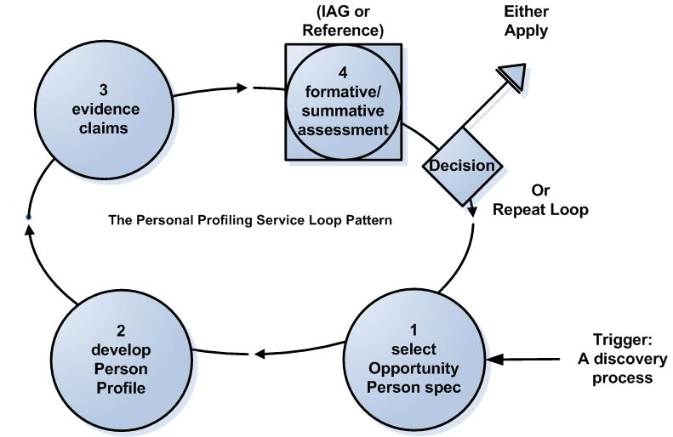

Generic Use Case 1
The trigger for the use of the service is typically the use of a discovery service.
1 The applicant selects a template with a profile of an opportunity, that is the set of requirements that a person should match to be eligible for a particular opportunity, for example a person specification for a job or a course entry profile for a university place;
2 The potential applicant creates a profile of themselves by populating a template with assertions and activities from their e-Portfolio;
3 Assists the applicant creates a profile of themselves by linking to evidence of assertions within their e-Portfolio;
4 A supporter of the applicant comments on the Personal Profile.
There is no logical difference between a Presentational e-Portfolio which is assessed for entry to employment or education, such as a Personal Statement, and an Assessment e-Portfolio for a formal examination. A Transition e-Portfolio may contain the Presentational e-Portfolio but may also contain personal materials from a Learning e-Portfolio which are private to the learner, not used in the application process but which may be used at the learner’s discretion in the new episode of education or employment.
A functional specification of the web services demonstrating this service will be available in September 2006.

1.3 Addressing the needs of the e-Framework
- Consultants for Becta have concluded that Transition e-Portfolio is mature enough to be implemented in the short and medium term. This Service Genre specifically expresses an important service for transition.
- e-administration The need to quality assure Fair Admissions to HE, a high priority for HEIs and Government, identifies the relationship with other Reference Models and scopes further areas where new Reference Models should be developed. On one level it therefore belongs within the e-administration domain.
- e-learning The Service Genre also belongs within e-learning. The standard pattern falls within the Personal Development domain. At the end of the MLEs for Lifelong Learning Programme the Centre for Recording Achievement was asked to scope a Reference Model for Personal Development Planning (PDP) but believed that, given the diversity of practice this was not practicable. A specific intention of the project was to bring the PDP domain within the e-Framework.
The Personal Statement Reference Model suggests that web services developed for one type of service (e.g. summative assessment in an administrative context) may be re-used for another (e.g. formative assessment in a learning context). This has the potential to transform a student’s experience of learning in all aspects of life by identifying the value of learning beyond formal education. On a technical level the elaboration of a bare web service for use in many contexts has important implications for the cost effective development of ICT tailored to individuals’ needs and preferences and as a basis for the incremental development of de facto and formal standards.
. ‘Proposition 3’
- Feedback The Wilson Review of HE admissions published for consultation in September 2005 recommended the provision of feedback to applicants which the Delivery Partnership will take forward. As with the 11 plus, applicants to HE who are rejected on the basis of summative assessment alone are at high risk of disengaging from learning. The same principle may apply to returners to work or employment or people seeking to develop new skills and college students applying to employment.
Unsuccessful applicants will use feedback to learn from the application in order to identify more appropriate opportunities and / or to match themselves more closely to requirements. The standard Structured Personal Statement pattern may well be elaborated with other web services and services and these may be expected to yield further common patterns.
- Quality Assurance A further area for exploration is the aggregation of feedback to individual applicants for quality assurance by colleges and universities and by national bodies responsible for Fair Admissions to University and equal opportunities in employment. This evidence will be directly relevant to research, including research on personalisation.

1.4 Benefits
  - Make available good practice in HR for the development of analogous quality assured process for Fair Admissions to HE in line with the key policy needs of HEIs and Government.
  - Develop existing practice using Progress File to take advantage of the much greater opportunities offered by e-Portfolio.
  - Provide a basis for the provision of feedback to applicants and for their continuing development as lifelong learners.
  - Define a key aspect of the amorphous term “PDP” more closely.
  - Quantified evidence for research in terms of the requirements set out in the Magenta Book.

Service Expressions

2.1 Personal Profiling Service Expression 1 (e-learning)
The following expression covers the formative use of the service to prepare a potential applicant, as an e-learning service.
Course Entry Profiles are analogous to the Person Specifications widely used by HR and recruitment professionals to score candidates’ profiles. This is a quality assured process designed from an equal opportunities perspective. The service expression follows this established HR pattern and applies it to the analogous process of HE admission
Use Case 2: Formative development of a Structured Personal Statement
- I select a particular course at a particular University. Web service 1 populates a blank template with the Course Entry Profile. Diagram 1:
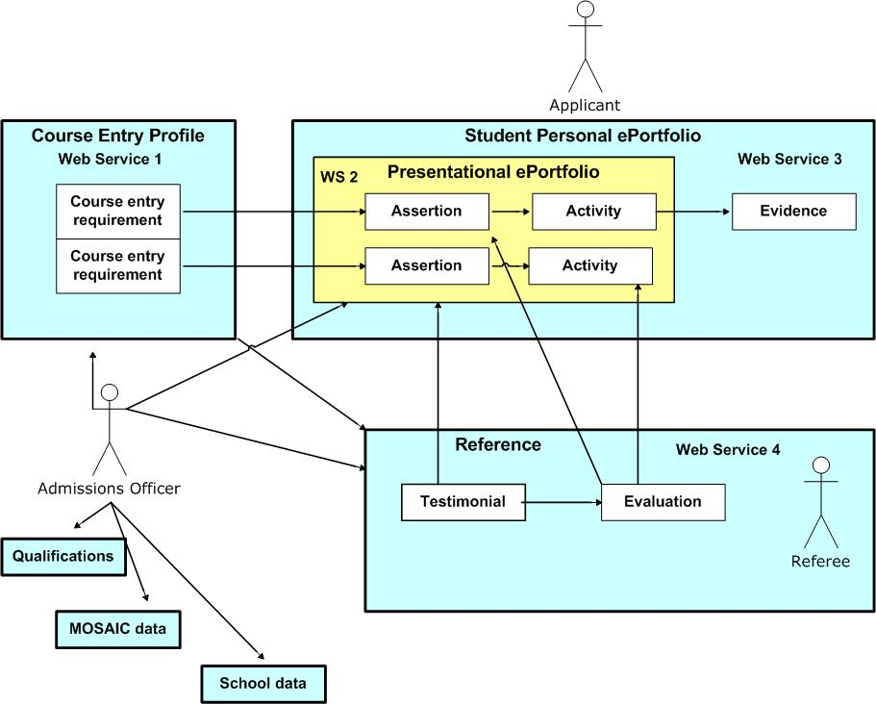
- I draw down material from my personal e-Portfolio into a presentational ePortfolio to make assertions of how my Personal Profile matches the entry profile. (WS2)
- I link assertions and activities to evidence in my personal e-Portfolio (WS3).
- My advisor scores my Personal Profile against the course entry profile and adds comments for us to discuss (WS4) i.e. my advisor formatively assesses my profile.
Note: A functional specification of the web services demonstrating this service expression will be available in September 2006 and the web services will be available for adaptation and re-use.

2.2 Personal Profiling Service Expression 2 (e-administration)
The following expression covers the summative use of the service to make a formal application, as an e-learning service.
Use Case 3: Summative assessment of a Structured Personal Statement
- I discuss with my advisor how well my profile matches the course entry profile (The discussion is supported by an IAG service (a type of Advice and Guidance Service)
- I complete the same steps a-c as for Use Case 1
- But at step d my referee uses WS4 to make a summative assessment commenting on (but not quantifying) the match between my Personal Profile and the course entry profile. My application and the open reference are sent to the target university through UCAS where the admissions officer also takes into account qualifications data (a Learner Achievement Record Service is being specified) and contextual data about my social background (Mosaic) and my school’s performance.

More overleaf

2.3 The HE Admissions Process (e-administration)
Diagram 3 provides an illustrative map of a quality assured centralised e-admissions service. This is not a service proposed for the e-Framework but may help scope such a service.

The development of a Structured Personal Statement for application to HE through UCAS is shown at A. Web services (to be specified) automatically apply social and school weightings to the qualifications and test results. A filter is applied and the most marginal applicants rejected. We follow the long-listed candidates, where the same web service (4) used by the applicant’s advisor and referee is used by a human to score the match of the Personal Profile against the course entry profile.
There is feedback for each of the outcomes with an emphasis in helping unsuccessful applicants identify how to make better and better targeted applications. However, here we track applicants who accept the places offered, through to induction.

2.4 Personal Profiling Service Induction expression (e-learning)
Diagram 4

Use Case 4
Trigger: I have been shortlisted by the HEI, the Personal Profile I have presented in a structured Personal Statement has been scored and used as the basis of feedback to inform me how I match the Course Entry Profile. I am asked to review the feedback in order to prepare for a first meeting with my HE advisor. The feedback is the student’s original application with scores added to his responses to each of the entry criteria and bare comments such as “fails to meet the minimum standard for this criterion”.
- I open the feedback and review the scores and comments made on my text: I have done much better than I expected in some areas, but worse in another area, which was formally below the minimum entry standard, but condoned because of my overall profile.
- I amend the text of the assertions and activities I put in my statement to clarify a couple of issues I think were unclear. I add some comments to cover other issues.
- I now think the evidence I presented gave only half the picture, and I now create new links to other evidence in my college e-Portfolio that clarifies a misunderstanding.
- I send this to my advisor together with some other stuff for induction expecting to use it to plan out my work in the first semester and make a good start to my HE career!

3 An Outline of the HE Admissions Domain

Diagram 5

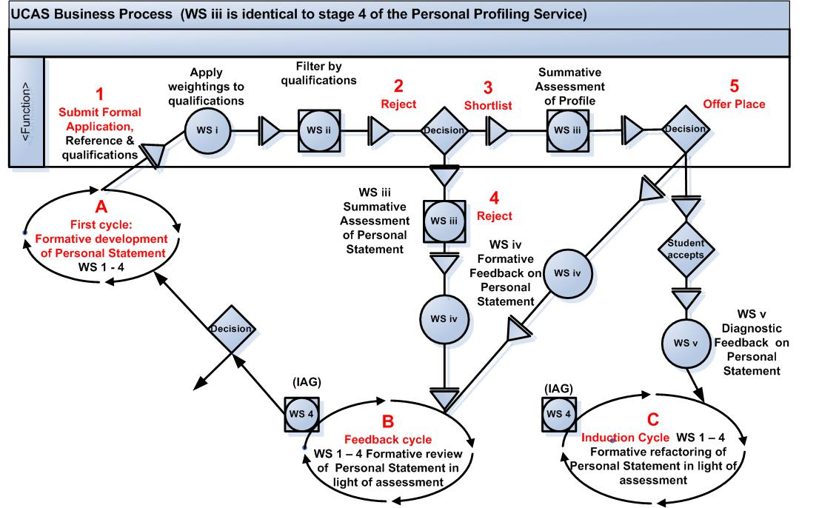

The e-Portfolio Reference Model project has concluded that e-Portfolio is not a service but an application or engine transferring information between the e-Portfolio enabled services used by the learner and the e-Portfolio enabled repositories holding the information over which the learner has control. Further details are set out as ANNEX A to this document. See also 1.6.1 classification
Some functionally similar services may have no relevance to education.
The report is available from http://www.admissions-review.org.uk/

