ANNEX 3 e-Portfolio and HE admissions
Author: Peter Rees Jones | Version: 1a
Date: 2006 07 14 | Status: Final
Intended audience: | This paper is intended for managers, admissions staff IT professionals with a special interest in HE admissions but no prior knowledge of e-Portfolio. For more information on e-Portfolio see Annex 2.

“…this is a really important point; we will have to re-engineer the data so that wherever you are in the education system the individual learner can demonstrate to another institution, an employer, or to a parent, what they have done, how they are succeeding and who they are.”
(Michael Stevenson head of DfES Technical Group January 2006)
“E-portfolios….are personal online spaces for students to access services and store work. They will become ever more useful as learners grow up and start moving between different types of learning and different institutions.”
(Ruth Kelly Secretary of State for Education, January 2006)

What is an e-Portfolio?
In the last century artists kept portfolios of their work, individuals kept commonplace books, photo albums and journals they shared with friends and produced CVs. in France workmen kept livrets containing certificates of their skills and testimonials of customers. e-Portfolio covers this same personal domain. At the same time awarding bodies certified the value of work within a portfolio and individuals drew on journals and diaries to develop their CVs and letters of application. Ownership was not a difficult problem since it was difficult to share these physical artefacts. In the new century it has become easy to transmit information and share these artefacts. It will soon become equally easy to make use of this information by means of web services. Information in an e-Portfolio may be:
- wholly owned by one stakeholder and not accessible to any other stakeholder without the owner’s permission, except under the terms of the Data Protection Act (DPA). This defines the term “ownership”;
- owned by one stakeholder, with another stakeholder having some specific rights over and above the DPA. This defines the term “information rights”;
This information may be held on behalf of a stakeholder by a service provider with no direct interest in the information itself. This defines the term “Stewardship”.
Increasingly students entering University may have a portfolio of artefacts and other information, for example, a learning journal, a set of drawings not submitted for assessment, an assessed project, assessed course work and exam work, a C.V. and transcripts of A2s: -
- the core of the portfolio is wholly owned by the learner (e.g. the learning journal, the set of drawings and the CV)
b1 other information may be owned by the learner with other bodies having some rights over it (e.g. the assessed project and course work) OR
b2 owned by another body with the learner having some rights over it (e.g. the right of a learner to access a transcript setting out their achievement owned by an exam board or university.)
The original Information Model for the HE Progress File was published by QAA in 2001 and implemented by all HEIs by 2005 contained these three types of information. It is proposed that this same model should apply to e-Portfolio. However, unlike an electronic Progress File, the first generation of practice, e-Portfolio will take advantage of the opportunities offered by the web, in particular web services and provide a basis for Lifelong Learning.
In the US there is widespread use of e-Portfolio, including assessed e-Portfolios for personal and professional development. In UK HE the emphasis has been on non assessed e-Portfolios, but in schools and colleges there is an increasing emphasis on e-Portfolios for assessment beyond the art and performance subjects following UCAS route B, for example in the 14-19 Specialised Diplomas being developed by Sector Skills Councils.

Government Policies
In England, DfES are developing proposals for a learning space capable of supporting e-Portfolio to be made available to all students in school and college by 2008. DfES and Becta have reviewed JISC work on e-Portfolio in colleges and universities in order to develop a common approach across sectors. The Schwartz and Wilson reviews of HE admissions have made specific recommendations for the use of e-Portfolio for HE admissions. Many learners in Wales already have access to an e-Portfolio provided by the Assembly Government, focused on careers. Transformation projects in colleges and universities in Scotland have similar themes. All these initiatives seek to establish a basis for lifelong learning and there is an increased emphasis on the link between education and employment.

“The JISC project…. is reviewing how admissions staff use information and evidence. The project aims to make information and evidence available in an accessible electronic form that can be customised to support the admissions process and give feedback to the applicant. The Project is specifically examining the potential of entry criteria and course information to structure the personal statement. This would allow academic staff to set prompts for their own courses….UCAS and other admissions services should also consider the inclusion of additional information to produce a fuller transcript of applicants’ achievement. A more informative application form may in itself reduce the need for additional testing”
(Stephen Schwartz Fair Admissions to higher education: recommendations for good practice p. 48; E9; 2005 09 00)
“There is also much work going on in the sector in relation to the development of e-portfolios, the content of which could include a portfolio of evidence compiled by the student, a developmental CV and a transcript or learner record. This includes work by UCAS and the [JISC] in the area of e-portfolios and online applications, and also development through the British Standards Institution of the technical standard UKLEAP, based on international standards, to support transfer of learner information. Additionally there are links into Europe and the Europass learner record. This type of information, representing an up-to-date collection of a student's achievement, could be used by HEIs to help inform admissions decisions. It could be a particularly useful record for those students not following the traditional A-level or Higher based route into HE.”
(Sir Alan Wilson, consultation on HE admissions; 2005 09 09.)

Customisation of the HE admissions business process
Standard HR practice is to specify the essential and desirable features applicants for a job should possess. This may include quantified information such as formal qualifications alongside applicants’ personal attributes and experience. Typically a sift of written applications identifies and prioritises potential candidates who can be assessed against the same criteria at interview.
The web services for HE admissions are intended to support the same pattern of process. A customised set of requirements including personal attributes would be available for each course. Candidates would map themselves against the requirements. Evidence within a student’s e-Portfolio would further reduce the need for interview. In this scenario:
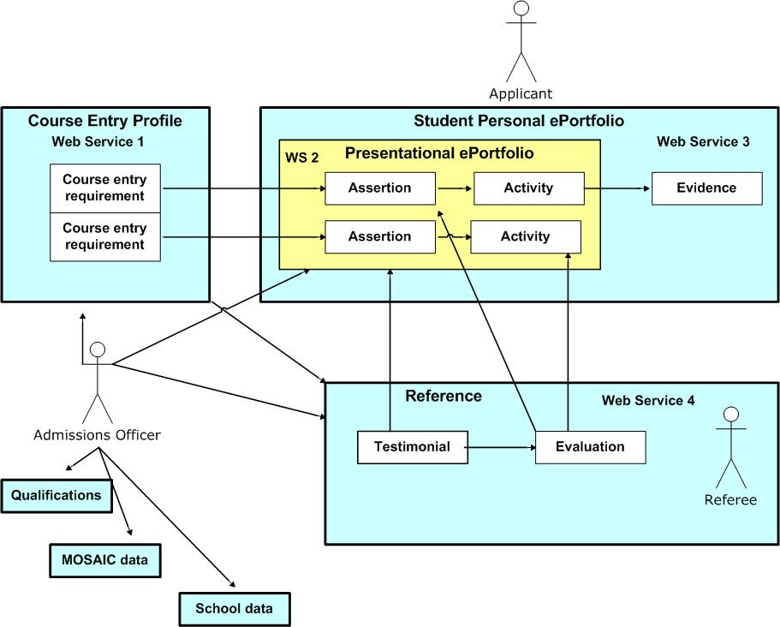
Web Service 1 An applicant selects a particular course at a particular University. The web service populates a blank template with the Course Entry Requirements.
Web Service 2 helps the applicant draw down material from her personal e-Portfolio into the presentational e-Portfolio to make assertions of how she meets the requirements.
Web Service 3 helps the applicant link assertions to evidence in her presentational e-Portfolio
Web Service 4 helps a referee provide a testimonial for the applicant and to evaluate her assertions, linking comments to specific items in the applicant’s presentational e-Portfolio.
Web Service 5 posts to the admissions officer the presentational e-Portfolio, reference and the permissions to access specific evidence within the personal e-Portfolio.
A further set of web services are being specified to enable the admissions officer to make effective use of this richer information at no extra cost in terms of staff time. Around this basic core a range of further services will provide additional support.

Personalisation of HE admissions
This use of e-Portfolio and a Structured Personal Statement has some similarities with the APeL processes by which adult learners without qualifications apply to HE. It allows the evidence of an applicant’s formal qualifications to be balanced against other personal attributes and qualities. It provides a transparent framework within which admissions officers can exercise their judgement and take risks in order to offer life changing opportunities to applicants from non traditional backgrounds. It could also help identify the particular needs of very able students. In both cases a Structured Personal Statement could identify how the standard curriculum should be personalised to meet the needs of the individual.
How may this affect the support the college or other body provides to the potential applicant? What are the implications for HEIs seeking to establish more efficient and effective support and induction to an increasingly diverse range of students in order to minimise drop out?

College support to applicants
The same set of web services for the business process of application to HE could also be used formatively within a college to develop students’ ability to map themselves against course requirements and set themselves challenging but realistic goals. Here a student would map himself against course requirements by completing the Personal Statement and linking to evidence in his e-Portfolio in the same way as the summative assessment scenario in section 2. However, in this formative scenario a coach, rather than a referee, would provide formative feedback to the student rather than a reference. Before reaching this stage, the student might already have followed a similar but simpler diagnostic scenario with a coach helping him confirm if he wished to apply to HE and what subjects he might wish to follow.

Feedback for all applicants
Feedback is of limited use to applicants where success is determined solely on the basis of formal qualifications and tests. Like the 11 plus, if used in isolation these processes can be expected to lead to unsuccessful applicants disengaging from learning. An admission officer’s assessment of a Structured Personal Statement against clear entry requirements could be scored (a common HR practice) and feedback provided to unsuccessful applicants on how they can improve their personal attributes as well as their test performance.
The same principle applies to successful applicants whose profiles fall below the normal thresholds for admission in some areas, for example an entrant to an IT course with below average qualifications in Maths or no experience of IT in employment environments.

Induction to HE
The e-Portfolio Reference Model is identifying the information within the UCAS domain that may provide a starting point for e-Portfolio within HE (the additional private personal information the student may wish to import will also be scoped). A use case for how the new student may introduce herself to her university tutor has been prepared.
Feedback from the admissions process is important here in identifying the issues the new student should address, but the student will also need to map herself against the more detailed and short term requirements of the first semester of the course. This may represent a further scenario in which the web services set out.

Integrative Learning and Web 2.0
Anecdotally, staff enrolling students in college, academic admissions officers and tutors, employers and professional bodies often emphasise that a key indicator of potential is the ability of a learner or employee to assess the quality of their work and apply what they have learned to future work. The use of e-Portfolio: -
- enables a learner to develop the capacity for self evaluation through the integration of formal and informal experience gained in education, work experience or personal life. This also allows a learner to identify his need for further learning to meet further goals.
- requires the learner to make effective use of web technology to identify an integrated profile of herself and present particular aspects of it to particular audiences for particular purposes.
Technology was once seen simply as a tool for delivering the Progress File. By contrast, e-Portfolio is a means by which the learner will develop her ability to make effective use of Web 2.0 and exploit the opportunities for advancement offered by the knowledge economy presently restricted to a small minority of citizens.

Use Case:
The following service flow centres on the review of an Individual Learning Plan (ILP) to support application to HE, following the diagnostic use of a Personal Statement. ILPs are common in UK schools, colleges and some universities. They can help customise learning to the individual; and therefore offer potential for an individual to personalise learning:
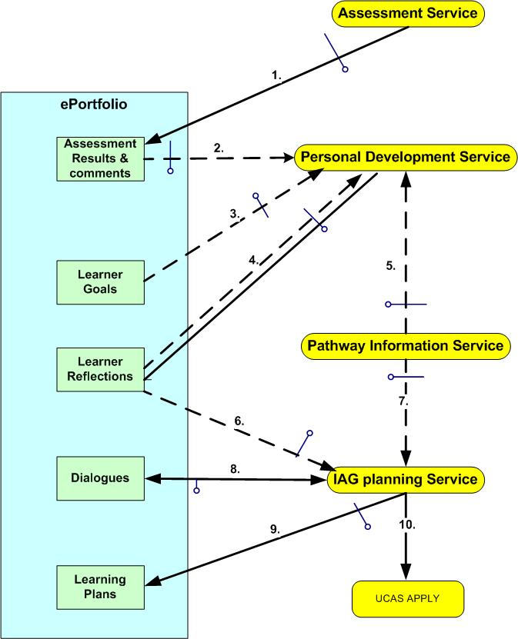

- Trigger An assessment result:
- I call this information into an e-Portfolio enabled Personal Development Service.
- I review the results against my goals ;
- in the context of past reflections.
- taking account of pathway information about the grades I need to meet my goals.
- I make some of my reflections available to my formal advisor in an Information Advice Guidance Planning Service
- My advisor also calls pathway info
- Our dialogue is recorded
- We negotiate a formal learning
- The plan sets out what I will do to apply to HE.

See http://www.tes.co.uk/search/story/?story_id=2166552
See http://www.qaa.ac.uk/academicinfrastructure/progressFiles/guidelines/progfile2001.asp
Web services 1,2,3 would assist the learner and an adaptation of web service 4 would allow the coach to provide feedback to the learner, rather than a reference to a referee.

