NIHR funding route
Details of the NIHR-funded route can be found on the School’s scholarship page:
http://www.nottingham.ac.uk/healthsciences/postgraduate/finance/scholarships/index.aspx
Applications for funding require an outline research proposal to be submitted with the application.
The MARM is frequently considered as training for carrying out a PhD. The dissertation produced for the MARM will be an outline PhD proposal and a small piece of empirical work. The research proposal should indicate what the PhD might be along with what the empirical work might be. The proposal should be no more than one side of A4 and should include; aim, rationale, background literature, proposed methodology and methods. Information on how to write a research proposal can be found here: http://www.nottingham.ac.uk/pgstudy/how-to-apply/how-to-write-a-research-proposal.aspx
You will also need to provide a personal statement.
Please find below a link which will take you through the application process: http://www.nottingham.ac.uk/pgstudy/how-to-apply/how-to-apply.aspx
Good luck!
Dr Alison Edgley
Associate Professor of Social Science and Health
Director of MA Research Methods (Health Pathway)
Room D1020
University of Nottingham
School of Health Sciences
Queen's Medical Centre
Nottingham
NG7 2HA
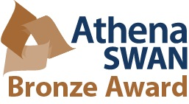
Tel: 0115 823 0913
Internal x 30913
Email: Alison.Edgley@nottingham.ac.uk
http://www.nottingham.ac.uk/healthsciences/people/alison.edgley

