Placement support strategies
Guidance for undergraduate students

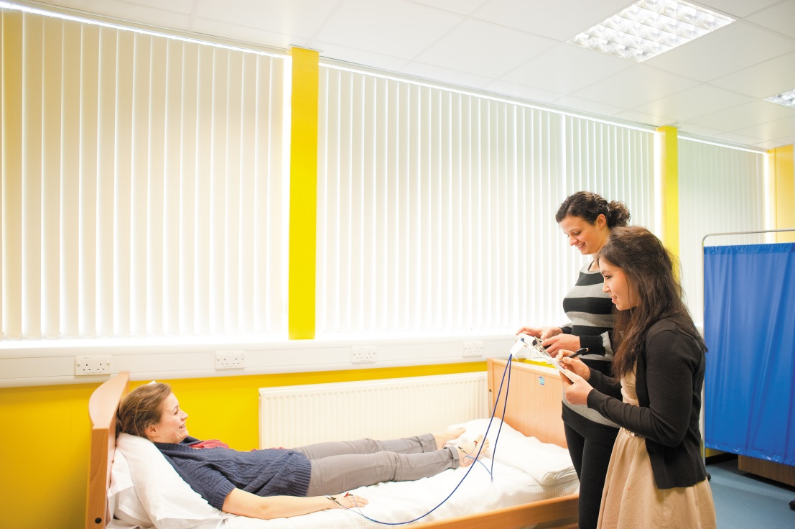

.
Placements can be a challenging time. A new environment with accompanying new stresses means the strategies for success you have developed may not now work so well. It is important that you prepare carefully. Try to anticipate where you may encounter difficulties and whether your current coping methods and ways of working will be useful in these new situations. Discuss this with your Practice Educator/Mentor and work together to adapt your strategies to clinical practice so you can make the most of the learning opportunities available.

This document gives suggestions for strategies to help you overcome aspects of placement you may find challenging.

Before Placement-
Before going on placement it is a good idea to consider your individual learning needs, strengths and areas for development. You should share these with your educator/mentor.

Nursing and Midwifery Students
Effective placement preparation is key to both enjoying and having a successful placement experience. Before you go on placement you will have had preparation for practice sessions which allow any questions, queries or concerns to be explored. Resources from these sessions are available on moodle. You will find information about your placement allocation on ARCPOW http://workspace.nottingham.ac.uk/pages/viewpage.action?title=ARCPOW&spaceKey=healthsciencesstudent and you can also contact the university link lecturer for the placement area if you have more specific queries. You may find it helpful to arrange a pre-placement visit to help prepare for your first day. Do make contact with the placement area before you are scheduled to attend. There are a number of resources to support you during placement including the placement chat rooms on Moodle, practice learning twitter @UoN_PST student forums and clinical supervision.

Physiotherapy and SRES students
A key part to a successful placement is preparation. Seek out as much information as you can about the area you will be going to; look on Moodle, https://moodle.nottingham.ac.uk/login/index.php and check the white board in the office to see who has been there before. Use the Placement Information form in your Handbook honestly to highlight your strengths and weaknesses and share the form with your Educator at the earliest opportunity, usually by email. It can be helpful to organise a pre placement visit in order to meet the team you will be working with, orientate yourself, and find out about their working practices. The Clinical Team can help you organise this and advise you on your pre-placement form also.

- Writing

Do you feel that you write slowly? Is your handwriting difficult to read? Are you worried you will make mistakes in the notes so that you have to rewrite them? Is your spelling and grammar inconsistent? It may be hard to take notes whilst someone is talking.

How patients’ notes are structured and how forms are used varies from place to place; familiarise yourself with the requirements as soon as possible. It can be helpful to look at qualified staff’s notes.

Using appropriate language, terminology, and approved abbreviations are all skills that need to be acquired. In addition, within the notes it is important to write the correct date, and not to transpose numbers (writing 261 instead of 216).

Strategies that may help:

- Ask for extra time and a quiet place to write notes

- Write up notes after each patient

- For reference each day have the day’s date written in your notebook

- Ask for copies of any templates, or notes systems to look at in your own time

- Take time to reread and check what you have written

- Prepare and use a crib sheet for assessments

- Use spell checkers, (could be on phone, if allowed to use)

- You may be able to use electronic notes

- You may find bullet points helpful

- Use a notebook to make a glossary of medical terms and drugs

- Use a digital recorder (check with your supervisor first due to confidentiality issues)

- Create a mind map or spider diagram containing the important information first

- Ask to see a copy of approved abbreviations for that clinical area

- Reading

Do you feel you read slowly, misread words, or have difficulties reading unfamiliar medical words and terminology?

Medical information is often presented on charts or forms which can be difficult to interpret until you are familiar with them. In addition, it can be difficult to pick out relevant information from a large set of medical notes.

Strategies that may help:

- Find a quiet place and some extra time to read

- Use a pen, ruler, or finger to help you track where you are on a page

- Read smart: ask yourself, what am I reading and why?

- Start with the most recent part of medical notes

- Jot down relevant information into your notebook, underline, highlight

- Use your notebook to record new words and their definition

- Use the electronic dictionary on your computer or phone

- Use a coloured overlay if you need one or ask for handouts to be on coloured paper
(rather than white)

- Ask if the layout on whiteboards could be changed

- Take a blank copy of relevant charts to look at in your own time

- Organisation

Do you find working in unfamiliar environments stressful? What’s your sense of direction like –are you the one who always get lost? Do you lose lots of your belongings?

Once you are on placement you will be working rather than studying. The better prepared you are, the more smoothly your placement will go.

How are you going to get to your placement? Where will you park (or where does the bus go from and to)? How long it will take from leaving your house to arriving at the hospital? Remember to add in the time it takes to go to your locker, get changed and onto the ward. Where do you need to go when you arrive? It is strongly recommended you have a ‘practice run’ to familiarise yourself with directions and confirm your timings - remember though to add extra time for rush hour. If you are getting a lift from someone, devise a contingency plan in case the person taking you is ill.

Strategies that may help:

- Do a pre-placement visit

- Draw maps or plans of where you are going

- Make a list of what you need for placement

- Have everything you need the evening before, pack your bag, pack your lunch

- Use a notebook or file to record new and relevant information.

- Have a different page or colour for each list, (eg a list of new medical conditions).
  - A highlighter in your pocket may be useful.

- Prepare crib sheets for the types of assessments you will be doing and use them
  - Update/modify these through placement with the help of your Practice Educator/Mentor

- Prepare for treatment sessions with ideas in your notebook
  - What will you do if the patient is the same, better, or worse?

- Write door key codes into your phone or notebook

- Diagrams of wards can help with knowing who is in which bed

- Time Management

Are you someone who always runs out of time or often late? In a new environment with so much happening it is easy to lose track of time. Wear a fob watch or have yours in your pocket. Try to work out how long tasks will take.

Although you may be happy to stay late on your placement to catch up with notes and tasks your supervisor may not be.

Strategies that may help:

- Use your watch, or have an agreement that you can use your phone, (perhaps have it in your pocket). The vibrate alarm can help keep track of time when doing tasks like assessments.

- Make a page-a-day diary to enter relevant deadlines, appointments, meetings, new patients, and to-do lists. Your highlighter may help.

- Look ahead and prepare for the next day, enter what you need to be doing on your calendar/diary, with timings.

- Make lists of everything you need to do, then break down into smaller steps – your supervisor may need to help you with this.

- Prioritise your list - what is most important? What is most urgent? Use your colours and diary to help with these. Discuss your prioritisation with your supervisor.

- Use your phone for reminders

- Verbal

Do you mix up your words or struggle to find the right word when you’re under pressure? You may worry your supervisor will question your knowledge or understanding in front of other staff and patients. You may feel embarrassed about having to speak out in front of people. Pronouncing new names and medical terms can be a difficult.

If you are concerned about these issues consider speaking to your supervisor at the start of placement or highlighting this on your Placement Information form.

Strategies that may help:

- Use your notebook to write down what is being said
  - Bullet points may help

- Consider recording instructions - obtain permission from your placement first

- Confirm your understanding of what has been said or seen by verbalising it to your educator

- Prepare for team meetings or handovers; make notes in your notebook and consider practising beforehand with your supervisor or fellow student

- Ask for time to think before answering a question, or asking for time to go off and think about what has been asked before answering

- Ask that you only have one question at a time

- Practice with friends or family what you are going to say

- Provide written reflective pieces for your Educator/Mentor to read rather than ‘telling’ them

- Patient Skills

Are you anxious about carrying out assessments and treatments with patients for the first time? Do you easily get side tracked and lose focus?

Learning to talk to patients, asking questions, listening, interpreting what is being said, and writing it down within a set time takes a high degree of multi-tasking and requires practise –you won’t get it all right the first attempt.

It is very different using all the skills you have practised at University with your peers to do it all with ‘real’ patients.

If you feel under pressure when you are being watched have discussions with your Educator/Mentor about the levels of supervision. It may be there can be times when you work more independently to build up your confidence.

Strategies that may help:

- Break down tasks into small chunks

- Keep it simple

- Prepare; look ahead in diaries so you can plan

- Use crib sheets

- Use charts, (i.e. pain charts) to collect information

- Practise, practise, practise - use friends and family

- Focus on the patient in front of you – you will know more than them

- Use patient goals to help prioritise treatment plans

- Recall and Working Memory

Are you the one who can never remember people’s names, towns, street names? Or maybe you feel everyone else gets the answer before you –although you know it. Or you can never recall what conversations you have had. It could be that your friends and relatives are always saying ‘I’ve told you that before’.

Memory problems can be exacerbated working under stress or in new situations. When there is so much new material to remember it is easy to miss some of what is being said, and can be hard to remember or understand all the instructions.

Following an assessment it can be difficult to immediately explain what you have done and what you have found, and then clinically reason and plan what needs to be done next. Some people find it helpful to step back and think over what they just done to put it into some sort of order.

Strategies that may help:

- Use your notebook to write down non-identifiable patient information. Remember the only place for names is patient’s notes

- Ask for time following patient contact to write your notes, think about what you have done, and organise your thoughts before being questioned

- It can help to * or highlight key findings to narrow your focus for clinical reasoning and planning

- Use mnemonics to recall key parts of prior knowledge, such as anatomy

- Picture or images can help – such as picturing Mrs Green having a green face

- Have your placement file handy so you can look up revision notes you have made

- Numbering, using your fingers, can help with sequencing or not forgetting a series of tasks

Finally

Use all the resources available to you. Good communication is the key to a successful placement – keep in touch with your University Link Lecturer through the placement, as well as making the most of the support offered by your Practice Educator/Mentor. If you have any concerns please contact one of the Team, we are more than happy to help.

For queries such as shift work, illness on placement, treatments you can/cannot administer, system access and competency achievement please look at your Course Handbook on your Moodle page.

Useful References

Nursing and Midwifery

Dyslexia, Dyspraxia and Dyscalculia: A Toolkit for Nursing and Midwifery Staff
www.rcn.org.uk/__data/assets/pdf_file/0003/333534/003835.pdf

Peer Mentor Leaders
https://twitter.com/PM_Leaders

Physiotherapy and Sports Rehabilitation

CSP into Physiotherapy – Welcome and Supporting Disabled Students
www.csp.org.uk/publications/physiotherapy-welcoming-supporting-disabled-students

General

Academic Support at the University of Nottingham
www.nottingham.ac.uk/studentservices/supportforyourstudies/academicsupport/index.aspx

Association of Dyslexia Specialists In Higher Education
www.adshe.org.uk

British Dyslexia Association
www.bdadyslexia.org.uk

Counselling Service
www.nottingham.ac.uk/counselling/index.aspx

Nightline
http://www.nottinghamnightline.co.uk/

Placement Support Twitter and Placement guidance video
https://twitter.com/UoN_PST
www.tinyurl.com/prepforpractice

Student Advice Centre
www.su.nottingham.ac.uk/advice/student-advice-centre/

Student Services
www.nottingham.ac.uk/studentservices/index.aspx

