MUSIC SALE!
Tuesday 29th October 2024
10am – 4.30pm
Music Department Foyer
Large stock of sheet music
Vocal (songs for high/low voices)
Instrumental and ensemble music
Contemporary Music
Orchestral & Choral scores
Opera & Operetta vocal & full scores
Books on Music
Any requests email Jane McDermott @ jachmcd@gmail.com
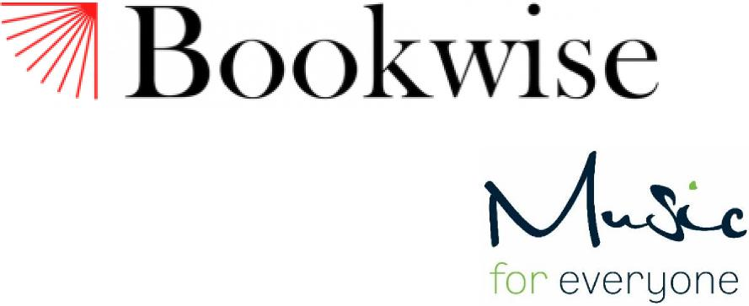
ALL AT A DISCOUNTED PRICE

Charity bookshops with second hand music
Nottingham (10 Goose Gate, Hockley), Southwell & Newark
info@bookwiseshops.co.uk
Raising money for Music for Everyone
Registered Charity No. 1153412 | www.music-for-everyone.org

