The Transition to Late Antiquity;

Large-scale excavations at Dichin, an early Byzantine Fortress, and intensive field survey in north central Bulgaria

The aim of this research programme (1996-2002) has been to investigate the character of the countryside on the Lower Danube during Late Antiquity. Currently, preparations are being made for full, final publication of the results in collaboration with our Bulgarian colleagues. The research design is intended to explain why the Late Roman city programme (1985-92) identified a dramatic change in the character, function and economic base of the ancient city of Nicopolis in the late 5th century AD. The method involved the large-scale excavation of a ‘type site’, near the modern village of Dichin, and the implementation of a new form of intensive field survey, researching the changes which took place within the city’s fertile territory, concentrating upon the Roman villa estates. These two aspects of the programme are described and then a tentative explanation as to their significance for the fate of Nicopolis is proposed.

A central goal, as in the previous project, was to carry out large-scale ceramic, archaeobotanical and zooarchaeological programmes, in order to explore the economic character of Dichin, evidence which could be compared with the remarkable finds at Nicopolis. In pursuit of these objectives, the scale of the excavations was impressive, including 30 professional field officers, 20 specialist staff and over 120 students, the core from the dept of Archaeology in Nottingham, others from other British universities and, from Bulgaria, from the Universities of Veliko Turnovo and Sofia. In total the team included c. 180 participants, working for 5 weeks during each of the successive field seasons; the largest British field project (fig 1) ever launched from the UK.

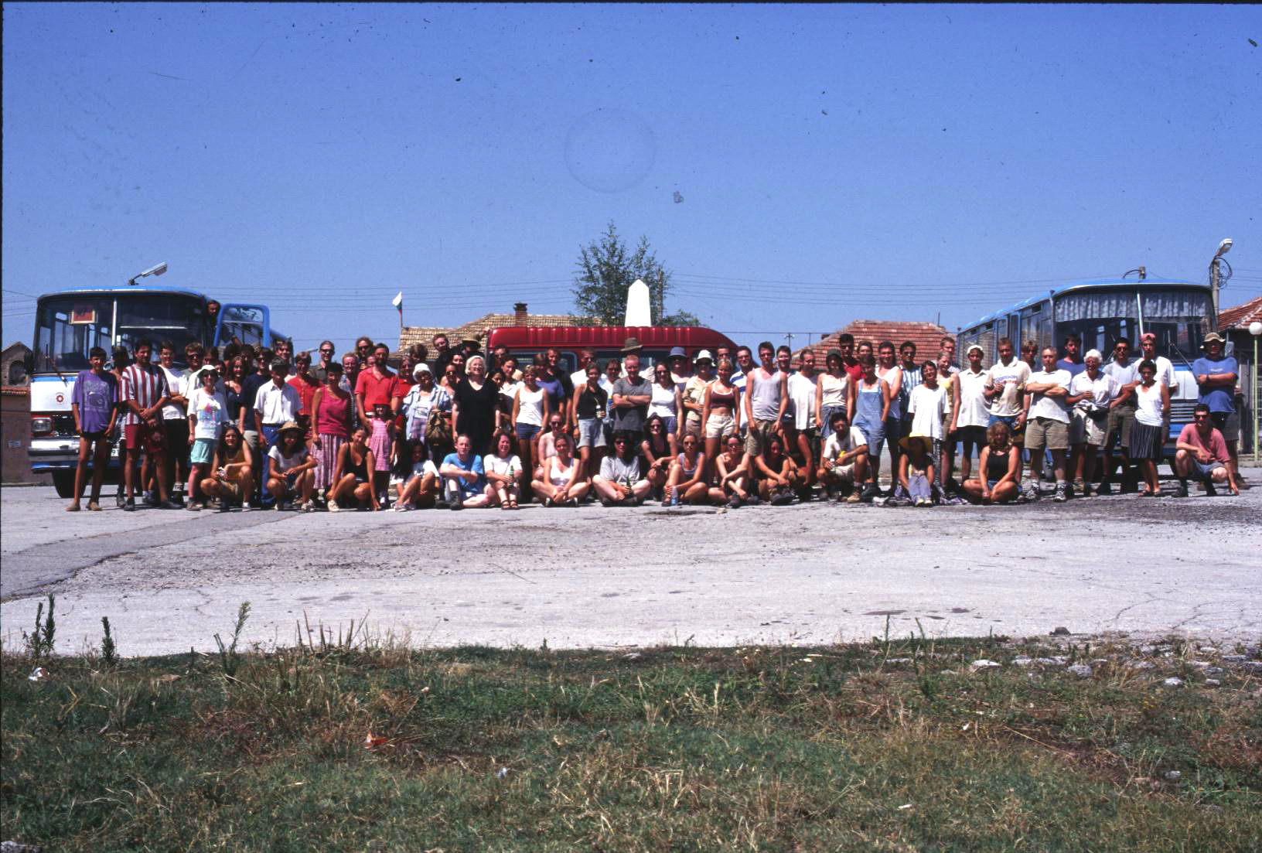

Fig 1
Dichin, the late Roman Fortress
The initial hope was that this site would prove to be a small rural settlement where the effects of local economic conditions, especially in agriculture and animal husbandry, would be easier to identify than in the ‘imperial’ city of Nicopolis. The site chosen (fig 2) occupies a slightly elevated position, c. 10m higher than the flat floodplain on the south bank of the river Rositsa, c. 11km west of Nicopolis, conspicuously not on the line of a Roman road: the nearest known route passed west from Nicopolis but follows the northern bank 3. Post-medieval stone-robbing had removed large sections of the fortifications. Within the site, although robbing was systematic and had removed the walls and the upper foundations of most buildings, the clearly visible trenches provided a coherent and useful plan, especially for the central and eastern parts of the site (Figs. 3 and 4).

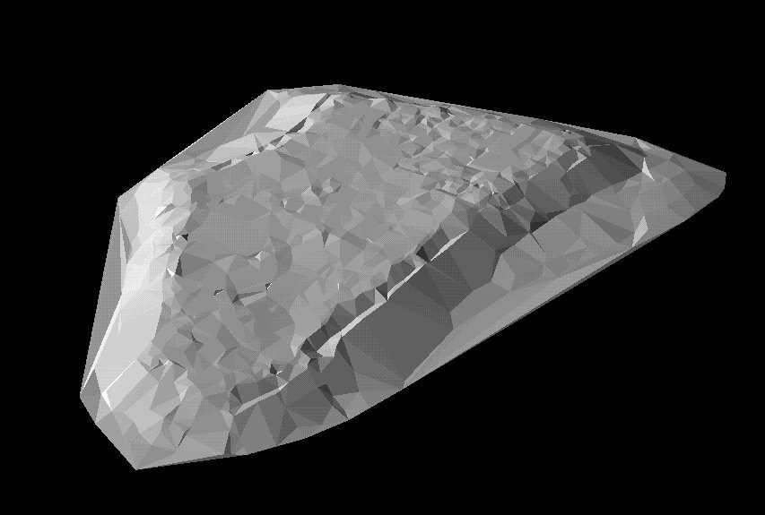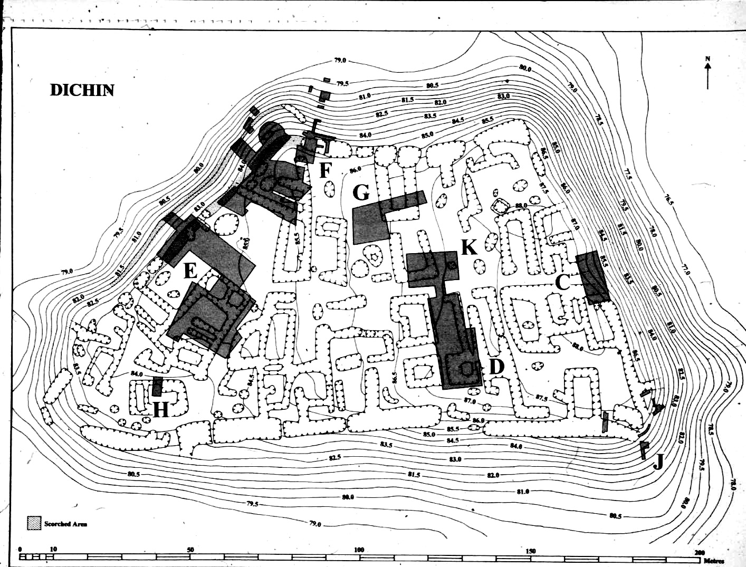

Fig 3 Fig 4

Despite this recent activity, occupation surfaces within structures, and between them, largely survived intact. Unlike Nicopolis, there had been no medieval or post-medieval occupation. The most striking feature of the plan was its regular layout, very different from the sprawling haphazard distribution of buildings, typical for late Roman villages. Large rectangular buildings lined both sides of a central roadway which continued west in a straight line from the eastern gate (area C). But it was the quality of the fortifications which immediately marked out Dichin as a site of unexpected importance. The curtain was 2.0m in width, faced with regular limestone blocks alternating with finely constructed tile courses, with a solid rubble and concrete core. An internal staircase was sufficiently well-preserved to calculate that the height of the curtain to the wall-walk was an impressive. 9.0m.There were two gates, well built from good quality limestone blocks, one on the north side (area F), the other centrally positioned on the eastern curtain, the entrance carefully protected by an externally projecting tower past which anyone approaching up the steep path would have to pass before entering the gate-chamber (Fig. 5). Two equally well-built circular corner towers were excavated, one at the conjunction of the western and northern curtains (area F), the other at the south-east corner. In area E, the upstanding remains, preserved c. 2m in height, included a rectangular tower which straddled the defensive wall, projecting both outside and inside the curtain, must have been similar to others which must have existed at regular intervals along the walls (Fig. 6). On its lower western and southern sides, the defences were further strengthened by the construction of an outwork (proteichisma) built of stone and limestone mortar. This description of the defences is of particular importance since it demonstrates that the quality of construction and the sophisticated tactical disposition of towers and gates could not have been to protect a simple village, but, can only have been the work of experienced military engineers. That Dichin was a fort explains the discovery of weapons, including spears, a plumbartum, and two shield-bosses (Fig. 7).
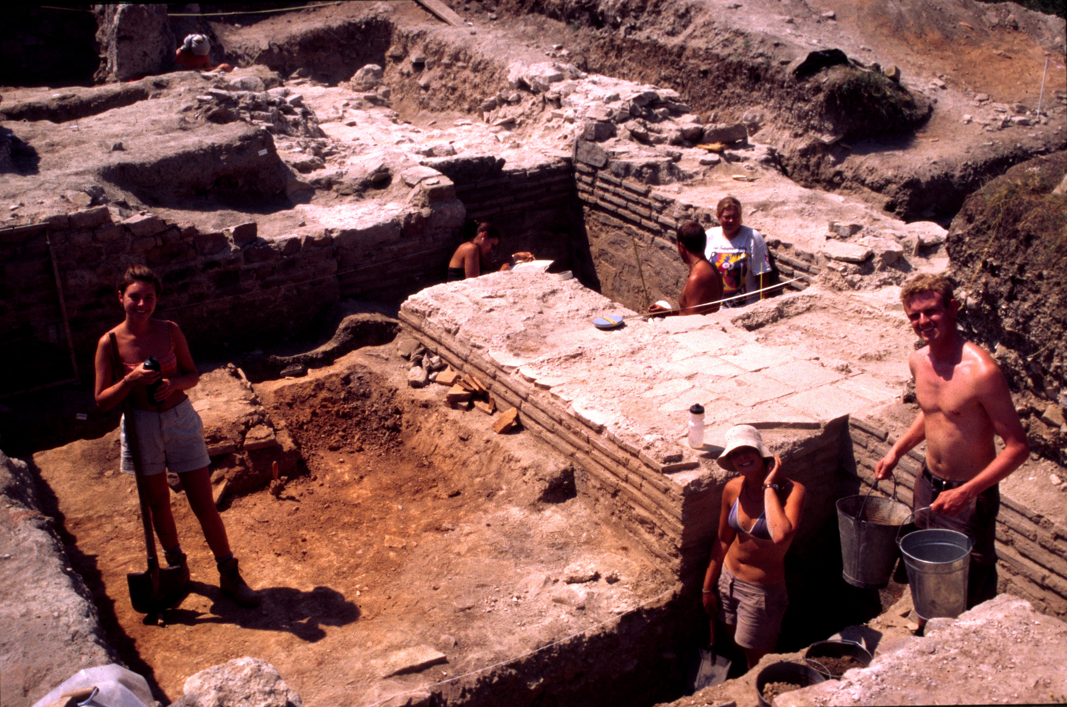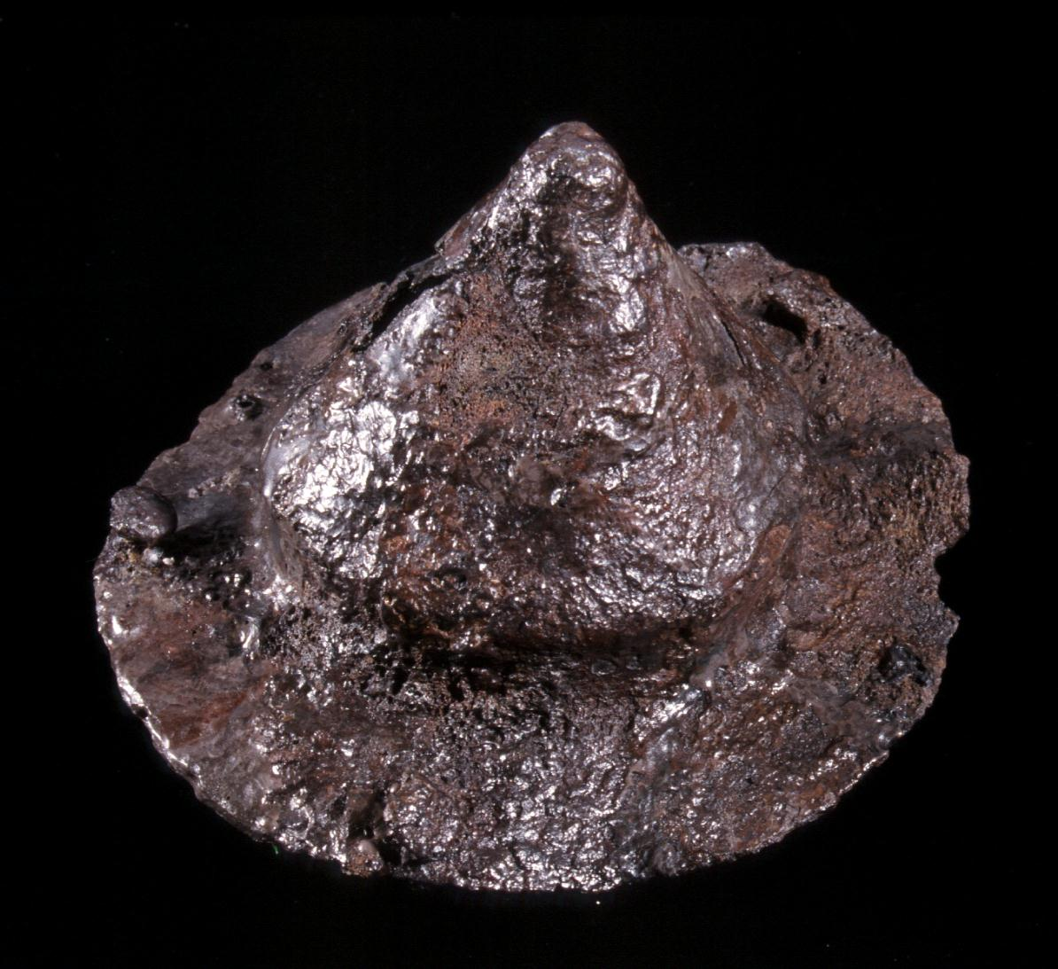

Fig 6 Fig 7

Just as surprising was the date of the fort. Most of the known late Roman defences on the Danube frontier belong to the Tetrarchic or Constantinian period, but the coin finds from Dichin, including gold issues, point to a much later construction date of c. 400 (Fig. 8).
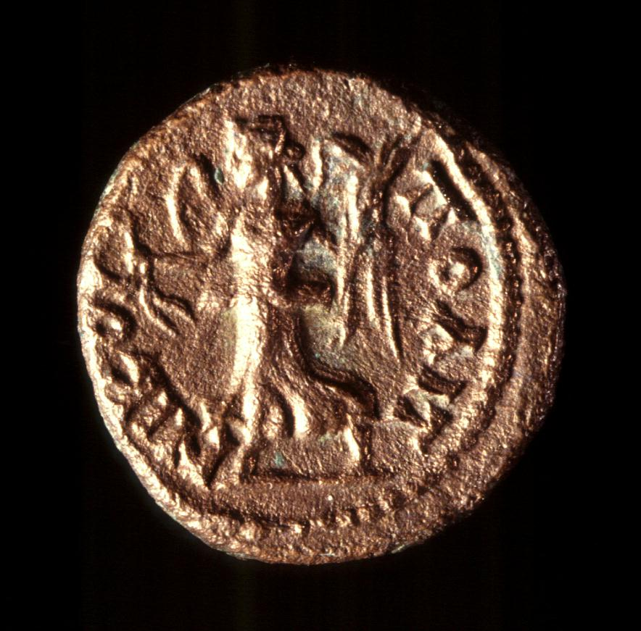

Fig 8

At the end of its first period, the fort was destroyed by fire. This was no accidental destruction: the burnt level was rich in finds and produced human bones, including the partly dismembered skeleton of an individual who had never been buried but must have been left in the destruction level. Its lower limb-bones had been gnawed by carnivores, perhaps wolves (Fig. 9). This amounts to compelling evidence that the fort had been sacked and least some of its occupants had been killed, bodies being left in the destruction level. As to the date of this event, coins provide only an approximate guide: it must have occurred at the very end of the 5th century AD. Immediately following the destruction, the fort was rebuilt on very similar lines, and continued in use until the later years of the 6th century, before finally being again destroyed by fire.

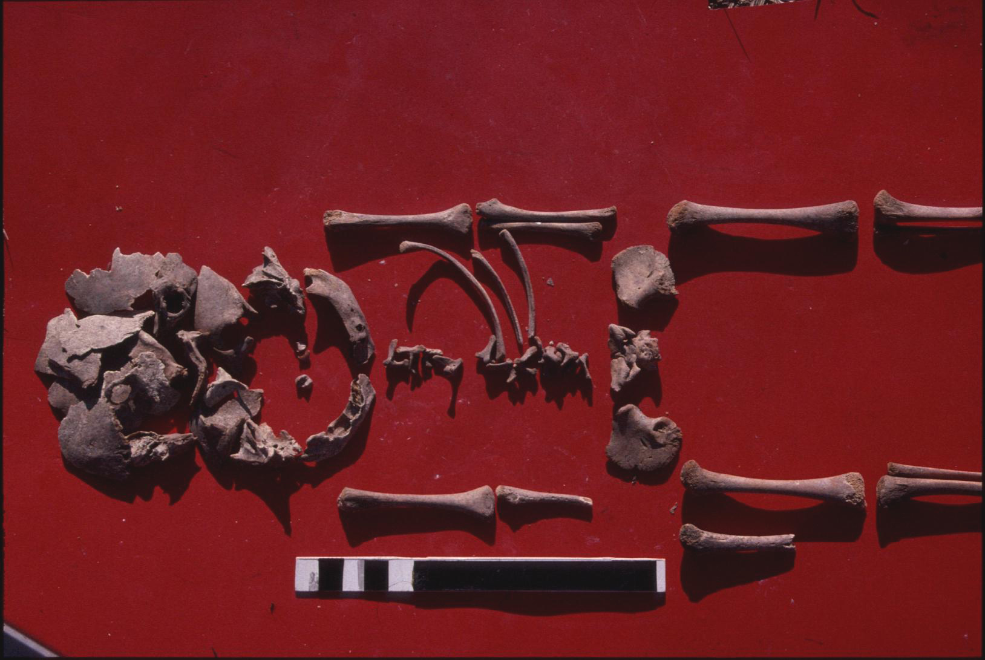

Fig 9

The first period (c. 400 – c. 500) is of particular importance for the central objective of the programme. A signal and unusual aspect of the site is the contrast between the high quality of the fort’s defences and the building methods employed for the interior structures, most of which were built of irregular limestone blocks bonded, not with limestone mortar, but with earth and with a superstructure of mud brick (Fig. 10). There was never an earlier, typically Roman layout of barracks built of bricks and mortar. These comparatively primitive buildings existed from the start and must have been erected immediately after the completion of the fortifications. Not that mortar was totally absent. A carefully constructed drain was well built from mortar and tile, probably a primary feature. More curious, however, is a secondary building (but still belonging to period 1) which was squeezed into the western side of the site (area E), butting awkwardly up against the curtain wall and medial tower (Fig. 11). Its northern and southern walls were well built from mortar bonded stone and well-faced although, at its eastern end, where it abutted a pre-existing building constructed with earth and stone, mortar was not used and the end wall was simply finished with stone and earth bonding. On the south side of the enclosure there was a church (area H) which did have mortared foundations at the east end, which would have been required if, as seems probable, it supported a semi-dome over the apse, yet its main walls and those of the narthex at the west end were simply built, again using rough stone blocks bonded with earth. Clearly, the value of lime mortar was certainly recognized but it seems not to have been available in any quantity and the stones generally used were roughly cut local blocks. The builders of these structures, presumably the first occupants of the fort, for the most part, had to make do with materials available close to the site. It seems they were unable to obtain mortar or better building stone from further afield. No such limitation affected the military engineers who constructed the defences, using plenty of mortar, well-cut facing blocks of stone and tile course. The preparation of lime mortar was not possible in the valley of the Rositsa but it could have been produced further south, at a distance no less than 8km from Dichin. Good facing stone would also have had to be brought from quarries, perhaps those used by the city of Nicopolis, even further away. The cost of transportation and organization was evidently available to build the walls at Dichin, but seems not to have extended to the garrison’s own buildings. Although the occupants were certainly soldiers, they were unable to count upon the same military infrastructure which was available for the builders of the fortifications. Could it be that the garrison was denied access to the raw materials because the limestone uplands to the south lay beyond their territorial jurisdiction? Even if true, it is curious that when they erected the store-buildings and barracks, they were unable to call upon the logistical support available to the regular army.

The internal buildings themselves were of unusual construction for a military installation. The fort was apparently divided into two distinct quarters. The first comprised the western half of the site which contained a series of store rooms, of which at least five had raised timber floors supported on mud brick bases (cf. area E, Fig. 13 and 14), again presumably because the garrison did not have the lime mortar required to construct the normal mortared stone bases invariably found in standard Roman granaries. In size, these structures (each c. 14 x 8m) had a capacity greatly in excess of the needs of what must have been a relatively small garrison. These horrea contained substantial quantities of cereals which were carbonized in the destruction level which ended period 1 (Fig. 15) although, at that time, the buildings also contained an assortment of materials, including wine and oil amphorae, a shield boss (probably still attached to its shield), as well as a wide range of crops.

Either side of the main road, in the centre of the site, the buildings, though also built of earth with stone bonding and mud brick superstructure, were very different in layout and function. Two were half excavated on the north side of the road (area K) and a complete building on the south side (area D). All were about the same size and, in the case of the example which was fully examined; it was 22m in length and 13m width (Fig. 16). The ground floors were used for storage: holes for amphorae and storage vessels were cut into the clay surface; two vessels survived in in situ (Fig. 17). Access to the first floor was up a flight of stone steps (Fig. 18). Presumably, given the size of these buildings, each ‘barrack’ was occupied by at least one family group.
Apart from the poorly built church and the granaries, there were apparently no other typical military buildings. There was no principia, no praetorium, nor baths.

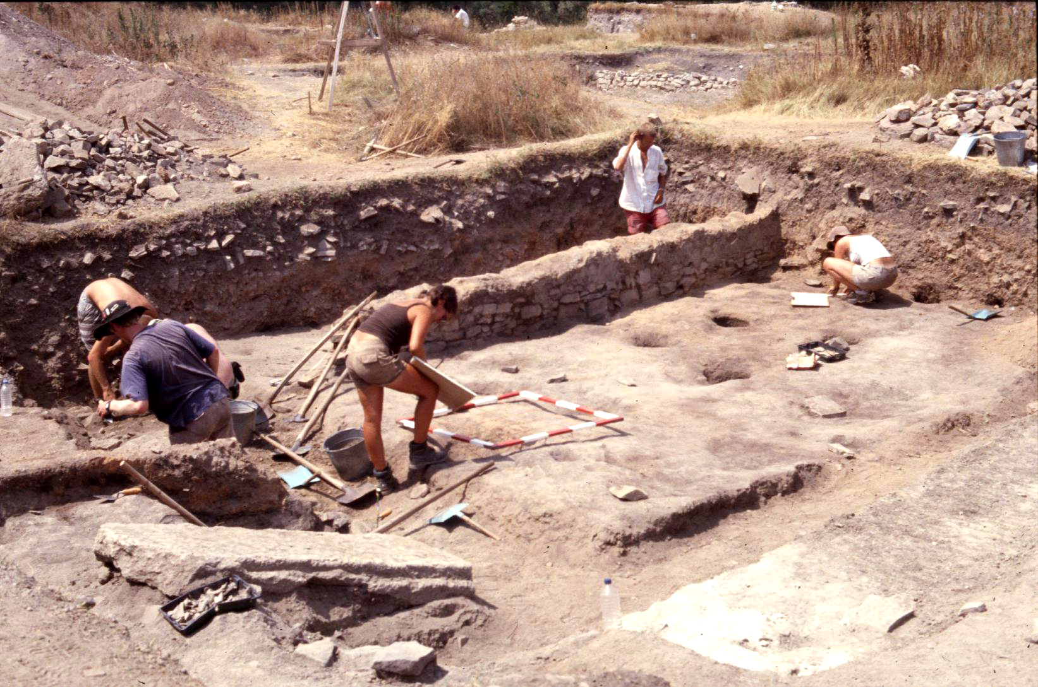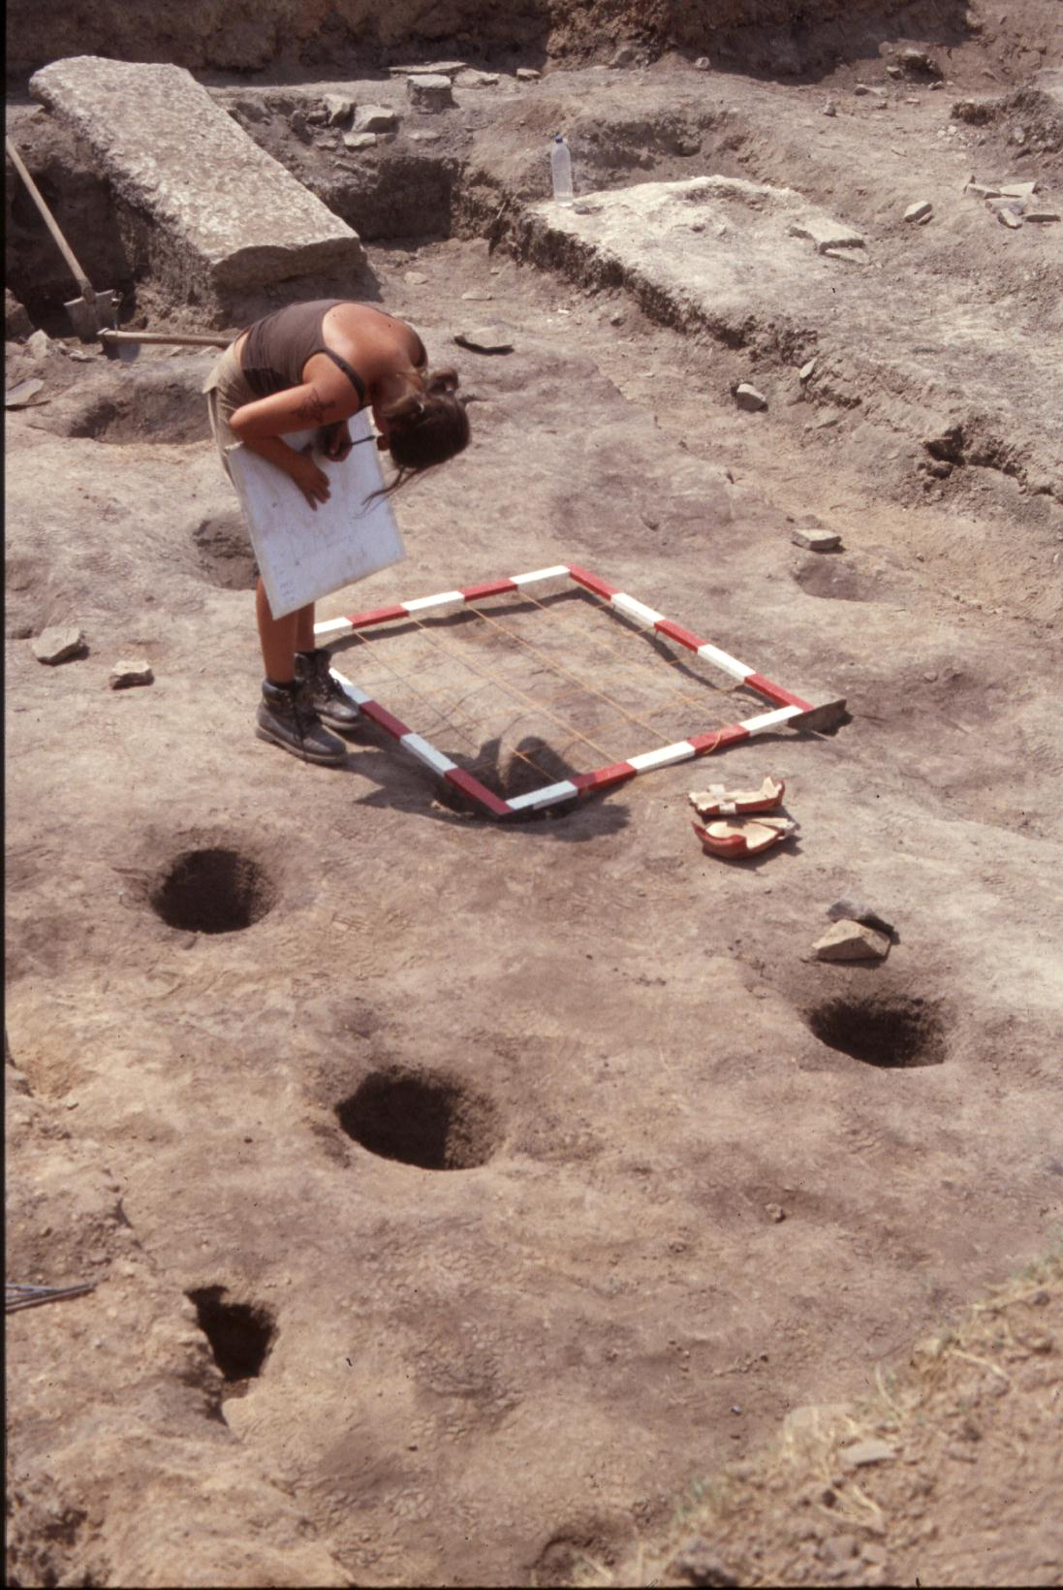

Fig 16 Fig 17

The rich finds from the destruction level (dating to the end of the 5th century) proved especially important. The wide variety of foodstuffs and the size of the granaries suggest that there had been no radical change in the productive capacity of the region. Consequently, the character of early Byzantine Nicopolis is unlikely to just reflect a collapse in the rural economy. Farming continued producing a wide range of goods; simply they were no longer reaching the city. Another interesting difference between Dichin and Nicopolis is the importance of beef in the diet which, especially in the late Roman period, seems to decline significantly in the case of the city but continued to be important at Dichin. Perhaps relevant here is the fact that the military sites of Novae and Iatrus also apparently continue to consume proportionately more beef than was the case in the city of Nicopolis. Another apparent difference is that, although beef was arriving ‘on the hoof’ for slaughter outside Nicopolis in the 4th to 5th centuries AD, at Dichin beef would seem to have been brought to the site as joints of meat. Although the finds from the destruction level included armour and weapons, there were also agricultural tools, including numerous complete scycles and scythes (Fig. 19) and a plough share (Fig. 20). Apparently, the occupants, along with their families, not only performed a military role but were also engaged in farming the land.

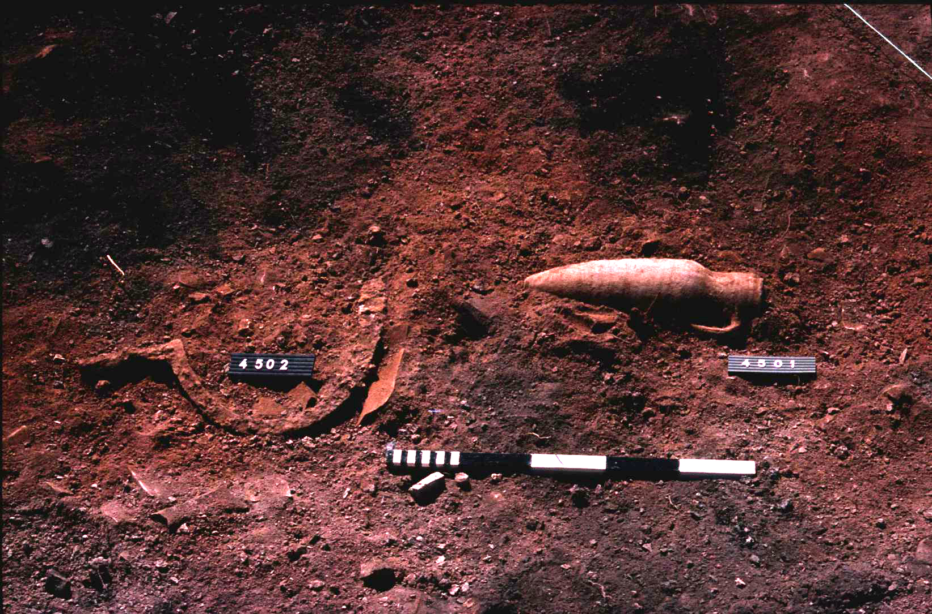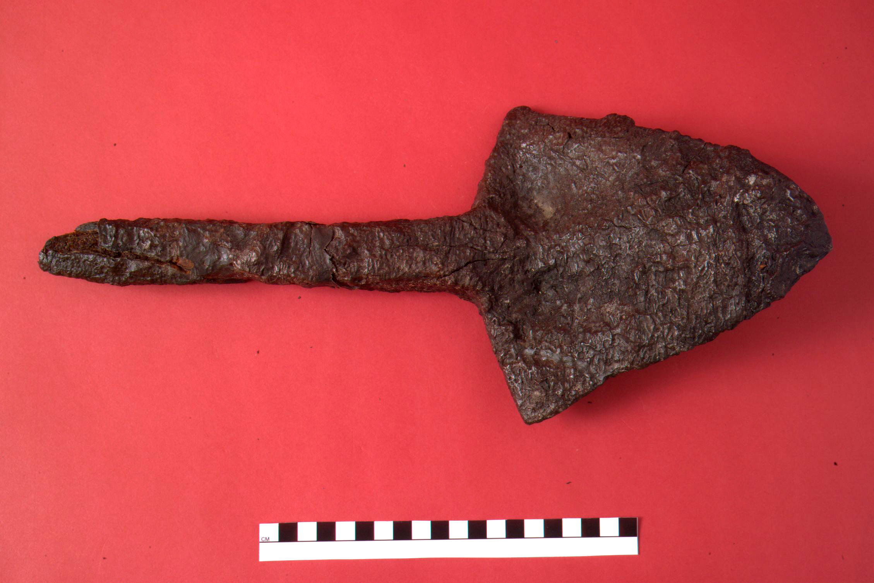

Fig 19 Fig 20

Dichin’s role in the 5th century

The substantial capacity and number of granaries and store buildings, compared to the size of the site and its evidently small garrison, is significant. Since the finds and the quality of the fortifications prove that Dichin was no village but a fort, its unusual location still needs to be explained. The most plausible reason for its location on the banks of the river Rositsa would be that Dichin was a supply base, to which agricultural goods were shipped including foodstuffs and materials exacted from the local population as anonna. From there, goods could be transferred by shallow draft boats downstream to the Yantra and on to the Danube to provision the frontier garrisons (Fig. 2). Today the Rositsa is shallow and scarcely navigable but there is reason to believe that it was wider and probably deeper in Antiquity. The dominance of pike amongst the fish bones suggests that there then existed a wide expanse of water where the river flowed slowly and was bordered by reed beds. The bones include bird species whose preferred habitat is larger rivers or lakes, a description which does not apply to the modern fast flowing and channelled stream of the Rositsa.

Although army engineers must have constructed the fort, its garrison appears to have been an irregular force, requiring none of the buildings expected of a normal military unit. They also were, in so far as building materials were concerned, unsupported by the military infrastructure. Apart probably from police duties, they were engaged in farming the surrounding land. The ceramic finds mark a clear break with the high quality red wares, so abundant during the Roman period. Instead, the fort was supplied with locally produced black wares, including ‘foederati ware’ which has forms more akin to products from beyond the Roman frontier than the immediate region. Even so, other pottery, especially in the case of imported fine wares and amphorae, point clearly to the existence of a supply system linked to the annona militaris). This semi-detached relationship between the garrison at Dichin and the Roman army also applies to the frontier. Although there is no way of proving the case for certain, it seems quite likely that the irregular garrison at Dichin comprised a force of Gothic foederati. However, the ethnic identity of the garrison is far from certain. The extent to which the Goths themselves represented an ethnic unit remains controversial, although even those who believe in the existence of an essential Gothic identity would accept that it encompassed different ethic groups which had allied themselves to the gothic cause.

The Field survey (site-specific survey) and the results

The objectives and the programme

Central to the research programme was the need to develop a method of survey which would provide a detailed understanding of the villas and villages within the territory of the ancient town of Nicopolis. The key issue was to discover whether there had been any dislocation in the nature of settlement, especially villas, since it was their owners who supported the city: numerous late tombstones from the city’s territory, dating to the 2nd to 3rd centuries, most surely set up on villa estates, attest to the participation of the landed elite in the administration of Nicopolis, either as members of the assembly (bouleutes) or holding magistracies within the town. Since the overall objective was to seek an explanation for the radical change in the character of the city, it was decided to concentrate upon the villa estates to see if – or when – the villa estates were established and, more particularly, when they were abandoned Mr Ivan Tsurov had been responsible for building up a detailed site index of all known Roman period sites within the Veliko Turnovo district. Although this information was acquired by extensive – not intensive – survey, which meant that only the large settlements (i.e. not hamlets, or isolated farmsteads) were generally included, given the specific objective of the programme, Mr Tsurov’s site index and his personal knowledge of all of the sites, proved more than adequate for the purposes of the survey.

To be successful, the basic requirement of the survey needed to identify the principal focus of the site and identify its function (village, villa, temple etc.). The intention was to confine the survey to Roman sites and not to attempt a survey of the countryside as a whole, nor to consider periods which did not date to the Roman, Late Roman and early Byzantine period.

The method

The region available for field survey amounted to some 2,000 square kilometres, included in excess of 500 known sites and stretched from the Stara Planina to the river Danube, including the city of Nicopolis and its territory as well as the fortress at Dichin (Fig. 2). During the summer months, visibility was invariably less than 20% within the rich agricultural lowland and much less in the uplands where forest and scrub cover made any kind of field survey impossible. Since the project in Greece had demonstrated how effective survey could be when visibility was approaching 100% (See the Macedonia Programme, Greece), it was decided to carry out the Bulgarian survey, not during the summer, but in the Spring, after ploughing had taken place but before harrowing and planting had started. Only fields where visibility was at or close to the maximum were surveyed. In the region, there is a simple rotation between wheat and sunflowers (or sweetcorn). Because the wheat is planted in the autumn, it is already sprouting by April and consequently those fields were it was growing could not be walked. However, fields where sunflowers were to be grown are ploughed in March or April and seed is sown only late in April or early May. Consequently, in any given year, only these fields could be subject to survey but, in most cases, the inaccessible fields would be available in the following year. It proved generally possible, by visiting each site in successive years, to carry out a total survey with 100% visibility. Only the very large sites had to be covered in three or four seasons, depending upon the crops they contained.

In theory, the use of click surveys to identify all surface remains of Roman period occupation (as in Greece, including pottery, small-finds, building stone and brick) seemed a reasonable approach to test whether the method could adequately replace the more traditional approach, using general pickup and total pickup within transect squares. In practice there was an immediate difficulty. Due to collectivisation in the Communist period, fields are generally very large indeed, regularly up to 1km in length so that clicking simply provided totals across the land surface without pinpointing accurately concentrations of material. Fortunately, on the first day of survey, an example of a traditional Bulgarian surveyor’s tool, the ‘pergel’ was found in a hedgerow where it had been left by surveyors engaged in dividing up state-owned fields to return the land to private ownership. The instrument is simple in design. It has two slats of wood which cross at the top to form a handle and a cross brace joining both of the ‘legs’ so that the distance between the two lower ends of this triangular apparatus is exactly 2m. Essentially, it is used as a larger version of a military pace stick. The operator walks across a ploughed field in a straight line, swinging the ‘pergel’ so that first one then the other pointed end of the instrument made contact with the soil. Following a compass bearing, it proved effective in measuring out a given distance in metres by counting the number of swings and multiplying by two. A modified version was subsequently made and used to measure out suitable subdivisions across fields: trial and error proved that 25m intervals were quite sufficient for locating even the smallest concentrations.

It was immediately clear from the first season that there was no dispersal of Roman pottery, tile or brick across the land surface. In all cases the limestone blocks, used as building stone, bricks/ tiles and pottery were restricted to small areas, usually no larger than c 20m in circumference. Away from a ‘focus’ of occupation debris, there was no off-site dispersal of materials, even where the terrain was undulating and occasionally sloped steeply. This was especially surprising because deep-ploughing, which regularly follows the direction of slope, might be expected to disperse surface debris, especially the lighter material such as pottery sherds.. It was evidently true that these concentrations represented buildings – a presumption confirmed by resisitivity survey (carried out by Dr Boyd, Cambridge University). What is more, the distribution of surface material often provided a surprisingly clear outline of the buildings which could be planed with some accuracy. One dense concentration proved that the dimensions of the primary focus of settlement at one site were similar to those of the peristyle villas commonly found in the resistivity surveys. Another clearly demonstrated the presence of a large, winged villa. Even smaller structures could be identified. One feature common to many of the smaller buildings, was the outline of a courtyard, its outer walls defined by lines of rough limestone blocks. Invariably, these ‘courtyards’ faced south of the ‘house’, as is the case today in modern villages where houses have similar courtyards, their outer walls, built from stone and earth and mud brick. Probably, as today, these Roman walled plots were used for vegetable gardens and protecting livestock. Invariably, these courtyard houses produced concentrations of pottery, indicating that they had been occupied and were not outbuilding - which always produced much reduced quantities of ceramics and very few small-finds.

Given that the surface evidence proved so productive in open ploughed fields, initially the procedure used in Greece was employed to examine individual buildings. However, the recovery of surface material from grid squares proved of no particular advantage: given the dispersal of material around individual buildings, the collection and weighing of surface debris provided no clearer definition than the quantity clicks used to locate them in the first place. Consequently, the use of grid squares was abandoned in favour of reliance upon click surveys to locate and define their presence, the results plotted and planned using GIS. Since the intention had always been to extract as much detail about each site as possible short of excavation, the survey involved the total quantification of all surface debris within an area which extended approximately 1km in each direction, moving away from the primary and largest focus of the settlement. Fieldwalkers were spaced at 5m intervals and they ‘clicked’ all surface material, each member working along his transect, recording debris up to 2.5m to his left and 2.5 m to his right. Usually, thanks to the support of Veliko Turnovo University, we employed up to 50 students during each of our Easter field seasons (1998-2002). Additional students walked in front of the line of clickers. These ‘outriders’ maintained the correct spacing of the walkers as they moved across the field in a line, their direction dictated by the pergel operator who measured out the field, stopping every 25m. The pergel usually walked at the left end of the line while another team member marked out the direction by advancing the line on the extreme right of the line. Once the pergel had measured out the first interval, one leg was pushed into the soil and the other swung at right angles to the route of march. By sighting along the now horizontal leg, the members of the clicking team could be stopped in turn as they came to the end of their transect. Immediately, the clicker operators had reached the stop point, recorders moved down the line, noting the densities of debris recorded by the students. For this process to be accurately measured, special recording sheets were introduced and improved each season. Cross-checks on locations were carried out using hand-held GPS which proved adequate in positioning the survey lines and geophysical survey squares within the landscape. At the end of the run, usually at a field boundary, the team was moved to take up position for the next click survey, immediately alongside the previously surveyed section of field. The procedure was then repeated, moving backwards and forwards across the field, recording a total density distribution across the entire landscape. Given that visibility was 100% and ALL THE LAND SURFACE was surveyed it proved possible to identify all Roman and late Roman buildings within a range of c. 1km of the primary focus (Fig. 21). One aspect of this survey requires particular emphasis: at no time were field-walkers expected to pick up pottery. Only if small-finds were spotted (eg. Coins, quernstones etc.) were they retained, their position plotted using GPS.

Once the data had been analyzed and put into GIS format, the location of all buildings was easily plotted. The next stage involved laying out geophysical squares over each of the concentrations. Generally, most of the smaller buildings could be covered by a single survey square of 30 x 30m. After the resistivity survey had been done, the square was used to provide additional information about the building by carrying out total pickup. All building material was weighed and then left on site. All pottery was bagged and returned to base for identification and quantification during the following summer fieldwork. It proved possible to distinguish between roof tile and building brick (except for the smaller fragments) and it was usually possible to determine whether the building had a tiled roof and to determine whether the structure was of sufficiently high status to have been at least partly built from brick and mortar. If brick and tile were absent or found in negligible quantities, it could be reasonably presumed that the building had been thatched and probably had walls of earth and stone. More often than not, these humbler buildings produced only very small quantities of pottery and so were mostly used as outbuildings for storage or for animals.

The collection of pottery only from the survey squares located over concentrations of building materials meant that assemblages could be assigned to individual structures. As might be expected, the majority of fine and course wares dated to the latest period of occupation but the earliest period (from the early 2nd century) was sufficiently well represented to establish the overall period of occupation. Work on assessing the significance of the finds is continuing and, since the quantities of recovered material are substantial, it should be possible to identify any differences in the types of assemblages, the relative proportions of coarse to fine ware, storage vessels etc and to estimate how long the building remained in use. Whether differences in the function of the buildings can also be found, is still uncertain. In most cases, this may be going too far: the majority of buildings have produced a mixed assemblage without any specialisation which could be used, for example, to identify a specialized industrial or storage function. Indeed, the ubiquitous presence of domestic ceramics in assemblages where pottery is plentiful, suggests rather than many of the buildings, even away from the main villa, were occupied, as has been argued for the buildings west of the main villa at Mramora, in the large western field, occupied it would seem by a village or settlement contemporary with the villa found in the eastern field (Fig. 22).

A major development in the method came with the appreciation that calculating the surface densities of building materials separately might provide still more detailed information. While surveying at the Mramora, it was decided to use separate clicks for brick/tile, building stone and pottery. This was applied to the east field after the western field had been quantified by total count of surface finds. This meant that, in each transect, three fieldwalkers were needed, each clicking only the material allocated to them. Generally it proved best to have the pottery clicked first by the front student in the transect (before the surface had been trampled by the team), then brick/tile, followed by building stone (noting only finds as large as a clenched fist). The adoption of this procedure proved remarkably successful. In the east field at Mramora, the distribution of brick/tile was the most concentrated – on the site of the main villa (its plan identified by geophysics) and on the sites of two other concentrations/buildings immediately south of the villa (Fig. 23). It seems that these two buildings were also ‘high status’, one of which might well have been a bathbulding. Building stone was associated with all buildings but, where the surface debris included only building stone, these must have been of ‘lower status’, no doubt constructed with low walls of stone and earth, supporting a mud brick superstructure (Fig. 24). For these structures, ceramic finds were also fewer than on the ‘high status’ sites, suggesting that they were not occupied – so presumably used for stock or for storage. The pottery distribution proved of particular interest (Fig. 25). Noticeable is the appearance – at the extreme eastern side of the survey – of an isolated concentration of pottery which is not associated with any building material. This anomaly can be explained by the date of the sherds - all of which were postmedieval. As was found during the excavations at Nicopolis, post medieval houses were grubenhäuser and all were wooden structures, none using tiles or bricks, rarely building stone; which explains this isolated concentration of pottery. The further Roman outbuildings, to the south, produced only a few sherds from total pickup which suggests they were not occupied. However, around the two subsidiary high status structures (where tile and brick were used) there was an appreciable amount of pottery indicating occupation. However, on the site of the main villa, most pottery was not found, as might be expected, within the villa buildings or in its central yard. Instead, the main concentration was outside the villa (identified by the resisistivity survey) and several metres to the east (Fig. 25). The most reasonable explanation would be that the villa was kept free of rubbish and that the concentration of pottery represented the location of the Roman period rubbish dump outside the main villa complex.

The method is not only capable of identifying the location of all buildings around the main villa, but it is possible to use comparative click surveys of different types of surface find to tentatively differentiate between high and low status buildings (on the basis of building materials) and to suggest which of the structures were inhabited and which were probably not (Fig. 22).

This kind of intensive survey can be used to identify not only types of settlement, especially villas, but also differences between villas, contributing significantly to the general character of nucleated settlement in the region.

The results

With the exception of one probably industrial centre on the left bank of the river Yantra and a possible temple site, all the others can now be confidently interpreted as villas.

The majority of the sites were square or rectangular peristyle villas with a central, colonnaded court surrounded by domestic accommodation. The houses used traditional Hellenistic methods of construction, with walls of mudbrick or pisė resting on a low base of clay bonded limestone blocks. Amongst the villas there was a marked contrast between those in the Rositsa valley and those further away from Nicopolis. All those surveyed in the valley of the Rositsa conform to a standard type. They were simple peristyle villas but, remarkably, they had very few outbuildings, regularly just one or two, probably serving as agricultural stores or accommodation for livestock. It seems that these were the centres of small estates, where the owner and his family worked their own land. Moreover, these ‘family estates’ were quite small and regularly spaced along both sides of the valley, usually c. 2.5km apart. Given the proximity of the valley to Nicopolis itself and its exceptional fertile soils, this planned landscape could well be explained as being family plots divided up and given to new settlers when the city was first founded. However, further away from the city, the morphology of the sites was very different. The villas here were irregularly spaced, at greater distances from each other and were generally much larger establishments. Again, a peristyle villa often formed the core of the settlement but this was only part of a larger complex, with more buildings dispersed across the surrounding area. One of the most important discoveries of the programme was that these villas, away from the Rositsa valley, had clusters of houses often at a distance of c. 500m from the main villa building. Many of these rectangular houses had south-facing courtyards, probably family plots for growing vegetables and keeping domestic stock. These would seem to be centres of large estates with associated communities, presumably estate workers. Perhaps they were the landed estates of local Romanized Thracians who, from the late 2nd century, start to appear amongst the ruling elite of the city. If so, then the associated villages may have contained dependant workers whose loyalties to the local Thracian villa-owner may predate the Roman pattern of settlement and ownership. Whatever the explanation, the existence of micro-regional variations in physical and apparently social organisation amongst the villas of the region is an observable reality which no doubt reflects differences in economic and social organisation, even though the interpretation offered above remains speculative and requires further research and excavation.

Of particular importance for the project was the discovery that all the surveyed sites had been destroyed by fire. Accidents could account for the burning of one or two but it is too much of a coincidence that all of them came to a dramatic end. Complete finds, such as agricultural tools, were recovered during the survey on deeply ploughed sites: the discard of such valuable items suggests that the villas were abandoned in haste. The date of this destruction is less easy to estimate. Most of the villas were certainly occupied before the middle of the 2nd century and continued into the 3rd century. However, difficulties in determining the date when the local fine-wares ceased production complicate the issue. However, what is certain is that the local fine wares were not in circulation any later than c. 400. Coin-finds of the 4th century and down to the last quarter of that century were common small-finds on the survey sites and the evidence from excavated villas in the region, and more widely in Bulgaria, point to a collapse of the villa economy towards the end of the 4th century. Given the events leading up to the destruction of Valens’ army in the Battle of Adrianople and the ensuing years of chaos under Theodosius I, it is tempting to blame the Goths for the destruction of the villas. A series of laws from these years confirms that the villa-owning class had been badly affected, if perhaps not totally eliminated. Maintaining a viable number of decurions in Moesian cities was proving difficult in 383 (Cod. Theod. XII.1, 96) and special measures were needed to prevent decurions escaping their obligations in 386 (Cod. Theod. I.32, 5) and again in 392 (Cod. Theod. XII.1,124).

Two programmes combined: an historical construct for the Lower Danube

The city of Nicopolis, from its foundation until the 3rd century, derived its income form the exploitation of its agricultural and industrial resources. The presence of the army on the Danubian frontier offered a profitable interchange (over and above the exactions of taxation) which benefited the land-owning villa class which, in turn, provided the funds for public building, paying for public entertainment at Nicopolis, including gladiatorial games and serving the city by holding civic offices: a success story, at least for the wealthier classes, and one shared by many other towns in the Antonine and Severan periods across the Empire. The existence of the ‘double city’ with a small wealthy elite residing within the protection of the urban defences but with a poorer, perhaps foreign extramural township provides an unexpected picture of life at 4th century Nicopolis (see the Late Roman city programme). Then came the decline and eventual destruction of the city at the hands of the Huns c. 450. But, by then, the basis of the city’s prosperity, the land, was no longer farmed by the villa class The destruction of the villas and their abandonment in the years following the defeat at Adrianople not only had direct implications for the fate of the city but also deprived the Empire of the resources it needed to sustain the army on the frontier. With the departure of Alaric for the West and the restoration of military control from Constantinople, there was as much an urgent need to restore the frontier forts as there was to provide for their supply. We know that arrangements for the import of the annona from western Asia Minor and the Aegean islands provided some of the requirements but local production of basic agricultural goods was of equal or even greater importance. It was for this purpose that forts, such as Dichin, must have been built by the military but, and this is the surprise, were intended for irregular garrisons, foederati, who no doubt offered local protection for the countryside but who were primarily there to supervise the collection of foodstuffs and other supplies which could be shipped north to the Danube, In return, the new soldiers, though under the control of the regular army possessed lands sufficient for their needs (presumably taking over the abandoned villa estates) and maintained themselves by farming. That land was handed over to the Goths in the Thracian diocese is well attested. What is not recorded in the literary sources – but the excavations at Dichin suggest – is that some were granted lands in return for military service and their incorporation into the imperial supply system. Although forts were provided for these irregular units, they were to some degree outside the normal military structure, exemplified by the lack of access to good building stone and a regular supply of lime mortar.

The collapse of the villa economy and the Empire’s radical solution to their problem of supply had profound consequences for Nicopolis. Its best lands, at very least, were directly under military control and, even with the eventual restoration of imperial control at the end of the 5th century, there would seem to have been no clear change in the nature of military control exercised by these soldier/farmers. Once rebuilt on very similar lines, Dichin continued to exist until the latter years of the 6th century. What is uncertain is whether or not it continued to act as a supply base; there is no certainty that the western quarter still have granaries. The fort my have been reduced to simply acting as a defensive base responsible for the protection of the Rositsa valley. What can be assumed, however, is that the land was under their control and could not be handed back to an urban elite whose responsibility it had been to supply the frontier. Without the return of that wealthy land-owning class, there was no possibility that the city could resume its traditional role and aspect which it had possessed, especially in the Antonine and Severan periods.

Because the aim of the survey programme was directed towards the villas in the region, it remains unknown how the other forms of settlement were affected. That would require another long-term research programme, adapting perhaps the site-specific methodology to provide a fully intensive approach to the landscape as a whole.

But it now seems clear why it was that when Nicopolis was provided with its new defences. By the 6th century, it was maintained by the Byzantine state as a military and ecclesiastical centre, sustained directly by imports from abroad and perhaps localised market-gardening (see the late Roman city programme). No doubt the same circumstances applied to the entire north Danubian plain although conditions may have been more favourable along the Black Sea coast. However in the interior, as Nicopolis demonstrates, the traditional regional economic base for urban life had disappeared. With this change to the new system of direct military control, ensuring the collection of resources, the survival of the region as part of the early Byzantine Empire depended entirely upon the support offered by the Empire. Towards the end of the 6th century, it must have proved increasingly difficult for Byzantium to provide the necessary resources needed to sustain the army and civilian government in the face of increasing dangers presented by the Slav and Avar invasions which must have weakened the supply system established at the beginning of the 5th century.

Any attempt to reconstruct the history of a region using archaeological research inevitably rests upon shifting sand. The extent to which the above sequence of events is true will be determined in the future when more sources, perhaps epigraphic, certainly archaeological, supplement the information available today. The story is still worth telling, if only the stimulate further debate and encourage future research to address major historical issues

Bibliography

POULTER, A. G. 1999: 'The Transition to Late Antiquity on the lower Danube; an interim report (1996-8), Antiquaries Journal 79, 145-185.

POULTER, A. G. 1999: Gradishte near Dichin: a new late Roman fortress on the Lower Danube', in Der Limes an der unteren Donau von Dikletian bis Heraklios, internationale Konferenz, Svishtov (1-5. September 1998), ed. A. von Snurbein, 211-31.

POULTER, A. G. 1999: The Roman to Byzantine transition in the Balkans: preliminary results on Nicopolis and its hinterland, The Journal of Roman Archaeology, 347 - 58.

POULTER, A. G. 2003: Cataclysm on the lower Danube: the destruction of a complex Roman landscape, in Landscapes of Change: rural evolutions in Late Antiquity and the early Middle Ages, ed. N. Christie, Aldershot, 223-53.

POULTER, A.G. 2007: The Transition to Late Antiquity on the Danube and beyond, The Brtish Academy, printed by Oxford University Press.

