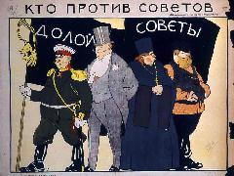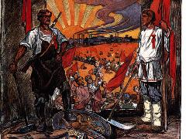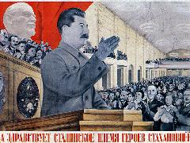

**4-YEAR MA & PHD FUNDING OPPORTUNITY**

**Modern Russian & East European Social/Economic History**

Midlands Graduate School Doctoral Training Partnership

To be held in the Department of History, University of Nottingham

The Department of History, University of Nottingham, invites expressions of interest from suitably qualified Home candidates for a fully-funded 4-year programme of study leading to a PhD in Modern Russian & East European social and/or economic history (from the mid-19th century). Candidates will be expected to demonstrate an excellent record of academic achievement in History, Russian & East European Studies or a related discipline, and potential for completing an original and independent research project in modern Russian & East European history.

The Department will select one or more candidates to co-develop full applications for funding offered through the [Area Studies (Russian and East European) Pathway](https://www2.warwick.ac.uk/fac/cross_fac/mgsdtp/studentships/nottingham/area-studies/) of the [Midlands Graduate School (MGS) Doctoral Training Partnership](https://www2.warwick.ac.uk/fac/cross_fac/mgsdtp/). The MGS is one of 14 accredited Economic and Social Research Council (ESRC) Doctoral Training Partnerships in the UK, and comprises the University of Warwick, Aston University, University of Birmingham, University of Leicester, Loughborough University and the University of Nottingham.

To apply, you must meet the ESRC’s [residency requirements](https://warwick.ac.uk/fac/cross_fac/mgsdtp/studentships/eligibility/) for a full award, intend to study full-time, and have a working knowledge of the relevant Russian & East European language(s).

At the University of Nottingham, successful applicants will join a strong team of PhD and Postdoctoral researchers in Russian & East European History in the [Department of History](http://www.nottingham.ac.uk/history), working under the joint supervision of [Professor Sarah Badcock](http://www.nottingham.ac.uk/history/people/sarah.badcock) and [Dr Nick Baron](http://www.nottingham.ac.uk/history/people/nick.baron). For a list of current ESRC-funded PhD projects in the Department, please see under the ‘Research’ tab [here](http://www.nottingham.ac.uk/history/people/nick.baron).

The MGS Area Studies (Russian and East European) Pathway 4-year programme comprises one year of training in relevant social science research methods (to MA level) plus 3 years of supervised research on an original topic in Russian & East European social and/or economic history (to PhD level).

Candidates who already have an ESRC-accredited MA in History or a cognate discipline, and can demonstrate extensive expertise in social science research methods, may apply for a +3 PhD programme. Candidates without MA degrees and those with a non-ESRC-accredited MA degree may only apply for the 1+3 programme.

MGS Studentships cover fees and maintenance stipend and offer extensive support for research training, as well as research activity support grants.

Application procedure

If you are interested in applying, please contact Professor Badcock ([sarah.badcock@nottingham.ac.uk](mailto:sarah.badcock@nottingham.ac.uk)) and Dr Baron ([nick.baron@nottingham.ac.uk](mailto:nick.baron@nottingham.ac.uk)) as soon as possible before 1 December 2018 (we cannot consider any enquiries or expressions of interest after that date), sending your CV, a one-page note on your preparation and motivation to conduct research to PhD level in modern Russian socio-economic history, and a one-page outline of your proposed research topic. Wecan advise on your eligibility and the fit of your proposed research with our interests and expertise.

If the Department agrees to support your application to the MGS, you will then need to submit an application a PhD place to the University of Nottingham (two academic references will be required) and for funding to the Midlands Graduate School, the deadline for which is **Tuesday 22nd January 2019** (23:59 GMT)

.

|  |  |  |
| --- | --- | --- |
| C:\Dropbox\Sync Folder\ESRC logos\JPG RGB Small with Border.jpg |  |  |