Internationally Educated Students

PGCE Course

A handbook for internationally educated students

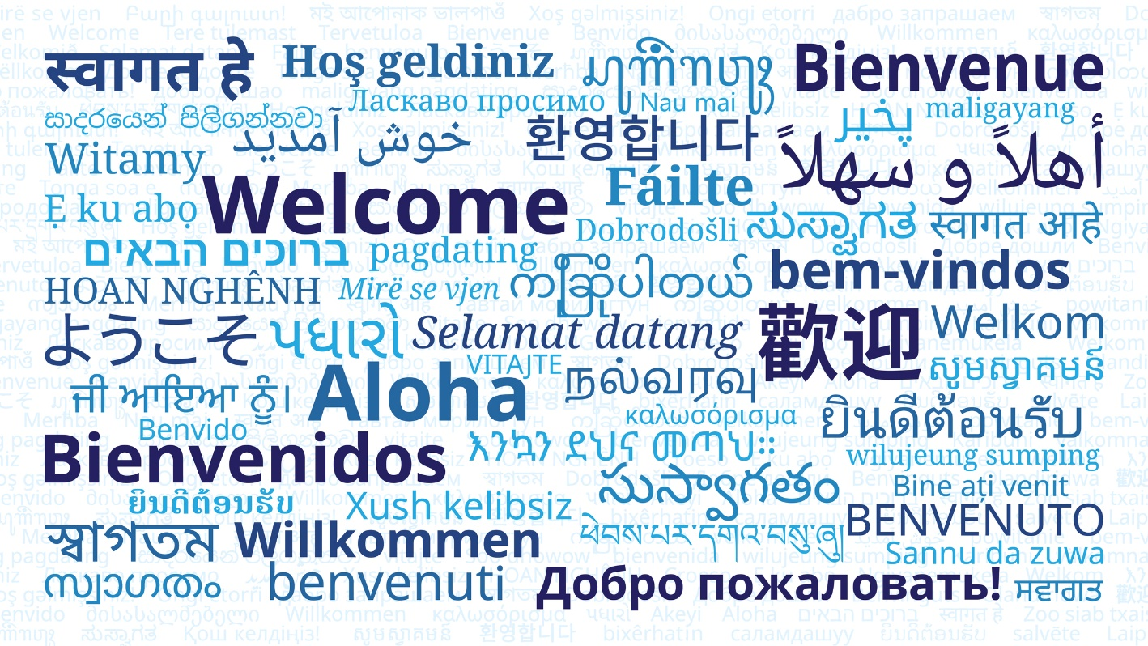

Enriching educational experiences for all

Welcome

We are delighted that you have been offered a place on the one-year PGCE course at the University of Nottingham and know that you will bring a positive energy and diversity, both to the course and to the schools that you will be working in.

Over recent years, we have become increasingly aware of the additional challenges faced by our PGCE students who have not been through the education system in England themselves. To understand, and successfully teach within, the system you need to be aware of its historical background, how education is perceived in society and the meaning of all the terminology.

We have drawn on the experiences of previous students and staff on this course to produce this booklet. Its purpose is to highlight some of the key characteristics of the English education system and to suggest possible ideas and strategies to use during different phases of the course.

We wish you all the best for a busy, successful and productive year ahead.

Support and contacts

Any student starting a new course faces particular challenges, and students relocating to Nottingham from an International context may also experience additional challenges. We would encourage all students to contact their personal tutor for advice and guidance in the first instance. The following contacts may also be helpful:

Secondary course leader Claire Clemmet - claire.clemmet@nottingham.ac.uk
Primary course leader Rachel Peckover - rachel.peckover@nottingham.ac.uk

University of Nottingham Student services
University of Nottingham International Office

Useful websites

Many beginning teachers can feel overwhelmed at the start of the PGCE with the different terminology, acronyms and jargon that surround teaching and learning in schools. The National Curriculum, the different Key Stages, 14 – 19 developments and whole school initiatives can be bewildering and confusing.

The following websites can provide information to help you to understand some of the terminology and latest developments in the English education system as well as providing you with opportunities to explore different teaching and learning styles.

Department for Education | Website with information on current educational issues, qualifications, teaching frameworks, good practice, latest policies
National Curriculum | Can be searched by phase or subject
Times Educational Supplement OR  Schools Week | A wide range of educational articles and resources
Teachers Media videos available on YouTube | Broad range of videos focusing on teachers’ work. Explore videos specific to your subject and consider different teaching and learning styles

Advice from previous international educated students

Drawing on the experiences and recommendations of internationally educated students, you may find the following suggestions useful:

- If you have not had time to complete the activities in this booklet before the start of the course, then complete them alongside your Personal Learning Record – Autumn Term.

- Do not be afraid to ask your mentor/class teacher a number of times for clarification if you are not sure what you are expected to do.

- Make a number of focused observations (any subject), specifically noting the language that is used for instructions, praise and sanctions. Start building up a glossary of key classroom management phrases.

- Ask to be observed very early on in your practice by your mentor or classroom teacher with a specific focus on the language that you are using.

- Sit next to a supportive peer during staff meetings and ask for clarification if you do not understand the terminology used.

- Ask your mentor what their expectations are of you attending before or after school meetings, or joining in with extra-curricular sessions.

- Ask to be videoed teaching a lesson and watch the video together with a supportive peer for constructive feedback on your language/instructions/body language/variety of activities, etc.

- Find out about the praise/sanctions strategies within your department and within the wider school community. Start building up your own glossary of phrases to use based on what you have observed.

- Resources: ask whether you need to pay for coffee/tea, bring in your own milk. Find out where the paper/cardboard/photocopier are kept.

- Ask to be paired up with an experienced teacher for lunch/break duties.

- If you are asked to teach PSHE lessons, ask to observe a number of lessons first and to team teach. You may need support from an experienced teacher to understand some of the issues which are dealt with in the lessons as they can be specific to UK culture.

- Discuss with your mentor/coordinator where you might bring an element of your cultural background into a session to enhance your students’ learning. (e.g. maths lessons in a different language, teaching an introductory lesson in your mother language).

- Stay in contact with other Internationally Educated Students during your placements.

- Talk to your tutor, mentor, coordinator if there are issues worrying or confusing you. These people are here to help you.

Preparing for the PGCE year

As a beginning teacher who has been educated internationally, we are really keen to work together with you over the next academic year to draw on your experiences and insights in order to enhance the experiences of the pupils you teach.
At the same time, we recognise that there will be many elements of the English education system which will be unfamiliar to you and at times very different from the system that you have been used to.
In order for you to have the best opportunity to meet the Teachers' Standards by the end of the course and to feel more comfortable and familiar with your understanding of the education system in England when you embark on the course, you are strongly advised to:
- if possible, arrange a pre-course visit to a school in England prior to the start of your course
- if this is not possible, complete the Virtual Primary School Experience booklet, before the start of the PGCE course. It contains a set of tasks to help you understand what happens in primary schools in England. This is relevant for all beginning teachers, those with a primary or secondary focus.

Complete the following sections of the booklet before the start of the PGCE course. It will help you understand some of the roles within schools, the terminology used and allow you to notice differences between you own educational experience and the context in which you are completing your PGCE course.

Add further to sections of this booklet in the early weeks of the PGCE course to enable you to capture your learning about different aspects of education in this country and understand the difference between your educational experience and the context in which you are learning to teach.

Different schools in England

Types of schools | Definition | Age range
a nursery school

a primary school

a secondary school

an academy

a college

a state school

a private school

a comprehensive
school

a grammar school

Key Stages and year groups: (complete the grid below, filling in the missing information)

 | Age of pupils | Year group at school
KS 1 | 5 – 7 years old | Primary years 1 and 2
KS 2
KS 3
KS 4
KS 5

Policies, Documentation and Exam Systems

Write down your understanding of the following.

Notes
The National Curriculum

Scheme of Work (SoW)

SATs
GCSEs

GCSE for your subject

A levels

Other 14 – 19 qualifications

Understanding language used in schools

Below is a table of some common acronyms, words and phrases used in schools. This is only a start; there will be many more. Complete and add your own as you encounter them.

Phrase/acronym | Meaning
OFSTED
Senior leadership team (SLT)
Head Teacher/Principal
Deputy Head Teacher/Vice-principal
Assistant Head Teacher/Principal
Head of Year
Tutor
Tutor group
Teaching assistant (TA)
Special Educational Needs (SEN)
SENCo
EYFS
Detention
Exclusion
Parents’ evening
The pastoral system
PSHE
PPA time
AfL
B4L
Cover Supervisor
EAL

Comparing perspectives

Consider the similarities and differences between your own education and education in England. Record the information below.

Roles and Responsibilities
Find out what the following roles involve

Role | Role descriptor
SLT:

Subject/Phase Leaders:

Year Leaders:

SENCO:

Higher Level TA:

Designated Safeguarding Lead:

Midday Supervisors:

Technicians:

Reprographics:

Site Manager/ Premises Officer:

Finding out more from teachers

Speak to teachers to find out about the following. Make notes in the first column. In the second column make notes about how the teachers’ responses compare with your own educational background:

Aspect of education | England | Where I was educated
The school’s tutorial and pastoral care system

The dress code for teachers and pupils

Primary

Aspect of education | England | Where I was educated
The subjects and how they are taught in EYFS
The subjects and how they are taught at Key Stage 1
The subjects and how they are taught at Key Stage 2
What happens if a pupil does not make sufficient progress in a year?

Secondary

Aspect of education | England | Where I was educated
The subjects and how they are taught at Key Stage 3

The subjects and how they are taught at Key Stage 4

The exams taught in your subject at Key Stage 4. Which exam board is used for your subject? Get a copy of the exam specification.

The subjects and how they are taught at Key Stage 5. Which exam board is used for your subject? Get a copy the exam specification.

What happens if a pupil does not make sufficient progress in a year?

The role of the teacher

Whilst you are observing classroom teachers, make notes on the following. Please add your reflections as to how this is similar/different from the role of the teacher where you were educated.

Observation | England | Where I was educated
When their day begins and ends

What duties they do in a typical week

What are the different aspects of a teacher’s role

What they do if a student misbehaves?
What are the departmental and whole school rewards and sanctions policies?

What they do in free periods and PPA time?

What extra- curricular or lunchtime activities are they involved in?

What does this teacher do if they are ill and needs to be absent from work? What should you do?
When and how does the school communicate with parents?

What meetings are you expected to attend? Write the dates in your planner/diary.

Classrooms in England

Drawing on your pre-course tasks and the early days in your placement school, consider the following:

Observation | England | Where I was educated
How committed are
the pupils to learning?

The types of activities in the classroom (active/
passive/ physical etc.)

How the teachers relate to the pupils (formal/ informal/tactile/ positive/ negative)

Are groups mixed ability or in ability sets?

How much is
the textbook used in
lessons?

How do teachers praise/use sanctions with pupils?

What work is produced by the pupils?

How do pupils behave? What is their attitude to learning?

How is work marked?
What comments are made? Are levels or grades used?

How many pupils are in a class?

