Initial Primary School Experience Booklet
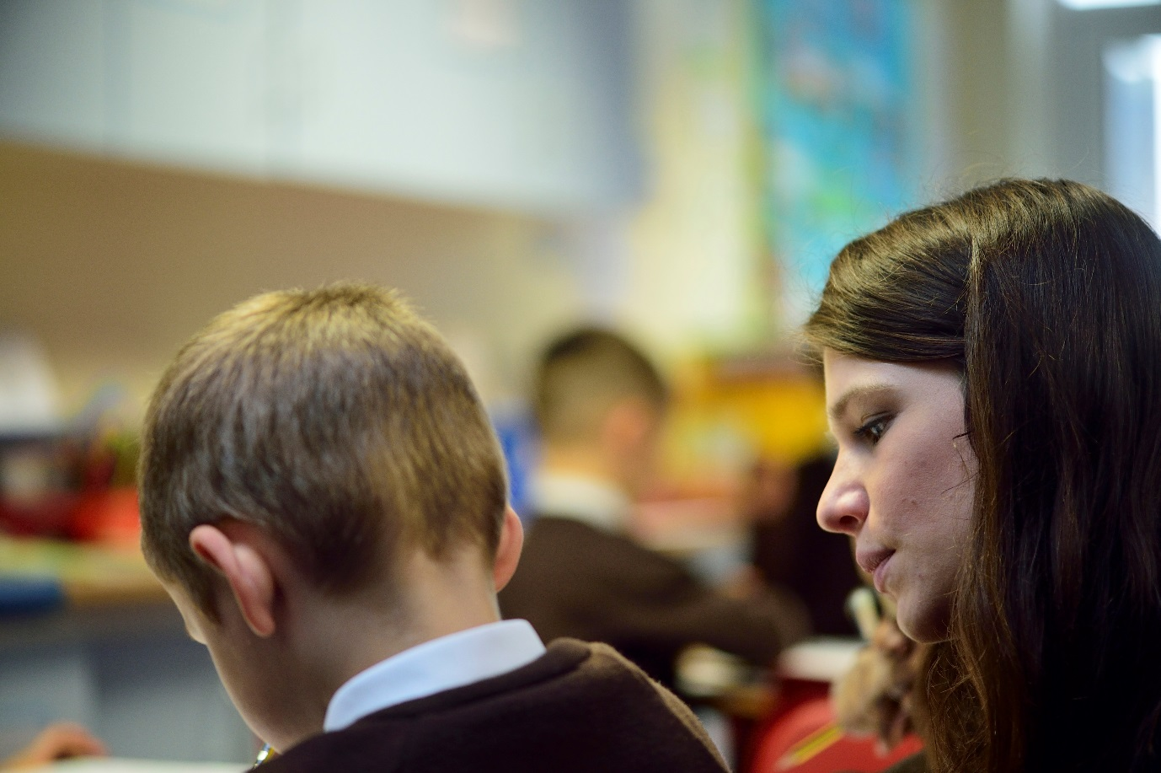

Name of beginning teacher: ……………………………………………………………………………….

Teaching Experience

This booklet is intended to prepare you for the beginning of the PGCE Primary course by giving you the opportunity to focus on some key aspects of teaching and learning and the role of the primary teacher.
You need to arrange to observe in a primary school for three days during the week beginning 2nd September. The days do not have to be consecutive. If possible, you should also try to gain any additional school experience in the summer term. You could refer to the tasks in this booklet then too.
Make sure you read through all the tasks before you visit so you can think about how best to organise your time. However, you may need to be flexible in when you carry out the suggested tasks, depending on the circumstances you find in your school. Please do not worry if you cannot carry out the tasks in precisely the manner set out here but please do as much as you can. Primary schools are hectic and dynamic places where you learn to be creative and adaptable! Also, try to visit more than one classroom and age group if possible.

The teacher’s day

Spend a day shadowing a teacher, attending and observing everything that the teacher does as part of the school day. Note the activities they are engaged in, including their engagement with parents, how they get ready for teaching, dealing with a playground incident, managing transitions between lessons, and how they spend their break and lunchtime.

- Make a list of all the activities. [e.g. setting up activities, teaching, reminding pupils of rules and routines, pastoral care of pupils, photocopying, checking and gathering/ organising equipment including sharpened pencils and workbooks, lesson planning, marking, liaising with other members of staff…]

- Estimate the time spent on each type of activity.

- Ask what further work will be done during the evening and add those activities to your list.

- What do you notice about the roles and responsibilities of a primary teacher?

Lesson observation(s)

This observation guide is designed to help you reflect on the lessons you see. You will not answer all questions in all lessons and not everything will be evident in every lesson. Highlight several questions before the lesson that you want to explore. Aim to look at different questions for each observation you are able to carry out.
Subject and focus of lesson:

Age group of children: | Number of children:
Highlight questions to focus on: | What do you notice? How is what you observe supporting learning?
The start of the lesson:
How does the teacher introduce the lesson objective?
How does the teacher check prior knowledge and/or learning from previous lessons?
Does the teacher do any modelling?
Is there any questioning? What type of questioning is it? Which pupils speak? How are responses encouraged from the children?
What is the balance of teacher/child talk?
What subject specific vocabulary do you notice the teacher/children using?
Behaviour for learning:
What strategies does the teacher use to gain the children’s attention and settle them?
How does the teacher keep children engaged?
What does the teacher do if a child is not paying attention?
What strategies does the teacher use to manage transitions from one part of a lesson to another?
How do children access resources?
How does the teacher support children to stay on task?
What ‘rewards’ does the teacher offer? (praise, eye contact, words, tangible rewards etc.)
What sanctions does the teacher use? (frown, naming, etc.)
Independent or group work
How do the children know what they will be doing?
What sorts of tasks are they doing?
Does the teacher work with one child at a time, a small group or large groups?
How do the other adults in the classroom work and with whom?
How are the children grouped?
The final stage of the lesson
What learning does the teacher revisit?
Which children report back on what they have learnt?
How do children know how well they have done?
How long does this phase of the lesson last?
What do other adults in the class do?
Is there homework?
Is the next lesson referred to?
Other:

Primary English

There may be words or phrases which are currently unfamiliar to you, so make sure you ask what these mean.

Reading
- What reading scheme(s) does the school use?
- What other reading resources/provision does the school have? (e.g. digital texts, class library, school library, book clubs, reading interventions, reading volunteers)
- Explore the reading environment in the school and classrooms. How is reading for pleasure promoted?
- How is home reading encouraged?
- Observe a shared/guided reading session (this might be with a group or whole class), using the template on the next page. Afterwards, discuss with the teacher what the next steps in learning might be for the children in the group.

Phonics
- Find out how phonics is planned and organised (e.g. do teachers follow a prescribed scheme? What other resources do they use? How are children grouped for phonics? When does phonics teaching and learning happen?)
- What provision is made for children needing extra support in this area?
- If you have time, observe a phonics lesson, using the template on the previous page. Afterwards, discuss with the teacher how they assess the children’s learning within a lesson and across lessons, and how they use this to inform their teaching.

Shared/guided reading observation template

Selected Text:

Reading focus (what aspect of reading is the teacher wanting the children to develop?):
Before reading | How does the teacher introduce the text, and the focus of the session?
During reading | What is the role of the teacher? children?  What questions are being asked/ answered?
After reading | How do any follow up activities support children’s reading?

Primary mathematics

This template is designed to help you to identify specific strategies that teachers employ to ensure children develop and extend their mathematical understanding. Use it flexibly, recording any aspects of maths teaching you are able to observe.
Observation focus | Example/ Notes
Questioning to elicit understanding (focusing on children’s conceptual understanding)

Questioning to promote mathematical reasoning

Choice of mathematical examples for children to develop understanding of calculation strategies and sequences of examples to promote understanding of calculations
Use of physical equipment
(manipulatives) and ICT to illustrate, model and explore mathematical understanding (e.g. using Dienes, PV counters, Numicon)
Teachers' subject understanding that enables connections to be made with other mathematical areas

Children's ideas to be linked and developed to ensure conceptual understanding

What mathematical talk is evident?

- Does this go beyond simple
question ->response?

- Is there deep discussion of the mathematical ideas or processes?
What systems does the class teacher use to assess children's understanding?

How does the teacher ensure a comprehensive record keeping system to record pupil progress?

The role of additional adults

Arrange to shadow an additional adult (e.g. Teaching Assistant) who is supporting learning during a whole class lesson.
- How does the class teacher decide which children the additional adult works with?
- How does the additional adult know what their role is in the lesson and what the children they work with are meant to learn?
- How does the additional adult report back to the teacher about the learning of the children they have worked with?

Getting involved

As well as completing the tasks one to five, spend some of your time interacting with the children. Negotiate with the teacher how you get involved in their learning. The following suggestions may be helpful:

- Help children with work set by the teacher

- Hear individual children read – ask for guidance from the teacher

- Join the teacher in any activities outside the classroom, e.g. playground duty or clubs

- Talk to and listen to children

- Supervise a small group of children during a group activity

- Read a story to the class. This should involve you thinking through the process of how to read the story and engage the children. Will you use voices with younger pupils or cliff hangers with older pupils? What types of book will you choose? How will you tackle tricky vocabulary or ideas?

Written Reflection (at the end of the three days)

Look back on all your school experiences and write a reflection.
- To begin with, try to focus your reflection on the following prompts
- I saw good teaching when…
- I thought it was good because…
- The best learning experience I saw was…
- I am most worried about…
- I would really like to learn how to…
- I would really like to try to…
- Then, reflect back on the group task you may have been involved in during your interview for the course. How have your thoughts changed towards any of the statements below and why?

- A good teacher always demonstrates enthusiasm for the subject they are teaching
- A good teacher is well-prepared, organised, and manages their time effectively
- A good teacher fosters an environment where pupils are encourages to think critically and ask questions
- A good teacher builds positive relationships with all pupils
- A good teacher establishes a classroom culture based on high expectations for all pupils

