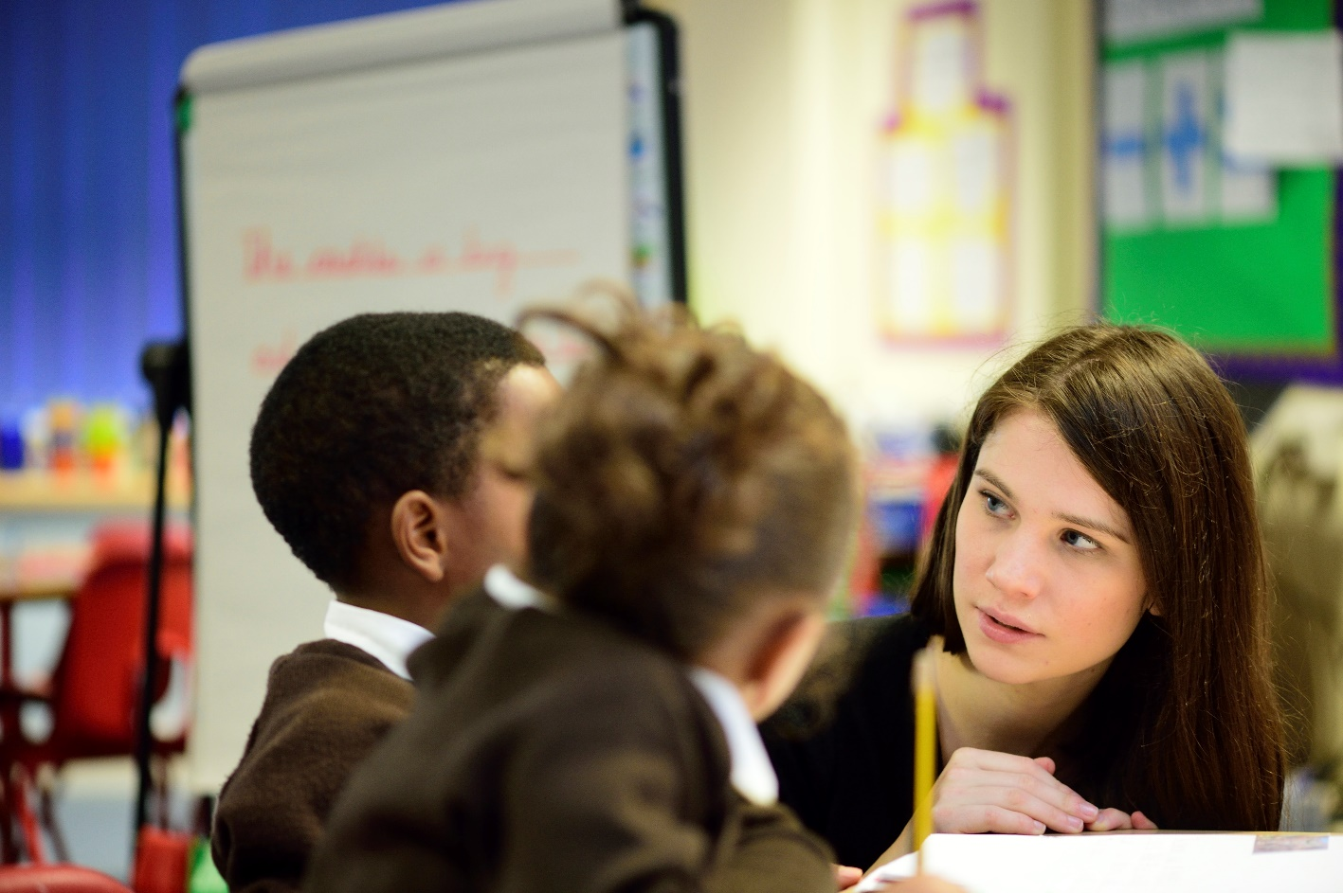

School of Education

PGCE

Pre-Course Virtual Primary Experience Book

Introduction

We expect all students who will be taking up a place on the PGCE course in August 2024 to spend some time developing their understanding of the primary phase prior to starting the course. Our students are normally required to organise 3 to 5 days experience in a primary school in order to do this but we are aware that this might not be possible for all. The aims of this ‘Virtual’ primary experience booklet are to give you an awareness of secondary pupils’ previous experience of school and to develop an understanding of issues concerned with the transition from primary to secondary.

We have set out below the purposes of primary experience in some detail to give you a clear idea of the value of spending some time in a primary school before embarking on a secondary PGCE. These purposes remain the same as you work through this booklet.

In general, the experience should allow you to:

- gain an increasingly sophisticated understanding of the complexities of what it is to teach effectively, including understanding: pupils, teaching, schools and the curriculum;
- think about your own experience of schooling and how this relates to yourself as a beginning teacher.

Specifically, the tasks you undertake will lead you to:

- consider your own thoughts and preconceptions about primary schools;
- develop an understanding of a school in its community;
- develop an understanding of the complexities of the teacher’s role;
- begin to collect evidence about how your particular subject – English, geography, history, mathematics, modern languages and science – is addressed at Key Stages 1 and 2;
- consider the transition from primary school to secondary school, and continuity from Key Stage 2 to Key Stage 3;
- explore how child protection and safeguarding is addressed in primary schools.

What does a ‘virtual’ primary experience involve?

During the course of your experience you will collect and record information and impressions from a number of short tasks that will be relevant to the first phase of your secondary ITE course:

- your experiences and preconceptions
- the primary school in its context
- finding out about your subject at Key Stages 1 and 2
- finding out about Literacy and Numeracy
- introduction to teaching
- transition from primary school to secondary school
- beginning to reflect on your learning and looking to the future
- considering the policies around safeguarding for your work as a teacher.

You are required to make and keep notes in relation to the tasks; the exact format of the task is indicated on the task sheets. You are not expected to write in essay format or at great length for any of the tasks. Most of the notes that you make will be in bullet point fashion, but there are some tasks that require a slightly longer response. You will need to bring these notes and the various documents to sessions and tutorial discussions during the first weeks of the PGCE course and eventually they will be included in your Professional Development Portfolio.

Possible readings to explore

The Cambridge Primary Review, published in 2009 was the result of a comprehensive survey of primary education at a time when a new curriculum was being planned. Although some of its recommendations were not implemented, it remains a valuable overview of issues within the primary phase.

You may also find this keynote lecture by Robin Alexander of interest.

When considering how to meet the needs of all pupils in your classroom, the following will provide insight and guidance:

Primary Schools responding to diversity: barriers and possibilities

Vulnerable children: needs and provision in the primary phase

How will primary experience be followed up on the PGCE course?

Your notes and reflections on primary experience will be followed up and developed through lectures, tutorial discussions and possibly a group presentation. The tasks in this booklet also serve as an introduction to the more extensive observations you will be required to complete for your Personal Learning Record during the Autumn Term.

Primary School Experience Tasks

Name:
Subject:

In completing these tasks please note the following:

  - recording your information in bullet point fashion is totally acceptable;
  - there is no need to copy out or word-process your notes;
  - record your notes on these sheets, but please feel free to add extra sheets. For certain tasks you are specifically asked to attach further information.

Task 1: Experiences and preconceptions

Before you begin your Primary School experience try to record some of your own memories of your own time in primary school. For example, do you remember any of the teachers - if so why? Can you remember some of the things you did and how you were taught?

What preconceptions do you have about primary schools today?

Task 2: The Primary School in its context

For this task identify a primary school in your local area or a primary school you know well (this could be your own primary school or a school where a friend or family member works).

Find out about the school and its context by doing as many of the following as you can:
  - look at the school’s website
  - read the school’s latest OFSTED report
  - go to Compare the performances of schools and colleges in England and find the school’s performance data
  - find out about the proportion of children eligible for Pupil Premium funding and how the school uses the funding

Task 3: Educating the whole child

Every Child Matters was a major policy of the Labour government that changed the ways schools work and teachers function within them. Following the tragic death of Victoria Climbie, a damning report on the failings of the various services involved was
published. The Every Child Matters green paper in response to the report resulted in the Children Act of 2004. Following on from this, the Coalition government commissioned reports by Professor Eileen Munro in 2011 and 2012 reviewing child protection, resulting in further reforms and changes to statutory guidance.

Schools play a key role in the life of a child and so have a safeguarding responsibility to the children in their care. In 2016 the Government produced further statutory guidance for schools which can be found in the Keeping children safe in education document.

Make some notes about the key messages in Part One of the Keeping Children Safe in Education document. Explore the Safeguarding policy for the school – this should be accessible from their website.

Task 4: Observing primary lessons – watch the two short lesson excerpts

Watch two short lesson excerpts:

Teachers TV: practically science

Teachers TV: primary maths- shape and space

Make notes on the following:

- How the teacher engages the learners
- How the teacher shares the learning intentions
- How the teacher differentiates the learning
- How the teacher gains the attention of the class
- How the teacher gets feedback on pupils’ learning
- How the teacher use group work
- The teacher’s use of positive praise

Task 5: Teacher observation

Watch the following YouTube video A Day in the life of a primary school teacher before completing the following task.

Make some notes on the class teacher’s working day. What sort of preparation is required? Make notes on ‘behind the scenes’ work done at school before and after the school day and also what the teacher does when she is not teaching.

Task 6: Finding out about your subject at Key Stage 2

How is your subject being taught and delivered in the primary school curriculum?

Outlined below are some subject specific questions and issues that we would like you to find out about. Just concentrate on your subject area.

Record your notes on a separate sheet and include with this document.

English

Look at the English National Curriculum for Key stage 2 and the summary and main findings of Ofsted’s Review of English teaching
  - How is English taught? Is it as a discrete subject or integrated across the curriculum?
  - Talk to the pupils about their perceptions of English as a subject.
  - Try to observe work in each of these areas of the curriculum: speaking and listening; reading; and writing.
  - What texts are used and what are the principles for choosing these?

Geography

Gather information on the place of geography in the primary school. In order to do this you will need to look at the National Curriculum Key Stages 1 and 2 and talk to the geography coordinator in the school. You may also be able to observe some geography being taught.

Consider the following:
- How significant is the teaching and learning of geography in the primary school?
- Is it identified and taught as a discrete subject or are aspects of it taught through topic work?
- What factors have impacted geography in primary schools? Have these had a
  - positive or negative effect?
- What type and range of resources are available to teach geography?
- What is the contribution of fieldwork to pupils’ geographical learning?

History

Look at the history National Curriculum for Key Stage 2. You will also need to talk to the history coordinator. If possible, try to observe some history being taught.

    - What sort of history is being studied? What skills and concepts are being developed? Find out how history is being taught. Is it a discrete subject or is it taught through literacy work or through topic lessons?
    - Look at the range of historical enquiries pupils are involved with.
    - Draw up a list of the variety of sources that pupils use.
    - Try to find out what the pupils most enjoy about history.
    - How much time is being allocated to the teaching of history?
    - What resources are available to teach history?

Mathematics

Look at the mathematics National Curriculum for Key Stages 1 and 2. Through reading, observation and conversation with teachers, try to find out:

- Where pupils do mathematics in other areas of the curriculum.
- How are the children grouped for their daily mathematics lesson? Why are they grouped like this? How does this affect their learning?
- What different approaches and styles of teaching are used for mathematics lessons? How do different styles benefit the learners?
- What range of resources does the school use for teaching mathematics?
- Discuss with teachers how they implement curriculum changes and where difficulties arise.

Modern Languages

The government made modern languages a statutory subject at Key Stage 2 from September 2014. Look at the languages curriculum for Key Stages 1 and 2 and find out how well-equipped teachers are for this development.

- Does the school allow for progression of skills and content across KS2?
- Which languages are taught, why and how?
- How many languages are spoken by the pupils in the school?
- How is Global Citizenship represented and explored in the curriculum?
- How is transition planned for in terms of modern languages progression at school?

Science

Using both your observations and discussions with appropriate members of staff, try to find out about the following areas:

- What information about achievement in science is given to the middle/secondary schools that take pupils?
- How does the school organise and co-ordinate the teaching of science? What roles do various teachers have?
- How is the National Curriculum programme of study used? For example,
  - has the school developed their own Schemes of Work or do they use a published scheme?
- Which teaching strategies are used for teaching science?
- What kinds of practical work, including investigations, are pupils engaged in and what resources and equipment are available to support this?
- Is there any contact with the local middle/secondary schools concerning the nature and the continuity of teaching of the science curriculum?

Task 7: Early Reading

Find out how reading is taught across the school. Please also read the summary of the Rose Review on the teaching of early reading and The Reading Framework (2023)

Task 8: Introduction to planning

Pick a Key Stage 2 topic in your subject area and think about how you would approach teaching that topic to a year 5 class.

You should decide what your aims are for the teaching, what activities you would like the pupils to do and the learning outcomes that the pupils should achieve as a result of carrying out these activities. You will find it helpful to write out a step-by step plan for what you will be doing with the pupils, with approximate timings.

Use the space below to record your planning for the lesson.

Task 9: Transition from primary school to secondary school

Watch this short video about transition from primary to secondary school from the pupils’ perspective Transition Tales

Read this report Children, their voices and their experiences of school

Make some notes on:
  - pupils’ perspectives on their primary school experience
  - the transition from primary to secondary school (page 16-18).

Task 10: Reflecting on your learning from this ‘virtual’ primary school experience and looking to your future career as a secondary school teacher

As you approach the end of your virtual primary school experience, look back on your responses to Task 1 and reflect on how your understanding of primary education has developed by completing this work.

Taking account of your learning from this work related to primary schools, what do you think you will need to consider as you begin your career as a secondary school teacher?

