Database searching worksheet

Activity 1: Accessing databases via NUsearch

NUsearch is the portal for searching all our library resources and subject specific databases.

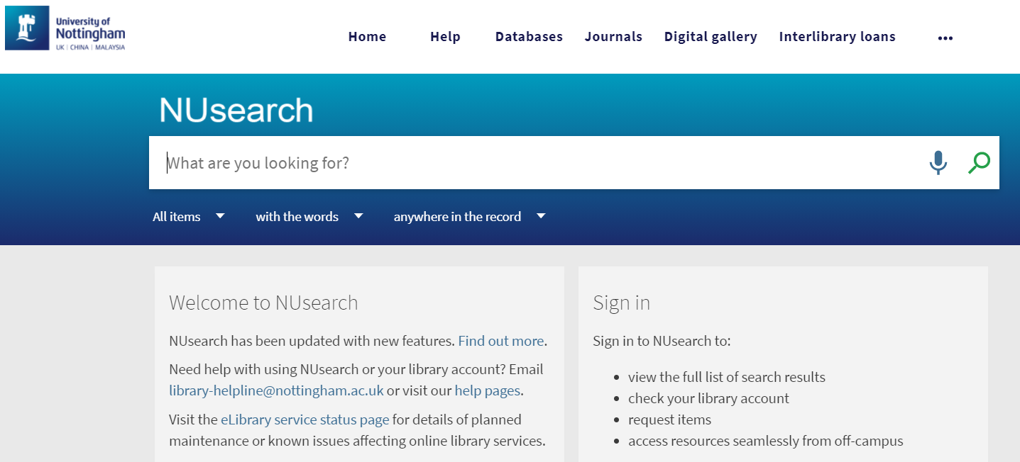

Click on Databases on the top menu. To find a database, enter the database name in the search box, or click on the first letter of its name, or browse by subject category.

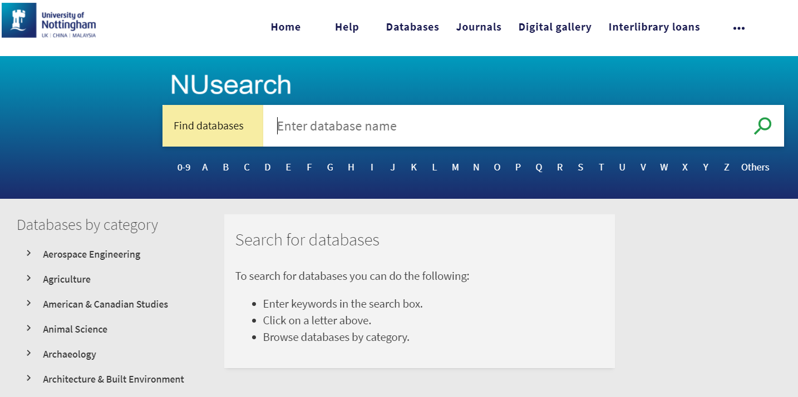
Activity 2: Developing a search strategy

If you have already developed a search strategy, try it out on some of the databases listed in the activities below. If not, use the worksheet to plan a search strategy using your own area of research interest.

Topic/question/problem
Write your topic/question/problem and underline the key concepts.

Synonyms
Write a key concept into each box in the top row, and in the column beneath, list as many synonyms/alternatives you can think of. Remember to include singular/plural, acronyms, newer/older terminology, US/UK spellings/terminology and technical terms.

[Concept 1] | [Concept 2] | [Concept 3] | [Concept 4]

Search operators
Look at your synonyms above and consider how you might streamline the search to combine with Boolean operators (AND, OR, NOT). Consider other techniques, such as:

- truncation/word stemming (e.g. analy*)
- wildcards (e.g. wom#n, organi#ing, p?ediatric, tumo?r
- exact phrase searching “…” (e.g. “modern slavery”, “ethnic minority”)
- word adjacency/proximity searching: NEAR/n, ADJn (e.g. cancer NEAR/2 therap*)

Limits
Think about any limits that might apply to your topic/question/problem.

Date range | Language | Material type | Other?

Broadening/Narrowing
Consider how you might broaden/narrow your search if you find too few/too many references.

Broadening search | Narrowing search
e.g. think of more synonyms, remember to use truncation | e.g. add more precise concepts, apply more limits (e.g. age/review articles)

You should now be ready to start entering your search on the database of your choice.

Activity 3: Searching Web of Science

Web of Science is a multidisciplinary database, covering sciences, social sciences as well as arts and humanities. It is big and broad, with coverage going back to 1900. Web of Science relies on keyword searching, so it’s important to use as many synonyms and related terms you can think of, as well as remembering alternative word endings.

- Use the OR function to search for related terms, e.g. literacy or education
- Use the * (wildcard) for alternative word beginnings or endings, e.g. *engineer*
- Use quotation marks for phrase searching, e.g. “learning disabilit*”
- Use near/n for adjacency, e.g. family near/2 therap*

Undertake a topic search using your research question from Activity 2. Alternatively, use the example search given in Web of Science to search for oil spills in the Mediterranean (oil spill* mediterranean).

Ensure that each search is coherent when typing words and phrases into the search box.

View and combine previous searches by clicking on Search History, then:

- Use OR, to bring together your alternative terms/synonyms; and
- AND, to find results containing both/all your search topics (e.g. “brain injury” AND rehabilitation).

On the results page, use the Refine Results to the left of the screen. Try refining your search by Year, or Document Type (e.g. Review).

To save your results, place a tick next to any of interest to add them to your marked list. Then click the Add to marked list link before moving to the next page. Once you have ‘marked’ all the references you need, click on Marked List at the top of the screen.

You can print, save and email results either from the initial results display or the Marked List. For exporting records, choose Save to EndNote desktop (if you have it installed on your own device) or Save to EndNote online (for the web version).

Consider registering for a personal account within Web of Science. This allows you to save your search history and to create and manage alerts.

Activity 4: Searching Ovid databases – MEDLINE, PsycINFO and Embase

To get the full search functionality of these databases it is important that you only search one database at a time. You can try re-running searches on the different databases later, if appropriate. Search for the keywords identified in Activity 2, if the topic is relevant.

To enhance your search, make use of Subject Headings, e.g. MeSH terms in MEDLINE, APA subject terms in PsycINFO and Emtree in Embase.

Make sure that the Map Term to Subject Heading box is ticked.

Search for each individual term one at a time from your list of synonyms, building up a list of search lines.

Once you have searched for all of your concepts, combine them using OR and AND, as appropriate.

In Ovid, remember:

- ADJn is used as the proximity operator
- When searching for keywords, untick the Map Term to Subject Heading box first
- Left-hand truncation is not used in Ovid databases

Combine search lines from your keyword (free text) searches and Subject Heading searches using OR, to bring together synonyms i.e. similar ideas/keyword phrases. Then use AND to bring together your separate concepts into a single results set.

Use the Limit your search options to limit your search to humans, English Language, review articles, date range or age group. Additional limits are worth checking.

The Export button (above the results display) allows you to save your search your results to referencing software e.g. EndNote or Mendeley. Your results can also be printed, emailed or saved in other formats.

You can set up a personal account within Ovid. This allows you to save your search history, so that you can re-run searches at a later date. The Search History option appears above your search. There is a Save All button under the search box.

Activity 5: Searching EBSCO databases – e.g. CINAHL, SPORTDiscus, Business Source Premier

On EBSCO databases, use the Suggest Subject Terms or Thesaurus options to run a search. Add each term/phrase one at a time into the search box. For example:

back pain
treatment outcomes

Combine the resulting sets using AND. View the results then use the options on the left hand side to refine your results.

Add any results you want to save or export to referencing software, using the Add to Folder icon on the right. Go to the Folder view.

Choose Export. Then select the option required using the radio buttons e.g. Direct Export in RIS Format (includes EndNote).

You can set up a personal account within EBSCO. This allows you to save your search history and to create or manage alerts.

Activity 6: Searching ProQuest databases – e.g. ASSIA

On Applied Social Sciences Index & Abstracts (ASSIA), use the search terms:

addiction NEAR/3 (drug* OR opiate*) AND teen*

Alternatively, select an appropriate database and use your search terms from Activity 2.
The Advanced Search option allows you to combine complex search strings with the operators AND, OR and NOT.

View the results. Then use the options on the left hand side to refine your results.

Select any records you want to export into referencing software. Choose the All save options icon on the upper right (above the results), then select the appropriate export option. The Export/Save to RIS option works with EndNote.

You can set up a personal account within ProQuest. Choose Save search/alert options to save your search history and to create or manage alerts.

Activity 7: Searching Scopus

Scopus is similar to Web of Science and has wide coverage in a range of disciplines and also includes books in addition to journal articles and conference papers.

Search for “cognitive architecture*” AND robot*

You can also try out your search terms from Activity 2.

Then view the results. Use the options on the left hand side to refine your search.

Select the records you want to save by highlighting the tick box.

Choose Export to transfer your selected results into referencing software (e.g. RIS format – EndNote).

Specify the record fields that you want to include in the data export.

You can set up a personal account within Scopus. This allows you to save your search history and create or manage alerts.

For further help, please contact the Library Helpline: library-helpline@nottingham.ac.uk

