Case Study (I)
Report upon an Outbreak of Cholera in the Ilkeston Urban Sanitary District
by Dr. S. W. Wheaton, 1893 (Medical Rare Books WC264 FAR: pp 145-147)
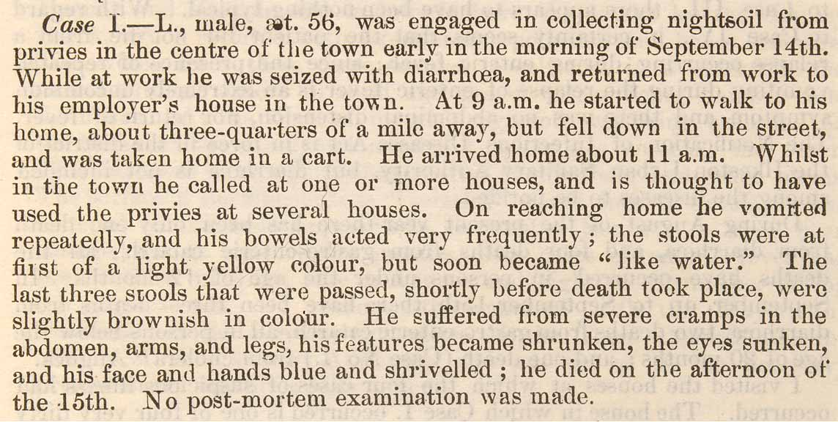
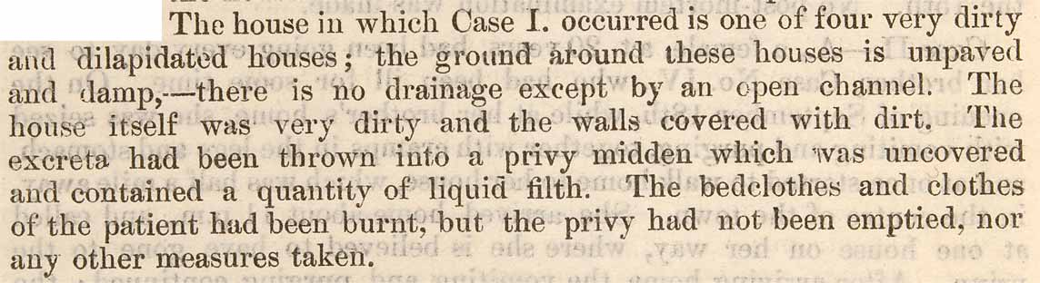
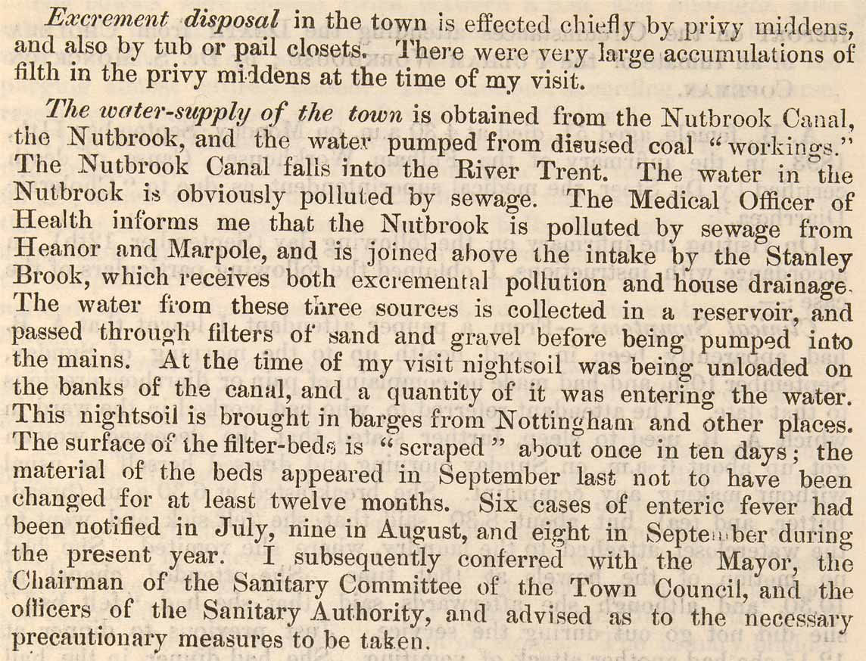

Case Study (II)
Report upon an Outbreak of Cholera in the Ilkeston Urban Sanitary District
by Dr. S. W. Wheaton, 1893 (Medical Rare Books WC264 FAR: pp 145-147)

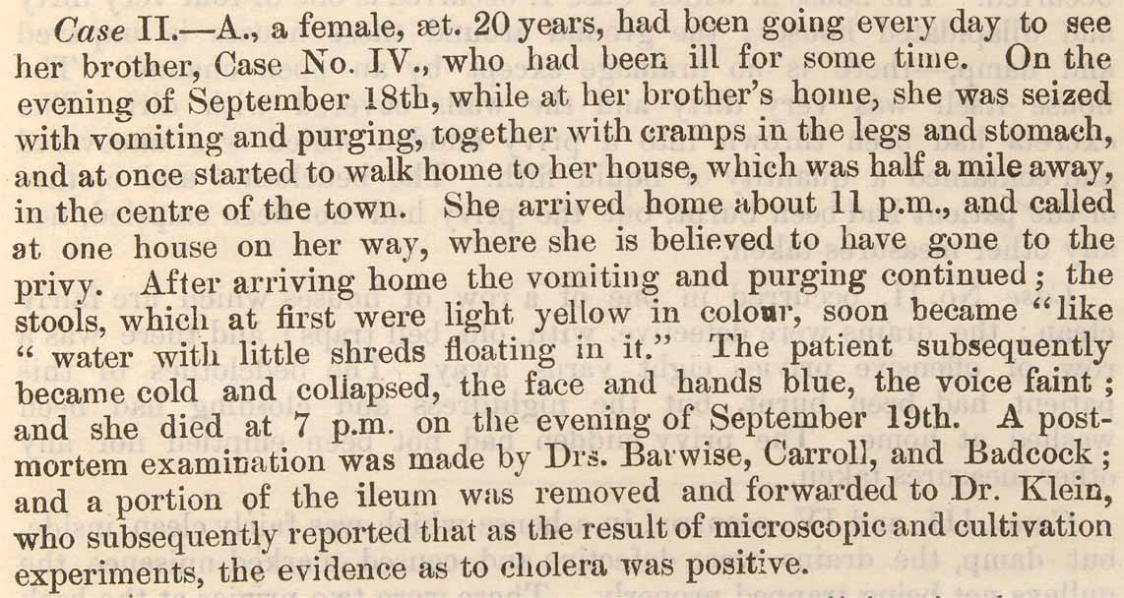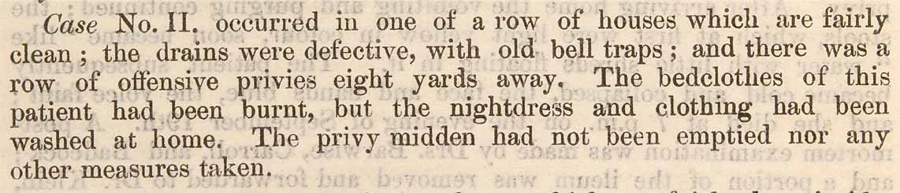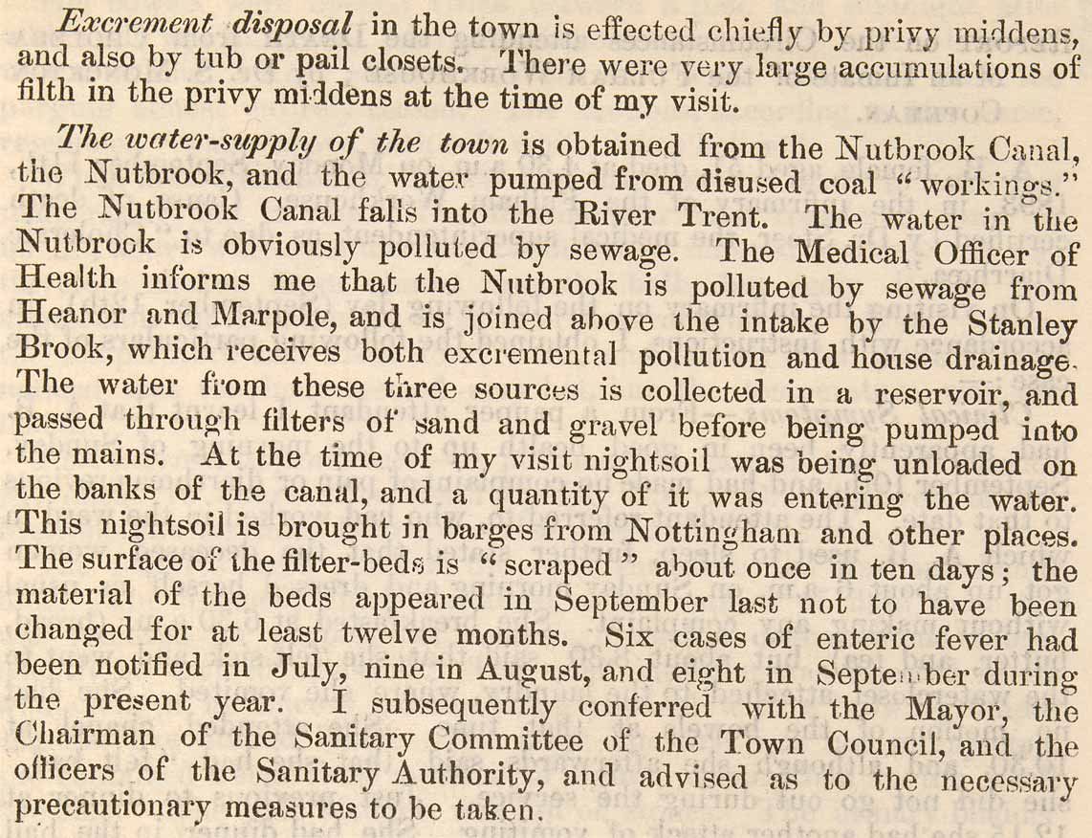

Case Study (III)
Report upon an Outbreak of Cholera in the Ilkeston Urban Sanitary District
by Dr. S. W. Wheaton, 1893 (Medical Rare Books WC264 FAR: pp 145-147)

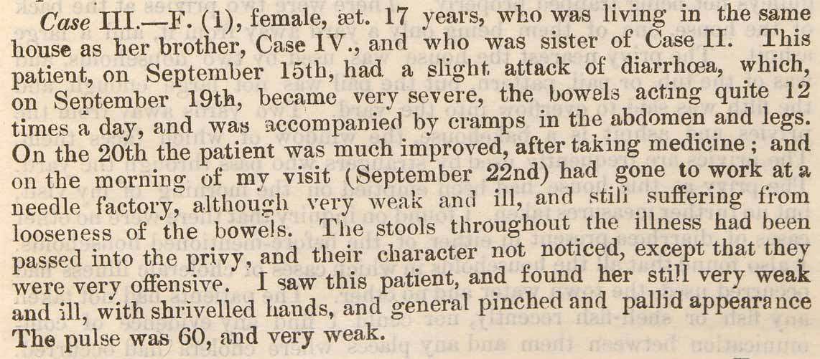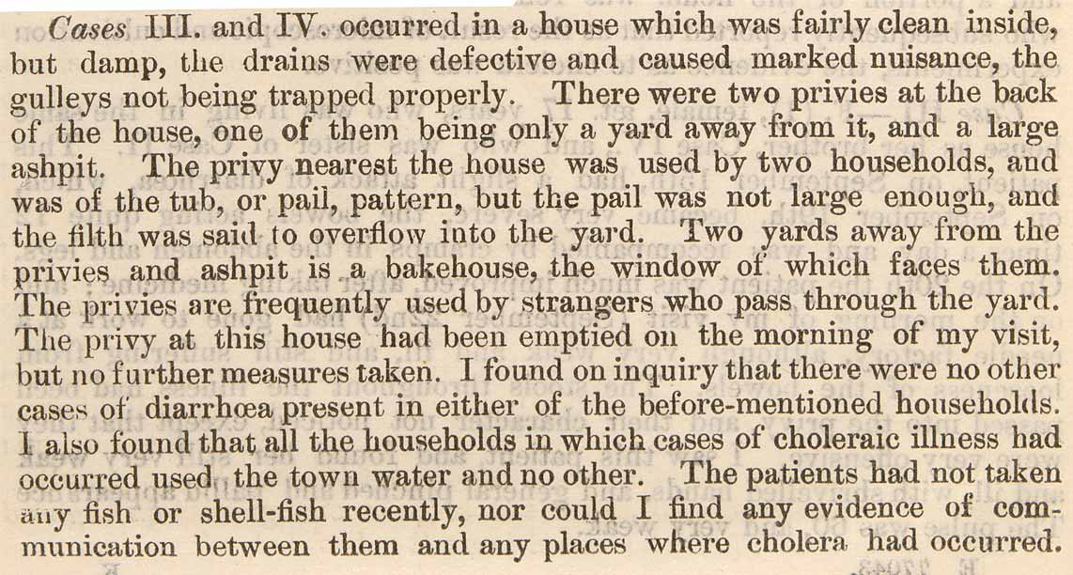

(cont)
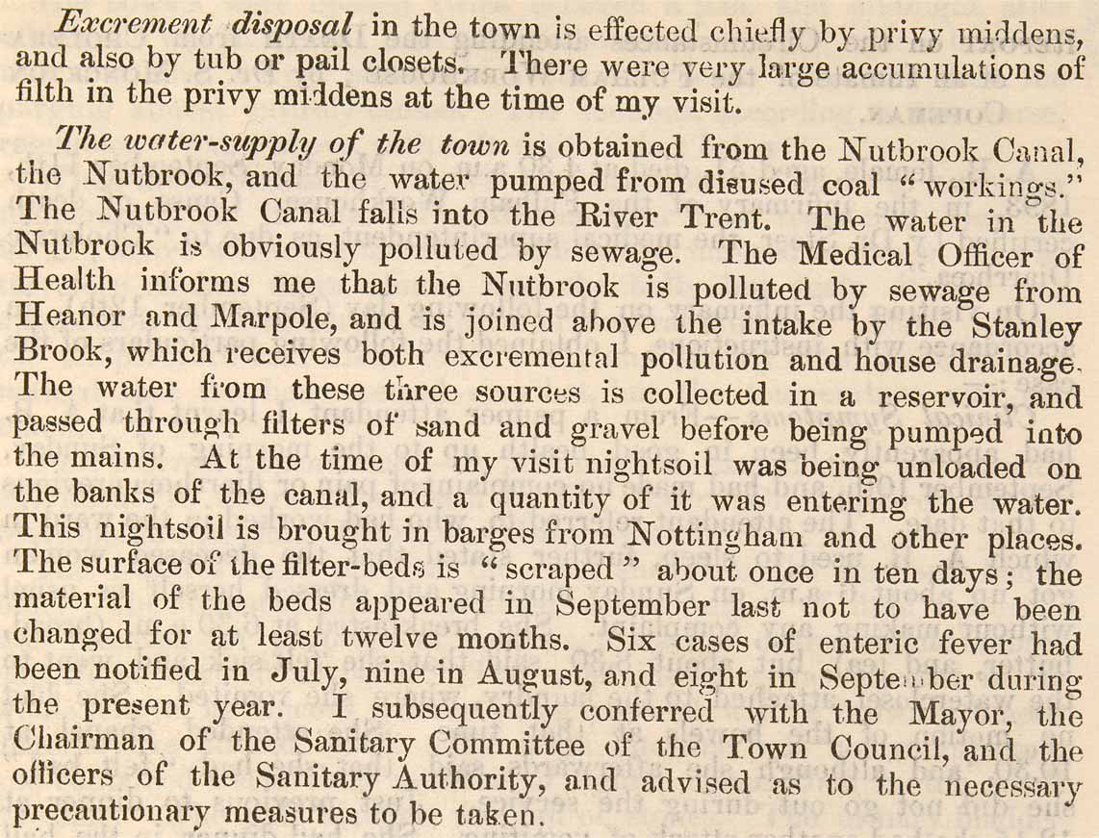

Case Study (IV)
Report upon an Outbreak of Cholera in the Ilkeston Urban Sanitary District
by Dr. S. W. Wheaton, 1893 (Medical Rare Books WC264 FAR: pp 145-147)

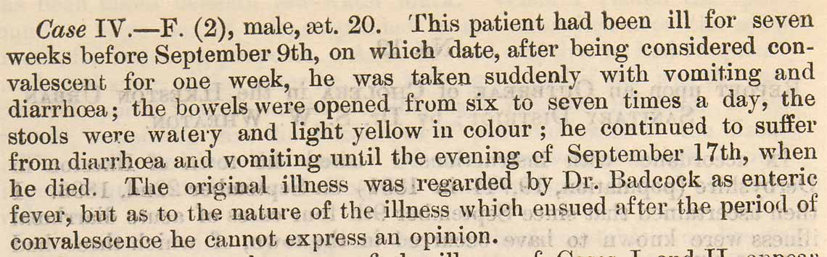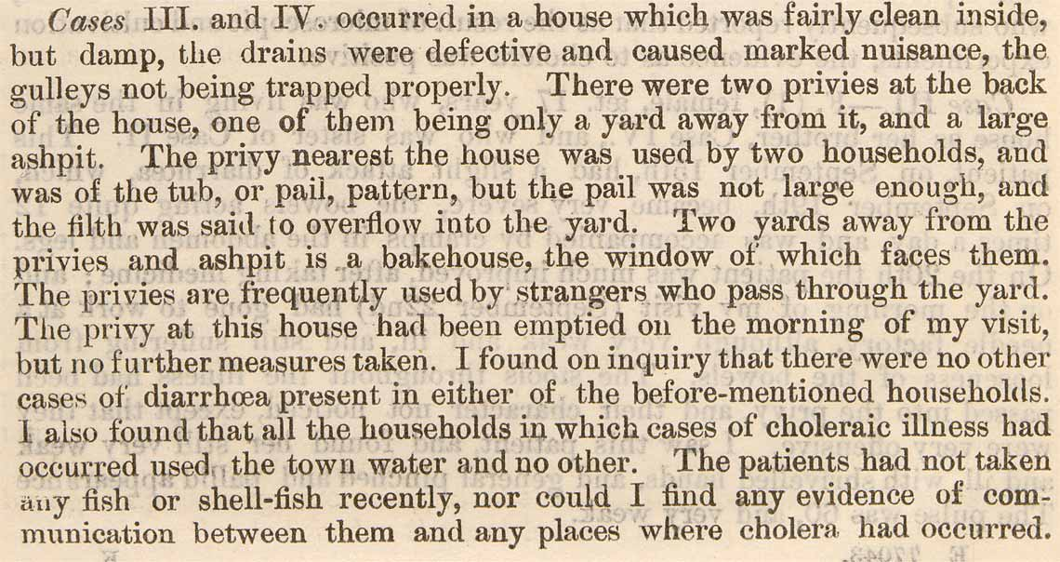

(cont)

