Public Health and Housing - lesson plans for teachers

Lesson 4 – Thomas Hawksley

Enquiry Question
How much did the inhabitants of Sun Street owe to Thomas Hawksley?

Aims

Gain an understanding on why water and sanitation reforms were introduced

Use original documents to explain the impact these reforms had on living conditions

Resources
- Picture 1 - Portrait of Thomas Hawksley, by H. Herkomer A.R.A. (1887), reproduced by Thos Kell and Son in Memoir of Mr. Thomas Hawksley: Excerpt [from] Minutes of Proceedings of the Institution of Civil Engineers. Vol. 117. Session 1893-94. Part 3 (London, 1894) (East Midlands Collection Pamphlet Not 3.V38 HAW)

Picture 2 - Woman collecting water from a communal water pump on Malt Mill Lane, Narrow Marsh area, 1931 (Picture the Past, NTGM000962)

Picture 3 – Trent Bridge Pumping Station, c.1896 (Picture the Past, NTGM006601)

Document 1 - Extracts from the evidence of Thomas Hawksley, First Report of the Commissioners for Inquiring into the State of Large Towns and Populous Districts. Minutes of Evidence, pp. 298-331; 1844 (572), XVII.1

Document 2 - Thomas Hawksley's obituary from The Times, 25 Sep. 1893 (4 pages)

Document 3 - Extracts from the Nottingham Enclosure Act, 'An Act for inclosing Lands in the Parish of Saint Mary in the Town and County of the Town of Nottingham', 1845 (East Midlands Special Collection Oversize Not 1.H4) (2 pages)

Document 4 - Extract from John Snow, On the Mode of Communication of Cholera (London: John Churchill, 1855)

Document 5 - Description of Nottingham in 1873. Extracts from Edward Seaton, A report on the sanitary condition of the borough of Nottingham (1873) (East Midlands Special Collection Not 3.G66 SEA) (3 pages)

Outline Starter
Teacher to put up the portrait of Thomas Hawksley (Picture 1) on OHP/ PowerPoint, don't tell the pupils anything.
Q and A using Worksheet 1 (see separate download):
- Who do you think this man is?
- Do you think he was rich?
- What job do you think he did?
- What can we learn about this man from the portrait?
- Why do you think he was significant in the 19th Century?
(cont)

Main
- Now place up the picture of the woman collecting water from the street (Picture 2). Discuss the photo. It was taken early 20th century.
Is the woman collecting or dumping water?
- Explain to pupils that there is a link between the man and the picture of the woman and their task of the lesson is to identify the link by working through original evidence.
- Evidence that the pupils will have:
  - Picture 3: Photograph of water works;
  - Document 1: Transcript from Thomas Hawksley’s evidence;
  - Document 2: Obituary (4 pages);
  - Document 3: Extracts from the Nottingham Enclosure Act, 1845 (2 pages);
  - Document 5: Report on Sanitary conditions in the Borough of Nottingham by Edward Seaton (3 pages);
- Use the 'How are we connected’ Worksheet 2 (see separate download) to collate information
- Then complete the info on referring back to Sun Street

Plenary
- What still needed to be done to improve conditions in Sun Street?

Alternative options
- Background information about Hawksley, supplied as supplementary background knowledge to their investigation.
- Any research material the school may have i.e. library resources, book boxes, internet
Background information on Thomas Hawksley (1807-1893)

Hawksley was the son of a worsted manufacturer in Arnold. In 1800 his father used the steam engine at his mill to grind corn, which he then handed over to the Corporation to be sold to the poor of Nottingham at reduced prices. The father had given the townspeople bread; his son gave them a constant supply of water.

Hawksley was educated at Nottingham Grammar School and then apprenticed to a firm of architects and engineer, in which he soon became a partner. In 1830, when he was only 23, Hawksley undertook the construction for the Trent Waterworks Company of a new pumping station adjoining Trent Bridge.

Water was obtained from the River Trent by filtration through natural beds of sand and gravel and pumped by a cylinder steam engine through a 15 inch main to a reservoir on Park Row near the General Hospital. In 1832 Hawksley personally turned on the tap which supplied water under pressure twenty four hours a day to the streets, courts and alleyways, so that at any hour the housewives of Nottingham could fill their pails at the tap in the yard.

Hawksley did not invent the principle of permanent supply under pressure, but he was the first engineer to apply it to the very real problem of supplying a large industrial town. According to the historian J.D. Chambers, in the Nottingham Journal of 30 June 1949, 'His contribution lay in the ingenuity which he applied to overcoming the problems of plumbing . . . and above all, in the patience he brought to bear on the still more intractable problem of persuading plumbers to carry out his instructions'.

Nottingham was the first of more than 30 British towns (and several abroad including Bombay) to benefit from Hawksley's genius, which received greater recognition from local authorities and from foreign rulers than it has from British historians. Yet he was the first civil engineer to apply his talents almost exclusively to the enormous problems of urban living in an increasingly industrial society.
Picture 1 - Thomas Hawksley (1807-1893)

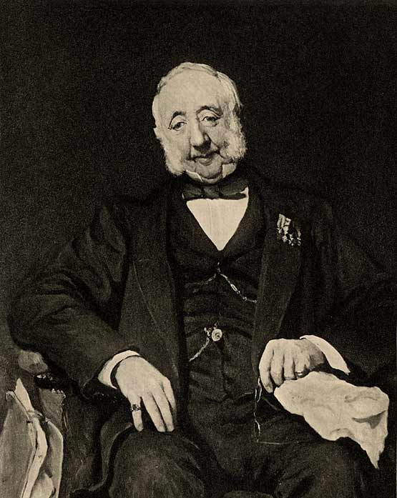

Picture 2 – Woman collecting water from a communal water pump on Malt Mill Lane, Narrow Marsh area, 1931 (Picture the Past, NTGM000962)

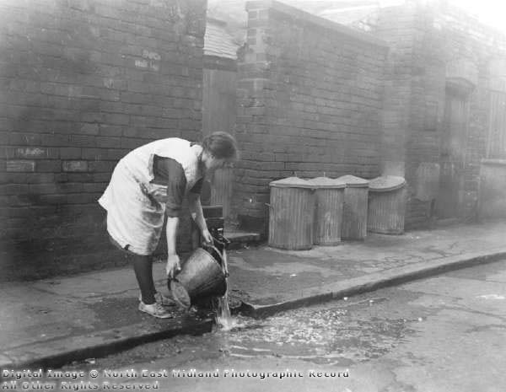

Picture 3 – Trent Bridge Pumping Station, c.1896 (Picture the Past, NTGM006601)

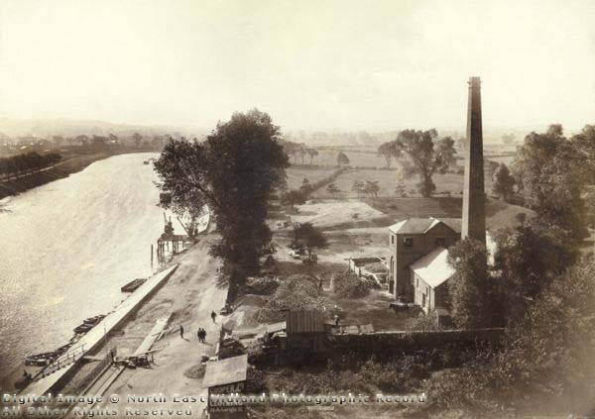

Document 1 - Extracts from the evidence of Thomas Hawksley, First Report of the Commissioners for Inquiring into the State of Large Towns and Populous Districts. Minutes of Evidence, pp. 298-331; 1844 (572), XVII.1

5242. What has been the effect produced on their habits by the introduction of water into the houses of the labouring classes? - At Nottingham the increase of personal cleanliness was at first very marked indeed; it was obvious in the streets. The medical men reported that the increase of cleanliness was very great in the houses, and that there was less disease.
5243. When, on the return home of the labourers' family, old or young, tired perhaps with the day's labour, the water has to be fetched from a distance out of doors in cold or in wet, in frost or in snow, is it not well known to those acquainted with the labourers' habit that the use of clean water, and the advantages of washing and cleanliness, will be foregone to avoid the annoyance of having to fetch the water? - Yes, that is a general and notorious fact. When the distance to be traversed is comparatively trifling, it still operates against the free use of water.
5244. Before the water was laid on in the houses of Nottingham, were the labouring classes accustomed to purchase water? - Before the supply was laid on in the houses water was sold chiefly to the labouring-classes by carriers at the rate of one farthing a bucket; and if the water had to be carried any distance up a court a halfpenny a bucket was, in some instances, charged. In general it was sold at about three gallons for a farthing. But the Company now delivers to all the town 76,000 gallons for £1; in other words, carries into every house 79 gallons for a farthing, and delivers water night and day, at every instant of time that it is wanted, at a charge 26 times less than the old delivery by hand.
5406. Under what circumstances do you consider the utility of the supply of water to be influenced by the defective state of the drainage? - Where one system terminated the other must commence. The use of water, however liberally supplied, will be limited and restricted by any inconvenience attending its removal. Its use as a means of cleansing and removing refuse, by the application of the water closet principle, will be directly dependent on the state of the drains...
[5418] ...My own observation and enquiry convince me that the character and habits of a working family are more depressed and deteriorated by the defects of their habitations than by the greatest pecuniary privations to which they are subject. The most cleanly and orderly female will invariably despond and relax her exertions under the influence of filth, damp and stench and at length ceasing to make further effort, probably sink into a dirty, noisy, discontented and perhaps gin-drinking drab - the wife of a man who has no comfort in his house, the parent of children whose home is the street or the gaol. The moral and physical improvements certain to result from the introduction of water and water-closets into the houses of the working classes are far beyond the pecuniary advantages [referring to the customary sale of night-soil. It was estimated that each tenement produced two good car-loads per annum], however considerable these may under circumstances appear.

Document 2 - Thomas Hawksley's obituary from The Times, 25 Sep. 1893 (4 pages)

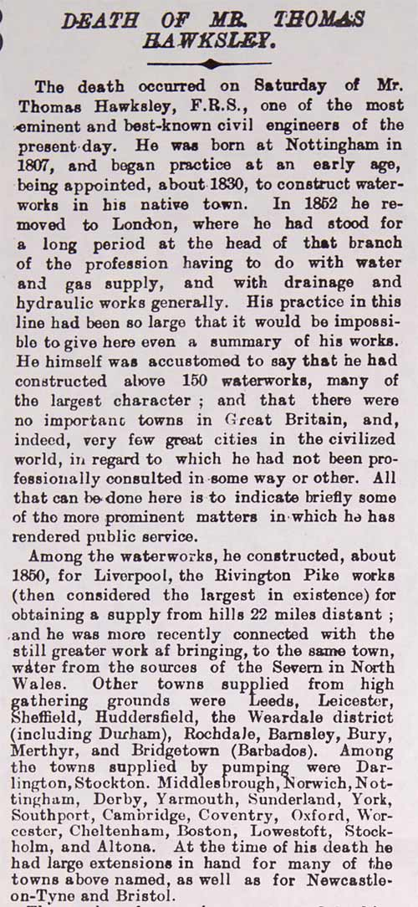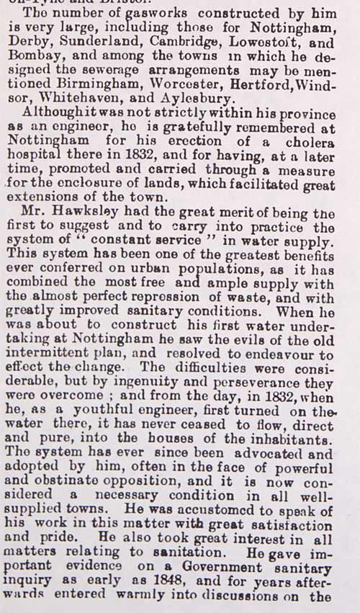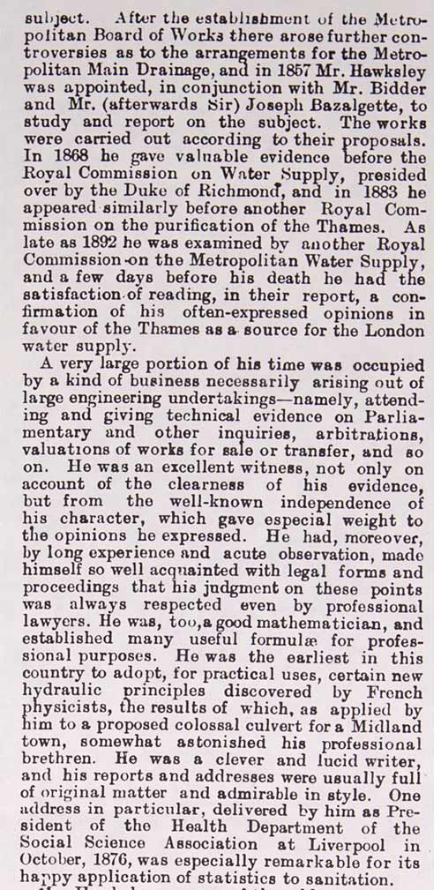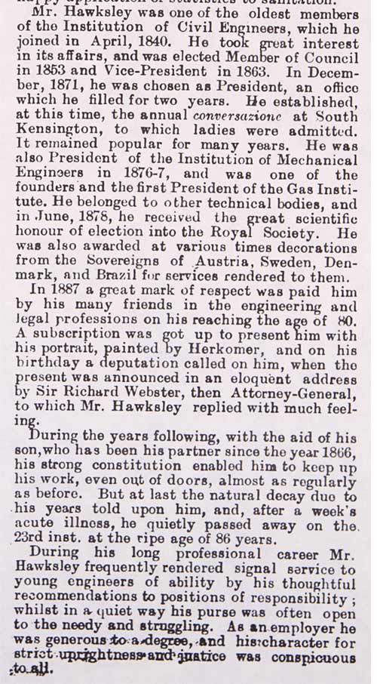

Document 3 - Extracts from the Nottingham Enclosure Act, 'An Act for inclosing Lands in the Parish of Saint Mary in the Town and County of the Town of Nottingham', 1845 (East Midlands Special Collection Oversize Not 1.H4)

(2 pages)

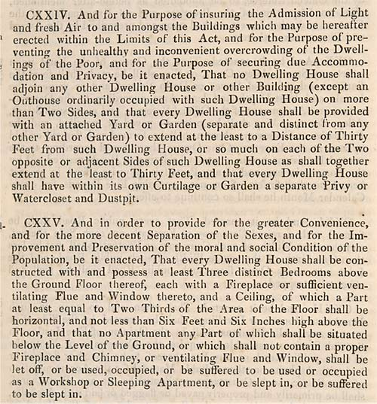

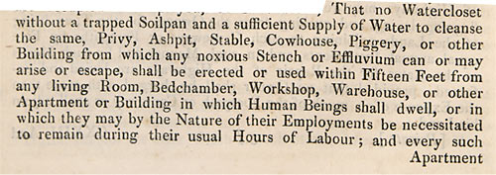

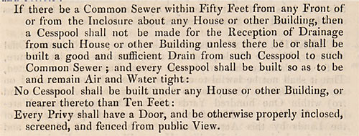

Document 4 - Extract from John Snow, On the Mode of Communication of Cholera (London: John Churchill, 1855)

Nottingham is supplied with filtered water obtained from the river Trent, some distance above the town. In 1832 this supply did not extend to all the inhabitants, and the cholera was somewhat prevalent amongst the poor, of whom it carried off 289; the population of the town being 53,000. After that time the water was extended copiously to all the inhabitants, and there were but thirteen deaths from the epidemic in 1849. The local Sanitary Committee placed the supply of water amongst the chief causes of this immunity from cholera, and I believe justly. There were but seven deaths from cholera in Nottingham last summer.

Document 5 - Description of Nottingham in 1873. Extracts from Edward Seaton, A report on the sanitary condition of the borough of Nottingham (1873) (East Midlands Special Collection Not 3.G66 SEA)
(4 pages)

