Laxton Open Field Village – lesson plans and activities for teachers

Activity 1 – Life In Laxton
Enquiry Question

- What can the auction document tell us about life in Laxton?

Aims

- To use the auction document to try and establish WHO, WHAT, WHEN, WHERE, WHY; to start thinking about the context and locality in which Joseph Rose lived

Resources

- Document 1 - Printed notice of sale by auction of household furniture and farming stock on the premises of Mr Joseph Rose of Laxton, 19 May 1849. List of household furniture and utensils, farming equipment, carts and wagon (Ma B 222/24)

- Local History Investigators Report worksheet

- Glossary of items mentioned in the auction notice

Outline Starter

- Make a list of all the items in the students' bedroom or home; ten minute deadline

- Discussion of what we mean by possessions and what value we place on 'things' in society today

- What do their items say about them as a person?

- How would they feel if they had to sell everything?

Main

- Complete the Local History Investigators Report worksheet with information from the1849 auction notice, for example, where did the auction take place and when?

- The Glossary can be used by the teacher to answer questions about the items listed in the auction notice

- Class discussion on initial conclusions as to why Joseph Rose sold his possessions

Plenary

- What else do you need to know? Is the auction document enough?

- End the activity with an awareness that more information is needed
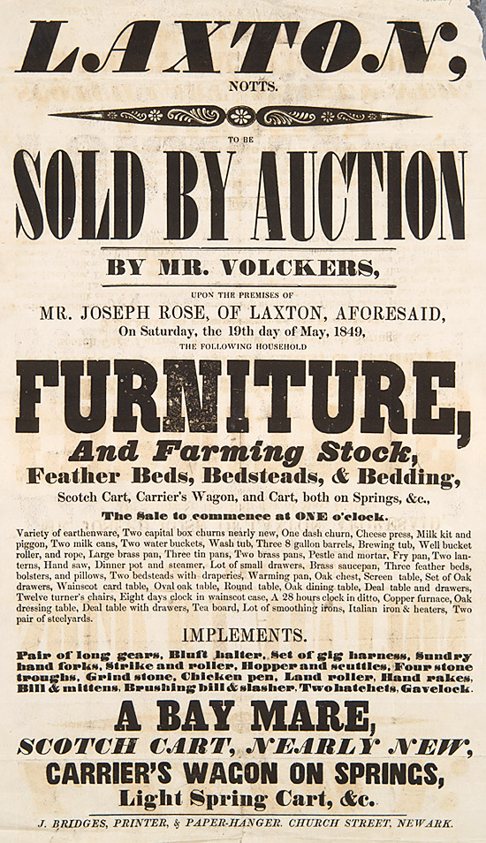
Document 1 - Printed notice of sale by auction of household furniture and farming stock on the premises of Mr Joseph Rose of Laxton, 19 May 1849. (Ma B 222/24)
Local History Investigators Report

Name and Form:______________________________________

WHO:

WHEN:

WHERE:
FURNITURE

IMPLEMENTS

What sort of person is Joseph Rose?

Initial Conclusions: Why did Joseph Rose sell his possessions?
_____________________________________________________________________________________________________________________________________________________________________

What else do you need to find out?
_____________________________________________________________________________________________________________________________________________________________________
Glossary

Sale particulars of furniture and farming stock on the premises of Mr Joseph Rose of Laxton, Nottinghamshire
19 May 1849
[Ma B 222/24]

Scotch Cart | 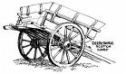
Carrier’s Wagon | 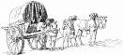
Earthenware | Pottery made from a porous clay that is fired at relatively low temperatures
Capital box churns | 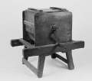
Dash churn | 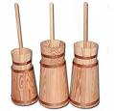
Piggon | A one handed milk bucket  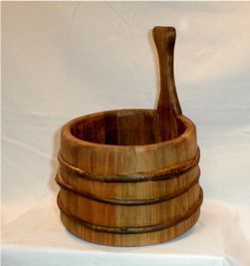
Wainscot card table | 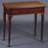
Turner’s chairs | 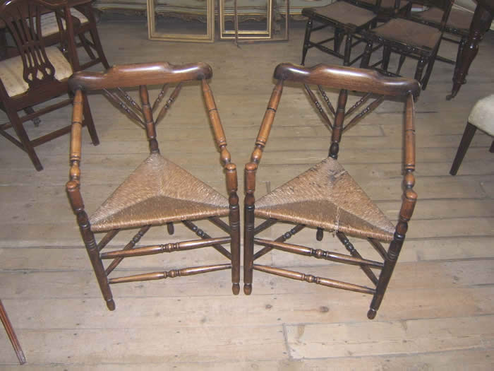
Eight days clock | 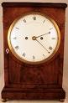
Smoothing irons | 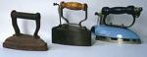
Steelyards | 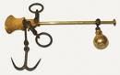  A transportable balance with unequal arm lengths.
Hopper and scuttles | Contained seeds to be scattered  