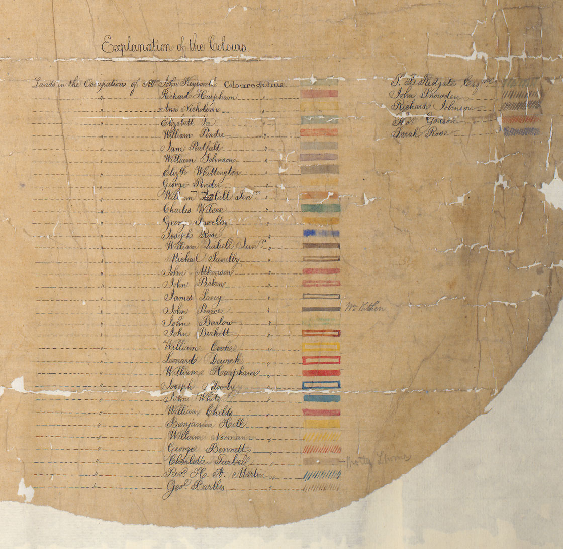
Document 2 – Key from coloured plan of Earl Manvers' estate in 1862 (Ma 5420)

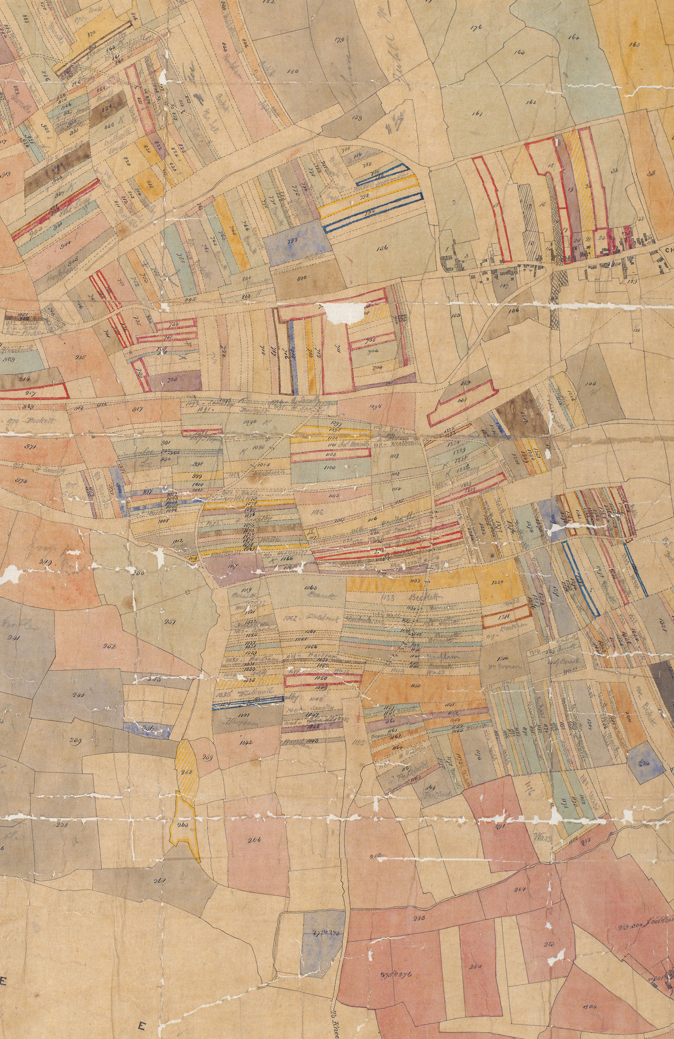
Document 2 – Detail from coloured plan of Earl Manvers' estate in 1862 (western portion) (Ma 5420)

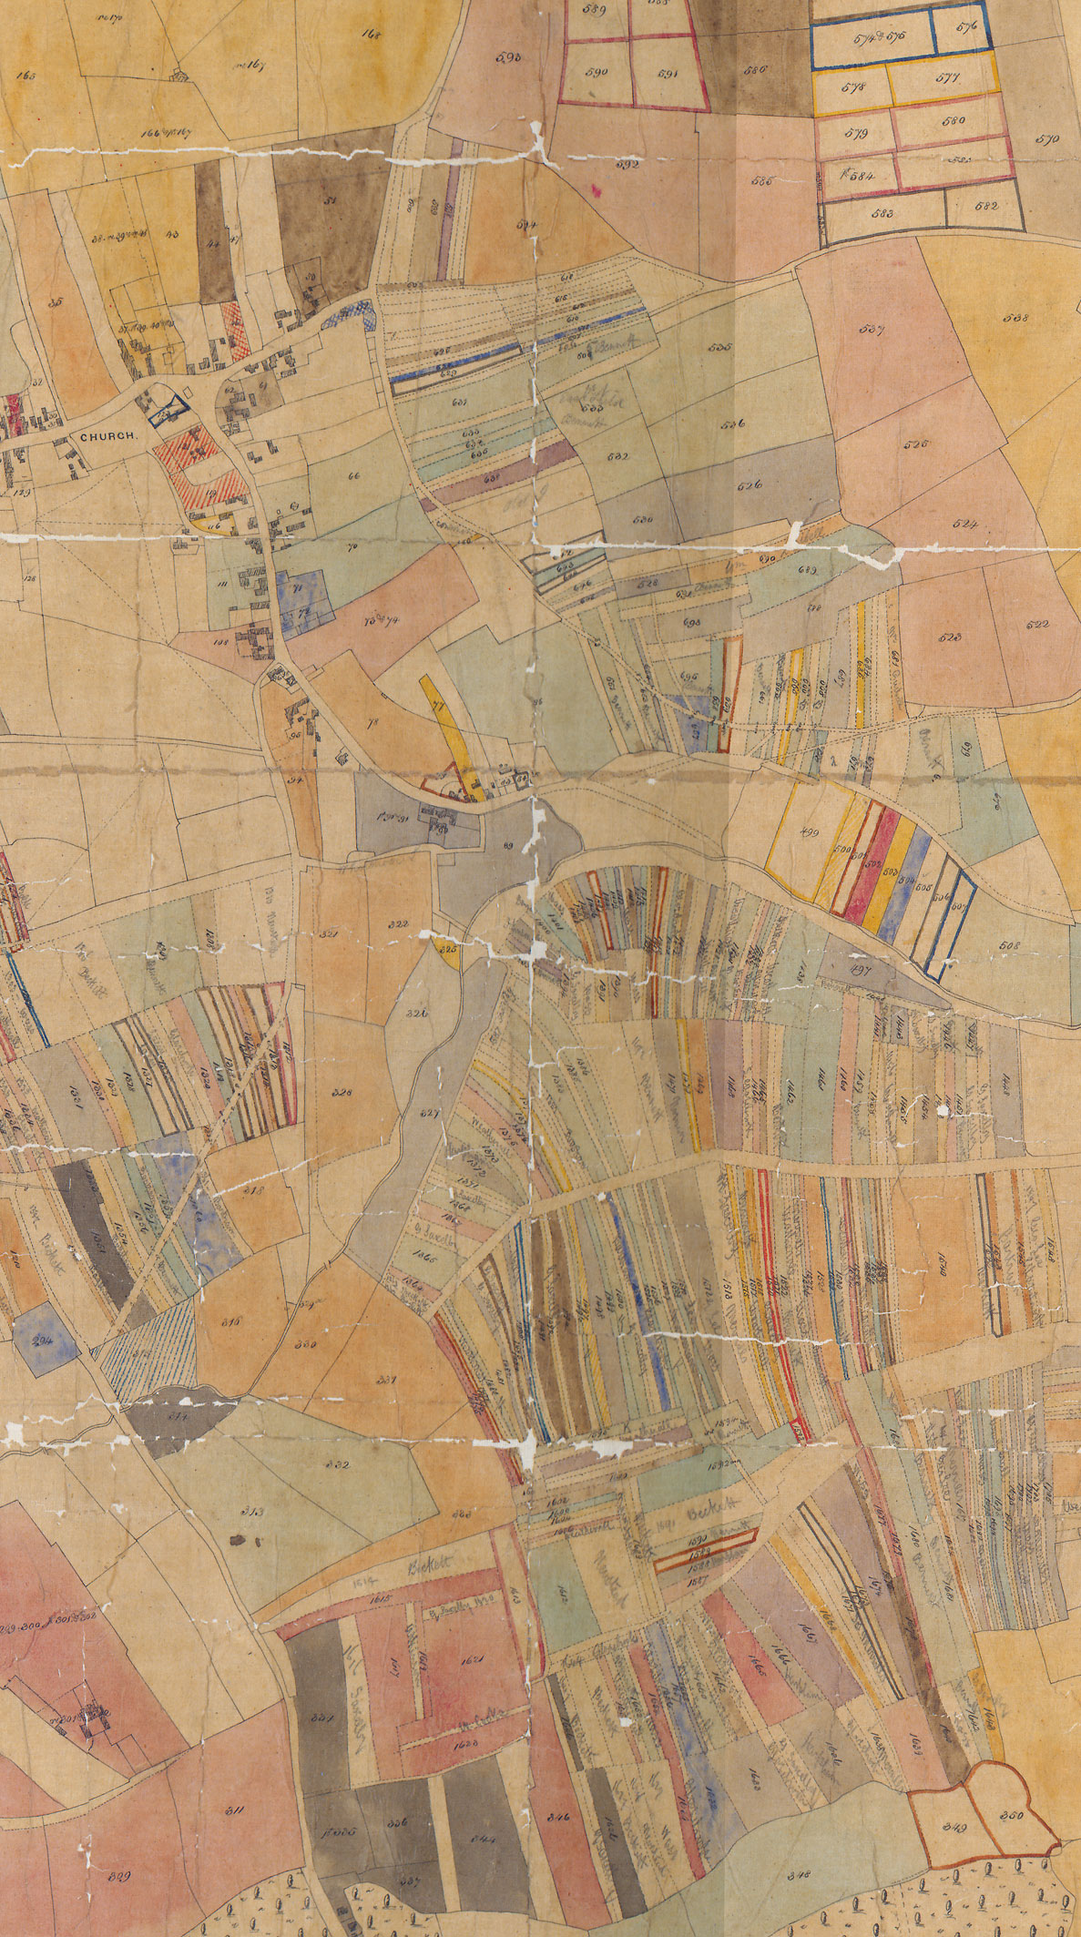
Document 2 – Detail from coloured plan of Earl Manvers' estate in 1862 (eastern portion) (Ma 5420)

Document 2 – Detail from coloured plan of Earl Manvers' estate in 1862 (eastern portion) (Ma 5420)

