Laxton Open Field Village – lesson plans and activities for teachers

Activity 2 – Joseph Rose
Enquiry Question

- What was the 'world' of Joseph Rose like?

Aims

- To build up a picture of the world of Joseph Rose and what Laxton was like in the 1860s using the resources outlined below

- There are opportunities here to explore further the concepts of change and continuity - images are available from 1635, to compare with 1862 and the 21st century

- n.b. This activity relies heavily on the archive material. Students may find the text difficult to interpret at first, but this is part of the challenge

Resources
- Document 1 - Copy of map of Laxton by Mark Pierce, 1635, in four sections (MS 280).
Notes: This is a copy of an original map held at the Bodleian Library, University of Oxford. The original map is accompanied by a terrier or survey, naming all the people who farmed each strip of land. The map clearly shows the houses in the village centre, and the 2280 strips of land in the four open fields. Towards the north of the village centre is the ‘demesne’ estate. This was the Lord of the Manor’s own land, concentrated into a compact holding near the remains of the medieval motte-and-bailey castle.
[n.b. This document is designed to be printed onto A3 paper and can be downloaded separately]

- Document 2 – Detail from coloured plan of Earl Manvers' estate in 1862 (Ma 5420).

Notes: Plots of land (including strips) are colour coded to show the holdings of each of the Earl’s tenants. The strips of land in the open fields are prominent

[n.b. This document is designed to be printed onto A3 paper and can be downloaded separately]

- Document 3 - Pages relating to Joseph Rose's house and farm 1862 (Ma S 16), with transcript

Notes: These pages come from a detailed survey of Earl Manvers’ estate by Thomas Huskinson, accompanying the coloured plan. Each farm was described and measured, and Huskinson offered advice on how the estate could be improved

- Internet resource such as Google Earth, Multimap or other online mapping product, projected onto a whiteboard (if possible). Or, a modern map of Laxton and a magnifying glass
Outline Starter

- Begin with Google Earth, another online mapping product, or a modern map, showing Laxton today

- Point out main features and introduce concept of continuity and change; highlight the village layout and the church

- Show the 1635 Mark Pierce map (Document 1)

Main

- Focus on the Manvers estate coloured plan of 1862 and the pages from the 1862 relating to Joseph Rose’s house and farm (Documents 2 and 3)

- Paired or small group work to locate Rose family strips and estimate amount of land they held, via map plotting exercise and using the coloured key on the map

- There is an opportunity here to create graphical representations of land ownership, location of strips, crops grown etc., for several Laxton families

- Q & A about who owns the best land, who owns the most land etc., and why this may be the case

- Study the pages from the 1862 survey relating to the Rose family and analyse the information carefully

- Create a concept map or mind map to translate the information to answer the question: What was the 'world' of Joseph Rose like? For example, the buildings could be sketched from the description, total acreages worked out, different land use etc.

Plenary

- Relate back to Laxton today; discuss what has changed and what has remained the same.
Document 3 – First page of estate schedule relating to Joseph Rose's house and farm, 1862 (Ma S 16)

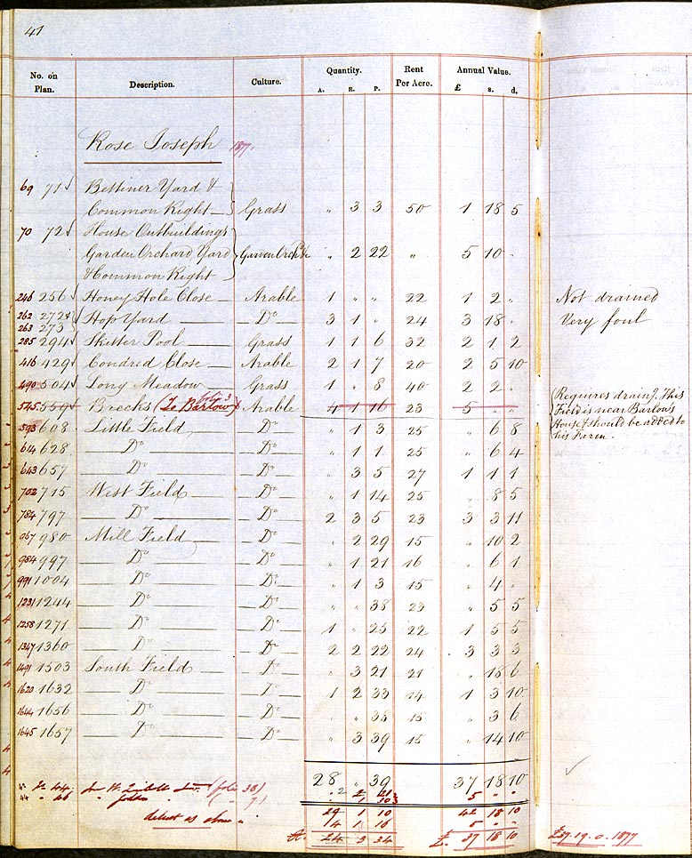
Document 1 – South-western section of copy map of Laxton by Mark Pierce, 1635 (MS 280)
Document 3 – Transcript of first page of estate schedule relating to Joseph Rose's house and farm, 1862 (Ma S 16)

No. on Plan | Description | Culture | Quantity |  |  | Rent Per Acre | Annual Value
No. on Plan | Description | Culture | A. | R | P. | Rent Per Acre | £ | s. | d.
 | Rose Joseph
71 | Bettiner Yard & Common Right | Grass | “ | 3 | 3 | 50 | 1 | 18 | 5
72 | House Outbuildings Garden Orchard Yard & Common Right | Garden Orchard &c. | “ | 2 | 22 | “ | 5 | 10 | “
256 | Honey Hole Close | Arable | 1 | “ | “ | 22 | 1 | 2 | “ | Not drained
272 & 273 | Hop Yard | Dº [ditto] | 3 | 1 | “ | 24 | 3 | 18 | “ | Very foul
294 | Skitter Pool | Grass | 1 | 1 | 6 | 32 | 2 | 1 | 2
429 | Condred Close | Arable | 2 | 1 | 7 | 20 | 2 | 5 | 10
504 | Long Meadow | Grass | 1 | “ | 8 | 40 | 2 | 2 | “
559 | Brecks | Arable | 4 | 1 | 16 | 23 | 5 | “ | “ | Requires drain[in]g. This Field is near Barlow’s House & should be added to his Farm
608 | Little Field | Dº | “ | 1 | 3 | 25 | “ | 6 | 8
628 | Dº | Dº | “ | 1 | 1 | 25 | “ | 6 | 4
657 | Dº | Dº | “ | 3 | 5 | 27 | 1 | 1 | 1
715 | West Field | Dº | “ | 1 | 14 | 25 | “ | 8 | 5
797 | Dº | Dº | 2 | 3 | 5 | 23 | 3 | 3 | 11
980 | Mill Field | Dº | “ | 2 | 29 | 15 | “ | 10 | 2
997 | Dº | Dº | “ | 1 | 21 | 16 | “ | 6 | 1
1004 | Dº | Dº | “ | 1 | 3 | 15 | “ | 4 | “
1244 | Dº | Dº | “ | “ | 38 | 23 | “ | 5 | 5
1271 | Dº | Dº | 1 | “ | 25 | 22 | 1 | 5 | 5
1360 | Dº | Dº | 2 | 2 | 22 | 24 | 3 | 3 | 3
1503 | South Field | Dº | “ | 3 | 21 | 21 | “ | 18 | 6
1632 | Dº | Dº | 1 | 2 | 33 | 14 | 1 | 3 | 10
1656 | Dº | Dº | “ | “ | 38 | 15 | “ | 3 | 6
1657 | Dº | Dº | “ | 3 | 39 | 15 | “ | 14 | 10
 |  |  | 28 | “ | 39 |  | 37 | 18 | 10

[n.b. The schedule is annotated in red ink with details for Joseph Rose’s landholding in 1877 – 15 years later – by which time he was a tenant of just under 25 acres]
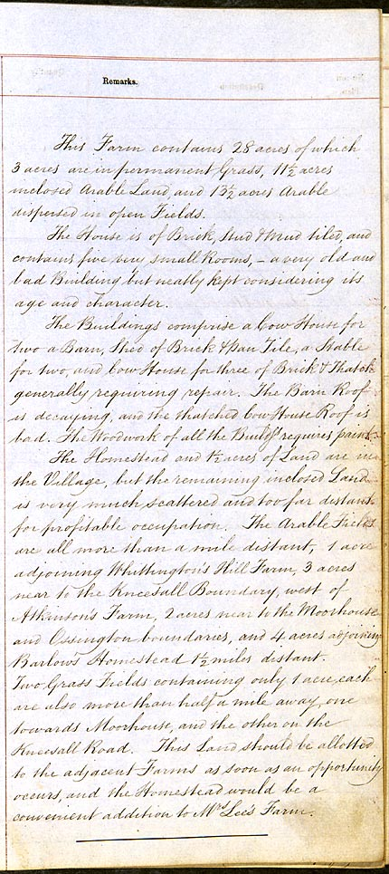
Document 3 – Second page of estate schedule relating to Joseph Rose's house and farm, 1862 (Ma S 16)

Document 3 – Transcript of second page of estate schedule relating to Joseph Rose's house and farm, 1862 (Ma S 16)

This Farm contains 28 acres of which 3 acres are in permanent Grass, 11½ acres inclosed Arable Land, and 13½ acres Arable dispersed in open Fields.

This House is of Brick, Stud & Mud tiled, and contains five very small Rooms, - a very old and bad Building but neatly kept considering its age and character.

The Buildings comprise a Cow House for two, a Barn, Shed of Brick & Pan Tile, a Stable for two, and Cow House for three of Brick & Thatch, generally requiring repair. The Barn Roof is decaying, and the thatched Cow House Roof is bad. The Woodwork of all the Buildings requires paint.

The Homestead and 1½ acres of Land are in the Village, but the remaining inclosed Land is very much scattered and too far distant for profitable occupation. The Arable Fields are all more than a mile distant, 1 acre adjoining Whittington’s Hill Farm, 3 acres near to the Kneesall Boundary, west of Atkinson’s Farm, 2 acres near to the Moorhouse and Ossington boundaries, and 4 acres adjoining Barlow’s Homestead 1½ miles distant. Two Grass Fields containing only 1 acre each are also more than half a mile away, one towards Moorhouse, and the other on the Kneesall Road. This Land should be allotted to the adjacent Farms as soon as an opportunity occurs, and the Homestead would be a convenient addition to Mrs Lee’s Farm.

