Laxton Open Field Village - lesson plans and activities for teachers

Lesson 3 – How Joseph Rose lived
Enquiry Question

- How did Joseph Rose live and how did his life change before and after the 1850s?

Aims

- To use the documents to work out how Joseph Rose lived in Laxton and to connect his life with the village

Resources

- Document 1 - Abstract of 1831 census return for the parish of Laxton, giving total number for households, male, females, occupations etc. (Ma B 174/334), with transcript

- Document 2 - Pages from 1862 survey of Earl Manvers’ estate in Laxton, giving details of Joseph Rose's house and farm and Sarah Rose's cottage (Ma S 16), with transcript

- Document 3 – Summary pages from the 1862 survey, giving details of all householders in Laxton (Ma S 16), with transcript

- Document 4 - Transcripts of detailed census information relating to the families of Joseph and Sarah Rose, 1841-1871

- ‘The 1862 World of the Rose Family’ worksheet

Outline Starter

- Discuss what a census is. Use the notes at http://www.ons.gov.uk/census/index.html to aid explanation. Emphasise how valuable census returns can be

Main

- Translation of the abstract of the 1831 census return for the parish of Laxton (Document 1). Magnifying glasses may be of use! This task can be short or long depending on time but the important aspect is to put into context Joseph Rose and his family

- Use the pages from the 1862 survey relating to Joseph and Sarah Rose (Document 2), the summary pages (Document 3), and the census returns (Document 4) to reconstruct Laxton in 1862 using words and pictures. Students to fill in the '1862 World of the Rose Family' worksheet

Plenary

- Students to describe their house today, and see if it could be drawn from word descriptions only

Alternative Options

- Use full census returns for Laxton, accessed online, to compare and contrast with 1831.
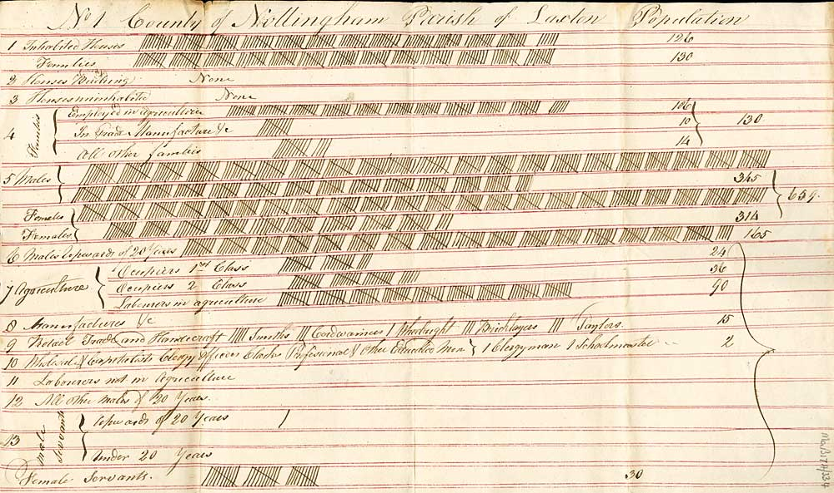
Document 1 – Abstract of 1831 census return for the parish of Laxton, giving total number for households, male, females, occupations etc. (Ma B 174/334)
Document 1 – Transcript of Abstract of 1831 census return for the parish of Laxton, giving total number for households, male, females, occupations etc. (Ma B 174/334)
No. 1 County of Nottingham Parish of Laxton Population

- Inhabited Houses. 126
Families. 130
- Houses Building. None
- Houses uninhabited. None
- Families. Employed in Agriculture 106
In Trade, Manufacture &c. 10
All other families 14 [total] 130
- Males 345
Females 314 [total] 659
- Males Upwards of 20 Years 165
- Agriculture. Occupiers 1st Class 24
Occupiers 2nd Class 36
Labourers in agriculture 90
- Manufacturers &c
- Retail Trade and Handicraft 5 Smiths 3 Cordwainers
1 Wheelwright 3 Bricklayers 3 Taylors 15
- Wholesale & Capitalists Clergy Officers Clarks
Professional & Other Educated Men –
1 Clergyman 1 Schoolmaster 2
- Labourers and in Agriculture
- All other Males of 20 years
- Male Servants. Upwards of 20 years – 1
Under 20 years
Female Servants 30
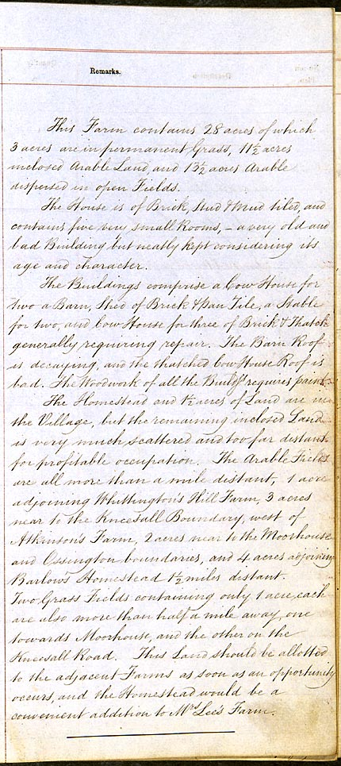
Document 2 – Description from estate schedule relating to Joseph Rose's house and farm, 1862 (Ma S 16)

Document 2 – Transcription of description from estate schedule relating to Joseph Rose's house and farm, 1862 (Ma S 16)

This Farm contains 28 acres of which 3 acres are in permanent Grass, 11½ acres inclosed Arable Land, and 13½ acres Arable dispersed in open Fields.

This House is of Brick, Stud & Mud tiled, and contains five very small Rooms, - a very old and bad Building but neatly kept considering its age and character.

The Buildings comprise a Cow House for two, a Barn, Shed of Brick & Pan Tile, a Stable for two, and Cow House for three of Brick & Thatch, generally requiring repair. The Barn Roof is decaying, and the thatched Cow House Roof is bad. The Woodwork of all the Buildings requires paint.

The Homestead and 1½ acres of Land are in the Village, but the remaining inclosed Land is very much scattered and too far distant for profitable occupation. The Arable Fields are all more than a mile distant, 1 acre adjoining Whittington’s Hill Farm, 3 acres near to the Kneesall Boundary, west of Atkinson’s Farm, 2 acres near to the Moorhouse and Ossington boundaries, and 4 acres adjoining Barlow’s Homestead 1½ miles distant. Two Grass Fields containing only 1 acre each are also more than half a mile away, one towards Moorhouse, and the other on the Kneesall Road. This Land should be allotted to the adjacent Farms as soon as an opportunity occurs, and the Homestead would be a convenient addition to Mrs Lee’s Farm.

Document 2 – Page from estate schedule relating to Sarah Rose's cottage, 1862 (Ma S 16)

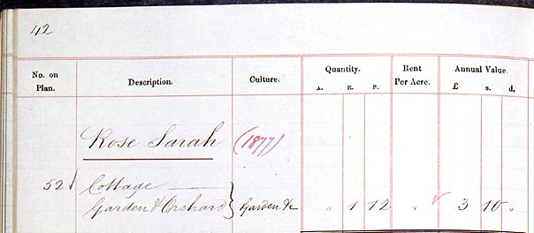

Document 2 – Transcription of page from estate schedule relating to Sarah Rose's cottage, 1862 (Ma S 16)

No. on Plan | Description | Culture | Quantity |  |  | Rent Per Acre | Annual Value
No. on Plan | Description | Culture | A. | R | P. |  | £ | s. | d.
 | Rose Sarah
52 | Cottage,  Garden & Orchard | Garden &c | “ | 1 | 12 |  | 3 | 10 | 1

Document 3 – First summary page from the 1862 survey, giving details of all householders in Laxton (Ma S 16)
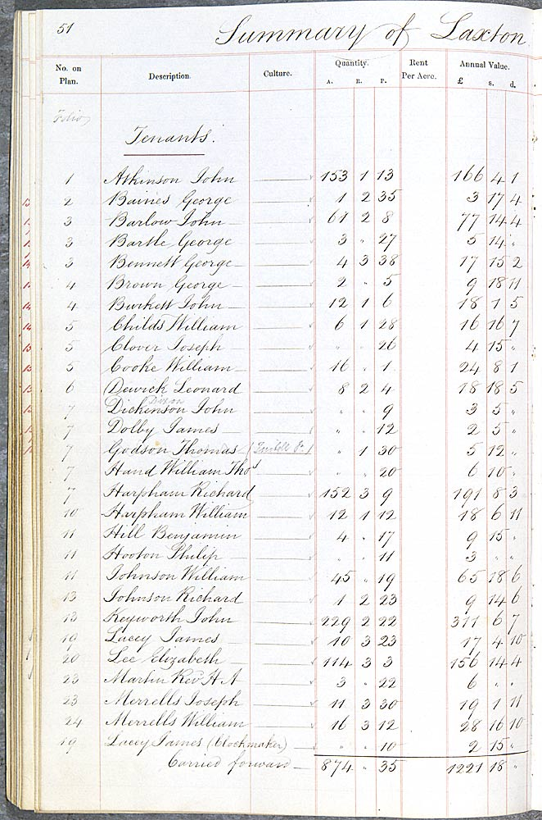

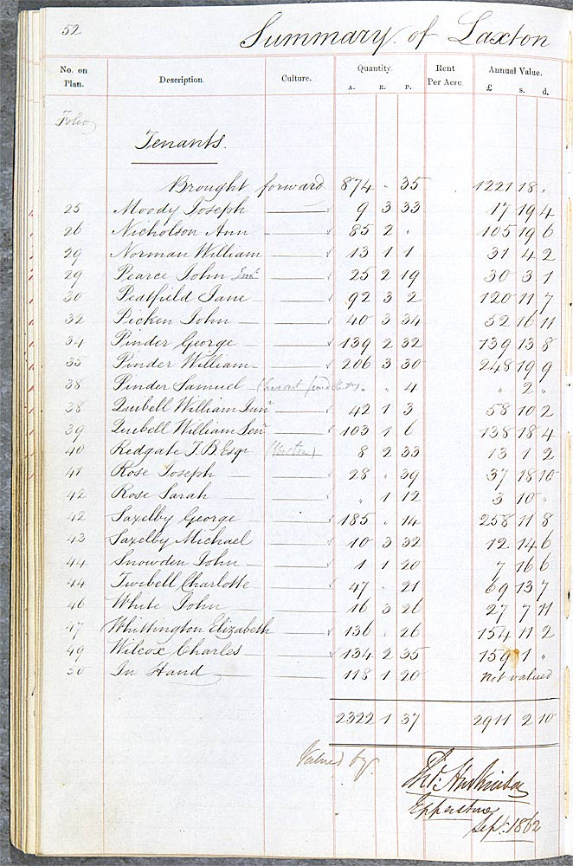
Document 3 – Second summary page from the 1862 survey, giving details of all householders in Laxton (Ma S 16)

No. on Plan  Document 3 – Transcript of first summary page from the 1862 survey, giving details of all householders in Laxton (Ma S 16) | Description | Culture | Quantity |  |  | Rent Per Acre | Annual Value
 | Description | Culture | A. | R. | P. | Rent Per Acre | £ | s. | d.
Folio | Tenants
1 | Atkinson John |  | 153 | 1 | 13 |  | 166 | 4 | 1
2 | Baines George |  | 1 | 2 | 35 |  | 3 | 17 | 4
3 | Barlow John |  | 61 | 2 | 8 |  | 77 | 14 | 4
3 | Bartle George |  | 3 | “ | 27 |  | 5 | 14 | “
3 | Bennett George |  | 4 | 3 | 38 |  | 17 | 15 | 2
4 | Brown George |  | 2 | “ | 5 |  | 9 | 18 | 11
4 | Burkett John |  | 12 | 1 | 6 |  | 18 | 1 | 5
5 | Childs William |  | 6 | 1 | 28 |  | 16 | 16 | 7
5 | Clover Joseph |  | “ | “ | 26 |  | 4 | 15 | “
5 | Cooke William |  | 16 | “ | 1 |  | 24 | 8 | 1
6 | Dewick Leonard |  | 8 | 2 | 4 |  | 18 | 18 | 5
7 | Dickenson Dixon John |  | “ | “ | 9 |  | 3 | 5 | “
7 | Dolby James |  | “ | “ | 12 |  | 2 | 5 | “
7 | Godson Thomas |  | “ | 1 | 30 |  | 5 | 12 | “
7 | Hand William Tho[ma]s |  | “ | “ | 10 |  | 6 | 10 | “
7 | Harpham Richard |  | 152 | 3 | 9 |  | 191 | 8 | 3
10 | Harpham William |  | 12 | 1 | 12 |  | 18 | 6 | 11
11 | Hill Benjamin |  | 4 | “ | 17 |  | 9 | 15 | “
11 | Hooton Philip |  | “ | “ | 11 |  | 3 | “ | “
11 | Johnson William |  | 45 | “ | 19 |  | 65 | 18 | 6
13 | Johnson Richard |  | 1 | 2 | 23 |  | 9 | 14 | 6
13 | Keyworth John |  | 229 | 2 | 22 |  | 311 | 6 | 7
19 | Lacey James |  | 10 | 3 | 23 |  | 17 | 4 | 10
20 | Lee Elizabeth |  | 114 | 3 | 3 |  | 156 | 14 | 4
23 | Martin Revd H.A. |  | 3 | “ | 22 |  | 6 | “ | “
23 | Merrells Joseph |  | 11 | 3 | 30 |  | 19 | 1 | 11
24 | Merrells William |  | 16 | 3 | 12 |  | 28 | 16 | 10
19 | Lacey James (Clockmaker) |  | “ | “ | 10 |  | 2 | 15 | “
 | Carried forward |  | 874 | “ | 35 |  | 1221 | 18 | “

Document 3 – Transcript of second summary page from the 1862 survey, giving details of all householders in Laxton (Ma S 16)
No. on Plan | Description | Culture | Quantity |  |  | Rent Per Acre | Annual Value
No. on Plan | Description | Culture | A. | R. | P. | Rent Per Acre | £ | s. | d.
Folio | Tenants
 | Brought forward |  | 874 | “ | 35 |  | 1221 | 18 | “
25 | Moody Joseph |  | 9 | 3 | 33 |  | 17 | 19 | 4
26 | Nicholson Ann |  | 85 | 2 | “ |  | 105 | 19 | 6
29 | Norman William |  | 13 | 1 | 1 |  | 31 | 4 | 2
29 | Pearce John |  | 25 | 2 | 19 |  | 30 | 3 | 1
30 | Peatfield Jane |  | 92 | 3 | 2 |  | 120 | 11 | 7
32 | Picken John |  | 40 | 3 | 34 |  | 52 | 16 | 11
34 | Pinder George |  | 139 | 2 | 32 |  | 139 | 13 | 8
35 | Pinder William |  | 206 | 3 | 30 |  | 248 | 19 | 9
38 | Pinder Samuel |  | “ | “ | 4 |  | “ | 2 | “
38 | Quibell William Jun[io]r |  | 42 | 1 | 3 |  | 58 | 10 | 2
39 | Quibell William Sen[io]r |  | 103 | 1 | 6 |  | 138 | 18 | 4
40 | Redgate J.B. Esq. |  | 8 | 2 | 33 |  | 13 | 1 | 2
41 | Rose Joseph |  | 28 | “ | 39 |  | 37 | 18 | 10
42 | Rose Sarah |  | “ | 1 | 12 |  | 3 | 10 | “
42 | Saxelby George |  | 185 | “ | 14 |  | 258 | 11 | 8
43 | Saxelby Michael |  | 10 | 3 | 32 |  | 12 | 14 | 6
44 | Snowden John |  | 1 | 1 | 20 |  | 7 | 16 | 6
44 | Twibell Charlotte |  | 47 | “ | 21 |  | 69 | 13 | 7
46 | White John |  | 16 | 3 | 26 |  | 27 | 7 | 11
47 | Whittington Elizabeth |  | 136 | “ | 26 |  | 154 | 11 | 2
49 | Wilcox Charles |  | 134 | 2 | 35 |  | 159 | 1 | “
50 | In Hand |  | 118 | 1 | 20 |  | Not valued
 |  |  | 2322 | 1 | 37 |  | 2911 | 2 | 10
 |  |  | Valued by
Tho[mas] Huskinson
Epperstone
Sept.[ember] 1862

Document 4 - Transcript of detailed census information relating to the families of Joseph and Sarah Rose, 1841

Extracts from the 1841 census, Laxton, Nottinghamshire, from the microfilm copy held at The University of Nottingham (King’s Meadow Campus East Midlands Collection Micro Em. L2.E41). The original returns are held at The National Archives, Kew (HO 107/850)

Names of each Person who abode therein the preceding night | Age and Sex | Profession, Trade, Employment or of Independent Means | Whether born in same County | Whether born in Scotland, Ireland or foreign parts
John Rose | 60 | Bricklayer | Y
Sarah do | 60 |  | Y
Richard do | 30 | Bricklayer | Y
Elizabeth do | 30 | Dressmaker | N | /
Charles do | 20 | Bricklayer | Y
Sarah do | 20 | Dressmaker | Y
Thomas do | 2 |  | Y
Catharine do | 14 |  | Y

Joseph Rose | 70 | Farmer |  | /
Elizabeth do | 70 |  | Y
Joseph do | 30 | AgLab | Y
Ann do | 30 |  | Y
Sarah do | 4 |  | Y
Ann do | 3 |  | Y
William do | 1 |  | Y
Joseph do | 1 month |  | Y

n.b. The census enumerators were instructed to round down the ages of all people over 15, to the nearest 5 years. Therefore, John Rose the bricklayer will have been between 60 and 64 years of age. Relationships between members of the household are not stated

Document 4 - Transcript of detailed census information relating to the families of Joseph and Sarah Rose, 1851

Extracts from the 1851 census, Laxton, Nottinghamshire, from the microfilm copy held at The University of Nottingham (King’s Meadow Campus East Midlands Collection Micro Em. L2.E51). The original returns are held at The National Archives, Kew (HO 107/2134)

Name of Street, Place or Road and Name or No. of House | Name and Surname of each Person who abode in the house on the night of the 30th March, 1851 | Relation to Head of Family | Condition | Age | Rank, profession or Occupation | Where Born | Whether Blind, or Deaf & Dumb
Main Street | Charles Rose | Head | M | 35 | Bricklayer Master | Notts Laxton
 | Sarah do | Wife | M | 35 |  | do do
 | Thomas do | Son | Un | 12 |  | do do
 | Mary do | Dau | Un | 7 |  | do do
 | Richard do | Son | Un | 2 |  | do do
 | John do | Son | Un | 1 month |  | do do

Main Street | Joseph Rose | Head | Marr | 41 | Farmer of 21 acres | Notts Laxton
 | Ann do | Wife | Marr | 39 |  | do do
 | Sarah do | Dau | Un | 14 |  | do do
 | Ann do | Dau | Un | 12 |  | do do
 | William do | Son | Un | 11 |  | do do
 | Joseph do | Son | Un | 9 |  | do do
 | John do | Son | Un | 7 |  | do do
 | George do | Son | Un | 6 |  | do do
 | Mary do | Dau | Un | 4 |  | do do
 | Harriet do | Dau | Un | 2 |  | do do
 | Thomas do | Son | Un | 6 months |  | do do

Document 4 - Transcript of detailed census information relating to the families of Joseph and Sarah Rose, 1861

Extracts from the 1861 census, Laxton, Nottinghamshire, from the microfilm copy held at The University of Nottingham (King’s Meadow Campus East Midlands Collection Micro Em. L2.E61). The original returns are held at The National Archives, Kew (RG 9/2475)

Road, Street &c, and No. or Name of House | Houses  Inhabited | Name and Surname of each Person | Relation to Head of Family | Condition | Age | Rank, Profession or Occupation | Where born | Whether Blind, or Deaf and-Dumb
Bar Street | 1 | Sarah Rose | Head | Widow | 46 | Dressmaker | Notts Laxton
 |  | Thomas do | Son | Un | 21 | Bricklayer | do do
 |  | Richard do | Son | Un | 12 | Scholar | do do
 |  | John do | Son | Un | 9 | do | do do
 |  | Martha Sarah do | Dau | Un | 7 | do | do do

Low Street | 1 | Joseph Rose | Head | Marr | 51 | Farmer 30 acres | Notts Walesby
 |  | Ann do | Wife | Marr | 49 |  | Notts Laxton
 |  | Sarah do | Dau | Un | 24 |  | do do
 |  | Joseph do | Son | Un | 19 | Malster | do do
 |  | Frederick do | Son | Un | 6 | Scholar | do do
 |  | Sarah Ann do | Gr Dau | Un | 2 |  | do do

Document 4 - Transcript of detailed census information relating to the families of Joseph and Sarah Rose, 1871

Extracts from the 1871 census, Laxton, Nottinghamshire, from the microfilm copy held at The University of Nottingham (King’s Meadow Campus East Midlands Collection Micro Em. L2.E71). The original returns are held at The National Archives, Kew (RG 10/3537)

Road, Street &c, and No. or Name of House | Houses  Inhabited | Name and Surname of each Person | Relation to Head of Family | Condition | Age | Rank, Profession or Occupation | Where born | Whether Blind, or Deaf and-Dumb
Bar House | 1 | Sarah Rose | Head | Widow | 53 | Dressmaker | Notts Laxton
 |  | Thomas do | Son | Unmar | 22 | Bricklayer | do do
 |  | Maria S. do | Daughter |  | 17 | Dressmaker | do do

 | 1 | James Laughton | Head | Unmar | 24 | Miller | do Egmanton
 |  | Betsey Wetherall | Servant | Unmar | 27 | Housekeeper | do Laxton
 |  | John Rose | Apprentice | Unmar | 19 | Miller | do do

 | 1 | Joseph Rose | Head | Mar | 61 | Farmer of 28 acres | Notts Walesby | /
 |  | Ann do | Wife | Mar | 59 |  | Notts Laxton
 |  | Frederick do | Son | Unmar | 16 | Farmers Son | do do

 | 1 | Joseph Rose | Head | Mar | 29 | Agricultural Labourer | do do
 |  | Elizabeth do | Wife | Mar | 36 |  | do do
 |  | Anne E. do | Daughter |  | 6 | Scholar | do do

The 1862 World of the Rose Family
Amount and value of land
Joseph Rose
Amount and value of land
Sarah Rose

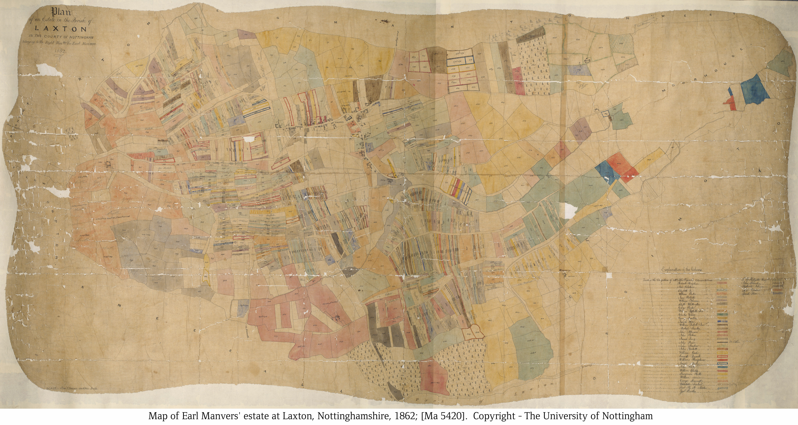
Drawing of house
Joseph Rose

Drawing of house
Sarah Rose

