NCMH PhD Tutorial 4: Sedimentation Equilibrium

Fundamental equation of sedimentation equilibrium:

From thermodynamic considerations or by equating sedimentation and diffusive forces, for an ideal single solute at sedimentation equilibrium:

{1/c(r)}.dc(r)/dr = ω²rM(1-$\bar{v}$ρ)/{RT} (1)

($\bar{v}$= partial specific volume of the solute, ρ = solvent density, ω = angular velocity, T = thermodynamic temperature, R = gas constant)

Integrated form (between selected radial positions r₁ and r₂)

c(r₂) = c(r₁)exp[ω²M(1-$\bar{v}$ρ)(r₁²-r₂²)/2RT] (2)

For systems other than ideal single-solute, either we can represent the data by specific model equations or we can more generally replace M by M_{w,app}, where M_{w,app} is the apparent weight average molecular weight of the material between positions r₁ and r₂ (we use the term "apparent" because of non-ideality)

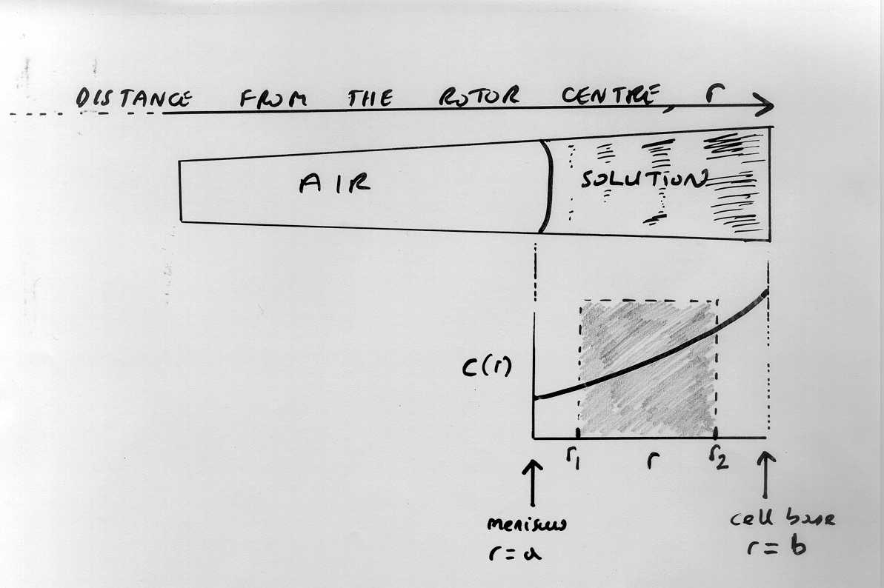

To describe the apparent weight average over all the material (from meniscus, r=a and cell base, r=b):

c(b) = c(a)exp[ω²M_{w,app}(1-$\bar{v}$ρ)(b²-a²)/2RT] (3)

For ideal monodisperse systems the M_{w,app}’s in eq(2) and eq(3) will be the same, otherwise only eq (3) represents the entire distribution of macromolecular solute.

The programmes IDEAL1, NONLIN etc are based around selected distributions (between r₁ and r₂) in the ultracentrifuge cell. MSTAR refers to the whole distribution.

Eq. 3 can be manipulated in a number of ways

1. Logarithmic form over the whole distribution
M_{w,app} = ln[c(b)/c(a)] . {2RT/[ω²(1-$\bar{v}$ρ)(b²-a²)]} (4)

2. Integral form over the whole distribution (c_{o} = initial loading concentration)
M_{w,app} = {[c(b) - c(a)]/c_{o}}. {2RT/[ω²(1-$\bar{v}$ρ)(b²-a²)]} (5)

n.b. at low loading concentration (<0.5 mg/ml for proteins)
M_{w,app} ~ M_{w}.

Since data near the meniscus or base are not measurable, some form of extrapolation of the c(r) data to c(a) and c(b), or ln[c(r)] to ln[c(a)] and ln[c(b)] is necessary.

(i) For homogenous/ monodisperse systems determination of c(b) is not too difficult. For heterogeneous sytems (polydisperse, self-associating), extrapolation can be difficult through strong curvature of c(b) or ln[c(b)]

(ii) Extraction of c(a) for uv absorption records is not difficult, since curvature is not strong near the meniscus. NB for interference optics, the optical record is NOT c(r) vs r but [c(r) - c(a)] vs r.

The M* function
The M* method was developed to address (i).

From manipulations of equation (1), the function M*(r), at a radial position r is defined by

$M∗(r)=\frac{\left(c(r)−c(a)\right)}{kc(a)\left(r^{2}−a^{2}\right)+\text{}2k\int_{a}^{r}{r\text{}\left[c(r)−\text{}c(a)\right]}\text{}\text{dr}}$ (6)
where k = $\frac{\left(1−\bar{v}ρ\right)w^{2}}{2RT}$,

The M*(r) function has several interesting properties.
The most important:

M*(r) extrapolated to the cell base = M_{w,app} (over the whole distribution).

{the analogy is with the computer "Pacman" game, with the M*(r) gradually homing in on the true M_{w,app} as eventually the whole distribution of solute in the ultracentrifuge cell has been considered by the time r=b has been reached}.

The extrapolation of M*(r) to find M_{w,app} is less steep than the c(r) or ln[c(r)] extrapolations to the cell base and has been tested by extensive simulation

 | Two component mixture | Very polydisperse | Self-association (isodesmic, no error) | Self-association (isodesmic, random error) | Single solute, random error
ln[c(r)] | 659000 | 473000 | 245000 | 215000 | 499000
M*(r) | 664000 | 487000 | 277000 | 263000 | 500000
True value | 667000 | 487000 | 302000 | 302000 | 500000

Please see the SEDFIT-MSTAR manual for full operating instructions

References:
Creeth JM & Harding SE (1982) Some observations on a new type of point average molecular weight J. Biochem. Biophys. Methods. 7, 25-34
Schuck, P., Gillis, R.B., Besong, D., Almutairi, F.M., Adams, G.G., Rowe, A.J. & Harding, S.E., 2014. SEDFIT-MSTAR: Molecular weight and molecular weight distribution analysis of polymers by sedimentation equilibrium in the ultracentrifuge. Analyst. 139, 79-92

Questions
- Give the relation between concentration c (mg/ml) (i) and absorbance A and (ii) and interference fringe displacement J
- Give the relation between the relative radial displacement function ξ(r) and r, a and b.

3. One form of the equation for sedimentation equilibrium in the analytical ultracentrifuge is

dlnc(r)/dr² = M_{w,app} (1- $\bar{v}$.ρ_{ο})ω²/(2RT)

Explain the significance of the term M_{w,app}.

In a sedimentation equilibrium study on a buffered solution of a DNA binding protein X at a low loading concentration (0.5 mg/ml) the following record of concentration versus radial distance was made:

r (cm) A₂₈₀
6.925 0.061
6.957 0.100
6.986 0.165
7.019 0.272
7.050 0.448
7.078 0.739

After plotting the appropriate graph, from these data comment on
the homogeneity and molecular weight of the solution. The buffer
had a density ρ_{ο} of 1.0021 g/ml and the partial specific volume $\bar{v}$
was 0.739 ml/g (calculated from the amino acid sequence). The
operating speed was 20410 rev/min and temperature was 20.0ºC.
R=8.31434 x 10⁷ c.g.s. units.

The molecular weight from protein sequencing was 24123 Da.
What can you conclude about this particular protein? Is this surprising?

4. For ribonuclease
M = 13683 Da, $\bar{v}$ = 0.694 ml/g

In a sedimentation equilibrium experiment with a solution of ribonuclease containing 0.780 mg/ml in a very dilute buffer at 25.00ºC and a rotor speed of 18,600 rpm, calculate the equilibrium concentrations at the cell bottom (r = b) and meniscus (r=a), if b and a = 7.013 and 6.750 cm respectively [Hint: Calculate C(b) - C(a) and C(b)/C(a); combine]. What is the exact concentration half-way down the solution column?
Ribonuclease is not self-associating within this concentration range. How useful however do you think is the ability to generate concentration increments like the above across the centrifuge cell for helping us understand the nature of those native and engineered protein molecules that do self-associate (dimerize, trimerize etc.)?

