Reading and Replying to Messages in the Discussion Tool
- In the Course Tools menu, click on the Discussions link. A discussion screen will appear:

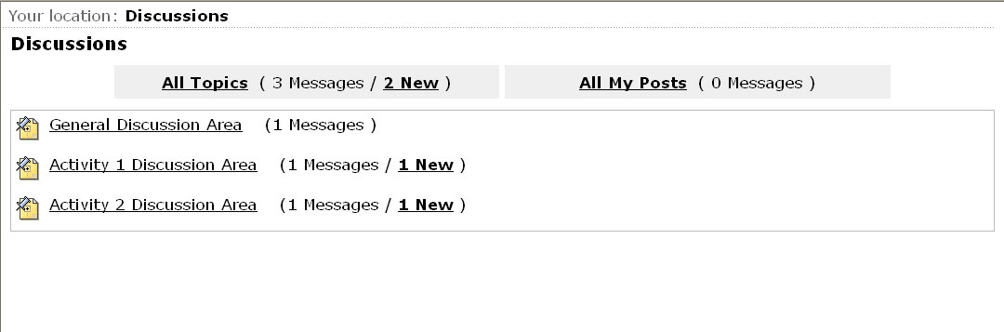
Click here to view all the messages in each topic.
Click here to view all the messages that you posted.
Click here to enter the discussion topic.
Click here to view new messages only.

- Click on a discussion topic. The following screen will appear:
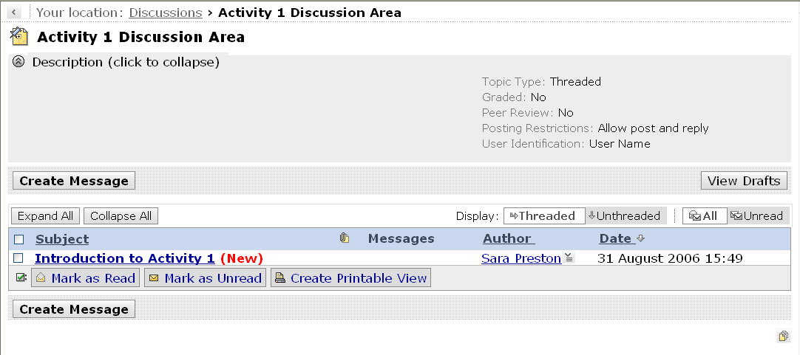
General information about the topic – this can be collapsed.
Click here to read the message.
Click here to view your messages as threaded. This means the original message is listed first followed by replies to that message.
Click here to view your messages as unthreaded. This means the messages are listed in chronological order.
Click here to either view all your messages or just those that are unread.
Click here to expand all threads or to collapse all threads.

Other choices (described in more detail on the following page):
- To start a new subject click on Create Message
- To review and post any drafts click on View Drafts
- To mark messages as read or unread, select the check box next to each message and then click on Mark as Read or Mark as Unread
- To print or save messages click on Create Printable View

- Click on a message to read it. The following screen will appear:
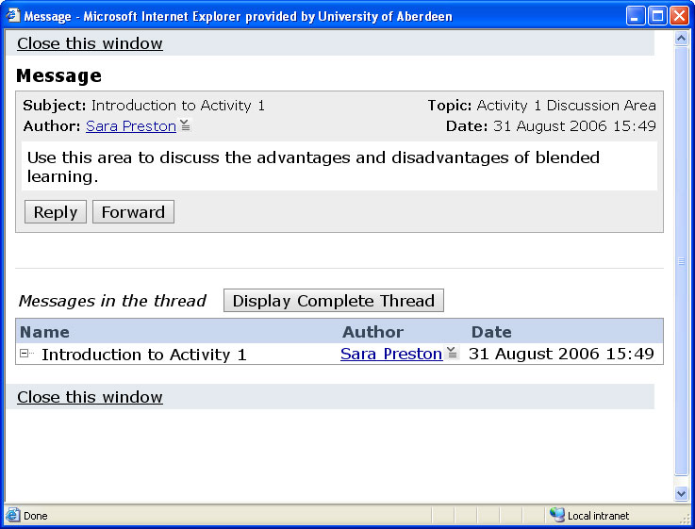
Click here to reply to the message. In the screen that appears, leave the Subject: field as it is, enter a message in the Message: section. Click on Add Attachments to attach any files. Click on Post.

Click here to close the window.

- Read and reply to a message.

Posting New Messages in the Discussion Tool
- Click on the Discussions link in the Course Tools menu. Enter a discussion topic.
- Click on Create Message. The following screen will appear:
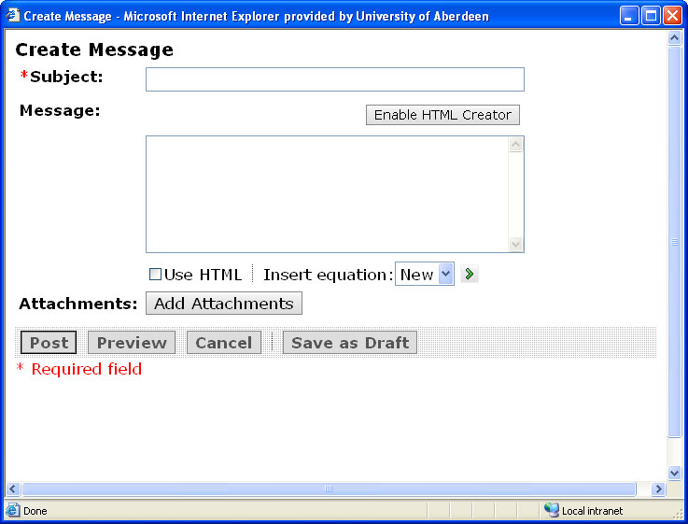
Click here to enter a subject here.
Click here to enter your message here.
Click here to add attachments.
Click here to post your message.
Click here to preview your message.
Click here to create and insert an equation.

- Compose and post your message.

Other choices:
- To enable you to format your message, like you would in a word processor, without having to enter HTML tags, click on Enable HTML Creator
- To save your message as a draft, for posting later, click on Save as Draft

Printing and Saving Messages
- Enter a discussion topic and select the message that you want to print or save by selecting the check box next to each message (Tip: to select all the messages on the page, select the check box next to Subject in the table heading).
- Click on Create Printable View. To print the compiled messages click on Print.
- To download and save the compiled messages click on Save as File.
- Click on Close this window to return to your discussion topic.

Searching for Messages
- In the Course Tools menu, click on the Search link. In the Search for: text box, enter your search terms. Under Search area:, select the areas to be searched.
- From the Search tool: drop-down list, select Discussion. Under Date: select the date criteria.
- From the Sort Results by: drop-down list, select how you want the results sorted. Click on Search.

