Submission Information for
Postgraduate Research Students

Compiled by
Registry and Academic Affairs in UK
Graduate School in China
Graduate School in Malaysia
Last Updated: 01/09/2022

Contents
Introduction & Contact Information 3

Preparation for submission of thesis for a research degree 4

When should I submit? 4
Key Dates to consider 4
Main graduation ceremonies 5
Inter-ceremonies 6
Further information on dates 6
Notification of Submission 7
Extension to your submission deadline 8
Late Submission of Thesis 9
Format of thesis 10
Word count 10

Submission of the thesis 11
How do I submit? 11
Softbound 11

Examination of thesis for a research degree 12
What to expect following submission: examination process explained 12
Examination Outcomes 13
Award of degree for which you are registered 13
Typographical errors or minor amendments 14
Referral 14
Other 15

Graduation arrangements for research degree candidates 15

Appendix A: University of Nottingham Deposit of Electronic Thesis 17
What to consider before uploading? 17
Confidential Content 17
Third Party Copyright Content 17
Setting an Embargo 18
Applying for a Restriction 18
How to upload your thesis in UK and Malaysia? 19
The steps in the Deposit process 19
How to upload your thesis in China? 23
The steps in the Deposit process 24

Appendix B: Supplementary Information for examiners, supervisors, and candidates 26
Criteria for award of PhD and other qualifications at Doctoral Level 26
Options available to the examiners 27

Introduction & Contact Information

Enclosed is all the information necessary for your thesis pending period (if eligible) and examination period including submission, uploading your thesis to the University’s e-theses service (http://eprints.nottingham.ac.uk/etheses/ for the UK and Malaysia campuses, and https://research.nottingham.edu.cn/admin for UNNC) and graduation. It applies equally across the UK, China and Malaysia campuses, unless specifically stated otherwise. It should be read in conjunction with all the policies in the University of Nottingham Quality Manual.
If you have any queries about anything in this document, please do not hesitate to contact:
- In UK, Registry and Academic Affairs:
  - for the Faculty of Arts please email ss-pgr-arts@nottingham.ac.uk
  - for the Faculty of Engineering please email ss-pgr-engineering@nottingham.ac.uk
  - for the Faculty of Medicine and Health Sciences please email ss-pgr-mhs@nottingham.ac.uk
  - for the Faculty of Science please email ss-pgr-science@nottingham.ac.uk
  - for the Faculty of Social Science please email ss-pgr-socsci@nottingham.ac.uk.
- In China, Graduate School:
  - for all Graduate Schools issues please email Director of Graduate School UNNC Evelyn Lin evelyn.lin@nottingham.edu.cn
  - for all Graduate School administrative matters please email UNNC Graduate School Administration Officer Claire Shi Claire.shi@nottingham.edu.cn
  - for all Graduate School IDIC/DTP administrative matters please email UNNC Graduate School Administration Officer and DTP Manager Jessica Wang Jessica.wang@nottingham.edu.cn
- In Malaysia, Graduate School:
  - please visit PGR Operations Team, Graduate School – Room H1B12a, Block H or email to: PGR.operations@nottingham.edu.my

Preparation for submission of thesis for a research degree

When should I submit?

You are normally expected to submit your thesis by the end of your registered period of study.
Periods of registration (also referred to as Registered Period of Study) for postgraduate research degrees are as set out in the University of Nottingham Qualifications Framework (UNQF) here and will vary depending on the degree you are on.
For example, for a PhD you would normally be registered for 3 years (full-time) or 6 years (part-time). Regulations set out the minima and maxima periods for your degree. In this example, you would not be able to submit earlier than upon completion of 2 years full time (4 years part-time), and no later than 4 years from the start of full-time study (8 years part-time). Please note that the terms and conditions of a studentship held by an individual may vary this.
The final submission deadline will be notified to you during your course of studies, and it is also available to you via Nottingham Hub.
Please refer to “Key dates” section below for additional guidance when deciding on the actual submission date.

Key Dates to consider

You are required to submit your thesis for examination by the submission deadline notified to you during your course of studies. The dates below are for graduation guidance only and vary across campuses. Even when they have been correctly observed, no guarantee can be given that the necessary examination procedures will have been completed in time for a candidate to graduate at the next degree congregation.
Please note (for UK), you must also have completed registration for graduation prior to the deadlines advertised on graduation website, here, in order to be eligible.

Main graduation ceremonies

For UK, China & Malaysia July Graduation
Activity | Date*
Submission of “Notification of Intention to Submit” form | No later than 1 January
Submit Thesis for Examination | No later than 1 April
Deadline for uploading corrected thesis or final thesis | 1 June
Deadline for final version of work to be approved in order for Graduation eligibility | 15 June
For China November Graduation
Activity | Date*
Submission of “Notification of Intention to Submit” form | No later than 1 June
Submit Thesis for Examination | No later than 1 August
Deadline for uploading corrected thesis or final thesis | 1 October
Deadline for final version of work to be approved in order for Graduation eligibility | 15 October
For UK December Graduation
Activity | Date*
Submission of “Notification of Intention to Submit” form | No later than 1 June
Submit Thesis for Examination | No later than 1 September
Deadline for uploading corrected thesis or final thesis | 1 November
Deadline for final version of work to be approved in order for Graduation eligibility | 15 November
For Malaysia February Graduation
Activity | Date*
Submission of “Notification of Intention to Submit” form | No later than 1 August
Submit Thesis for Examination | No later than 1 November
Deadline for uploading corrected thesis or final thesis | 1 January
Deadline for final version of work to be approved in order for Graduation eligibility | 15 January

Inter-ceremonies

In addition to the two degree congregations in summer and winter, there are two inter-ceremonies held in March and October. These allow you to graduate and receive your certificate but not attend a ceremony.
For UK, China and Malaysia March Inter-Ceremony
Activity | Date*
Submission of “Notification of Intention to Submit” form | No later than 1 September
Submit Thesis for Examination | No later than 1 December
Deadline for uploading corrected thesis or final thesis | 1 February
Deadline for final version of work to be approved in order for Graduation eligibility | 15 February

For UK, China and Malaysia October Inter-Ceremony
Activity | Date*
Submission of “Notification of Intention to Submit” form | No later than 1 April
Submit Thesis for Examination | No later than 1 July
Deadline for uploading corrected thesis or final thesis | 1 September
Deadline for final version of work to be approved in order for Graduation eligibility | 15 September

Further information on dates

- If your submission deadline falls on a non-working day then you are permitted to submit on a first working day after this deadline
- Information on dates of University closure can be found at:
  - For UK: http://www.nottingham.ac.uk/staff/bankhol.phtml
  - For China: https://www.nottingham.edu.cn/en/about/key-dates/key-dates.aspx
  - For Malaysia: https://www.nottingham.edu.my/AboutUs/Datesandcampusinformation/Calendar/Publicholidays/index.aspx

Notification of Submission

Three months prior to the actual submission of your thesis you should complete the “Notification of submission of thesis” form and return that to University (using contact details in “Introduction” section).
This will allow for the appropriate arrangements to be made for your examination. Any delay in submitting your form can lead to a delay in your examination taking place.
The form can be downloaded here:
- For UK: https://www.nottingham.ac.uk/studentservices/forms/forms.aspx
- For China: https://studentportal.nottingham.edu.cn/ [access required]
  - Start the process by clicking on “Start” in the Action Section in “Notification of submission of thesis / dissertation for examination of a research degree (Service Card)
  - Please email Graduate School (GraduateSchool@nottingham.edu.cn) if you request to change the proposed submission date.
- For Malaysia : UNM Publish Share
Your supervisor’s signature on the ‘Notification of Intention to Submit’ form acts as a confirmation:
- That the thesis is the result of work done mainly while the you have been registered as a student of The University of Nottingham.
- That you have been given appropriate guidance on plagiarism and relevance of thesis restrictions.
- That if appropriate to your discipline, you are aware of the requirement to submit all data collected during the period of study as a research student of this University, to your School prior to arrangement of the viva voce examination.
When submitting the form you confirm that you are aware of the word limits and required format of submission (see more info below).
Once it is received by university, we contact your School to ask them to arrange examiners for you. When approved, we will email you with the names of your examiners, asking you to declare any conflict of interest.

Extension to your submission deadline

In exceptional circumstances an extension to the submission deadline can be granted. All applications should be agreed with your School and submitted with supporting evidence to the University for consideration. Applications will only be considered if received no less than 3 months in advance of the final submission deadline.
The Extension policy can be found in the University’s Quality Manual: http://www.nottingham.ac.uk/academicservices/qualitymanual/researchdegreeprogrammes/the-thesis-pending-period.aspx
A maximum of 6 months (12 for part time students) extension will be granted for a first request. Second or subsequent requests which will exceed 12 months (24 months for part time students) will require approval by the University’s Quality and Standards Committee.
Note: this procedure is referred to as “extension to thesis pending period”, but students not entitled to a thesis pending period, may also use this procedure if they need to apply for an extension to their submission deadline.
Applications for extensions of time should be made to Registry and Academic Affairs at UK, the Graduate School at UNM or the Graduate School at UNNC. Please use contact details in “Introduction” section relevant to your Campus.

Late Submission of Thesis

You are required to submit your thesis for examination by the submission deadline notified to you during your course of studies. Full time doctoral students submitting a thesis after this deadline, without receiving formal approval from the University for an extension of time, will be permitted to submit up to twelve months after their latest submission date as long as the maximum period from initial registration has not been reached. More on max period here: http://www.nottingham.ac.uk/academicservices/qualitymanual/registrationattendanceandstudy/maximum-period-from-initial-registration.aspx
Once the work has been submitted the late submission fee for each month or part month that passes between your expected submission date and the date that your thesis is actually submitted will be raised and is payable immediately:
- In UK, please refer to University Fee Schedule for further info: https://www.nottingham.ac.uk/fees/index.aspx, (please see under Postgraduate Research – Exceptional Fees – Current Academic Year)
- In China, please refer to University Policies for further info [access required]:
University Policies - UNNC Partial Tuition Fees Policy (Late Submission Fee Policy) (a partial tuition fee of RMB2,000 per month or part month)
- In Malaysia, please refer to University Fee Schedule for further info: https://www.nottingham.edu.my/Study/Offer-holders/Paying-your-fees/Malaysian.aspx & https://www.nottingham.edu.my/Study/Offer-holders/Paying-your-fees/International-students.aspx (please see under Postgraduate - Submission After Agreed Submission Date)
For students who are not on doctoral programmes, or who are not full time, or for whom this is not the first submission, there is no recourse to submit a thesis late and an extension to thesis pending must be requested.

Format of thesis

Electronic version of your thesis should be a searchable PDF with your name and student ID as part of the PDF file name, as in “Name – Student ID – thesis”. Theses should be presented as A4 size, normally with 12 font typescript. There should be a margin of at least 1.5 inches, preferably 2 inches (5cm), on the left side of the page, both for typescript and diagrams, to allow for binding (if required). Other margins should be of at least 1 inch (2.5 cm).
The thesis must be the result of your own work, done mainly while you were registered as a student of this University.
You are not precluded from incorporating in your thesis any part of work already submitted by yourself for a degree in this or any other university, provided that in the application to the University for admission to the course for the degree for which you are registered, or at an appropriate later date, you stated a desire to do so, and in the thesis itself you indicate the part of the work so incorporated. In any such case you may be required to produce previous work.

Word count

The accepted ‘word limits’ (not targets), inclusive of appendices, footnotes, tables and bibliography, are:
- For UK and Malaysia only, MPhil* – the thesis should not normally exceed 60,000 words
- PhD – the thesis should not normally exceed 100,000 words
- Other research degrees - please see specific regulations at:
  - https://www.nottingham.ac.uk/qualitymanual/research-degree-progs/pgr-prog-regs.aspx
- Theses in alternative formats – please see specific regulations at:
  - http://www.nottingham.ac.uk/academicservices/qualitymanual/researchdegreeprogrammes/alternative-formats-of-thesis-submission.aspx
In addition, in Malaysia generally, a thesis should have a minimum of 10,000 words.

Submission of the thesis

How do I submit?

You are required to upload an electronic version of your thesis for examination, in searchable PDF with your name and student ID as part of the PDF file name, as in “Name – Student ID – thesis”. This should be done:
- in UK, via eprints (http://eprints.nottingham.ac.uk/etheses/). See Appendix A for detailed instruction and/or student services website here.
- in China via https://research.nottingham.edu.cn/admin. See Appendix A for detailed instructions.
- in Malaysia via email to PGR.operations@nottingham.edu.my; and copy respective school administrator (when emailing the thesis).

Softbound

If following the electronic submission, the examiner(s) will require a hard copy, this will be available upon request only and coordinated by your Internal Examiner. The expectation would be for internal examiners to use the University printers.
External examiner may also be recommended to print it, and the expense to be claimed back via expenses process – these costs are then to be met from the School budgets.
You may be required by your School to submit soft-bound copies alongside your electronic version. [Currently, no Schools require soft-bound copy. This document will be updated regularly to list any new requirements.]
If soft-bound required, this should be communicated to you in advance by your School, together with the information on the number of copies and exact binding requirements, i.e., spiral-bound or plastic-bound. Normally theses presented in level-arch or box-files will not be accepted, unless the work is in a different format as per “Alternative formats of thesis submission” regulations: http://www.nottingham.ac.uk/academicservices/qualitymanual/researchdegreeprogrammes/alternative-formats-of-thesis-submission.aspx

Examination of thesis for a research degree

What to expect following submission: examination process explained

Every research thesis will be evaluated by Examiners who have appropriate academic qualifications, relevant expertise in the area of research being examined, and a suitable level of experience in examining research degree submissions.
Normally each research submission will be examined by one Internal Examiner who is a member of staff of the academic School at Nottingham and one External Examiner who is a member of staff of another academic institution.
Once you submit, university will confirm receiving your thesis with you. Submitted thesis and template reports forms will be shared with your examiners (when appointed), who will proceed with examining your thesis independently, and will return their reports to Registry and Academic Affairs in UK, or Graduate Schools at China or Malaysia.
In most cases, the degree will be awarded on the examination of the thesis, and on oral examination, the viva voce.
Examiners and/or relevant office (depending on your Campus) will contact you to arrange mutually convenient date for the viva.
Viva is an oral exam that will test your general comprehension of the field of study within which the subject of the thesis falls, your acquaintance with the general literature of the subject and knowledge of the relation of the work to the wider field of scholarship. It will normally take place at the University and within 3 months of the submission of the thesis.
You are allowed to take a copy of your thesis into the viva for reference. This can be in printed format as well as electronic (i.e. on laptop). If you take your laptop into the viva, the panel would need to be satisfied that you are only accessing the thesis as submitted and not anything else. You are advised to notify your internal examiner first.
For detailed guidance on VIVA please go here: https://www.nottingham.ac.uk/qualitymanual/research-degree-progs/viva-voce-examinations.aspx
You will receive informal feedback following the viva, but the official outcome will be communicated to you in writing in due course, upon university receiving and approving joint report from examiners.
Please refer to next section for possible examination outcomes and Appendix B for further guidance.

Examination Outcomes

Award of degree for which you are registered
If the outcome of your examination is that your work needs no further corrections, you should upload the final work to University’s etheses service:
- In UK and Malaysia, http://eprints.nottingham.ac.uk/etheses/. Please follow instructions in Appendix A for submitting;
- in China, https://research.nottingham.edu.cn/admin. Please follow instructions in Appendix A for submitting.
Your examiner will then check that the version that has been uploaded is the same work that has been approved at examination. Once this approval has been given, you will become eligible for graduation. Please see the “Key Dates” section for the appropriate dates for graduation eligibility. If your examiner informs us that they will not be able to approve your work in time for you to become eligible for graduation we will inform you in writing of this.

Typographical errors or minor amendments
If you have been recommended minor corrections to your thesis within one month or three months, you should upload the corrected work to the University:
- In UK to http://eprints.nottingham.ac.uk/etheses/. Please follow instructions in Appendix A for submitting,
- In Malaysia please submit via email to PGR.operations@nottingham.edu.my; and copy respective school administrator (when emailing the thesis),
- in China, https://research.nottingham.edu.cn/admin. Please follow instructions in Appendix A for submitting,
together with a separate document listing all of the corrections made as requested by examiners.
Once you have uploaded your thesis the relevant examiner will check that the corrections are satisfactory. If they are they will formally approve your work by informing Registry and Academic Affairs (in UK) or Graduate School (in China and Malaysia). Once this is done, relevant team will write to you confirming your graduation date (if known). If your examiner informs us that they will not be able to approve your work in time for you to become eligible for graduation we will inform you in writing of this. Please see the “Key Dates” section for the appropriate dates for graduation eligibility.

Referral
If it has been recommended that you resubmit your work within twelve months, then you should follow the same procedure per your initial submission (see: “How to Submit?” section). Your resubmitted thesis should be accompanied by a separate document listing all of the corrections made as requested by examiners. A referral recommendation carries a fee. Please see the University Fee Schedule for more information:
- in UK https://www.nottingham.ac.uk/fees/index.aspx (please see under Postgraduate Research – Exceptional Fees – Current Academic Year).
- in Malaysia please refer to University Fee Schedule for further info: https://www.nottingham.edu.my/Study/Offer-holders/Paying-your-fees/Malaysian.aspx & https://www.nottingham.edu.my/Study/Offer-holders/Paying-your-fees/International-students.aspx (please see under Postgraduate - PhD re-examination fee)
- In China: https://www.nottingham.edu.cn/en/graduateschool/fees.aspx

Other
For other outcomes of examination, please see The University regulations: http://www.nottingham.ac.uk/academicservices/qualitymanual/researchdegreeprogrammes/phd-and-mphil-regulations.aspx

Graduation arrangements for research degree candidates

The University holds degree congregations twice a year, in summer and winter (please refer to “Key dates” for more information). The usual expectation is that students will graduate at the next ceremony following the successful completion of their studies. If you have special reasons for wishing to defer graduation you may make a written application to:
- In UK, to Registry and Academic Affairs, graduation@nottingham.ac.uk
- In China, to Graduate School GraduateSchool@nottingham.edu.cn and Student Graduation Graduation@nottingham.edu.cn
- In Malaysia, to Graduation Office, graduation@nottingham.edu.my
to request permission to defer. You will need to explain the special circumstances leading to your request. Permission to defer will only be granted in exceptional circumstances and you should be aware that your degree certificate will not be issued, nor can we confirm that your degree has been awarded, until your degree has been formally conferred at a ceremony.
In order to make appropriate arrangements for the ceremony, information is normally available to candidates who are expected to be eligible to graduate:
- In UK, in September for winter ceremonies or February for the summer ceremonies
- in China, in September for winter ceremonies and April for the summer ceremonies
- In Malaysia, in June for July ceremonies or January for February ceremonies
It is important that you keep your contact details up to date via the Portal (https://hub.nottingham.ac.uk ) so that information about graduation reaches you. You will be asked to complete an online graduation form, indicating whether or not you wish to attend the ceremony, by appropriate deadlines. As arrangements have to be made well in advance of the ceremonies, you may be sent information and asked to apply before your final results are known. Even if you are not sure whether you will have completed in time to graduate at the ceremony, you should still respond by the deadline, as it will not be possible for you to be added to the proceedings after the closing date. If you subsequently find that you have not completed in time to graduate at the ceremony, your name will be withdrawn and you will be issued a refund for your graduation tickets. Please remember it is your responsibility to ensure that you have completed the graduation form well in advance.
In order to be eligible for graduation your Internal Examiner or Lead External Examiner (in cases where there are two external examiners) will have to formally approve the final electronic copy of your thesis.
If you have any queries about degree congregations, you may wish to contact the Graduation Team:
- In UK, email: graduation@nottingham.ac.uk
- In China, email: graduation@nottingham.edu.cn
- In Malaysia, email: graduation@nottingham.edu.my
who co-ordinate the arrangements for the ceremonies. If your query concerns the submission of your thesis or the examination process you should contact Registry and Academic Affairs (for UK) or Graduate School (for China and Malaysia) as per contact information in the Introduction section of this document.

Appendix A: University of Nottingham Deposit of Electronic Thesis

All doctoral candidates for research degrees are required by University regulations to upload a version of their thesis to the University eTheses service.
- UK uses the same platform and process for uploading your first submission, as well as corrections and/or re-submission: http://eprints.nottingham.ac.uk/etheses/.
- China uses the same platform and process for uploading your first submission, as well as corrections and/or re-submission: https://research.nottingham.edu.cn/admin.
- In Malaysia , you first and corrected submission are done via email to PGR.operations@nottingham.edu.my , only the final copy needs to be submitted to eprints http://eprints.nottingham.ac.uk/etheses/. Please follow instructions in this Appendix on submitting FINAL copy only.
Once the degree has been conferred, your final version will be retained for publication in the repository, all other copies will be deleted.

What to consider before uploading?

Confidential Content
If the content of the thesis contains confidential material then a second version with the sensitive material removed should also be submitted. Similarly, if you have conducted a survey or presented a case study, the data may need to be anonymized.

Third Party Copyright Content
You need to identify whether the thesis reproduces any substantial material for which copyright belongs to a third party. If it does, you are personally responsible for establishing in advance that it is lawful to retain this in the version of your thesis to be published via Nottingham eTheses. You must also ensure that ownership of copyright in any such third party content is explicitly and sufficiently acknowledged within the thesis. Any material that was created by someone else, whether or not it was previously published, is likely to fall under the definition of third party copyright. Examples could be reproductions of photographs, graphs, illustration or extensive quotations. The guide Copyright and intellectual property guidance for electronic thesis submission outlines various avenues open to you to establish permission to retain this content. If permission to reproduce cannot be established, an alternative version with the copyright material removed should also be submitted.

Setting an Embargo
Unless you indicate a different preference on the thesis submission template, the public version of the thesis will be published online once the degree has been conferred. You may prefer to select the option to make your thesis fully open access as recommended by many funding bodies. You may also wish to delay online publication of the full text by requesting an embargo period, of up to two years*, to allow publication through alternative channels. Note that with embargoed theses, while the full text is not publicly available, the bibliographic details (author, title and abstract) are discoverable and available to read. You must discuss these options with your supervisor.

Applying for a Restriction
In special cases the Senate may impose a restriction on the consultation of a thesis for a period of two years from the date of the award of the degree if requested to do so. Full information is available at:
https://www.nottingham.ac.uk/qualitymanual/research-degree-progs/pgr-applications-for-restriction-or-embargo.aspx
Unless you indicated different preference, the public version of the thesis will be published online once the degree has been conferred. By default, in order to view the full text, readers will need to identify themselves and to agree to a declaration that they will not reproduce the thesis or any substantial portion of it, without obtaining the written permission of the author.
Once the full text of your thesis has become publicly available an electronic copy may also be included in the British Library Electronic Thesis Online System (EThOS) and the metadata will be discoverable via Internet search engines.

How to upload your thesis in UK and Malaysia?
Written theses should be deposited in PDF format. (This option is usually available within word processing software. For example Microsoft Word offers a 'save as PDF' option. Open your Word document, click on the Office button on the top left corner, go to save as, then click PDF. This will save your document in a PDF format. However data, audio and video files may also be uploaded.
Note: the below instructions refer to ALL submissions in UK, but only to FINAL submission in Malaysia (other copies of your thesis can be submitted via email, see relevant sections of this document for further information).

The steps in the Deposit process

- You will need the following information:
  - the type of degree - PhD, DM, MPhil, MRes, etc.
  - the full title of your thesis
  - the abstract of your thesis
  - the names of your supervisors
  - the year and month when you expect to graduate
  - the full text of your thesis, in PDF format

- At the Nottingham etheses Home Page, Login with your University username and password

- Click on "New Item"
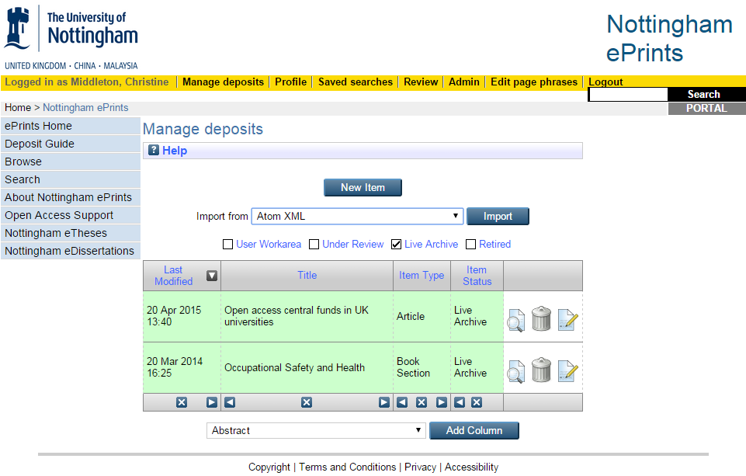

- On the following pages, select Item Type (i.e. "Thesis"), Thesis type and Faculty/School from the pick lists.

- Upload your PDF(s). For each file you will need to provide further information. Please DO NOT start a new thesis deposit if you have supplemental files (e.g. list of corrections, audio, video). Put them all on the same record.
Note: Research data should be archived separately, please see the research data management webpage for more information.
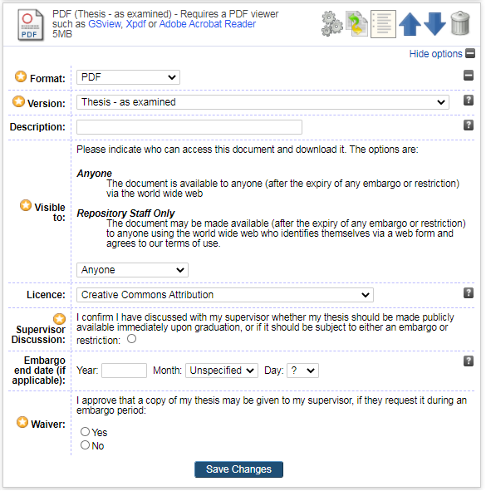

Use Version to indicate:
- Thesis – as examined
- Thesis for reader access – any sensitive & copyright-infringing material removed
The free text Description field please indicate if this is your:
- first submission,
- corrected thesis, or
- re-submission.
‘Visible to’ allows you to specify who can access the full text of your thesis. UON advocates a policy of openness wherever possible and research funders may also require outputs to be available open access. Please consider the open access status of your thesis in discussion with your supervisor. Select:
- Anyone: the document is available to anyone via the world wide web
- Repository staff only: the document can be requested by site visitors who identify themselves via a web form.
Repository staff only: should be used for any access other than the Open Access “Anyone” option. It allows a log to be maintained of those requesting the full text of a thesis. If the title is embargoed, (i.e. suppressed pending future publication), then access will be declined. If the thesis is restricted then there is a later option to specify this and it will not be discoverable at all.
Licence: You should check the appropriate licence to assign to your work with your supervisor. Supervisors know the circumstances surrounding the research – the commercial and ethical sensitivity, the possibility of patent application and funder requirements. For more information on the meaning of Creative Commons licences, please see UoN Libraries Licences webpage.
Supervisor discussion: You must check the appropriate licence to assign to your work and whether an Embargo is required with your Supervisor.
Embargo: You may request an embargo period if you wish to suppress the full text pending publication of an article or book based on the content of your thesis. Please note that bibliographic details of your thesis, including any abstract, will be visible to the public.
Supervisor access waiver: where an embargo is applied to your thesis it cannot be released without author permission. Please indicate whether you will pre-approve a request from your supervisor to view the thesis during an embargo period.

- Click Next to fill in the bibliographic details template (author, title, abstract etc).

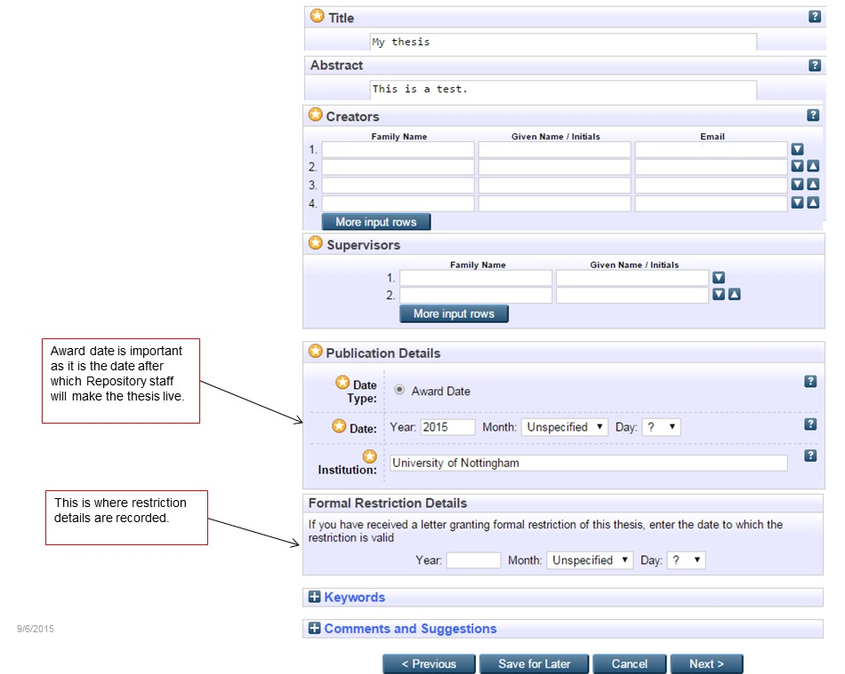

For Award Date enter the date when you expect to graduate.
If a thesis has an official Restriction, then enter the details here to ensure that the thesis is not visible within the live repository.
Optionally add Keywords to help others to find your thesis
Comments and Suggestions are only visible to you and administrative staff. If there are particular reasons why you would need an embargo for longer than 2 years, please give details here.
- Read the Deposit Licence carefully and deposit your files(s). Note: there is currently no automated confirmation from the system.

How to upload your thesis in China?

Written theses should be deposited in PDF format. This option is usually available within word processing software. For example Microsoft Word offers a 'save as PDF' option. Open your Word document, click on the Office button on the top left corner, go to save as, then click PDF. This will save your document in a PDF format. However data, audio and video files may also be uploaded.
Note: the below instructions refer to both initial submission and resubmission.

The steps in the Deposit process

- You will need the following information
  - the type of degree - PhD, EdD or MRes
  - the full title of your thesis
  - the abstract of your thesis
  - the names of your supervisors
  - the year and month when you expect to graduate
  - the full text of your thesis, in PDF format
- Login with your University username and password at: https://research.nottingham.edu.cn/admin
- Click on "add content" on the page
- On the following pages, select Item Type (i.e. "Thesis"), Thesis type from the pick lists.
- Upload your PDF(s). For each file you will need to provide further information.

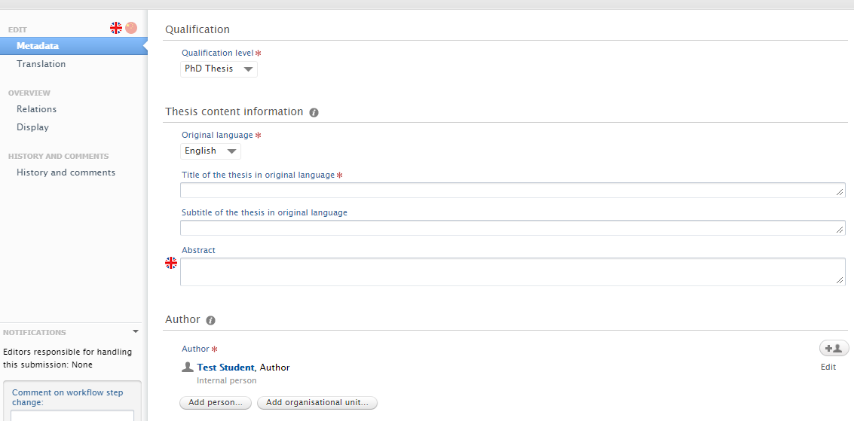

Document Visibility allows you to specify who can access the full text of your thesis. You must check this with your Supervisor.

If the thesis is to be embargoed or restricted, an embargo end date must be set.
Select:
- Public-No restriction: the thesis will be publicly available after the end date
- Backend-Restricted to UNNC RIS users: the thesis will be available to UNNC RIS users after the end date

Metadata-Visibility, select:
- Public: embargo
- Confidential: restriction

If the title is embargoed (i.e. suppressed pending future publication), then access will be declined. If the thesis is restricted then there is a later option to specify this and it will not be discoverable at all.

Licences: LRLR can advise on the meaning of Creative Commons licences (email copyright@nottingham.ac.uk). The supervisors know the circumstances surrounding the research – the commercial and ethical sensitivity, the possibility of patent application. We have received strong indications that supervisors want and need to be involved in this decision.

Embargo: You may request an embargo period if you wish to suppress the full text pending publication of an article or book based on the content of your thesis. The bibliographic details including any abstract will be visible.

- Read the Deposit Licence carefully and deposit your files(s) and click save.

- Your submission will be checked and a public version will appear in the archive after your award has been conferred.

Appendix B: Supplementary Information for examiners, supervisors, and candidates
Note: The official regulations for higher degrees are given in the Quality Manual at https://www.nottingham.ac.uk/academicservices/qualitymanual/researchdegreeprogrammes/regulations-for-higher-doctorates.aspx

Criteria for award of PhD and other qualifications at Doctoral Level
These are awarded to students who have demonstrated:
- the creation and interpretation of new knowledge, through original research or other advanced scholarship, of a quality to satisfy peer review, extend the forefront of the discipline, and merit publication;
- a systematic acquisition and understanding of a substantial body of knowledge which is at the forefront of an academic discipline or area of professional practice;
- the general ability to conceptualise, design and implement a project for the generation of new knowledge, applications or understanding at the forefront of the discipline, and to adjust the project design in the light of unforeseen problems;
- a detailed understanding of applicable techniques for research and advanced academic enquiry.
Typically, holders of the qualification will be able to:
- make informed judgements on complex issues in specialist fields, often in the absence of complete data, and be able to communicate their ideas and conclusions clearly and effectively to specialist and non-specialist audiences;
- continue to undertake pure and/or applied research and development at an advanced level, contributing substantially to the development of new techniques, ideas, or approaches;
and will have:
- the qualities and transferable skills necessary for employment requiring the exercise of personal responsibility and largely autonomous initiative in complex and unpredictable situations, in professional or equivalent environments.

The thesis must be presented in a satisfactory manner. The subject matter must be clearly and precisely expressed, its arguments logical and intelligible, and its language appropriate. It must show that the candidate not only has ideas, but also has the power of putting them into suitable words.
The thesis must be the result of the candidate’s own work. This requirement does not preclude a candidate obtaining limited assistance with the routine collection and/or processing of data under guidelines and instructions clearly devised by the candidate. When such help is obtained it should be with the prior approval of the supervisor who must be satisfied that the spirit of the ‘own work’ requirement is not breached.
Prior publications of papers arising from the research being undertaken will not adversely prejudice the assessment of the thesis by the Examiners.
The viva voce examination is an essential and important part of the examination of the candidate. It will normally include questions designed to ascertain that the thesis embodies the candidate’s own research. It will test the candidate’s general comprehension of the field of study within which the subject of the thesis falls. It will test the candidate’s acquaintance with the general literature of the subject, knowledge of the relation of the work to the wider field of which it is a part, and the respects in which the work advances, modifies, or otherwise affects this wider field of scholarship.

Options available to the examiners

When the examiners assess the candidate’s thesis they will be following the guidelines set out in the Quality Manual: http://www.nottingham.ac.uk/academicservices/qualitymanual/researchdegreeprogrammes/index-page-research-degree-regulations.aspx
Further information for examiners, supervisors and candidates can be accessed under Key Documentation, here:
https://www.nottingham.ac.uk/qualitymanual/research-degree-progs/pgr-procedures-for-assessment.aspx

* These dates are for graduation eligibility only. You are required to submit your thesis, at the very latest, by the submission deadlines notified to you during your course of studies.
* These dates are for graduation eligibility only. You are required to submit your thesis, at the very latest, by the submission deadlines notified to you during your course of studies.
* Due to local context, Master of Philosophy (MPhil) is not applicable to China campus (UNNC) for applying as a degree nor as a result of PhD examination.
* For Creative Writing students, and extended embargo of up to 7 years is permissible.

