Faculty of XXX
[Insert School/Dept/Programme name]
Minutes of Meeting for Student Staff Forum (SSF) Academic Year 20xx – 20xx
1st Meeting

Date :

Time :
Venue :
Staff Representatives
Senior Tutor :
Director of Teaching and Learning :
Student Representatives

Year 1 :
Year 2 :
Year 3
Absent with Apology :

Item | Particulars |  |  | Comment/Decision/Note(s) | Action(s)
1.0 | Chairman’s Introduction & Announcements
 | 1.1 | Objectives of the meeting  - To provide a forum for meaningful conversation, exchange of ideas and information between the student representatives and the School  - To discuss and provide response based on feedbacks/matters raised by student representatives

2.0 | Matters Arising from Last Meeting
 | 2.1 | N/A | N/A | N/A

3.0 | Feedback and Suggestion by Students
 | 3.1 | Module ABC (ABCF023)

4.0 | Module/Course Review Input from Students

Meeting was officially adjourned at xxx.Prepared by: Facilitated by:

5.0
Recognition Highlight by Students
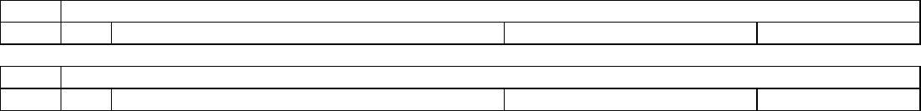
6.0
Feedback and Suggestion by Staff
7.0
Next meeting schedule

Name: Position: xx Representative Date:
Name:
Position: Senior Tutor Date:

