Studentship Form
The Precision Imaging Beacon wishes to promote cross-disciplinary interaction between Schools, with an expectation of at least two supervisors.
First Supervisors name | Prof. Thomas Meersmann | School Addresses | Sir Peter Mansfield Centre – University Park  School of Medicine
Co Supervisors name | Dr. Paul Glover | School Addresses | Sir Peter Mansfield Centre – University Park  School of Physics
Co Supervisors name |  | School Addresses
Start date | Sept 2019 | Duration | 3.5 years
Student | TBC following selection process
Project Title | Hyperpolarized MRI at ultra high magnetic field.
Project Abstract | Hyperpolarized (HP) nobles gases, such as HP xenon, enable new MRI contrast to probe different structural and functional aspects of lungs in health and disease. HP xenon is also a promising contrast agent for the brain that will benefit form the ultra high magnetic field (7 Tesla) MRI system at Nottingham. New strategies with the benign (non-radioactive) HP markers are being explored at the Sir Peter Mansfield Imaging Centre (SPMIC) to enable new contrast modalities. For example, molecular MRI is being developed at SPMIC to allow for imaging of the distribution of certain biomarker molecules in the body through specially designed biosensor molecules. SPMIC has pioneered the usage of the noble gas isotope ⁸³Kr as a completely new HP MRI contrast agent. Nottingham’s unique expertise and capability in HP ⁸³Kr technology and the very high field facility with the 7T whole body Scanner at SPMIC provide a unique environment at the interface between physics and medicine to advance these exciting new MRI modalities.
Graphic for Advertising  (Must be high resolution) | 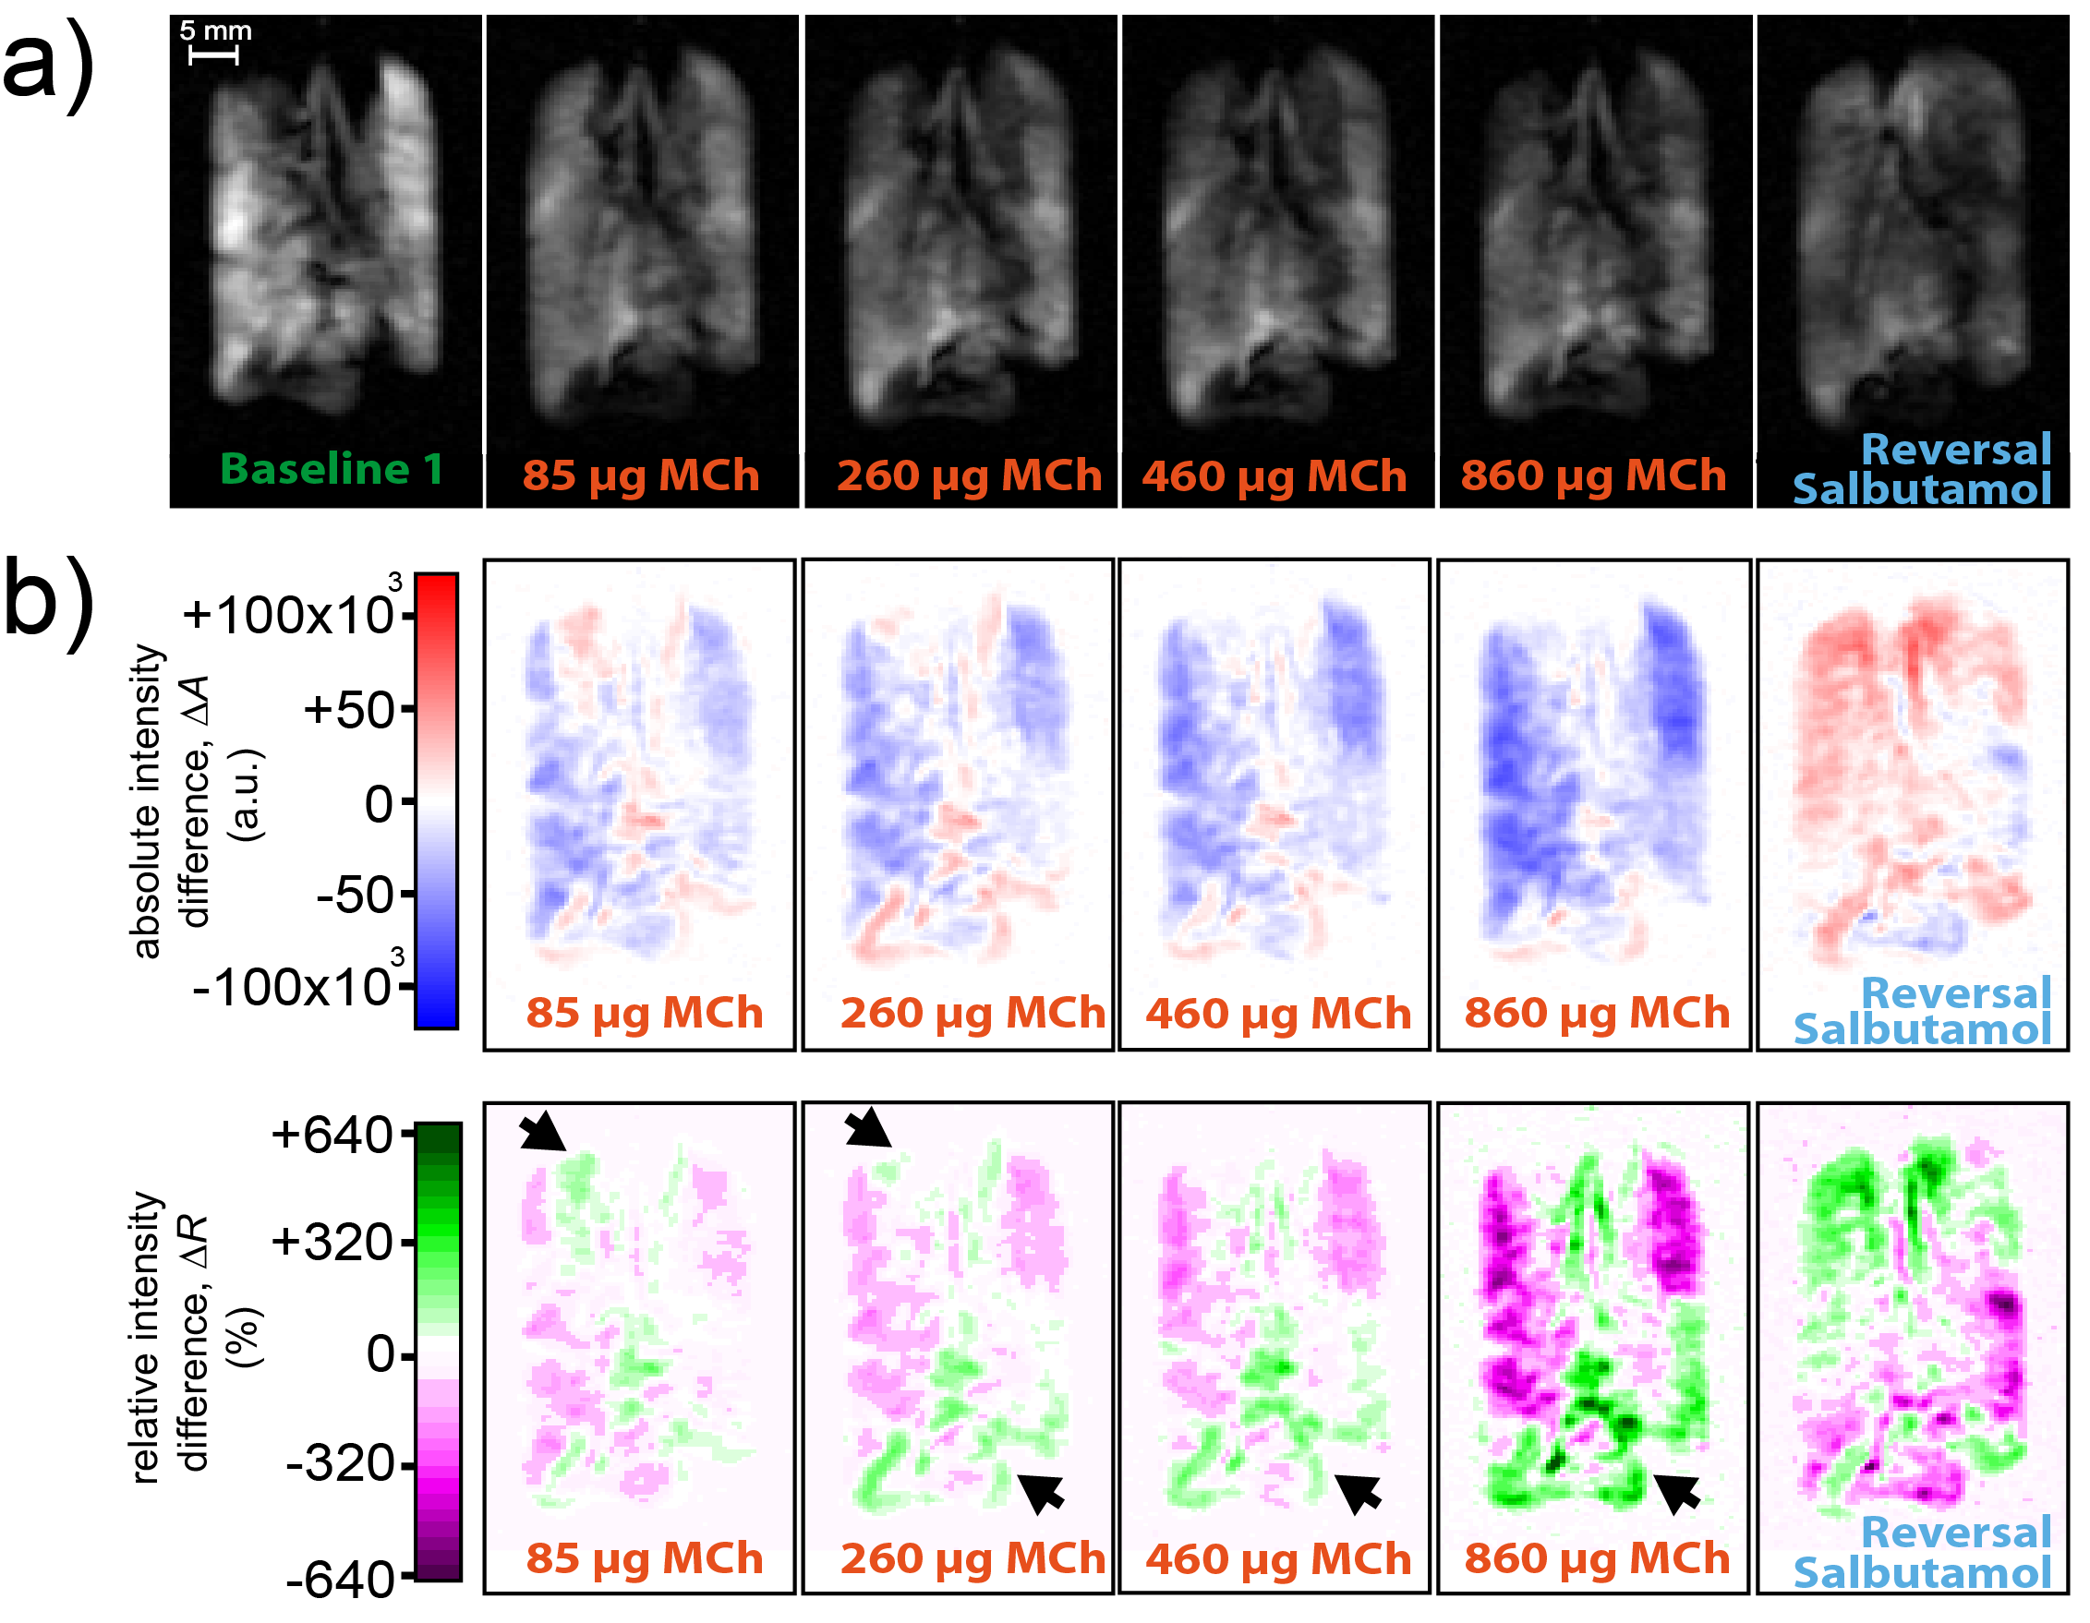  Pulmonary HP xenon-129 MRI of an animal model of asthma during methacholine challenge leading to airway obstruction and its reversal through salbutamol (from Lilburn et al, Magnetic Resonance in Medicine, 76 (2016), 1224. DOI 10.1002/mrm.26003)

