Studentship Form
The Precision Imaging Beacon wishes to promote cross-disciplinary interaction between Schools, with an expectation of at least two supervisors.
First Supervisors name | Dr Shahideh Safavi (25%) | School Addresses | School of Medicine
Co Supervisors name | Dr Mike Barlow (25%) | School Addresses | School of Medicine
Co Supervisors name | Prof Penny Gowland (20%) | School Addresses | School of Physics & Astronomy
Co Supervisors name | Dr Andrew Prayle (15%) |  | School of Medicine
Co Supervisors name | Prof Ian Hall (15%) | School Addresses | School of Medicine
Start date | Sept 2019 | Duration | 3.5 years
Student | TBC following selection process
Project Title | Developing multi-modal functional MRI approaches for clinical use
Project Abstract | We aim to develop multi-modal functional MRI to use in patients with lung disease. Hyperpolarised xenon-129 MRI (129Xe-MRI) is our focus.  129Xe-MR lung imaging has been in development for over two decades and 129Xe-MR brain imaging is an emerging field. The successful applicant will be responsible for developing ADC and dissolved phase imaging capabilities at University of Nottingham for both pulmonary and neuro-imaging, on multiple MRI platforms, with particular focus on the open upright 0.5T MRI scanner. They will also develop under-sampling methods, such as compressed sensing sequences coupled with deep learning, to maximally exploit the magnetisation of the hyperpolarised noble gas.  The student will be working with physicists and clinicians, and involved in clinical studies. The potential clinical studies are:  - impact of cystic fibrosis transmembrane conductance regulator (CFTR) potentiators in patients with cystic fibrosis  - cognitive impairment in patients with chronic (e.g. emphysema) and acute respiratory disease (e.g. pneumonia)  The student will be supported by clinical academics and MR physicists at the Nottingham NIHR Biomedical Research Centre and the Sir Peter Mansfield Imaging Centre.
Graphic for Advertising  (Must be high resolution) | 3D reconstruction of 129Xe-MR ventilation scan in a healthy volunteer  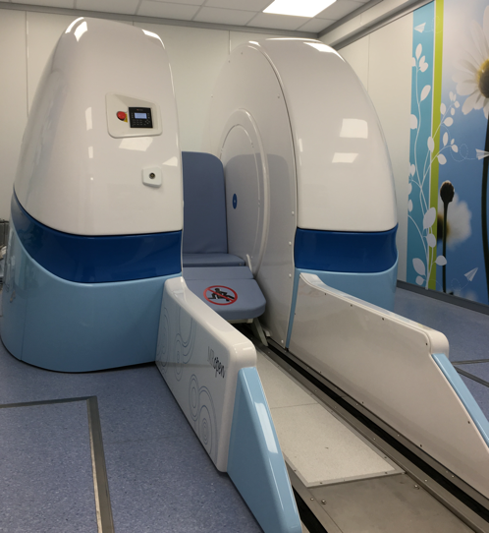  Open upright 0.5T MRI scanner

