Teacher Pack Activity 1 - The Great Greeting Experiment
Cover page
Learning outcomes
This activity demonstrates how easy it is to transfer bacteria from one person to another through touch. It is expected that the students will have a better understanding of:

1) How bacteria infections can spread from person to person
2) How our behaviour can help reduce the spread of bacteria and how this can reduce the use of antibiotics

Link to curriculum
Fits into GCSE curriculum ‘
GCSE ‘communicable diseases’ -
explain how communicable diseases (caused by viruses, bacteria, protists and fungi) are spread in animals and plants

- Scientific attitudes
- Discussion about clinically relevant problems in today’s medicine. Specifically how personal hygiene can reduce the spread of infections
- Experimental skills and investigations/Analysis and evaluation
- By using this as a practical experiment students can observe how easy it is to spread bacteria between people through touch and objects and how this could translate to a bigger problem in a healthcare setting.

Equipment needed
You will need:
- Vaseline and hundreds of thousands OR a set of UV torches and UV paint.
- Worksheet A
- Biodegradable wet wipes
- Powerpoint: http://bit.do/superbiomaterials

Risk assessment
Provided within this teacher pack is also a detailed risk assessment of the activity highlighting any potential risks and hazards that could be associated to the activity. Please note this is an example only and any risk assessments should be independently assessed and reviewed.

Instructions for Teacher
Introduction Go through power point presentation: http://bit.do/superbiomaterials
The experiment
Explain the students will be working in pairs.
Assign one student in each pair the ‘disease carrier’.

The student who is the disease carrier takes a small amount of Product X and rubs it over their hands (like applying a hand cream).

The disease carrier must then greet their partner in four different ways:

- Wave
- Fist bump
- Hi 5
- Handshake

After each greeting, students must record on sheet A if there has been any hand transfer and where by drawing on the printed hands, remembering to look at the front and back of their hands. Between each greeting the ‘receiver’ student must wash their hand with a wet wipe, and the disease carrier, reapply the transfer product.

Once the students have done the 4 greetings and recorded their findings, they can then swap roles and feedback to the class.

Section B

The teacher must apply the transfer product to an object ie. A ruler/cup. The teacher explains that this must be passed around the class between students for 60 seconds. At the end of 60 seconds the teacher must ask how many people have become ‘infected’ ie. have the transfer product on their hands.

You can repeat this but by sending round more than one infected object and recording the ‘spread of infection’ after 60 seconds.

This demonstrates how bacteria can spread between people through intermediate objects.

Ask the class to think of other locations /activities where bacteria could easily spread between objects (eg. On the train, door handles, banisters, phones, keyboards etc.).

Discussion points
- Which greeting transferred most ‘bacteria’ and why

- Can we change our behaviour to reduce spread of bacteria between people? What actions can we take? (discuss good hygiene, between people and through objects)

- In what environment/ place/ profession is it particularly important to be vigilant with personal hygiene? (to introduce the idea of a healthcare setting and spread of infection)

- Think of different ways bacteria could be spread in a healthcare setting (discuss from staff toughing patients/other staff/ staff touching medical equipment used on patients/ patient to patient)

Expansion
Explain to the students that there has been an outbreak of MRSA in hospital. They have to come up with 10 actions to try and prevent/control the spread of the infection. Make sure they understand MRSA is a bacterial infection, it is difficult to treat and spreads through contact. They will work in groups of 4 and will have 10 minutes to complete the task.
This will then be discussed as a group.

Instructions for students
The Great Greeting Experiment
Learning objectives
After this lesson you will have a better understanding of how bacteria can spread between people and objects and the importance of vigilant hygiene in a healthcare setting. You will cover:

1) How bacterial infections can spread from person to person
2) How our behaviour can help reduce the spread of bacteria and how this can reduce the use of antibiotics
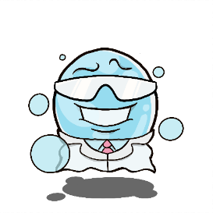
You will need:
Worksheet A and B
Either Hundreds of thousands and Vaseline OR UV gel and UV torch
Wetwipes/tissue

Section A
You will work in pairs, one of you will be assigned as the disease carrier.
The disease carrier will apply the transfer Product to their hands, like a hand cream (represents bacteria).
They will then greet their partner in the ways below. Between each greeting you must record on Worksheet A the transfer of Product X onto your partners hand. Both students in each pair must then wipe their hands. The ‘disease carrier’ must then reapply Product X and move onto greeting 2.
- Wave
- Fist bump
- Hi 5
- Handshake

Then swap roles with your partner and see if you get similar results.

Section B
Transfer between an intermediary object – follow the teacher’s instructions.
Answer the questions at the bottom of Worksheet A on the reverse side.

Worksheet A
Greeting | Front of hand | Back of hand
Hand wave | 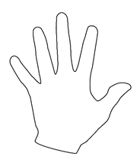 | 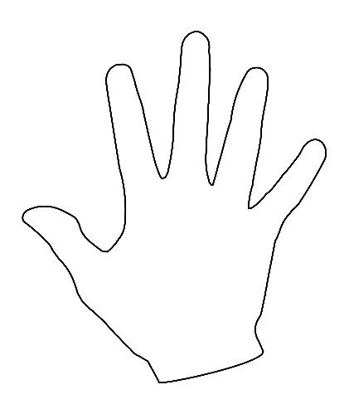
Hi 5
Fist bump
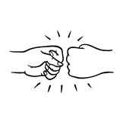
Handshake

Answer the following questions:
- Which greeting transferred the most of product (bacteria) onto the other person?

- Can bacteria be transferred through intermediary objects?

- What can individuals do to help reduce the transfer of bacteria?

- In what environment is it very important to be vigilant with hygiene?

Expansion
MRSA outbreak!

You are the manager of a hospital and have just been told 10 patients in Ward A have an infection caused by Methicillin Resistant Staphyloccus MRSA bacteria. MRSA is a bacteria that is very difficult to treat because it has developed resistance to lots of antibiotics. It spreads through contact and can survive outside the body on surfaces for days to weeks. It is your job to help stop the spread of infection.

In groups of 4 you have ten minutes to come up with 10 actions that you will take to stop the spread of the MRSA bacteria from the infected patients to the rest of the patients in the hospital.

Think about the following:

- How might the bacteria spread from the patient to other people (direct or indirect)?
- How can you kill the bacteria if it does spread from the patient?
Who do you find in a hospital (patients, medical staff, visito

