
Postgraduate Application Form
Please complete all questions in BLOCK CAPITALS in black ink and complete tick boxes as appropriate.
We also require you to submit two references in sealed envelopes and all other supporting documentation before your application can be considered.
Surname/Family name |  |  | Title (Mr/Mrs/Miss/Ms/Dr)
Forenames |  |  | Date of Birth |  | Male | Female
Maiden name/Other names |  |  | Telephone number
Current address  Postcode From |  |  | Mobile number
Current address  Postcode From |  |  | E-mail address
Add permanent home address if different from above  Postcode From To |  |  | Telephone number
 |  |  | Mobile number
 |  |  | E-mail address

Nationality Country of birth
Country of permanent residence (please state the country you are a permanent resident of, except for periods of temporary absence)
Have you or your parents been resident in the UK for the past three years? Yes No
If yes, was this solely for the purpose of education? Yes No
How do you intend to finance your studies? (Please tick as many as apply)
Self Family Employer Sponsor Other Please state
Is this funding fully confirmed? Yes No
For fee purposes do you think you are (tick one)
UK European Union Channel Islands International/non-EU

Academic history

Please list all qualifications taken (regardless of whether this was successfully completed). Please start with the most recent. All applicants should enclose copies of official transcripts of their qualifications.
Note: If you have not yet finished your qualification please enter the details and add N/A in the Qualification and class of degree box. Schools may not be able to make a decision on your application without at least a copy of your transcript or latest mark sheet. If you are completing a bachelors/masters degree, please include a list of modules you are taking in your final year.
International applicants requiring a Tier 4 student visa to study in the UK - please note that the information you provide here will be used to produce your Certificate of Acceptance to Study (CAS) if you are offered a place. Please ensure the information is completely accurate giving the correct title of your degree as it appears on your transcript and the full name of the institution. You must include details of all previous study in the UK regardless of whether this was successfully completed.
Name and address of institution | Dates of attendance | Qualification and class of  degree (if any) (give grade  point average if applicable) | Principal subject(s) taken
 | From
 | M M Y Y
 | To
 | M M Y Y
 | From
 | M M Y Y
 | To
 | M M Y Y
 | From
 | M M Y Y
 | To
 | M M Y Y
 | From
 | M M Y Y
 | To
 | M M Y Y
Other information relevant to your academic history:

English language qualification(s)
Is English your first language Yes No (If no please complete question 5a.)

Is/was English the language of instruction for your first degree? Yes No
If English is not your first language please provide details of your English language qualifications with results obtained and the date you took the test or will be taking the test.
You must provide a copy of your English language test score report with your application.

 | Score | Date obtained
IELTS
IELTS |  | M | M | Y | Y
IELTS |  | M | M | Y | Y

References
Please give the names of your two referees. At least one should be from an academic member of staff at the institution where you gained your most advanced qualifications.
Referee one | Referee two
Name | Name
Address | Address
Position | Position
Telephone number | Telephone number
E-mail address | E-mail address

Personal statement
(All applicants) Please use this space to summarise your academic interests and your reasons for choosing your intended course of study. You may continue on the back page if necessary.

Career history
Please give details of relevant employment and/or professional experience. Please start with the most recent. Continue on the back page or enclose a CV if necessary.
Dates |  |  |  |  |  |  | Nature of work and position held  (please specify whether post was full or part-time) | Name and address of employer
From |  |  | To
M M | Y | Y | M | M | Y | Y
From |  |  | To
M M | Y | Y | M | M | Y | Y
From |  |  | To
M M | Y | Y | M | M | Y | Y

How did you learn about The University of Nottingham and its postgraduate programmes?
Printed postgraduate prospectus School/department brochure
The University of Nottingham website
Tutor
Personal recommendation
Exhibition/Fair (UK) (please state which location this was in)
Exhibition/Fair (Overseas) (please state which country this was in)
British Council
University of Nottingham event (please state which event you attended)
University agent
Course listing website (eg prospects)
Advertisement in newspaper/journal (please name which journals)
Advertisement in directory (please name directory)
Other (please specify)

Disability, dyslexia or long-term medical condition
The University of Nottingham aims to provide an environment in which all of our students are able to participate fully in University life. In order to help us provide suitable support, please indicate whether you have a disability below. This will not affect judgements concerning your academic suitability for a course, and any information will be treated confidentially. This information will be made available to the University’s Disability Services Department who can provide support to applicants and students.
No disability  You have a social/communication impairment such as Asperger’s syndrome/other autistic spectrum disorder  You are blind or have a serious visual impairment uncorrected by glasses  You are deaf or have a serious hearing impairment  You have a long standing illness or health condition such as cancer, HIV, diabetes, chronic heart disease, or epilepsy | You have a mental health condition, such as depression, schizophrenia or anxiety disorder  You have a specific learning difficulty such as dyslexia, dyspraxia or AD(H)D  You have physical impairment or mobility issues, such as difficulty using your arms or using a wheelchair or crutches  You have a disability, impairment or medical condition that is not listed above  You have two or more impairments and/or disabling medical conditions

When completed please return to:

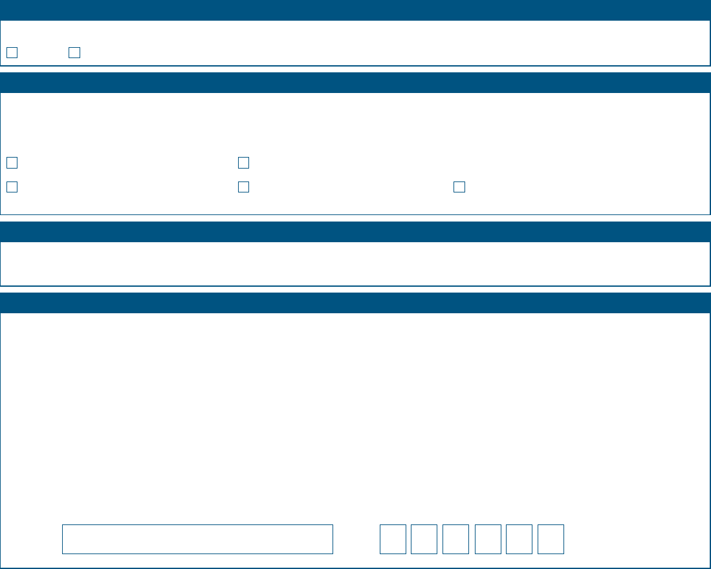
Two references in signed and sealed envelopes
If your application is successful you will need to provide original or certified copies at registration.
Current or former University of Nottingham students do not need to provide a transcript of their studies at Nottingham, as the Admissions Office
has access to this information.
Transcript of studies
Research proposal (if required) CV (optional)
English language test score report
(if English is not your first language)
Signature
Data
D
D
M
M
Y
Y

Criminal convictions
Do you have any criminal convictions (excluding monitoring offences for which a fine and/or three penalty points were imposed)
Yes No
Please check that your application is complete and that you have enclosed all the relevant documents
Declaration
I certify that the information provided above is correct and I understand that the University will withdraw my application and any subsequent offers if any aspect is found to have been falsified.
In completing and submitting your application form, you will be providing the University of Nottingham with personal data, including in some cases sensitive personal data, as defined in the Data Protection Act 1998. The University will use this data for the purposes of processing your application and for other administrative purposes relating to your application. This personal data may also be shared with and used by third parties in connection with your application, for example in order to verify your identity, qualifications, work experience and other information that you provide. Some of these third parties may be located outside the UK (including outside the European Economic Area). By submitting your application, you will be deemed to be giving your consent to the processing and use of your personal data as set out in this paragraph.
For further information about how we will process your personal data please read: Data Protection Statement: www.nottingham.ac.uk/go/dataprotectionstatement Data Protection Policy: www.nottingham.ac.uk/go/dataprotectionpolicy
The Admissions Office, External Relations, The University of Nottingham, University Park, Nottingham, NG7 2RD, United Kingdom.
If you require this form in an alternative format, please contact us. t: +44 (0)115 951 5559
e: alternativeformats@nottingham.ac.uk

