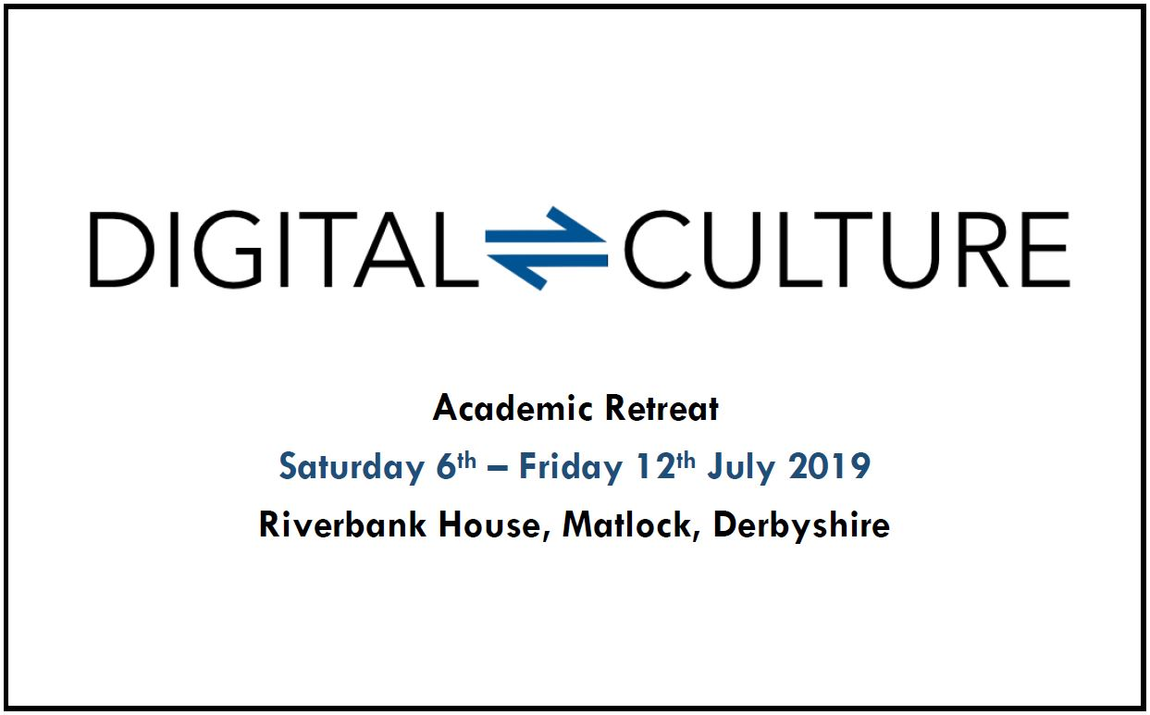

**Academic Retreat, Saturday 6th – Friday 12th July 2019, Riverbank House, Matlock, Derbyshire**

|  |
| --- |
| **Name** |
|  |
| **Subject Area / Home Institution** |
|  |
| **Please summarise your research interest, project or practice. [200 words]** |
|  |
| **Why would you like to attend the DCRN Academic Retreat? [200 words]** |
|  |
| **Please indicate if you would be interested in giving a ‘Show and Tell’ or ‘Work in Progress’ paper. If yes, provide a brief description of what it might be. You will not be obligated to stick to this idea.** |
|  |

We are currently in the process of finalising the itinerary for the week. Below is a preliminary timetable for how days will be themed. As accommodation will be limited, please indicate which days you would be most interested in attending:

|  |  |  |
| --- | --- | --- |
| Day | Theme | Tick |
| Saturday 6th July [half-day] | Set-Up |  |
| Sunday 7th July | Icebreakers and Film Screening |  |
| Monday 8th July | Linguistics, and Methods in Digital Humanities |  |
| Tuesday 9th July | Systems & Management, and Life in Academia |  |
| Wednesday 10th July | Show and Tell / Work in Progress Sessions |  |
| Thursday 11th July | Videogames, and Writing (Publishing and Journals) |  |
| Friday 12th July [half-day] | Discussion: Futures of Digital Cultures research in the Midlands |  |

The deadline for submitting this form is midnight on **Sunday 31st March**.

Please email your completed form to [george.cox@nottingham.ac.uk](mailto:george.cox@nottingham.ac.uk).