   | 

Understanding the natural history and impact of itching (pruritus) in patients with drug-induced liver injury (DILI)
Chief Investigator: Professor Guruprasad P Aithal; Local Researcher(s): Sophie Cusick.
FINAL Version 2.0 / 01 JUNE 2025/ IRAS ID: 331517

We would like to invite you to take part in our research study.

Before you decide we would like you to understand why the research is being done and what it would involve for you. One of our team will go through the information sheet with you and answer any questions you have. Talk to others about the study if you wish. Ask us, if there is anything that is not clear.
  What is the purpose of the study? |   Why have I been invited?
The liver produces bile, which goes to and from the gut to help us digest food. If there is a problem with this, bile acid in circulation can increase and cause itching (also called pruritus).  In drug-induced liver injury (an unpredictable adverse hepatic reaction to a medication), bile production may be affected as the liver is damaged. Therefore, some patients with drug-induced liver injury may develop itching as a symptom.  We aim to investigate why some patients who experience liver injury caused unexpectedly by drugs/supplements suffer from itching symptoms, and how it affects their quality of life. We aim to find out if, there are certain rare genetic variations linked to this and what factors, affect the severity of itching.  This will be part of a student PhD project. |   You are being invited to take part because you are over 18 years old and have symptoms that may possibly be caused by drug-induced liver injury, based on your liver function test results and medical history. (This may be later found to have another cause), but you can still continue in the study unless further tests show that your liver function is below the required threshold for inclusion, in which case we will not require any further participation). We are inviting around 60 participants like you to take part.  *No drugs or treatments are being tested*

Do I have to take part? | It is up to you to decide whether or not to take part. If you decide to take part, you will be given this information sheet to keep and asked to sign a consent form.  If you decide to participate, you can withdraw at any time and without a reason. This will not affect your legal rights or care. If you withdraw some information collected so far cannot be erased and this information may still be used in the project analysis. Any blood sample collected and sent for analysis, may not be retrieved but we can discard this result from the analysis.
What will happen to me if I take part?
If you decide to take part in this research, a trained member of the local research team will approach you either at your medical appointment or via a letter offering a research appointment. At the appointment, they will explain the research study and answer any questions you may have. The research will usually be incorporated into your medical visit where clinical blood samples are already being taken and will take around 20 minutes.
At the appointment, the researcher will:
- ask for your written consent to participate in the research. (We may be able to take your consent verbally over the phone if you are unable to attend the research centre for a study visit at the time of acute injury symptoms.)
- measure your height, weight, and waist circumference if possible.
- ask you to verbally complete a health questionnaire (22 questions, taking 5 mins).
- discuss and collect your health & medical history (including medications and symptoms).
- confirm your consent to anonymised data being shared with collaborators in the USA.
- ask for your consent to access your digital medical records to follow your recovery over 2 years.
- ask for a contact phone number so we can follow up on your progress via phone at a convenient time so that we can repeat the health questionnaire (see below).
- ask if we can keep your details in our secure database to contact you about our future research where relevant. (This is optional- you can indicate this on the consent form)
If you are currently experiencing itchiness as a symptom of your liver injury:
- You will be asked to complete an Itching Questionnaire (48 questions, taking 10 mins) which will also be repeated by phone at the same time as the health questionnaire.
- and if you consent to DNA genetic analysis, they will collect a 5ml blood sample (approx. 1 teaspoon). (This is optional- you can indicate this on the consent form). If you agree and your consent was completed verbally (over the phone), we will arrange for you to come in for a study visit; at which you will be able to complete and sign a copy of the consent form.
After the study visit:
If you agree, the study team or the Nottingham research team will contact you 4 further times (after approx. 1 week, 4 weeks, 3 months, and 6 months) to ask you to repeat the health questionnaire and itching questionnaire (if applicable) – this will be done over the phone (taking around 15 mins). Or we can post the questionnaires to you to complete & return if you prefer. (If you are attending the research centre you can also complete them in person) If after 6 months your symptoms continue you will be asked to continue to complete questionnaires every 3 months for up to 2 years.


If itching only develops after the first study visit, a further visit can be arranged. At this visit a blood sample will be taken for testing and the itching questionnaire completed as done for other itching cases. If the results of clinical testing done on the study day show that your liver function has recovered and does not meet the research inclusion criteria, we will no longer need you to take part in the follow-up research activities. You will continue to have the required clinical care and we will still provide the genetic test results, if done. If your sample has not been sent for analysis it will be disposed of.

What will happen to blood samples I give?  Blood samples collected from people who report itching will be sent for genetic analysis - see next section. This analysis will be done in the UK. They will not share the test results with anyone else. | Will any genetic tests be done?  For patients with itching symptoms, we will assess 77 different genetic markers, which are thought to be linked to rare, treatable inherited liver diseases that cause itching. This testing is optional and is documented on the consent form. We will inform your care team of the results and they will notify you in the rare event that there are any clinically significant findings.  If the genetic tests reveal any medical condition, your care team will discuss this with you and will provide appropriate genetic specialist follow-up care for you and your family.
Expenses & payments  Participants will not be paid to participate in the study. Travel expenses will be offered for any additional visits incurred as a result of participation. |   Involvement of the General Practitioner/Family doctor (GP)  Your participation in this study will be documented in your local health records and is available to the care team. A copy of your consent form will be filed in your records. Where centres use central electronic health records, this information may also be accessible by your GP.

What are the possible benefits of taking part?
We cannot promise the study will help you particularly but the information we get from this study may help others in the future. Understanding the prevalence and impacts of itching associated with liver diseases will inform the healthcare and research community about the burden of itching in this group of patients. This is expected to inform clinicians about potential treatment approaches for itching.
There is a very small chance that a genetic basis could be discovered in some participants, which may contribute to explaining the symptoms. This may reveal that you have an inherited disorder impacting on your liver function, which may be treatable with new drugs. Any diagnosis or genetic risks will be explained and discussed with you by your care team who will follow up further if necessary.
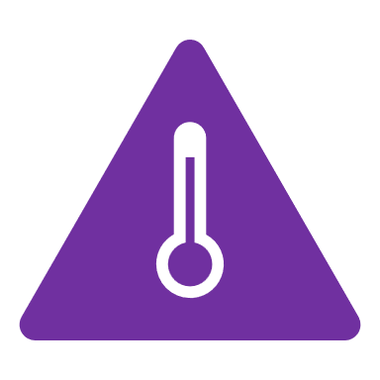
What are the possible disadvantages and risks of taking part?
There are minor risks associated with the blood sampling procedure such as some swelling and/or bruising at the needle prick site. Only qualified researchers with appropriate experience will do blood sampling to minimise this risk. The genetic analysis may identify an inherited disorder, which could be present in other family members, impacting on them. If this is the case, you will be referred to the clinical genetics department of the recruiting centre NHS Trust. They will offer counselling and follow-up to you and your family. The genetic tests being done do not detect any known severe, life-threatening conditions- any findings will be explained by a specialist care team.

What will happen if I don’t want to carry on with the study?
Your participation is voluntary, and you are free to withdraw at any time, without giving any reason, and without your legal rights being affected. If you would like to withdraw, contact the local researchers or central team and they can organise this for you. If you withdraw, or are withdrawn from the study for any reason, we will no longer collect any information about you or from you but we will keep the information about you that we have already obtained.


What if there is a problem?
If you have a concern about any aspect of this study, you should ask to speak to the researchers who will do their best to answer your questions. The researchers’ contact details are given at the end of this information sheet. If you remain unhappy and wish to complain formally, you can do this by contacting the National Health Service complaints procedure or NHS [Patient Advice & Liaison Service (PALS) or Patient Advice & Support Service (PASS)]: 0800 183 0204. email: PALS@nuh.nhs.uk.

In the event that something does go wrong, and you are harmed during the research, and this is due to someone's negligence then you may have grounds for legal action for compensation against the University of Nottingham, but you may have to pay your legal costs. The normal National Health Service complaints mechanisms will still be available to you.

What happens when the research study stops?
When the study ends, we will assess all the results, provide a report to the funder, and write up our findings for dissemination.

 What will happen to the results of the research study?
The results will be reported to the funders, published and presented at scientific meetings and in student presentations/dissertations/PhD theses, which will be available for further dissemination.
All data will be anonymised. A lay summary will be available on the NIHR Nottingham BRC website and associated University of Nottingham social media platforms.
A summary, will also be sent to participants who consent to future contact.

 Who has reviewed the study?
All research in healthcare, is looked at by an independent group of people, called a Research Ethics Committee to protect your interests. This study has been reviewed and given a favourable opinion by London – Bloomsbury Research Ethics Committee.

Who is organising and funding the research?
This research is being organised by the University of Nottingham. The study team are based in the Nottingham Digestive Diseases Centre and are part of the Clinical Research Facility at the Queens Medical Centre in Nottingham. The research is being funded by Ipsen, a PhD studentship award from the University of Nottingham to Maria Vargas and is supported by NIHR Nottingham Biomedical Research Centre. Maria will be part of the study team and will analyse the data and include it in her thesis.


How will we use information about you?

The University of Nottingham are the sponsor of this study. This means we are responsible for looking after your information and using it properly.
We will need to use information from you and from your medical records for this research project.
This information will include your NHS number, name and contact details. Delegated individuals from the research team, Sponsor team and/or regulatory authorities will use this information to do the research or to check your records to make sure that the research is being done properly.
We will use this information to follow up your health status in local and central NHS records.
If you agree we will also keep your contact details to send you the findings of the study and/or to contact you about participating in future research studies.
People who do not need to know who you are will not be able to see your name or contact details. Your data will have a code number instead.
We will keep all information about you safe and secure. Once we have finished the study, we will keep some of the data so we can check the results. We will write our reports in a way that no-one can work out that you took part in the study.
We may share our research data with researchers in other Universities and organisations, including those in other countries, for research in health and social care. Sharing research data is important to allow peer scrutiny, re-use (and therefore avoiding duplication of research) and to understand the bigger picture in particular areas of research. Data shared in this way will be anonymised.

What are your choices about how your information is used?
• You can stop being part of the study at any time, without giving a reason, but we will keep information about you that we already have.
• If you choose to stop taking part in the study, we would like to continue collecting information about your health from your hospital records. If you do not want this to happen, tell us and we will stop.
• We need to manage your records in specific ways for the research to be reliable. This means that we won’t be able to let you see or change the data we hold about you.

Where can you find out more about how your information is used?
You can find out more about how we use your information
• reading our privacy statement https://www.nottingham.ac.uk/utilities/privacy/privacy-information-for-research-participants.aspx
• at www.hra.nhs.uk/information-about-patients/
• our leaflet available from www.hra.nhs.uk/patientdataandresearch
• by asking one of the research team
• by sending an email to mc-nddcbru@exmail.nottingham.ac.uk, or
• by ringing us on 0115 9709966.

Thank You for taking the time to read this information.

Your local research team is:
Researcher:
Sophie Cusick – Research practitioner 0781277082

Doctor/Principal Investigator:
Professor Guruprasad P. Aithal

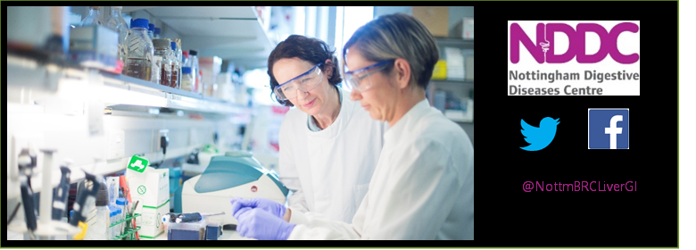

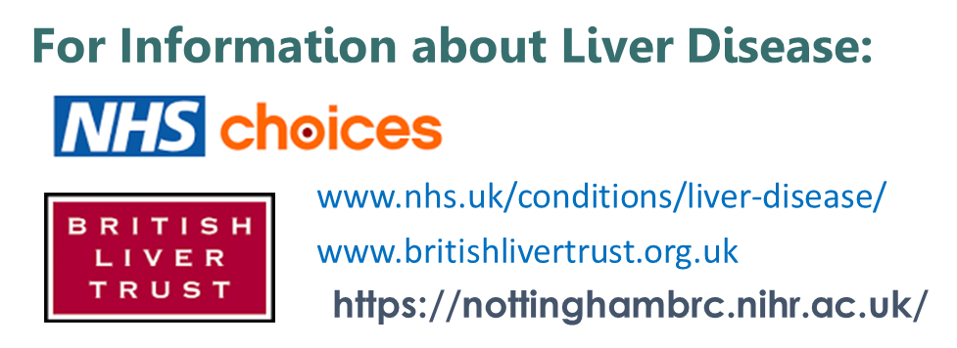
Nottingham Digestive Diseases Centre / Clinical Research Facility:
Queens Medical Centre, Nottingham NG7 2UH. U.K.
Tel. 0115 9709966

