

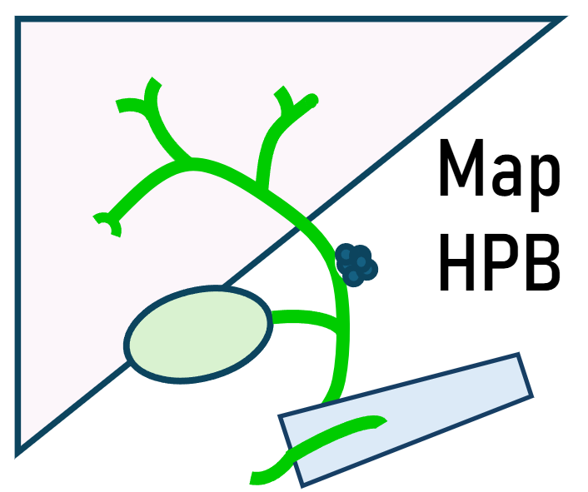

Participant Information Sheet:
Surgical Resection Group

What is the purpose of the study?
The project aims to develop new tests/approaches to diagnose and treat abnormalities in the liver, pancreas, gallbladder and bile duct (called hepato-pancreato-biliary lesions) which can sometimes develop into cancers. Some of these abnormalities can cause the bile duct to become narrow and reduce the flow of bile which needs treating and can make it hard to get samples for diagnosing the problem. We want to test new technologies which are still being developed that create detailed 3-D maps of the affected areas to see if this would improve the reliability of diagnostic tests. We want to determine if there are any characteristics of the tissue that can indicate if it is likely to be developing into a cancer and what treatments will be effective.
The project will also create a bioresource of surplus liver, gallbladder, pancreas, bile duct tissue left over from medical procedures which will be used by researchers to develop and test new tools for cancer care. This will be used to develop a flexible robot or ultra-thin endoscope to navigate the body as a possible way to analyse the abnormality and deliver treatments in the future.

Final version 1.1: 1/6/25
IRAS Project ID: 338833
Title of Study: In-depth characterisation of biliary strictures and hepato-pancreato-biliary focal lesions for development of new technologies to tackle hepato-pancreato-biliary cancers
Name of Chief Investigator: Prof Guruprasad Aithal
Local Researcher(s): Dr Saikat Mandal; Dr Jane Grove
We would like to invite you to take part in our research study. Before you decide we would like you to understand why the research is being done and what it would involve for you. One of our team will go through the information sheet with you and answer any questions you have. Talk to others about the study if you wish. Ask us if there is anything that is not clear.

Why have I been invited?
You are being invited to take part because you are undergoing clinical care to remove part of your liver, pancreas, gallbladder or bile duct.
We are inviting 20 participants like you to take part.

Do I have to take part?
No. It is up to you to decide whether to take part. If you do decide to take part, you will be given this information sheet to keep and be asked to sign a consent form. If you decide to take part, you are still free to withdraw at any time and without giving a reason. This would not affect your legal rights.

What will happen to me if I take part?
If you agree to take part in the study:
- There will not be any change to your clinical care investigations/treatment.
- We will ask the hospital pathology lab for any tissue/material that is left over after all the medical tests are complete. This will be used for research and will be labelled with a code so that you cannot be identified.
- The samples will be analysed and used for research experiments. The research tests/analyses are still being developed so it may not be clear what the results mean. The tests are not the same as tests done by a healthcare provider, however if the tests show something unexpected or suspicious, we will let your clinical team know about the findings. The care team will decide if further tests are needed based on the clinical context.
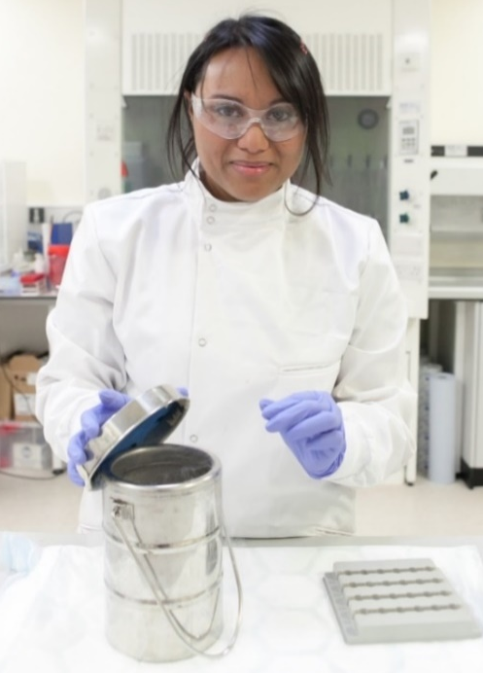
- We will also collect information about your diagnosis, test results (including digital images of tissue and radiological investigations), treatments and follow-up from your medical records over the next 24 months. This will be linked to your samples through a code.
- Taking part will not involve any extra visits for you. Samples will be taken during your standard care procedure, and not as extra procedures.

Optional parts of the study:

We will ask to take your blood sample (up to 20 ml or 1.5 tablespoons in 3 vials) at the time of registration and when you attend further clinical follow ups. These samples will be collected when blood samples are taken for medical tests, where possible; so there are no extra sample procedures for you. Blood samples may be used to identify biomarkers to help us with more accurate diagnosis and to test new treatment approaches

Figure 1: Sample laboratory
If your tissue has not been evaluated using genetic tests, we may test the tissue samples for changes in the DNA that can arise in cancers. This is optional. We will analyse these DNA changes, which may help us to identify tests that could help to diagnose these cancers at an earlier stage and with more accuracy. We may also analyse the DNA in fluid samples. If any tests reveal DNA changes, with your permission, we will inform your care team of the result. They may decide if any further tests are needed
We will ask if a small amount of the tissue that is removed during your treatment can be used for experiments on animals to develop preclinical models. This will involve injecting your tissue or cells under the skin of mice to grow more tissue. The tissue can be used to grow more cells for further research. The cells grown will be different to the original cells donated but they create a useful model to investigate the cancer properties, rather than needing further samples from patients. All housing and use of these animals is carried out and approved under, The animal’s (scientific procedures) Act 1986
We will ask if any samples remaining when this study is complete can be used by other researchers for new projects. This will be done be creating a tissue bank where the samples and linked information are available. If you consent to this; your samples will be stored for use in future studies, some of which, will be carried out by researchers other than the current team who ran this study; including researchers working outside the UK and/or for commercial companies. Your samples/ data, will be anonymised so you cannot be recognised.

If you agree that you can be contacted in the future, we will store your personal contact details in our research database and we will send you a general summary of the research findings when the study is completed, if you have indicated this on your consent form. Also, If you have agreed to be contacted about future research studies, you may be sent information about other research projects.

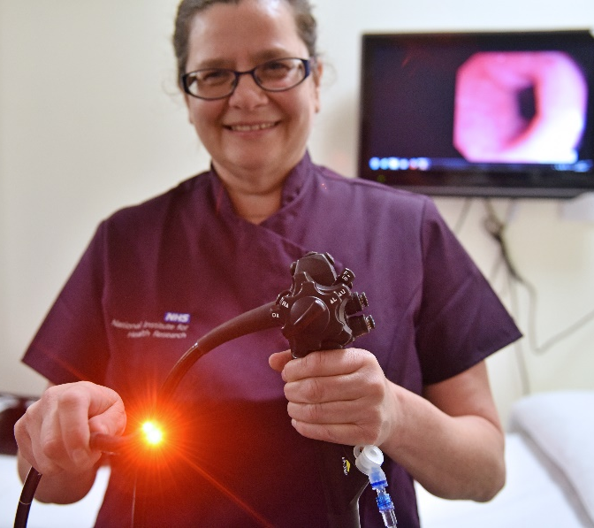
Expenses and payments
Participants will not be paid to participate in the study.

What are the possible disadvantages and risks of taking part?
There are no risks associated with the donation of surplus clinical tissue or body fluid samples like bile or cyst fluid (if available) which is simply left over from your clinical procedures and diagnostic testing.
The risks associated with extra samples being taken during your procedure are also not expected to be any higher than having the procedure itself and taking clinical samples as this does not involve re-inserting the medical device.
Figure 2: Endoscopy unit
Current guidelines advise that multiple samples should be taken to ensure there is enough for diagnostic assessment. Previous studies have not found any substantial added risk of complications when multiple, additional samples were taken during endoscopy procedures. There no risk associated with donating an extra blood sample of 20 ml for research.

What are the possible benefits of taking part?
We cannot promise the study will help you but the information we get from this study may help in the development of improved diagnostic tests and treatments for tumours in organs such as liver, pancreas, gall bladder and bile duct.
Any genetic test results or unexpected test results found as part of the study will be provided to the clinical team. This may be helpful for deciding which treatments may be more effective but if the tests are not done by approved healthcare providers, the care team may perform extra tests to confirm or clarify the result.
If you donated additional research sample, we would also make this available for clinical testing if your diagnostic tests are inconclusive. In this case a further procedure to take more samples may not be needed.

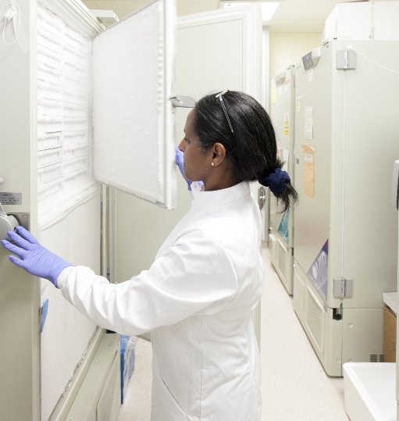
What happens when the research study stops?
At the end of the study, we will stop collecting information from your electronic records.
If you have agreed that your anonymised samples can be used by other projects, we will transfer them to a research tissue bank, otherwise any samples which are not sent for analysis will be disposed in accordance with the Human Tissue Authority’s codes of practice.
You will continue to follow the clinical care pathway and receive care from the hospital medical team.

Figure 3: Sample storage

What if there is a problem?

If you have a concern about any aspect of this study, you should ask to speak to the researchers who will do their best to answer your questions. The researchers’ contact details are given at the end of this information sheet.

If you remain unhappy and wish to complain formally, you can do this by contacting Patient Advice & Liaison Service (PALS) Tel. 0800 183 0204 Email: nuhnt.PALS@nhs.net or online via https://www.nuh.nhs.uk/complaints.
The University has in force the relevant insurance policies which apply to this study. In the event that something does go wrong, and you are harmed during the research, and this is due to someone's negligence then you may have grounds for a legal action for compensation, but you may have to pay your legal costs. The normal National Health Service complaints system will still be available to you.

How will we use information about you?
We will need to use information from you and your medical records (GP and hospital) for this research project. This information will include your initials, NHS number, name, contact details, hospital number, biopsy numbers, digital image IDs. A copy of your consent form will also be sent to the University of Nottingham. People will use this information to do the research or to check your records to make sure that the research is being done properly.
People who do not need to know who you are will not be able to see your name or contact details. Your data will have a code number instead.
The University of Nottingham is the sponsor of this research and is responsible for looking after your information. We will keep all information about you safe and secure by:
- Keeping documents with identifiable information in a locked cabinet.
- Using a code instead of your name on samples and documents where possible.
- Using password protection of computers and files.
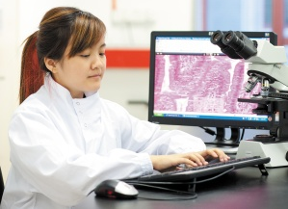

If you agree that samples can be shared through the tissue bank some of your information may be sent to other countries.

International transfers
We may share data about you outside the UK for research related purposes to:
- allow peer scrutiny
- re-use (and therefore avoiding duplication of research)
Figure 4: Data analysis
- understand the bigger picture in particular areas of research.
If this happens, we will only share the data that is needed. We will also make sure you can’t be identified from the data that is shared where possible. This may not be possible under certain circumstances – for instance, if you have a rare illness, it may still be possible to identify you. If your data is shared outside the UK, it will be with the research collaborators and partners at research organisations.
We will make sure your data is protected. Anyone who accesses your data outside the UK must do what we tell them so that your data has a similar level of protection as it does under UK law. We will make sure your data is safe outside the UK.
- the countries your data will be shared with have an adequacy decision in place. This means that we know their laws offer a similar level of protection to data protection laws in the UK
- we use specific contracts approved for use in the UK which give personal data the same level of protection it has in the UK. For further details visit the Information Commissioner’s Office (ICO) website
- we do not allow those who access your data outside the UK to use it for anything other than what our written contract with them says
- we need other organisations to have appropriate security measures to protect your data which are consistent with the data security and confidentiality obligations we have. This includes having appropriate measures to protect your data against accidental loss and unauthorised access, use, changes or sharing
Once we have finished the study, we will keep some of the data so we can check the results. We will write our reports in a way that no-one can work out that you took part in the study.
We will keep your study data for the minimum period of time required by 7 years after the study ends. The study data will then be fully anonymized and securely archived or destroyed.
What are your choices about how your information is used?

- You can stop being part of the study at any time, without giving a reason, but we will keep information about you that we already have.
- If you choose to stop taking part in the study, we would like to continue collecting information about your health from central NHS records and your hospital records. If you do not want this to happen, tell us and we will stop.
- You have the right to ask us to remove, change or delete data we hold about you for the purposes of the study. We might not always be able to do this if it means we cannot use your data to do the research. If so, we will tell you why we cannot do this
- If you agree to take part in this study, you will have the option to take part in future research using your data saved from this study.

Where can you find out more about how your information is used?

You can find out more about how we use your information:
- by reading our privacy statement https://www.nottingham.ac.uk/utilities/privacy/privacy-information-for-research-participants.aspx
- by sending an email to our Data protection officer at dpo@nottingham.ac.uk
- our leaflet available from www.hra.nhs.uk/patientdataandresearch
- by asking one of the research team
- by sending an email to mc-nddcbru@exmail.nottingham.ac.uk, or
- by ringing us on 0115 9709966.

What will happen if I don’t want to carry on with the study?
Your participation is voluntary, and you are free to withdraw at any time, without giving any reason, and without your legal rights being affected. If you would like to withdraw, contact the research team (details on page 10) and they can organise this for you. If you withdraw, or are withdrawn from the study for any reason, we will no longer collect any information about you or from you, but we will keep the information about you that we have already obtained.

Involvement of the treating care team and General Practitioner/family doctor (GP)

Your participation will be documented in the hospital records so that your care team and the pathology department are aware that you have agreed to take part in the study ensuring samples can be recalled from the research team where appropriate. We will also inform the care team of any potentially clinically relevant research findings which they may want to consider but they are not intended to direct clinical care.

What will happen to any samples I give?


We may analyse your samples using specialist technologies (such as Raman spectroscopy, mass spectrometry and transcriptomics) which can measure substances present in different areas of the tissue. This creates maps of the region to visualise the structure and properties of any abnormalities. This may be useful to pick out features of a tumour that can indicate how it will develop and what treatments may be effective. Samples will also be used for developing new tests measuring substances that can indicate different types of liver, bile duct, and pancreatic cancers.

We may use your samples to test technologies in development which use electrical stimulation of nanoparticles to destroy cancer cells. This may involve maintaining the tissue in the lab for up to 8 days.

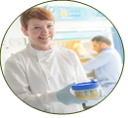
Any cancer tissue obtained from your samples may be used for animal experiments to create preclinical models i.e. rodents which then develop a similar tumour mass that can be studied in the lab. These experiments are strictly regulated under a government licence for this work.
Tissue samples may be used to test the functionality (such as imaging capability) of new devices being developed to access abnormalities by moving along the bile duct. Based on previous robots that have been used in throat surgery, we will build very slender devices that can be used with an endoscope to collect 3D images in the future.
Figure 5: Tissue laboratory

We would also like to seek your consent so that any remaining samples may be stored and used in possible future research – this is optional (please indicate if you agree to this on the consent form). The samples will be stored with a code unique to you and securely at the University of Nottingham under the University’s Human Tissue Research Licence (no 12265).
Some of these future studies may be carried out by researchers other than the current team of Prof Guru Aithal, who ran the first study, including researchers working for commercial companies. Samples may be used by researchers in countries outside the UK which may have different laws about human tissue. Any samples or data used will be anonymised, and you will not be identified in anyway. If you do not agree to this any remaining samples will be disposed of in accordance with the Human Tissue Authority’s codes of practice.
If you withdraw from the study, we can dispose of any samples that remain in the study tissue bank if you request this, but some samples may have already been used. We cannot recall samples sent to other labs.

Will any genetic tests be done?

Genetic analysis may be done to evaluate the properties of your tissue, blood and body fluids such as bile, cyst fluid (if available). We may test the tissue samples for changes in DNA that can arise in cancers. This is optional. If we do any analysis which provides information which could be useful or relevant for your care, we will contact your care team who will inform you of the results. These tests should not be used to direct your care unless obtained from approved clinical testing labs.


What will happen to the results of the research study?
The results of the research will be reported to the funders, published and presented at scientific meetings and in student presentations/dissertations/PhD theses, which will be available for further dissemination after 2027.
All data will be anonymised. A lay summary will be available on the NIHR Nottingham BRC website and associated University of Nottingham social media platforms in 2027.
A summary will also be sent to those participants who requested to receive the study summary on completion.

Who is organising and funding the research?
This research is being organised by the University of Nottingham and is being funded by UK Research & Innovation (UKRI) and supported by NIHR Nottingham Biomedical Research Centre, a partnership between the University of Nottingham and Nottingham University Hospitals NHS Trust.

Who has reviewed the study?

All research in healthcare is looked at by independent group of people, called a Research Ethics Committee, to protect your interests. This study has been reviewed and given favourable opinion by Yorkshire & The Humber - Sheffield Research Ethics Committee.

Further information and contact details:

website: https://www.nottingham.ac.uk/research/groups/giandliverdiseases/medical-surgical-research/map-hpb-cholangiobotics.aspx
Adult Clinical Research Facility, E floor, Queens Medical Centre, Nottingham NG7 2UH
Tel: 0115 9709966

Lead Researchers:
Dr Saikat Mandal: Saikat.Mandal@nhs.net, saikat.mandal@nottingham.ac.uk
Nottingham Digestive Diseases Centre, Queens Medical Centre Nottingham NG7 2UH

Chief Investigator: Prof Guru Aithal guru.aithal@nottingham.ac.uk
Nottingham Digestive Diseases Centre, Queens Medical Centre Nottingham NG7 2UH

